College Event Photo Gallery
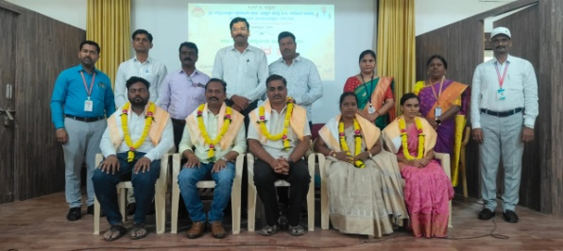
Alumni Association Programme: Felicitation to a notable alumnus.
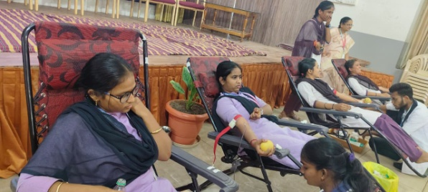
Students donating blood at the Voluntary Blood Donation Camp.
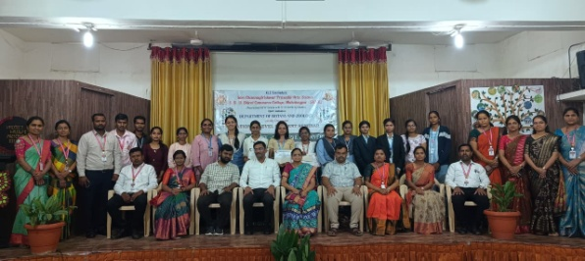
Dignitaries, faculty and student participants at the National Level Student Seminar, Department of Botany and Zoology.
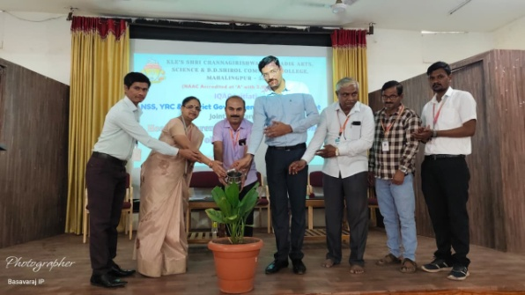
NSS, YRC volunteers and District Government Hospital officials plant a sapling to inaugurate the Health Awareness and Blood Donation Camp.
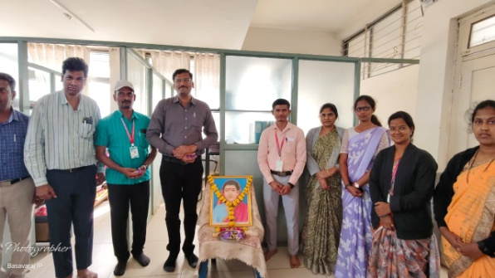
Faculty and staff members pay floral tribute to Savitribai Phule portrait on her birth anniversary
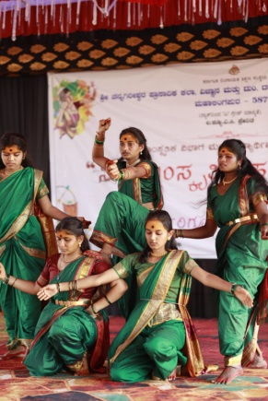
Students perform a traditional folk dance on stage.
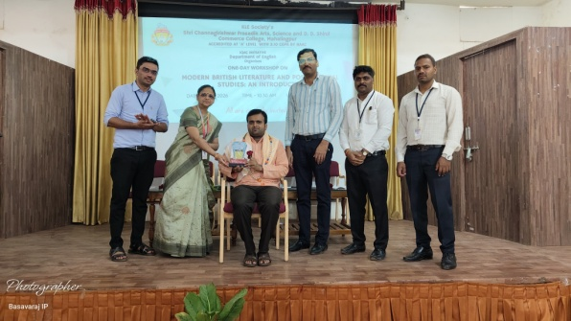
Chief guest felicitated with a memento at the One-Day Workshop on Modern British Literature and Postcolonial Studies, organized by the Department of English.
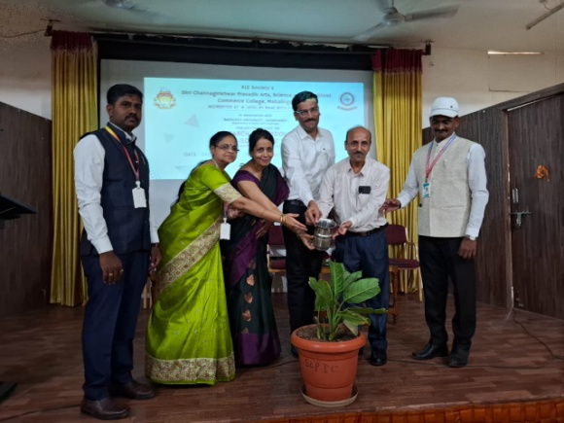
Dignitaries water a sapling to inaugurate the Research Methodology workshop, held jointly with Bagalkot University.
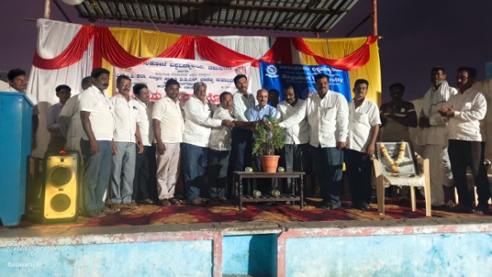
Guests and local residents jointly inaugurate an evening program of NSS
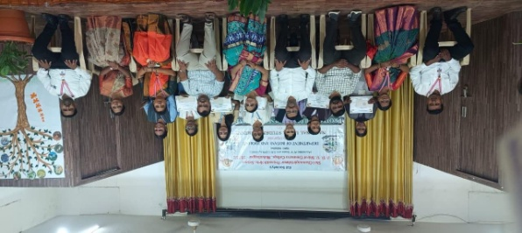
Certificates being distributed to student participants at the National Level Seminar, Department of Botany and Zoology.
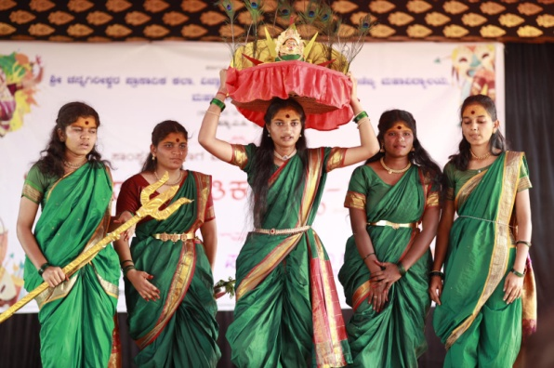
Students in traditional attire perform a mythological dance drama on stage.
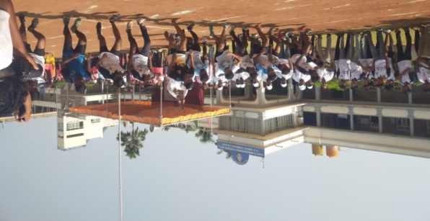
Students take part in a running race on the college grounds during the sports meet.
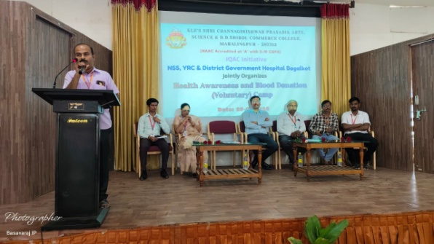
Chief Medical officer addresses the gathering at the inaugural session of the Health Awareness and Blood Donation Camp.
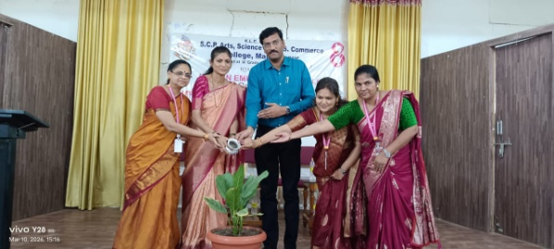
Dignitaries water a plant during a Women's Empowerment programme, an IQAC initiative.
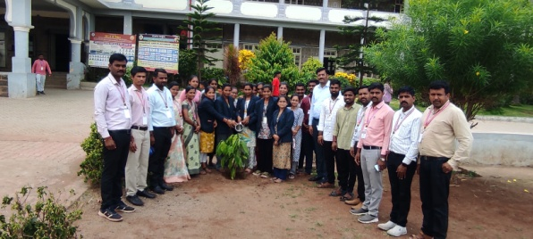
Faculty, staff and students plant a sapling outside the college as part of world environment day.
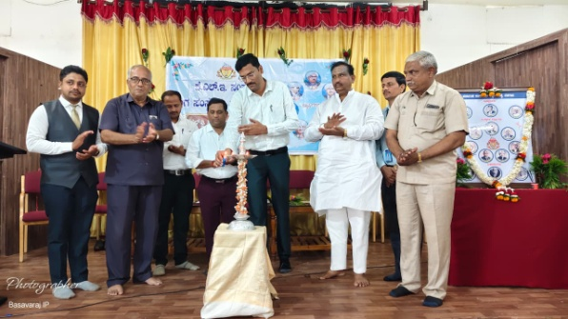
Lighting of the lamp marking the KLE Society Founders' Day commemoration.
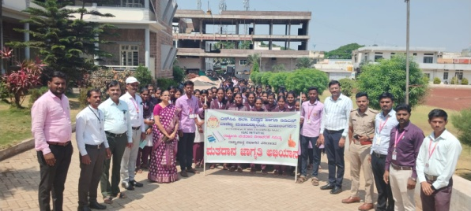
Students and staff, joined by police personnel, take part in the Voter Awareness Campaign.
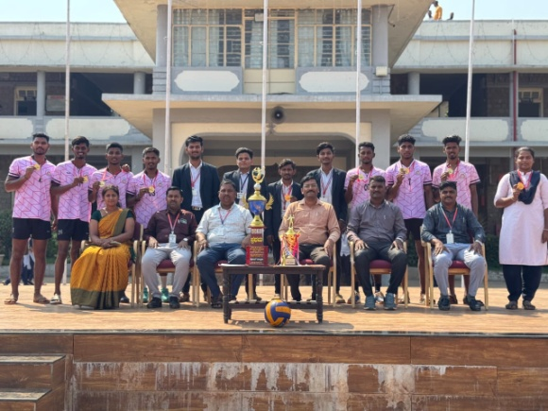
The college volleyball team poses with their trophy and medals alongside faculty and dignitaries.
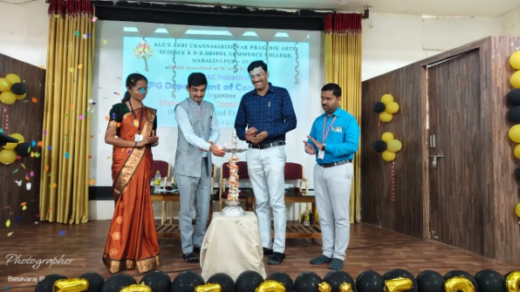
Lamp-lighting ceremony inaugurating the Orientation programme of the PG Department of Commerce.
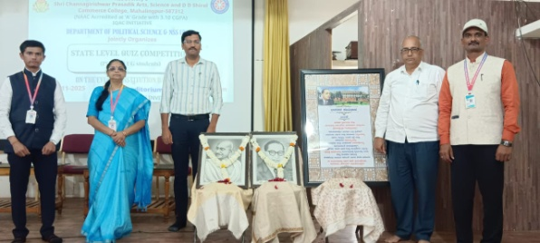
Dignitaries pay tribute to Mahatma Gandhi and Dr. B. R. Ambedkar at the State Level Quiz Competition organized by the Department of Political Science and NSS.

