College Event Photo Gallery

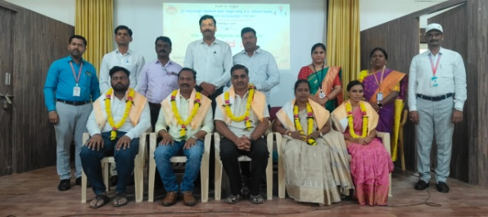  Alumni Association Programme: Felicitation to a notable alumnus.. | 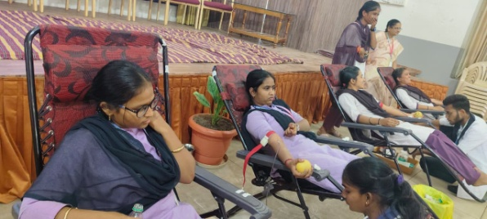  Students donating blood at the Voluntary Blood Donation Camp.
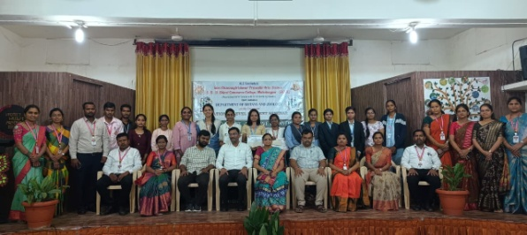  Dignitaries, faculty and student participants at the National Level Student Seminar, Department of Botany and Zoology. | 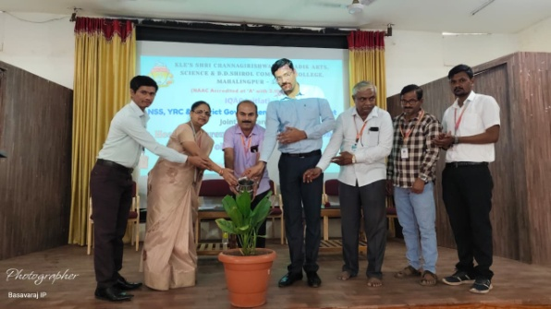  NSS, YRC volunteers and District Government Hospital officials plant a sapling to inaugurate the Health Awareness and Blood Donation Camp.
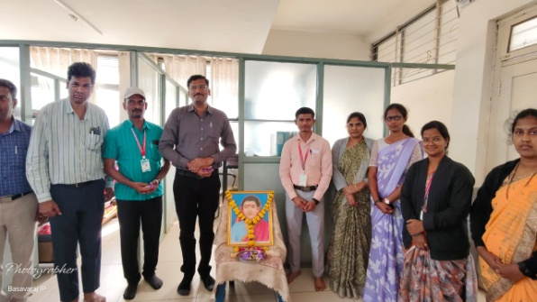  Faculty and staff members pay floral tribute to Savitribai Phule portrait on her birth anniversary | 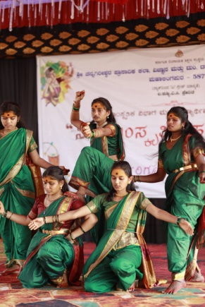  Students perform a traditional folk dance on stage.
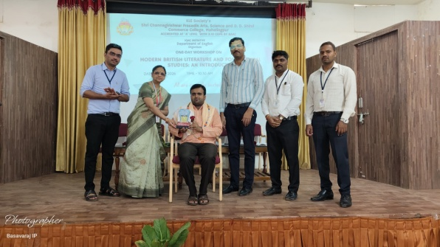  Chief guest felicitated with a memento at the One-Day Workshop on Modern British Literature and Postcolonial Studies, organized by the Department of English. | 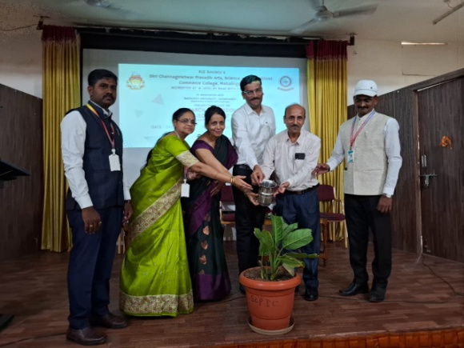  Dignitaries water a sapling to inaugurate the Research Methodology workshop, held jointly with Bagalkot University.
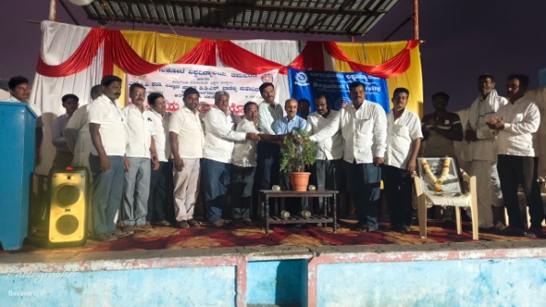  Guests and local residents jointly inaugurate an evening program of NSS | 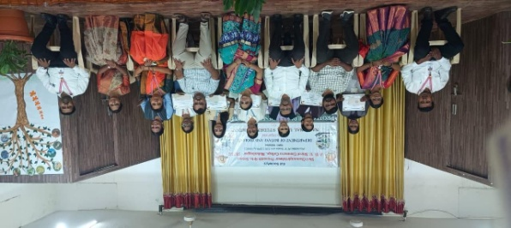  Certificates being distributed to student participants at the National Level Seminar, Department of Botany and Zoology.
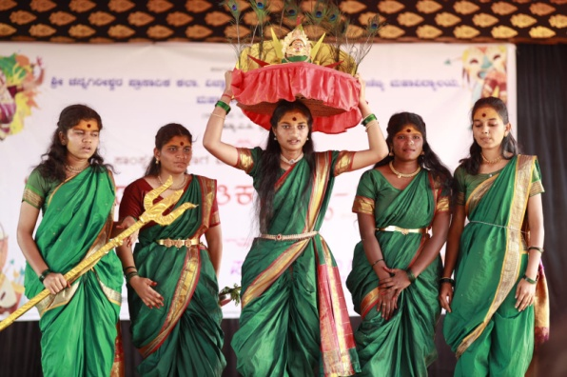  Students in traditional attire perform a mythological dance drama on stage. | 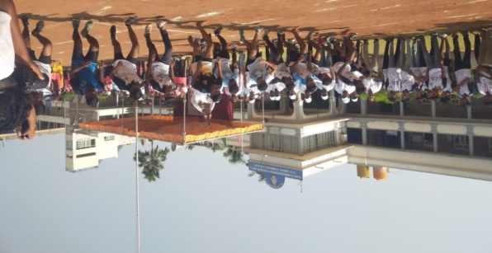  Students take part in a running race on the college grounds during the sports meet.
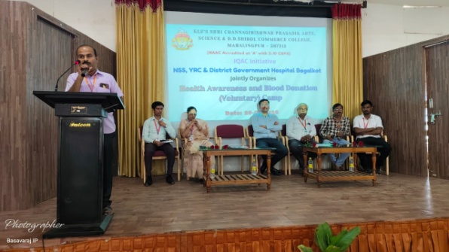  Chief Medical officer addresses the gathering at the inaugural session of the Health Awareness and Blood Donation Camp. | 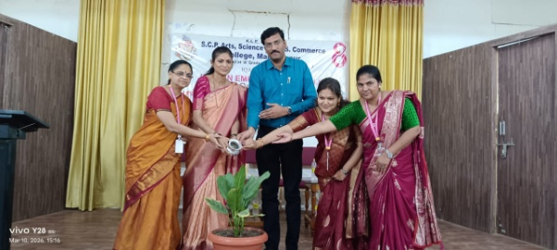  Dignitaries water a plant during a Women's Empowerment programme, an IQAC initiative.
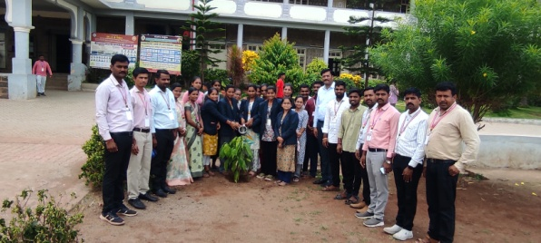  Faculty, staff and students plant a sapling outside the college as part of world environment day. | 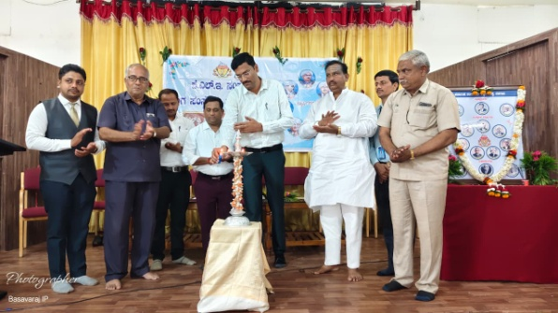  Lighting of the lamp marking the KLE Society Founders' Day commemoration.
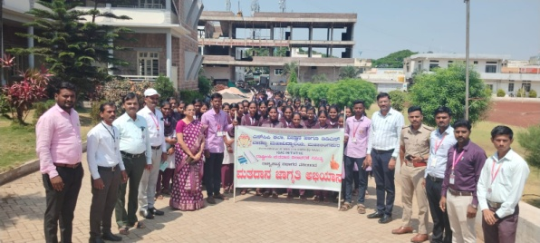  Students and staff, joined by police personnel, take part in the Voter Awareness Campaign. | 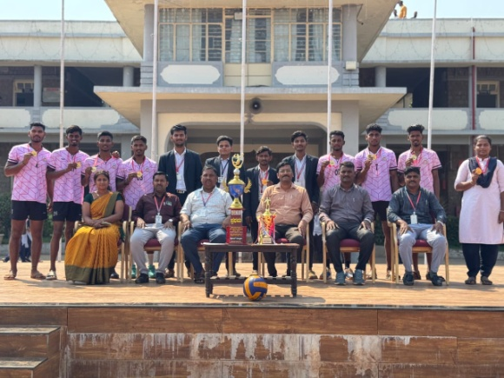  The college volleyball team poses with their trophy and medals alongside faculty and dignitaries.
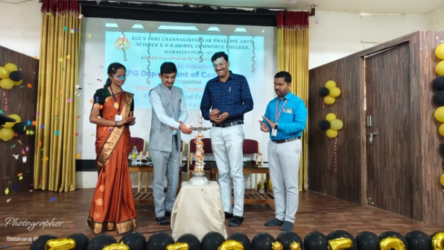  Lamp-lighting ceremony inaugurating the Orientation programme of the PG Department of Commerce. | 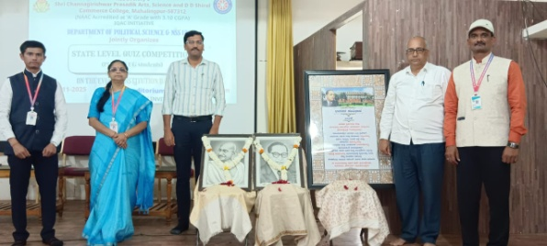  Dignitaries pay tribute to Mahatma Gandhi and Dr. B. R. Ambedkar at the State Level Quiz Competition organized by the Department of Political Science and NSS.

