

Guideline
Automation Test

 | /FSOFT-HCM
Issue/revision | 1.0
Effective date | 13-Feb-2017

Table of content
1. Introduction 3
1.1. Purpose 3
1.2. Application scope 3
2. Content 4
2.1. Using framework 4
2.2. Keywords 6
2.3. Script Template 11

Introduction

Purpose
The purpose of this document is to help reader knows how to use Automation Test framework for testing.

Application scope
This regulation is applied for internal projects at Automation Test Team.
Internal project types are:
- Study and training to prepare for next external project.
- Training new technology, language
- Business team make proposal or develop new market.
For develop internal tool project at OGs/branch/company, will be controlled follow Fsoft standard process.

Content

Using framework
Step 1: Run .jar file received, there is a window appear like the picture below
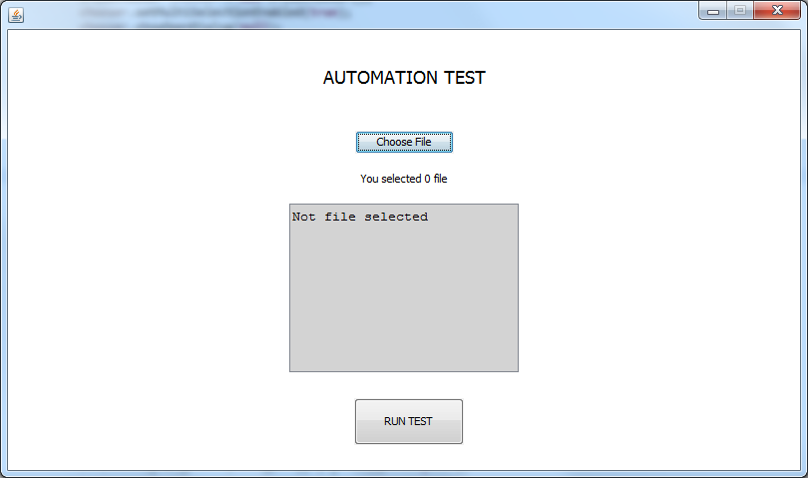
Picture 2.1.1. Automation Test Framework interface
Step 2: Select Choose File
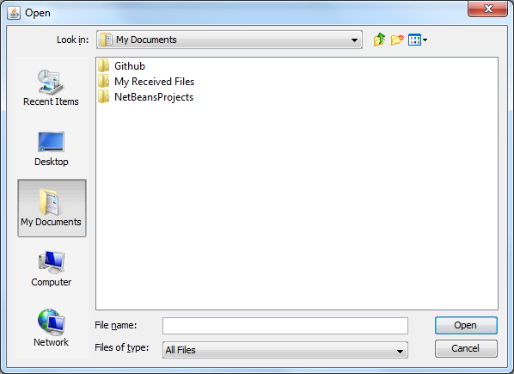
Picture 2.1.2. Open File interface
Step 3: Choose your scripts. Select Open.
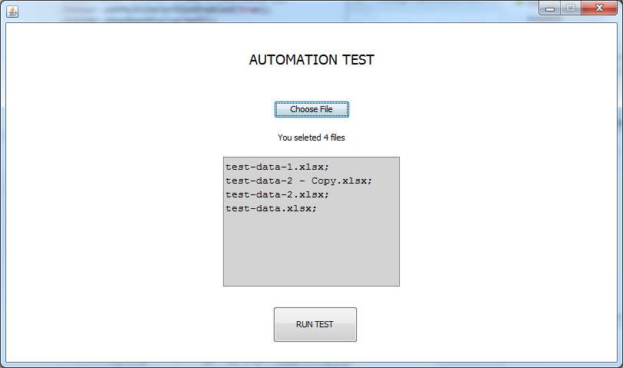
Picture 2.1.3. There’re all files choosen
Step 4: Select RUN TEST.
Step 5: Read report at [.jar location]/test-output/index.html and
[.jar location]/test-output/emailable-report.html
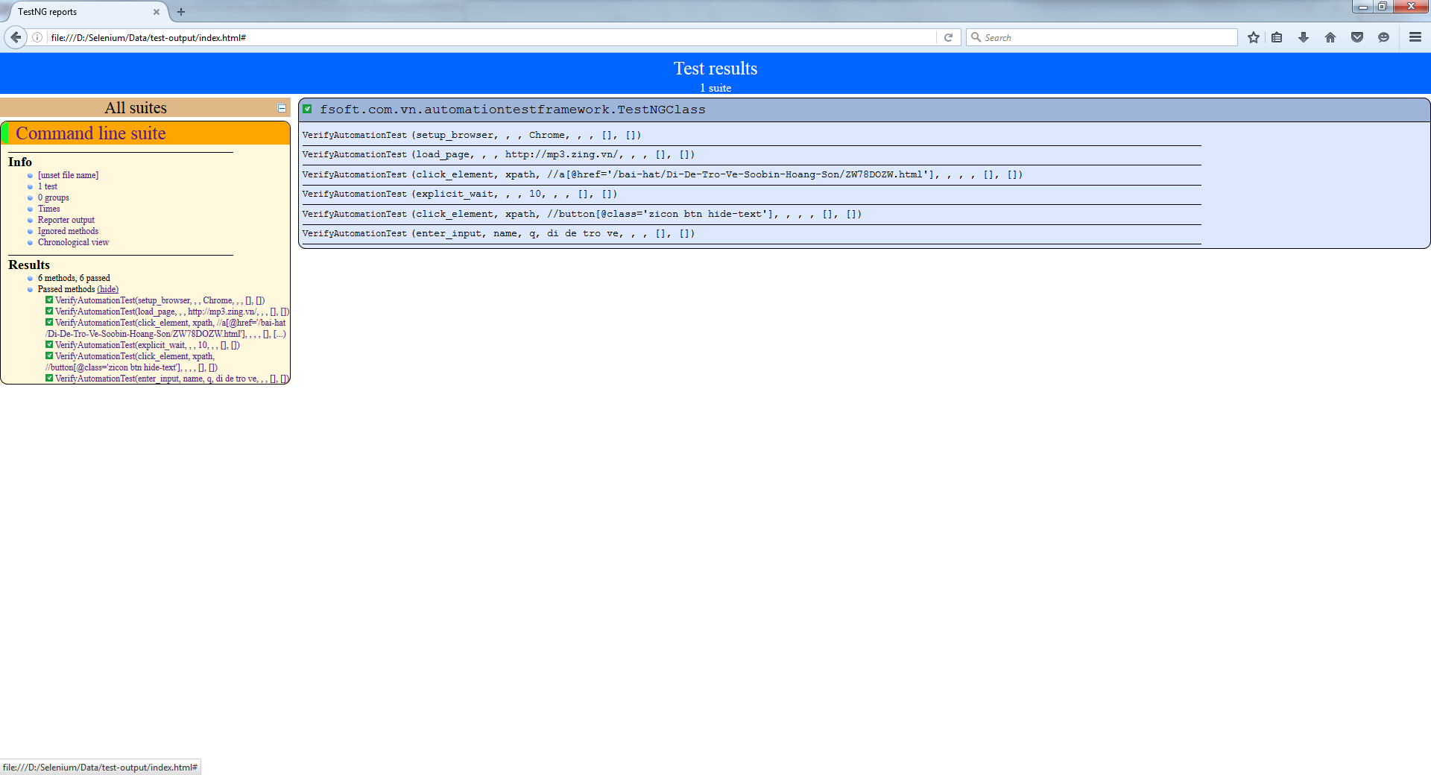
Picture 2.1.4. index.html
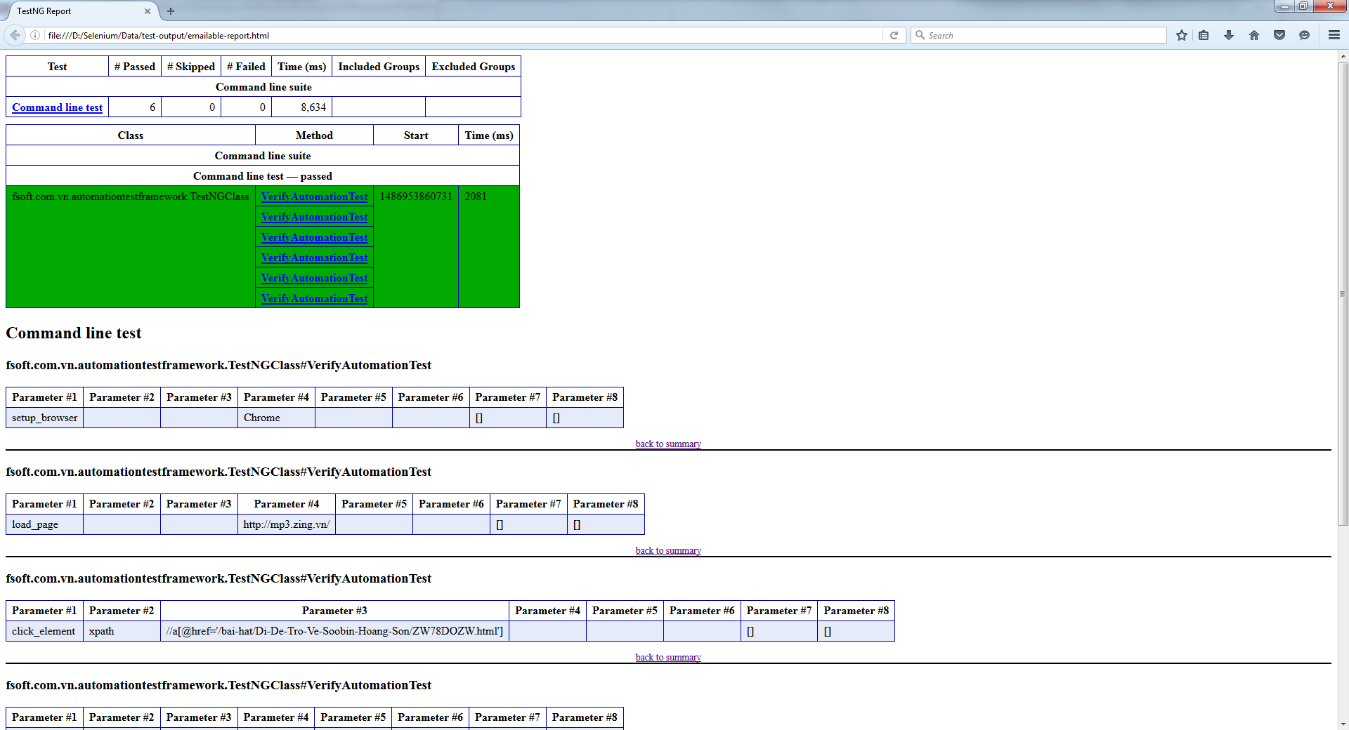
Picture 2.1.5. emailable-report.html

Keywords
No. | Keyword | Input | # of input params | Process/Purpose | Output | # of output params
1 | setup_browser | Input Value: Browser ID (IE, Chrome) | None | Choose the browser to run the system under test. | Passed or Failed | None
2 | load_page | Input Value: The URL to open. | None | Open/ load the page of system/ module/ function under test | Passed or Failed | None
3 | switch_frame | Input Value: The window/ frame (default/ contentFrame) | None | Selects either the main document, or the first frame on the page when a page contains iframes. | Passed or Failed | None
4 | enter_input | Input Value: the input string | None | Input the string to the control in UI. | Passed or Failed | None
5 | verify_element_present | Input Value: True/ False | None | Verify the element is avaiable or not avaiable in the UI. | 1. If input value is TRUE:  - Passed: the element is avaiable  - Failed: the element is not avaiable  2. If input value is FALSE:  - Passed: the element is not avaiable  - Failed: the element is avaiable | None
6 | enter_input_hidden | Input Value: input String  OR  Input Params for the input string | Optional | Enter the value to input hidden field | Passed or Failed | None
7 | select_drop_down | Input Value: the string of item that want to select in drop down list  OR  Input Params for the input string for selected item | Optional | Input the value to the drop down list. | Passed or Failed | None
8 | count_drop_down | Locator Id, Locator String, | None | Count the number of items in drop down list and store in Output Param | Passed or Failed | Output Param1
9 | click_element | Locator Id, Locator String | None | Clicks a web element on the page based on the locator id and string. | Passed or Failed | None
10 | verify_text | Input Value: the expected result (String)  OR  Input Param: the expected result (String) | 1 | Compare the value (text) of input element with expected result | Passed or Failed | None
11 | verify_text_contains | Input Value: the expected result (String)  OR  Input Param: the expected result (String) | None | Compare the text in html tag with expected result | Passed or Failed | None
12 | verify_field_text | Input Value: the expected result (String)  OR  Input Param: the expected result (String) | None | Compare the text in text field with the expected result | Passed or Failed | None
13 | compare_two_var | Input Param: 2,  Input Param1: variable 1,  Input Param2: variable 2 | 2 | Compare the value of variable 1 and variable 2 | Passed or Failed | None
14 | verify_table_cell_text | Input value: the expected result (String),  Row: row number (start from 0)  Column: Colum number (start from 1) | None | Verify the text in cell (row, column) if it matchs with the expected result | Passed or Failed | None
15 | table_row_sel | Input Value: True/ False  Row #: 0: started row,  Column#: the column to search the Input to select,  Input Param: Input string to search on data table | Optional | Select the row that matches with the string value | Output Params: Row number at selected item | 1st selected row
16 | store_cell_data | Column: Column number,  Input Params: Row Number | None | Store the value in cell (Column, Row) to output param | Value in cell (column, row) | Output Param1
17 | switch_alert_ok | None | None | Switch the window to alert pop up and click OK. | Passed or Failed | None
18 | compare_JSAlert_msg | Input Value: expected string value  OR  Input Params: expected string value | None | Compare the value of java script alert with the string in Input Value (Input Param1) | Passed or Failed | None
19 | page_scroll | Input Value: pixel value to scroll the page | None | Scroll down the page to X pixel  X: is defined as Input Value | Passed or Failed | None
20 | screen_shot | Input Value: Screenshot name | None | Capture the current screen and save in ..\SelScripts\TestAuto_Framework\screenshots folder | Passed or Failed | None
21 | wait_time | Input Value: wait time in second | None | Wait for next step | None | None
22 |  | Locator String: the element to get the data | None | Get the value from element and store to Output Param | The string value | None
23 | deselect_drop_down | Locator ID/ Locate String | None | De-select the default value(s) in the drop down/select box as below screen shot | Passed or Failed | None
24 | close_driver | None | None | Close the current window | Passed or Failed | None
25 | quit_driver | None | None | Quits Selenium driver, closing every associated window. | Passed or Failed | None
26 | send_key | Keyboard button action | None | Simulation keyboard action base on input value | None | None
27 | start_loop | Element Position | Required | Start loop from the specific line | None | None
28 | end_loop | None | None | End the loop to support reading multi-data | None | None

Script Template
