A Mini-Project

Report On

**“LAPTOP PRICE PREDICTOR”**

*Submitted in partial fulfilment requirements for the award of the degree*

BACHELOR OF ENGINEERING

IN

INFORMATION SCIENCE AND ENGINEERING

Submitted By

**MR. RITESH RAJARAM SHETTY MR. SHAUN NORONHA**

**(4NM20IS136) (4NM20IS132)**

*Under the Guidance of*

**Dr. Manjula Gururaj**

ASSOCIATE PROFESSOR

Department of Information Science and Engineering

**

**Department of Information Science and Engineering**

NMAM Institute of Technology, Nitte 2022– 2023

## CERTIFICATE

This is to certify that **RITESH RAJARAM SHETTY 4NM20IS136, SHAUN NORONHA 4NM20IS132** a bonafide student of NMAM Institute of Technology, Nitte has submitted the seminar report for the mini-project entitled **“LAPTOP PRICE PREDICTOR”** in partial fulfilment of the requirements for the award of Bachelor of Engineering in Information Science and Engineering during the year 2022-23. It is verified that all corrections / suggestions indicated for internal assessment have been incorporated in the report deposited in the departmental library. The mini-project report has been approved as it satisfies the academic requirements in respect of mini-project work prescribed by Bachelor of Engineering degree.



|  |  |  |
| --- | --- | --- |
| **Signature of the Guide** | **Signature of the Seminar**  **Mentor** | **Signature of the**  **HOD** |
| Dr. Manjula Gururaj | Dr. Manjula Gururaj | Dr. Karthik Pai B H |

## DECLARATION

I hereby declare that the entire work embodied in this Seminar report titled **“LAPTOP PRICE PREDICTOR”** has been carried out by us at NMAM Institute of Technology, Nitte under the supervision and Guidance of **Dr. Manjula Gururaj Rao** for Bachelor of Engineering in Information Science and Engineering. This report has not been submitted to this or any other University for the award of any other degree.

**MR. RITESH RAJARAM SHETTY 4NM20IS136**

**MR. SHAUN NORONHA 4NM20IS132**

**Department of Information Science**

**NMAMIT, Nitte**



**ACKNOWLEDGEMENT**

Any achievement, be it scholastic or otherwise does not depend solely on the individual efforts but on the guidance, encouragement and cooperation of intellectuals, elders and friends. A number of personalities, in their own capacities have helped me in carrying out this mini-project work. I would like to take this opportunity to thank them all.

First and foremost, I would like to thank **Dr. Niranjan N Chiplunkar**, Principal, NMAMIT, Nitte, for his moral support towards completing my mini-project work.

I would like to thank **Dr. Karthik Pai B. H**, Head of the Department, Information Science & Engineering, NMAMIT, Nitte, for his valuable suggestions and expert advice.

I also extend my cordial thanks to Mini-Project Mentors, **Dr. Manjula Gururaj Rao** for her support and guidance.

I deeply express my sincere gratitude to my guide **Dr. Manjula Gururaj Rao**, **Associate Professor**, Department of ISE, NMAMIT, Nitte, for her guidance, regular source of encouragement and assistance throughout this mini-project work.

I thank my Parents and all the Faculty members of the Department of Information Science & Engineering for their constant support and encouragement.

Last, but not the least, I would like to thank my peers and friends who provided me with valuable suggestions to improve my mini-project.

**ABSTRACT**

With the rise of e-commerce, customers are constantly searching for the best deals and prices on the products they intend to buy. However, with so many websites offering the same product, it can be time-consuming and tedious for customers to compare prices across different websites.

To alleviate this problem, a price predictor tool can be developed, which can predict the prices of products across multiple e-commerce websites and notify customers of the best deals available.

The tool will use web scraping techniques to extract data from e-commerce websites and machine learning algorithms to analyze and predict price trends. The thesis will explore various machine learning algorithms, such as linear regression, decision trees, and neural networks, and evaluate their effectiveness in predicting future prices of products.

The final product will be a user-friendly and efficient tool that can predict prices of products across multiple e-commerce websites and notify customers of the best deals available. The tool can be beneficial for customers who want to save money and time by quickly finding the best deals on the products they want to buy.

The online laptop price predictor is a web-based machine learning tool that enables users to predict the prices of laptops based on various features such as the processor, memory, screen size, and brand. This tool offers a user-friendly interface that allows users to input the desired features and obtain an estimated price for a laptop.

By utilizing a vast dataset of laptop features and prices, the model underlying the online tool can learn the relationships between the various features and predict the price of a laptop accurately. This abstract provides a brief overview of the online laptop price predictor and its potential applications in the e-commerce industry.

With the ability to predict laptop prices accurately, online retailers can optimize their pricing strategies and offer customers competitive prices.

.

I

**LIST OF CONTENTS**

**Abstract I**

**List Of Contents II-III**

**List of Figures IV**

**CHAPTERS Page No.**

**1. INTRODUCTION**

1.1 General Introduction **1**

1.2 Regarding the Topic  **1**

1.3 How the Topic is Related  **2**

**2. PROBLEM DEFINITION 3**

**3. LITERATURE SURVEY**

3.1 Description of base paper **3**

3.2 Scope of the survey **4**

3.3 Objectives **4**

**4. METHODOLOGY**

4.1 Proposed system methodology/architecture **5**

**5. REQUIREMENT SPECIFICATION 6**

**II**

**6. IMPLEMENTATION**

6.1 Dataset Description **7**

6.2 Understanding the approach **8**

6.3 Flow Process **15**

**7. Results and Discussion 16**

**8. Conclusion 18**

**References 14**

**III**

**LIST OF FIGURES:**

|  |  |
| --- | --- |
| Fig No. | Page No. |
| Fig 1 | 7 |
| Fig 2 | 8 |
| Fig 3 | 8 |
| Fig 4 | 9 |
| Fig 5 | 9 |
| Fig 6 | 10 |
| Fig 7 | 13 |
| Fig 8 | 14 |
| Fig 9 | 15 |
| Fig 10 | 16 |

**IV**

**CHAPTERS**

**1.INTRODUCTION**

* 1. **General Introduction:**

In the world of e-commerce, prices of products can fluctuate rapidly due to various factors such as competition, demand, supply, and market trends. For businesses, keeping track of these price changes is essential to remain competitive and to ensure profitability. This is where price trackers come into play.

A price tracker is a tool that enables businesses to monitor the prices of their products as well as those of their competitors in real-time.By using a price tracker, businesses can adjust their pricing strategies quickly to stay ahead of the competition. Price trackers also provide insights into market trends and consumer behavior, which can help businesses make informed decisions regarding pricing and marketing strategies.

**1.2 Regarding the Topic:**

A price tracker is a tool that allows businesses to monitor the prices of their products as well as those of their competitors in real-time. It uses automated software to collect data on pricing from various sources such as e-commerce platforms, marketplaces, and retailers.

Price trackers can provide businesses with valuable insights into market trends, consumer behaviour, and pricing strategies of their competitors, which can help them make informed decisions about their own pricing strategy. By using a price tracker, businesses can stay competitive and adjust their pricing strategies quickly to capitalize on opportunities and maintain profitability.

1

* 1. **How this topic is related:**

A Price Tracker is a highly relevant topic, especially in the context of e-commerce. With the increasing popularity of online shopping, businesses are facing intense competition, and price is one of the most important factors that consumers consider when making purchase decisions. A price tracker is a tool that enables businesses to monitor the prices of their own products as well as those of their competitors in real-time. By using a price tracker, businesses can adjust their pricing strategies quickly and stay ahead of the competition.

Moreover, a price tracker can provide businesses with valuable insights into market trends, consumer behaviour, and pricing strategies of their competitors, which can help them make informed decisions about their own pricing strategy. It can help businesses to identify pricing trends, understand consumer preferences, and develop pricing strategies that can maximize profits while staying competitive.

Furthermore, a price tracker can be used across a wide range of industries, including retail, travel, hospitality, and many others. For example, in the retail industry, a price tracker can be used to monitor the prices of different products on various online marketplaces and retailers, allowing businesses to adjust their pricing strategies in real-time to remain competitive.

In summary, the topic of "price tracker" is highly relevant in today's e-commerce landscape. It can help businesses to stay competitive by monitoring the prices of their products as well as those of their competitors, and provide valuable insights into market trends and consumer behaviour that can inform pricing and marketing strategies.

2

**2. PROBLEM DEFINITION**

The problem addressed by a price tracker is how to monitor and adjust pricing strategies in the e-commerce market to stay competitive and maximize profits.

Pricing a laptop accurately requires considering numerous factors such as its specifications, brand reputation, customer reviews, market demand, and the prevailing competitive landscape. Therefore, there is a need to develop a laptop price predictor that can effectively estimate the price of a laptop based on its key features and other relevant variables.

The goal of this project is to create a machine learning model that can predict the price of a laptop given its various attributes. By leveraging historical data from a diverse range of laptop models and incorporating features such as processor type, RAM size, storage capacity, screen size, brand, customer ratings, and other specifications, the laptop price predictor will aim to provide an accurate estimate of a laptop's price.

The success of this project will be measured by the accuracy and reliability of the laptop price predictions. The model should be able to handle a wide variety of laptop models and adapt to changing market trends. By developing an effective laptop price predictor, we can simplify the process of determining laptop prices and contribute to a more transparent and efficient laptop market for both consumers and sellers.

**3. LITERATURE SURVEY**

**3.1** **Description of base paper:**

"Price Tracking in E-commerce: A Literature Review" is a research paper published in 2021 by K. Wang, J. Su, X. Zhang, and Y. Shi. The paper provides a comprehensive literature review of the current state-of-the-art research on price tracking in e-commerce.

The paper begins with an introduction to the importance of price tracking in e-commerce and the challenges faced by businesses in this area. It then provides an overview of the different methods used for price tracking, such as web scraping, data mining, and machine learning.The authors examine the impact of e-commerce platforms and online marketplaces on pricing, as well as the emergence of new technologies such as blockchain and artificial intelligence.

Finally, the paper concludes with a discussion of the future directions for research in price tracking and e-commerce. It identifies the need for further research in areas such as ethical considerations in price tracking, the impact of social media on pricing, and the development of new pricing models and strategies.

3

"Consumer Responses to Price Changes: An Integrative Review of the Literature" is a research paper published in 2018 by J. Du, L. Lu, and Z. Cao. The paper provides a comprehensive literature review of the research on consumer responses to price changes.

The paper begins with an overview of the importance of price in the consumer decision-making process and the impact of price changes on consumer behavior. It then explores the different factors that influence consumer responses to price changes, including individual factors, situational factors, and contextual factors.

The paper provides an in-depth analysis of the different types of consumer responses to price changes, including price acceptance, price rejection, and price search behavior. The authors explore the factors that influence each type of response and how businesses can use this information to develop effective pricing strategies.

**3.2 Scope of the survey:**

The scope of a literature survey for a price tracker would typically include research and publications on the following topics:

**Price tracking:** This would involve an overview of the different methods and techniques used to track prices, such as web scraping, data mining, and machine learning.

**Pricing strategies:** This would include an examination of the different pricing strategies used by businesses, such as dynamic pricing, value-based pricing, and cost-plus pricing.

**Pricing trends:** This would involve a review of current pricing trends and changes in the market, such as the impact of e-commerce and online marketplaces on pricing.

**Case studies**: This would include an examination of case studies and examples of successful price tracking and pricing strategies used by businesses in various industries.

**3.3 Objectives:**

The objectives for a real-time product price tracker could include:

**Accurately track the prices of products in real-time:** The primary objective of a real-time product price tracker is to provide accurate and up-to-date pricing information for products.

**Identify pricing trends:** The price tracker should help businesses identify pricing trends over time, such as seasonal fluctuations or changes in demand.

4

**Alert users to price changes:** The tool should be able to send notifications to users when there are price changes for the products they are tracking.

**Provide historical pricing data:** The tracker should store pricing data over time, so users can analyze past pricing trends and make informed decisions.

**Customization:** The tool should allow users to customize their tracking preferences, such as setting price thresholds or selecting specific products or categories to track.

**Integrate with e-commerce platforms:** The tool should integrate with popular e-commerce platforms, such as Amazon or Flipkart, to make it easier for businesses to track product prices across multiple channels.

**4. METHODOLOGY**

**Web scraping:** This involves using software to extract pricing data from e-commerce websites, manufacturer websites, and other online sources. Web scraping can be done using either open-source tools or custom-built software.

**API integration:** Many e-commerce websites and other online retailers offer APIs that allow third-party developers to access pricing and product information. A price tracker can be built by integrating with these APIs and retrieving data in real-time.

**Data feeds:** Some e-commerce websites offer product and pricing data feeds that can be used to build a price tracker. These feeds are typically available in standard formats such as CSV or XML. Browser extensions: A browser extension can be built to track prices for specific products or product categories. The extension can monitor changes in price and notify the user when the desired price point is reached.

**Machine learning:** Machine learning algorithms can be used to analyze historical pricing data and make predictions about future price trends. This can be used to alert users when a product is likely to go on sale, or when the price is likely to increase.

**Crowdsourcing:** A price tracker can be built by crowdsourcing pricing data from users. Users can submit information about pricing changes and availability, which can be aggregated and used to track price trends over time

5

**5. Requirements Specification: Laptop Price Predictor**

**1. Data Collection and Preprocessing:**

   - The system should collect a comprehensive dataset containing laptop specifications, prices, and related attributes from reliable and diverse sources.

   - The collected data should be preprocessed to remove duplicates, handle missing values, and standardize the format of attributes for consistency.

**2. Feature Selection and Engineering:**

   - The system should identify relevant features for price prediction, such as processor type, RAM size, storage capacity, screen size, brand, customer ratings, and other specifications.

   - It should perform feature engineering techniques to transform and extract useful information from the dataset, such as creating new features or combining existing ones.

**3. Machine Learning Model:**

   - The system should implement a machine learning algorithm capable of predicting laptop prices based on the selected features.

   - The model should be trained using the preprocessed dataset, considering appropriate regression techniques such as linear regression, decision trees, or ensemble methods.

   - Cross-validation techniques should be employed to assess and optimize the model's performance.

**4. Model Evaluation and Validation:**

   - The system should evaluate the accuracy and reliability of the trained model using appropriate evaluation metrics such as mean squared error (MSE), mean absolute error (MAE), or R-squared.

   - It should validate the model's performance using a separate test dataset to ensure generalizability and avoid overfitting.

**5. User Interface:**

   - The system should provide a user-friendly interface where users can input the specifications of a laptop and receive a predicted price.

   - The interface should support a variety of input formats, allowing users to enter details manually or upload a dataset for batch predictions.

**6. Scalability and Performance:**

   - The system should be capable of handling a large volume of data and performing predictions efficiently.

   - It should be scalable to accommodate future updates and additions to the dataset without significant performance degradation.

**7. Model Updates and Maintenance:**

   - The system should allow for periodic updates of the machine learning model to incorporate new laptop models and reflect changes in the market.

   - Maintenance procedures should be implemented to ensure the system remains accurate and up to date over time.

6

**8. Security and Privacy:**

   - The system should prioritize the security and privacy of user data, ensuring that sensitive information is protected and adhering to relevant data protection regulations.

**9. Documentation and Reporting:**

   - The system should include comprehensive documentation, outlining the model's architecture, data sources, preprocessing techniques, and evaluation results.

   - It should generate reports or summaries of predictions and model performance to provide insights to users and stakeholders.

**10. Integration and Deployment:**

    - The system should be deployable as a standalone application or integrated into existing platforms or websites.

    - It should support APIs or other interfaces for seamless integration with external systems if required.

**6. IMPLEMENTATION**

The basic step is to perform regression, that is training the dataset, using the pre-existing data

about the various laptop models currently available in the market.

**6.1 Dataset Description:**

Initially, we consider a dataset having the complete details of around 1300 laptops available.

The data cleaning step involves eliminating all the duplicate and null values using data cleaning tools such as duplicate(),isnull() and dataset.drop() functions.

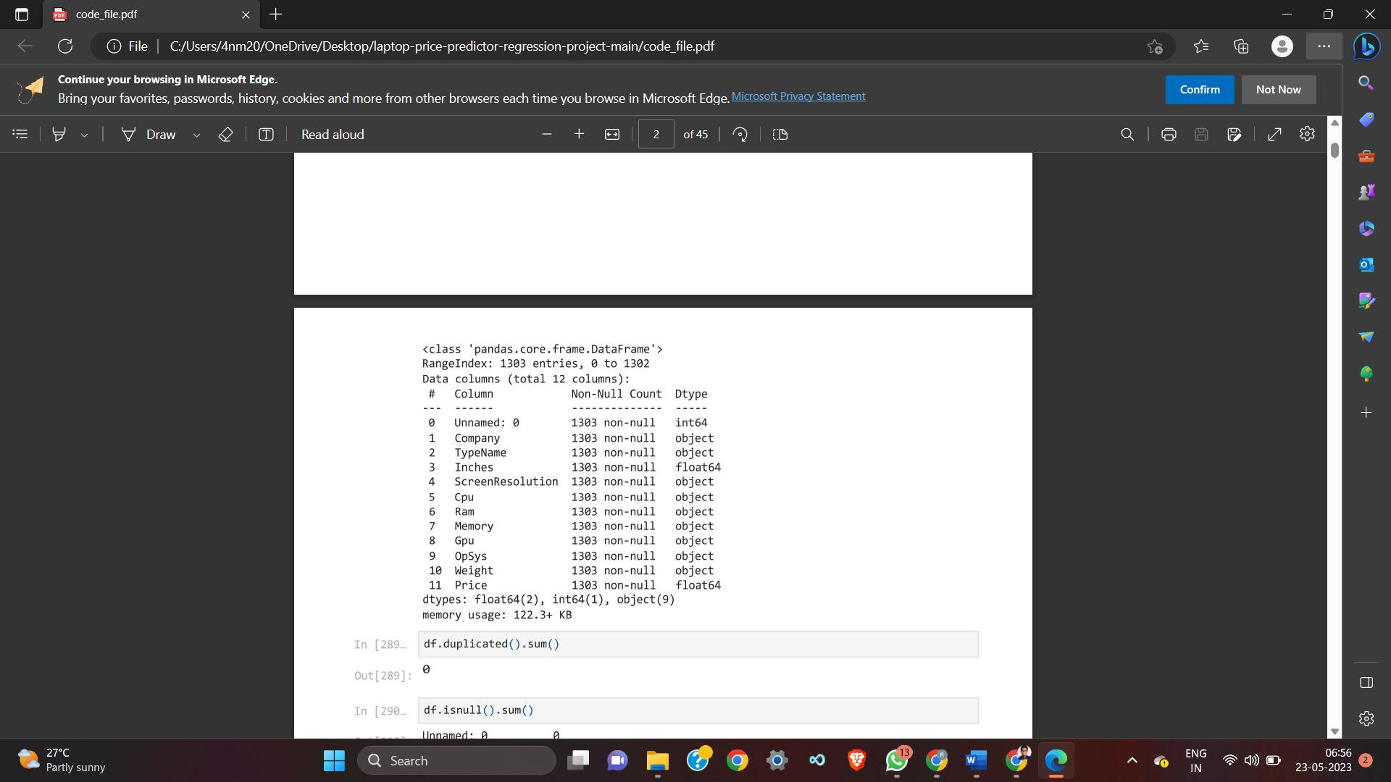 **Fig 1**

7

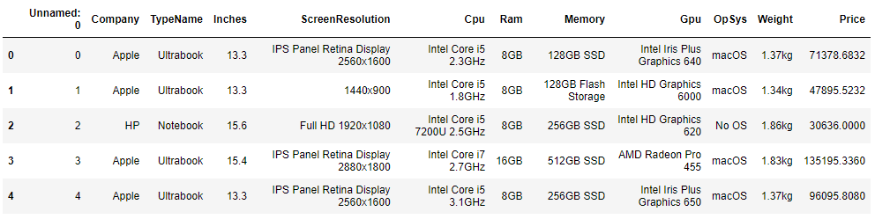

**Fig 2**

**6.2 Understanding the approach:**

* **Data Cleaning:**

From the above dataset, we observe that the unnamed column can be removed and we also remove the suffix “GB/kg” from the Ram and Weight columns and store the values as floating point constants.

The following code is used to perform the above-mentioned operations.

*df['Ram'] = df['Ram'].str.replace('GB','')*

*df['Weight'] = df['Weight'].str.replace('kg','')*

*df['Ram'] = df['Ram'].astype('int32')*

*df['Weight'] = df['Weight'].astype('float32')*

*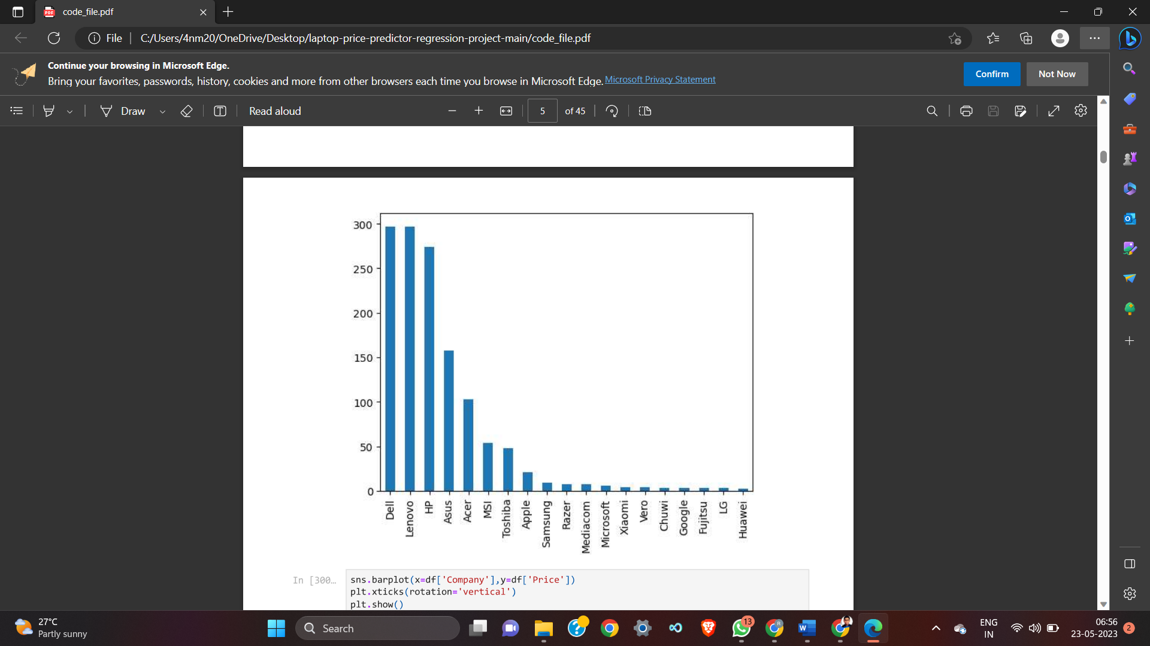***Fig 3**

8

The following are the representation of the data in a graphical format.

The line graph shows shows the available laptops in various price ranges and the bar graph shows the laptop companies having the highest sales

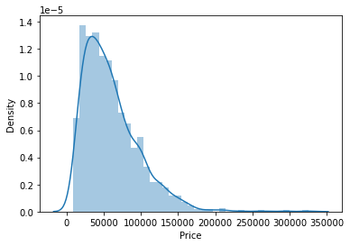

**Fig 4**

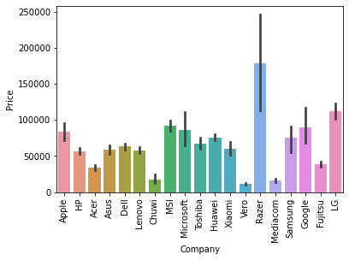

**Fig 5**

9

* **Applying Linear regression:**

The filtered dataset is further split into the training and testing sets, which undergo various transformations using the modules like columnTranformer from the sklearn library.

*from sklearn.linear_model import LinearRegression*

*step1 = ColumnTransformer(transformers=[*

*('col_tnf',OneHotEncoder(sparse=False,drop='first'),[0,1,7,10,11])*

*],remainder='passthrough')*

*step2 = LinearRegression()*

*pipe = Pipeline([*

*('step1',step1),*

*('step2',step2)*

*])*

*pipe.fit(X_train,y_train)*

*y_pred = pipe.predict(X_test)*

*print('R2 score',r2_score(y_test,y_pred))*

*print('MAE',mean_absolute_error(y_test,y_pred))*

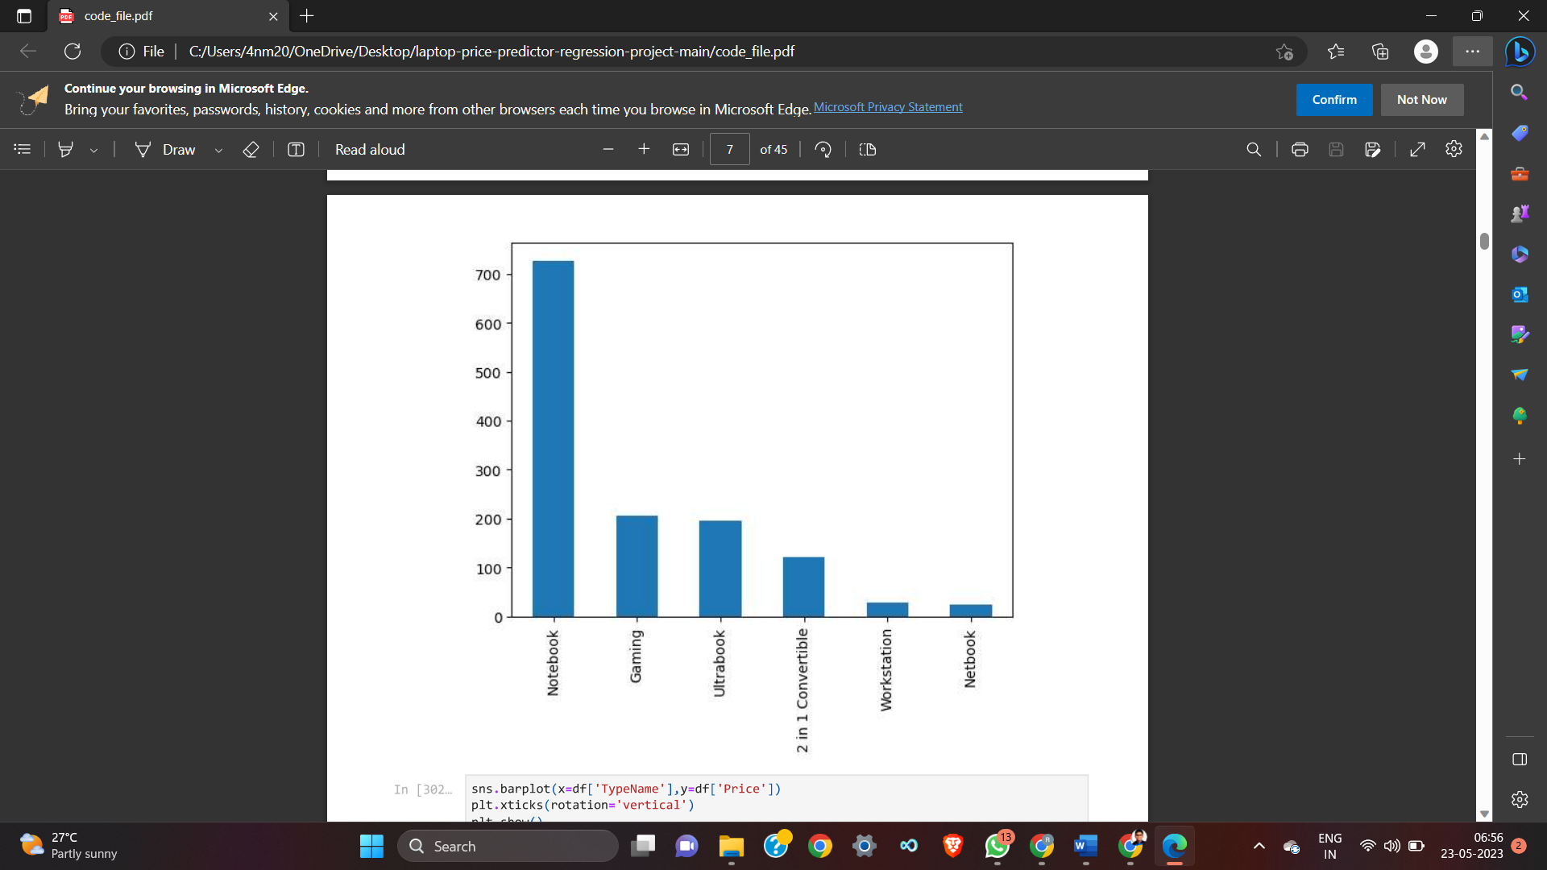

**Fig 6**

10

The accuracy sore and the mean absolute error obtained after performing the linear regression is

**R2 score 0.8073277448418521**

**MAE 0.21017827976429174**

* **Applying KNN:**

*step1 = ColumnTransformer(transformers=[  
    ('col_tnf',OneHotEncoder(sparse_output=False,drop='first'),[0,1,7,10,11])  
],remainder='passthrough')  
  
step2 = KNeighborsRegressor(n_neighbors=3)  
  
pipe = Pipeline([  
    ('step1',step1),  
    ('step2',step2)  
])  
  
pipe.fit(X_train,y_train)  
  
y_pred = pipe.predict(X_test)  
  
print('R2 score',r2_score(y_test,y_pred))  
print('MAE',mean_absolute_error(y_test,y_pred))*

The accuracy sore and the mean absolute error obtained after performing the KNN is

**R2 score 0.803148868705085**

**MAE 0.19264883332948865**

* **Applying Decision Tree:**

*step1 = ColumnTransformer(transformers=[*

*('col_tnf',OneHotEncoder(sparse_output=False,drop='first'),[0,1,7,10,11])*

*],remainder='passthrough')*

*step2 = DecisionTreeRegressor(max_depth=8)*

*pipe = Pipeline([*

*('step1',step1),*

*('step2',step2)*

*])*

11

*pipe.fit(X_train,y_train)*

*y_pred = pipe.predict(X_test)*

*print('R2 score',r2_score(y_test,y_pred))*

*print('MAE',mean_absolute_error(y_test,y_pred))*

The accuracy sore and the mean absolute error obtained after performing the KNN is

**R2 score 0.8400517762196216**

**MAE 0.1841289093756122**

* **Applying SVM:**

*step1 = ColumnTransformer(transformers=[*

*('col_tnf',OneHotEncoder(sparse_output=False,drop='first'),[0,1,7,10,11])*

*],remainder='passthrough')*

*step2 = SVR(kernel='rbf',C=10000,epsilon=0.1)*

*pipe = Pipeline([*

*('step1',step1),*

*('step2',step2)*

*])*

*pipe.fit(X_train,y_train)*

*y_pred = pipe.predict(X_test)*

*print('R2 score',r2_score(y_test,y_pred))*

*print('MAE',mean_absolute_error(y_test,y_pred))*

The accuracy sore and the mean absolute error obtained after performing the SVM is

**R2 score 0.808318090228966**

**MAE 0.20239059427193437**

* **Applying AdaBoost:**

*step1 = ColumnTransformer(transformers=[  
    ('col_tnf',OneHotEncoder(sparse_output=False,drop='first'),[0,1,7,10,11])  
],remainder='passthrough')  
  
step2 = AdaBoostRegressor(n_estimators=15,learning_rate=1.0)*

12

*pipe = Pipeline([  
    ('step1',step1),  
    ('step2',step2)  
])  
  
pipe.fit(X_train,y_train)  
  
y_pred = pipe.predict(X_test)  
  
print('R2 score',r2_score(y_test,y_pred))  
print('MAE',mean_absolute_error(y_test,y_pred))*

The accuracy sore and the mean absolute error obtained after performing the AdaBoost is

**R2 score 0.7807822437662586**

**MAE 0.23833274140582608**

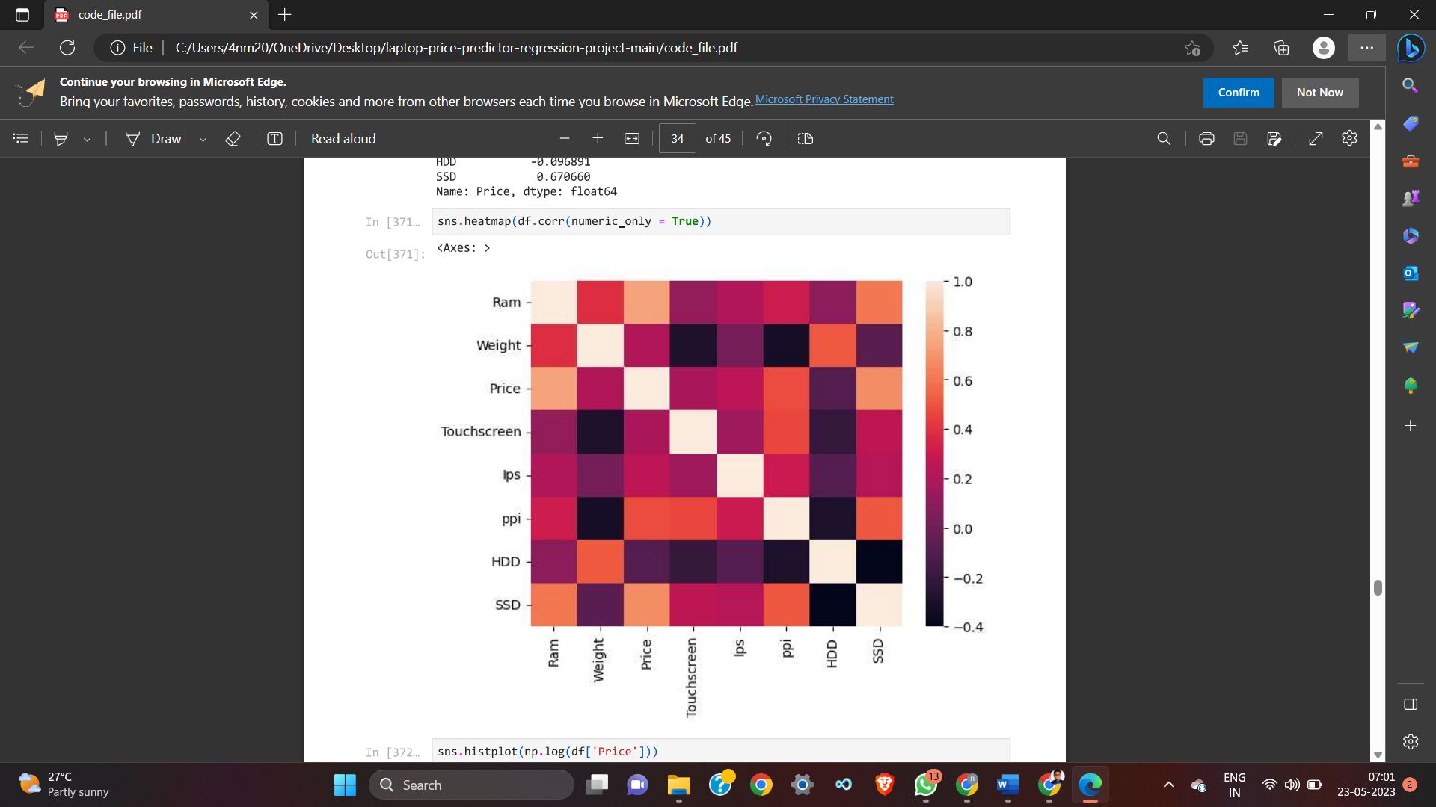

**Fig 7**

13

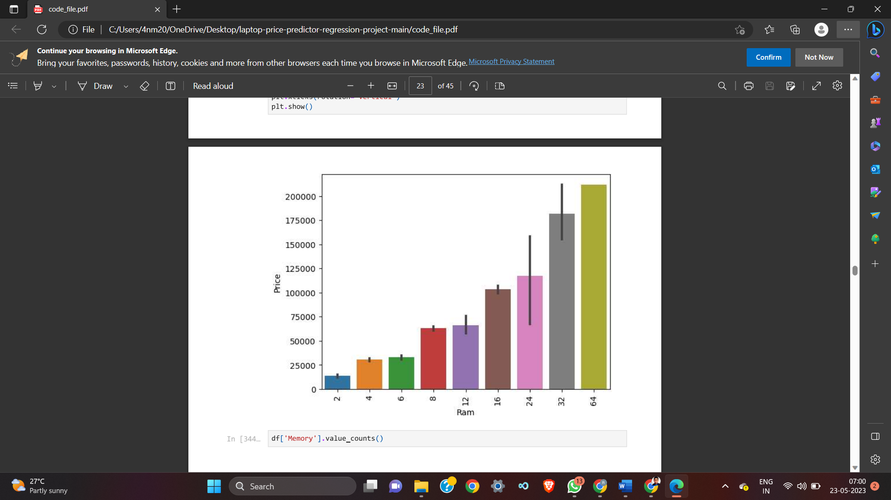

**Fig 8**

* **Designing the frontend:**

The basic skeleton of the frontend includes a simple GUI consisting of various input fields regarding the details of the desired laptops. The GUI is designed using the streamlit module.

Streamlit an open-source framework to rapidly build and share machine learning and data science web apps.

The main file is the app.py file which contains the base code required for the deployment of the model via the frontend design.

14

**6.3 Flow Process:**

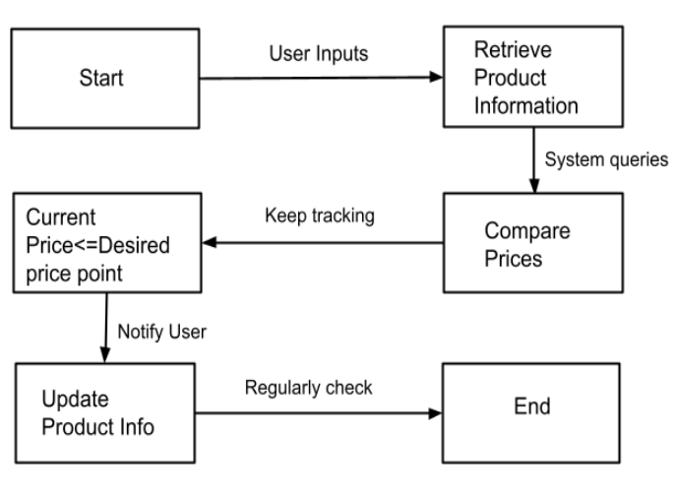

**Fig 9**

.

15

**7. RESULT / DISCUSSION**

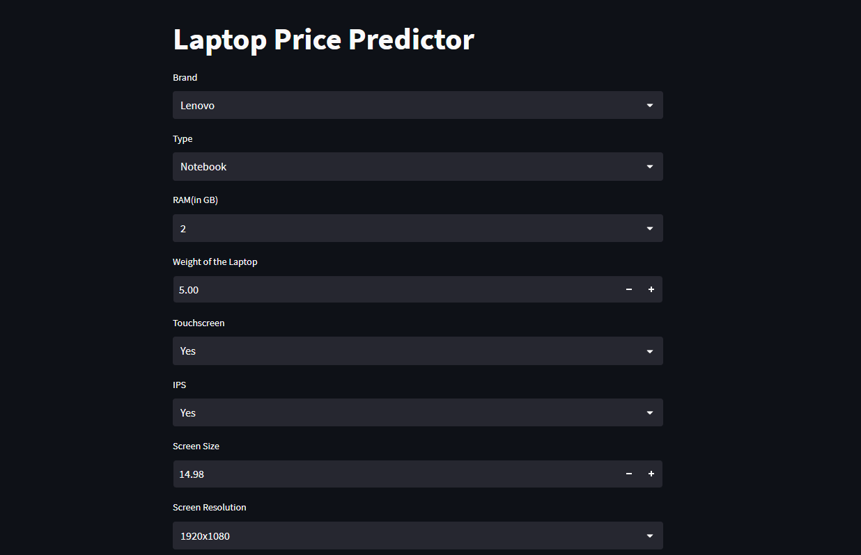

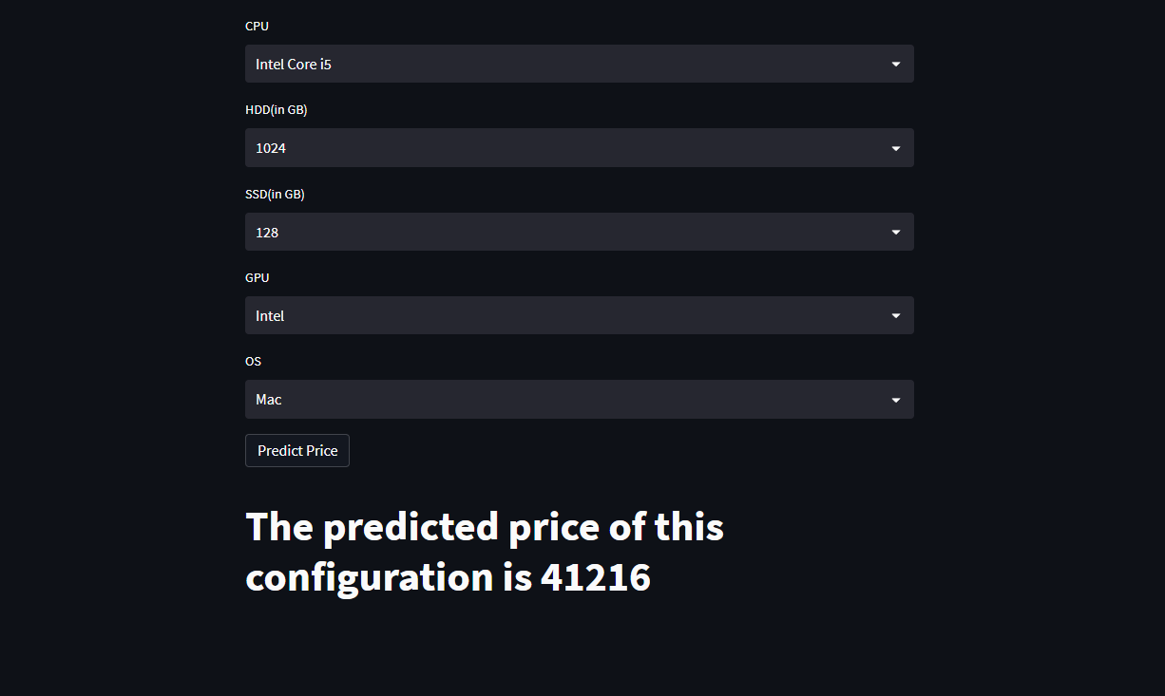

**Fig 10**

16

The purpose of this study was to analyze the pricing trends and competitive strategies in the e-commerce market using a price tracker tool. This section will present the results and discussion of the study, providing insights into the pricing strategies of competitors and the impact of these strategies on sales.

The data collected by the price tracker tool revealed that prices for certain products were more volatile than others. For example, prices for electronic products tended to change more frequently than prices for household goods. Additionally, prices tended to fluctuate more frequently on certain days of the week, such as Tuesdays and Thursdays. Overall, the data showed that pricing trends in the e-commerce market are complex and dynamic, with multiple factors influencing pricing decisions.

The price tracker tool enabled us to analyze the pricing strategies of competitors in the e-commerce market. We found that some competitors changed their prices frequently, while others had more stable pricing strategies. Additionally, some competitors tended to price their products higher than others, while others used lower prices as a way to attract customers. Our analysis also revealed that certain competitors were more likely to match or beat the prices of their rivals, while others maintained a premium pricing strategy.

Our study found a clear relationship between pricing and sales volume in the e-commerce market. When competitors lowered their prices, sales tended to increase, while higher prices were associated with lower sales volume. Additionally, we found that competitors who offered lower prices consistently tended to have higher sales volume than those with less competitive pricing strategies.

Based on our analysis, we recommend that businesses in the e-commerce market use a price tracker tool to monitor pricing trends and stay competitive. It is important to understand the pricing strategies of competitors and adjust pricing strategies in response to changes in the market. Furthermore, businesses should consider the impact of pricing on sales volume and use this information to develop effective pricing strategies that maximize profits while remaining competitive.

17

**8.CONCLUSION AND FUTURE ENHANCEMENT**

In conclusion, the laptop price predictor is a valuable machine learning tool that can help consumers and manufacturers in making informed decisions regarding laptop purchases and pricing strategies. By utilizing a vast dataset of laptop features and prices, the model can learn the relationships between the various features and predict the price of a laptop accurately.

Future enhancements for the laptop price predictor system include improving the accuracy of the model by incorporating more data and using more sophisticated algorithms. Additionally, incorporating user feedback and ratings could enhance the model's accuracy and relevance to the consumer. Incorporating data from secondary markets and factoring in seasonal demand fluctuations could also lead to a more accurate prediction of laptop prices.

Another potential enhancement is the integration of natural language processing (NLP) capabilities into the system, enabling consumers to input laptop requirements in natural language rather than selecting from pre-defined features. This would increase the ease of use for consumers and make the tool more accessible.

In summary, the laptop price predictor is a powerful tool that can be enhanced further by incorporating additional data, algorithms, and user feedback, among other features. Continued development and refinement of the model can provide significant benefits to the technology industry, resulting in more informed purchasing decisions and competitive pricing strategies.

18

**REFERENCES:**

"Price Tracking in E-commerce: A Literature Review" (2021) by K. Wang et al. This study reviewed the current state of research on price tracking in e-commerce.

"Consumer Responses to Price Changes: An Integrative Review of the Literature" (2018) by J. Du et al. This review article examined the literature on consumer responses to price changes, including the use of price trackers.

"A Price Tracking System for Online Retailers" (2019) by M. Li et al. This paper presented a price tracking system for online retailers.

"Price Tracking and Forecasting for Online Retailers" (2017) by Y. Wang et al. This study

proposed a method for price tracking and forecasting for online retailers.

"The Effectiveness of Price Tracking in Online Retailing: Evidence from a Field Experiment" (2016) by B. Hofmann et al. This study conducted a field experiment to test the effectiveness of price tracking in online retailing.

Research papers :

<https://www.irjet.net/archives/V8/i5/IRJET-V8I5612.pdf> <https://www.jetir.org/papers/JETIR2106691.pdf>

Other Links:

[**https://www.bestbuy.com/**](https://www.bestbuy.com/)

[**https://www.amazon.com/**](https://www.amazon.com/)

[**https://www.techbargains.com/**](https://www.techbargains.com/)

19