**ABSTRACT**

MASCOTA is a Pet Adoption database management system. A

pet adoption database management system ( DBMS) is a computer

program that is used to store , retrieve , and manipulate data for

pets. The DBMS is responsible for organizing and storing

data in a structured format , such as a database and for providing

users with the tools to access and the data as needed.

A pet adoption DBMS may be used to store customer and pet

information , inventory data , and customer details providing customers wide range of pets to adopt , among other

types of data . Some common features of a pet adoption DBMS

include the ability to search for and retrieve specific data , generate

reports and analyses , and track changes to data over time . The

DBMS may also include security measures to protect the data from

unauthorized access or tampering.

**TABLE OF CONTENTS**

**Title Page …………………………………………………………………………………… 1**

**Abstract …………………………………………………………………………………….. 2**

**Table Of Contents ………………………………………………………………………… 3**

**Introduction ………………………………………………………………………………... 4**

**Objectives …………………………………………………………………………………... 5**

**Hardware / Software Requirements ……………………………………………………. 6**

**Methodology ……………………………………………………………………………….. 7**

**Implementation ……………………………………………………………………………. 8**

**ER Diagram ………………………………………………………………………………… 10**

**Schema ……………………………………………………………………………………... 11**

**Results ……………………………………………………………………………………… 13**

**Conclusion And Future Scope …………………………………………………………. 14**

**References …………………………………………………………………………………. 15**

**INTRODUCTION**

A Pet Adoption database management system ( DBMS ) project

involves creating a computerized system for storing and organizing

data related to a pet adoption's operations.This includes information

on customers, orders, inventory, and pets sold. The DBMS allows store

employees to quickly and easily access this information to perform

tasks such as tracking inventory levels , processing orders , and

generating reports.

One of the main benefits of using a DBMS for a pet adoption is the

ability to efficiently store and retrieve large amounts of data . This

can save time and resources , as employees no longer have to

manually search through paper records or spreadsheets to find the

information they need. Additionally,a DBMS can help to ensure data

accuracy and consistency , as it allows users to input and

update information in a standardized way.

Overall,a pet adoption DBMS can help to improve the efficiency and

effectiveness of the store's operations , and can provide valuable

insights into different breeds of pets adopted and customer behavior.

**OBJECTIVES**

* To Design and implement a database that stores information of various breeds of animals effectively and reduces redundancy.
* To develop a simple interface for users and admin where concerned data can be entered and retrieved.
* Providing an interactive interface for the customer for online adoption of preferred pets.
* To design and implement a database system to store and manage information about various pets, their description, and their availability in the store.
* To enable users to quickly search and retrieve information about specific pets or groups of pets.
* To allow for the easy expansion and update of the database as the store adds new pets or changes its inventory.

**HARDWARE / SOFTWARE REQUIREMENTS**

**Software Requirements:**

* IDE : Visual Studio Code Editor
* Client – Side Technology : HTML , CSS , JavaScript
* Database Server : MySQL , PHPMyAdmin
* Backend : PHP , Ajax , Jquery
* Operating System : Windows / Linux

**Hardware Requirements:**

* Processor : Pentium – 3 or Higher
* RAM : 64MB or Higher
* Hard Disk : 80GB or Higher

**METHODOLOGY**

**Admin Registration Page:**

This page is used to register new Admin by entering the relevant

details. The Admin has the right to add or remove a staff..

**User Registration Page:**

This page is used to register users by entering all the relevant details.

**User login Page:**

This is the landing page. Through this page, users will be able to login.

**User Home Page:**

Every user has an interface which links to the pet adoption details page.

**PET Page:**

This page has all the details related to the pets and inserts pet details and various breeds of pets into the database.

**Contact Us page:**

This page has all the details related to the founders and the different ways to contact.

**Link page:**

This page has all the details related to pets n providing the links for nurturing and taking care of pets.

**IMPLEMENTATION**

Development environment:

* Visual studio code
* XAMPP Distribution
* MySQL database

Languages used:

**FRONT-END:**

* HTML : HTML stands for Hypertext Markup Language. It is used to design web pages using a markup language.
* CSS : CSS is the language we use to style an HTML document. It describes how HTML elements should be displayed.
* JavaScript : It is a programming language that is one of the core technologies of the World Wide Web, alongside HTML and CSS which helps in adding functionality to the website.

**BACK-END:**

* PHP : The term PHP is an acronym for Hypertext Pre-processor. PHP is a server-side scripting language designed specifically for web development. The files have the extension “.PHP”.
* JavaScript : It is a programming language that is one of the core technologies of the World Wide Web, alongside HTML and CSS which helps in adding functionality to the website.

**BUILT IN FUNCTIONS:**

* Admin : The admin can add a new staff i.e., register a new staff by giving him a username and password which the staff can use while logging into the website. Also, the admin can delete a staff. Addition/Deletion of staff by the admin is also possible.
* User : New users can be registered through the user registration by entering all the relevant details .The user is given the ability to book products and can track all the products purchased.

**ER DIAGRAM :**

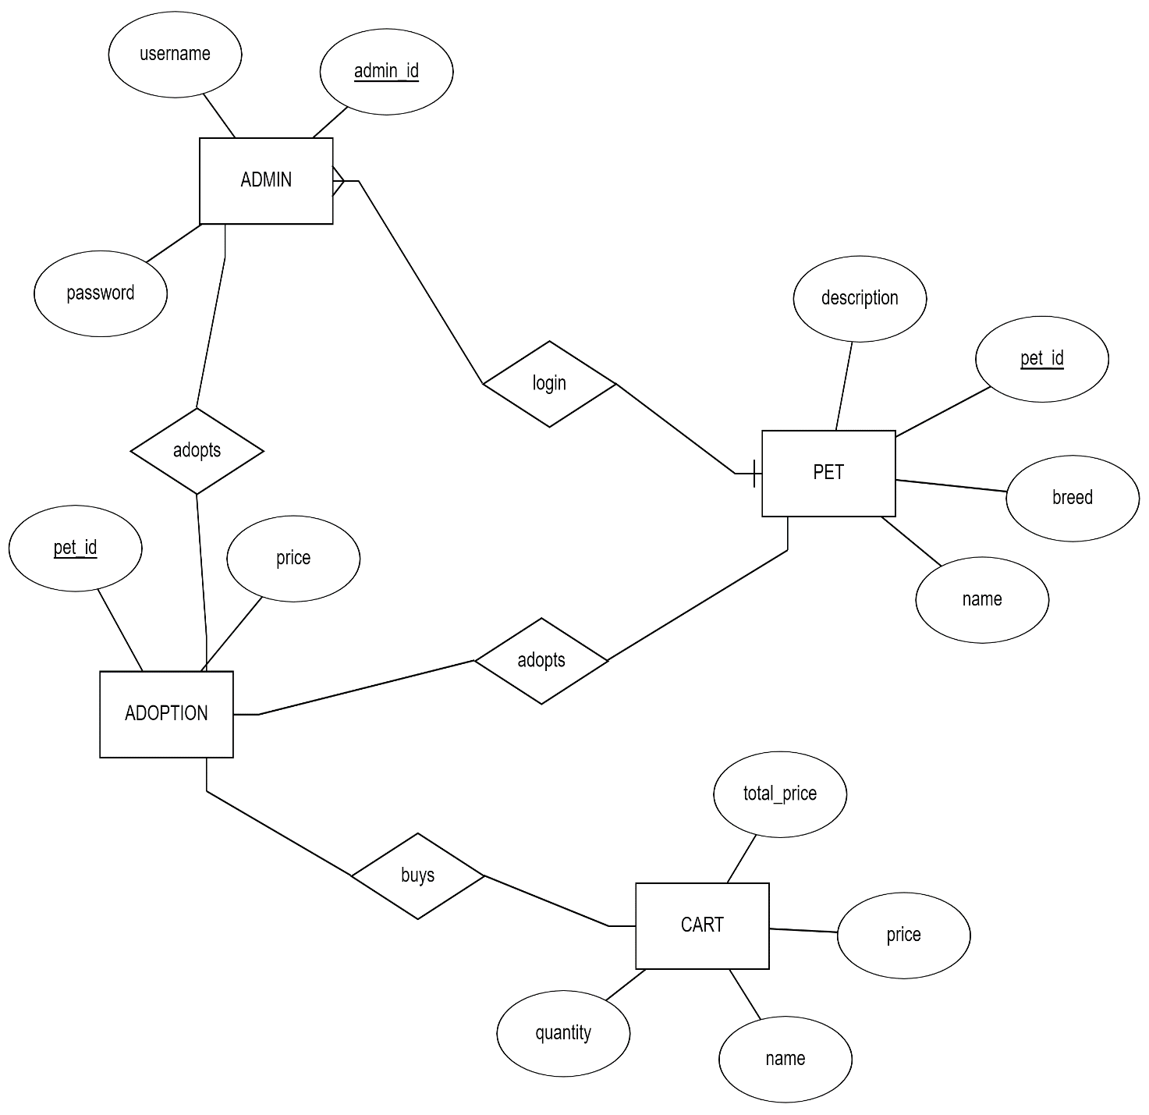

**SCHEMA DIAGRAM :**

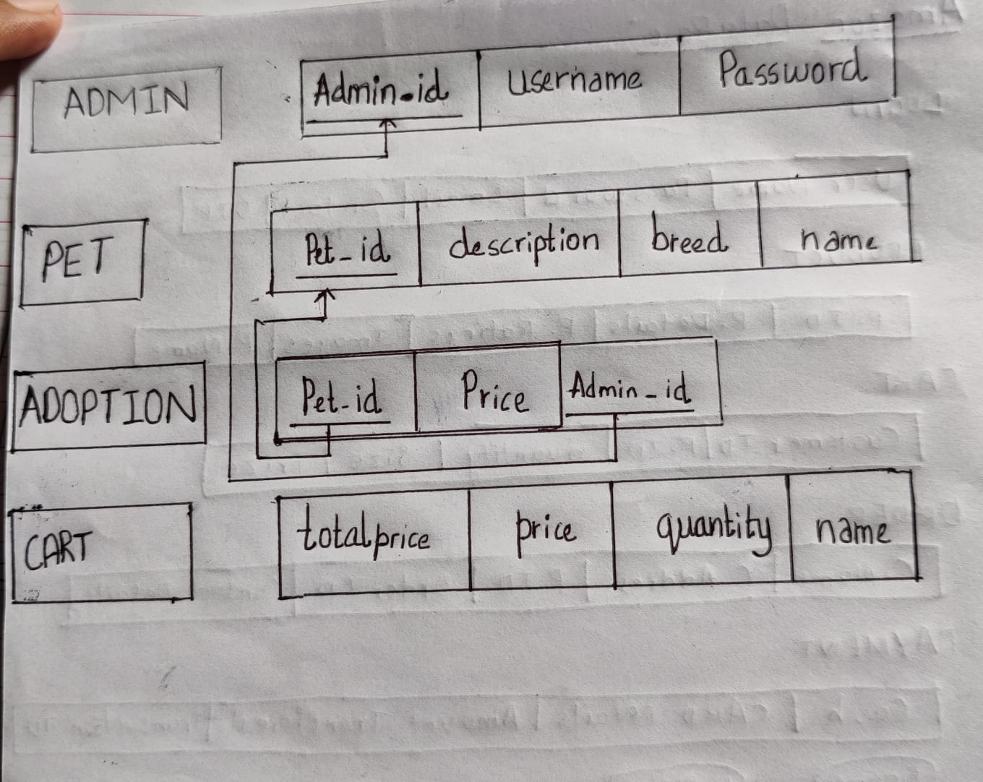

**RESULTS AND DISSCUSSIONS**

**User Login page:**

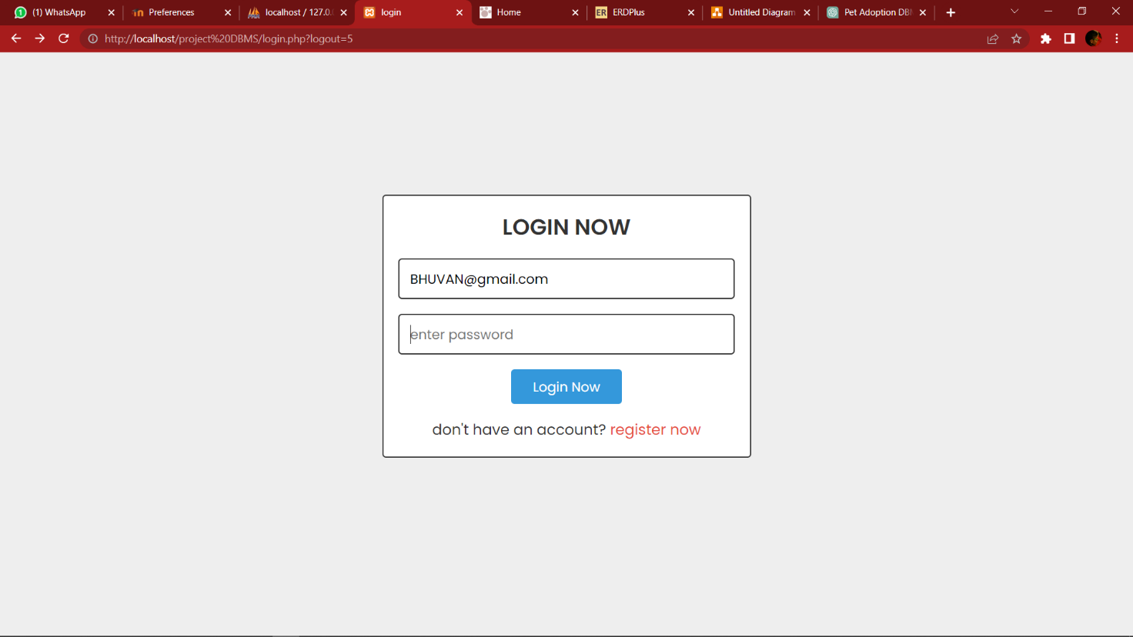

**User Home Page:**

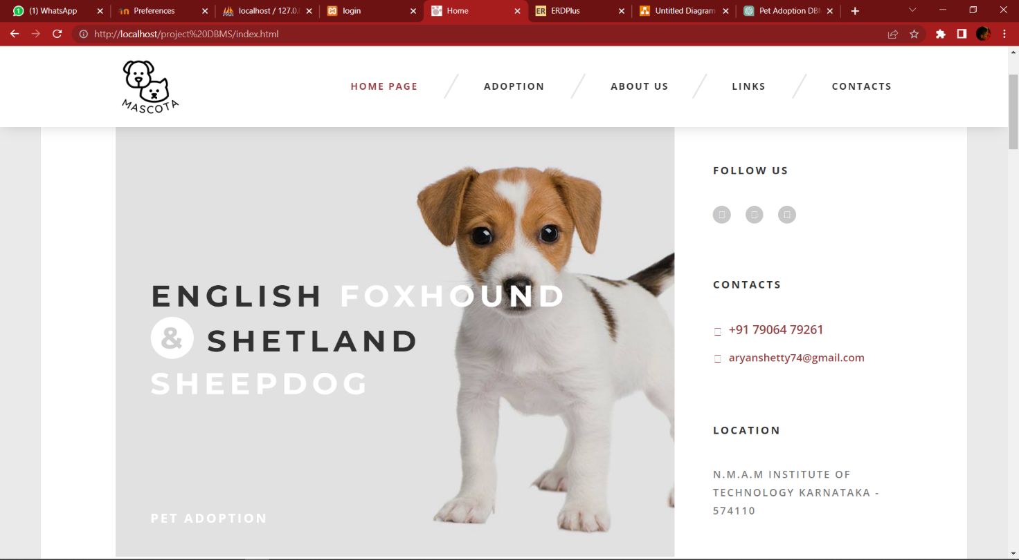

**ADOPTION Page:**

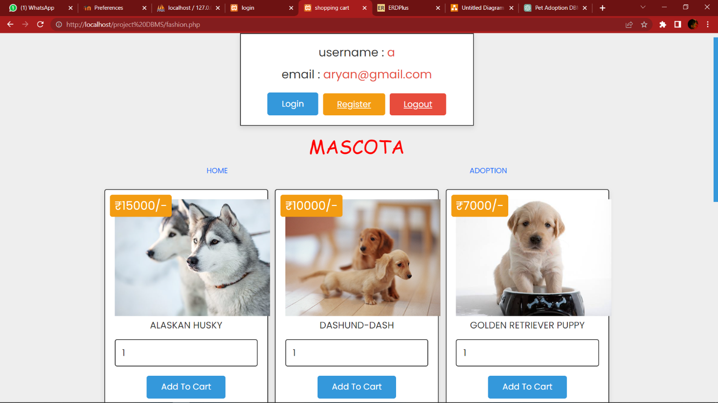

**Contact us Page:**

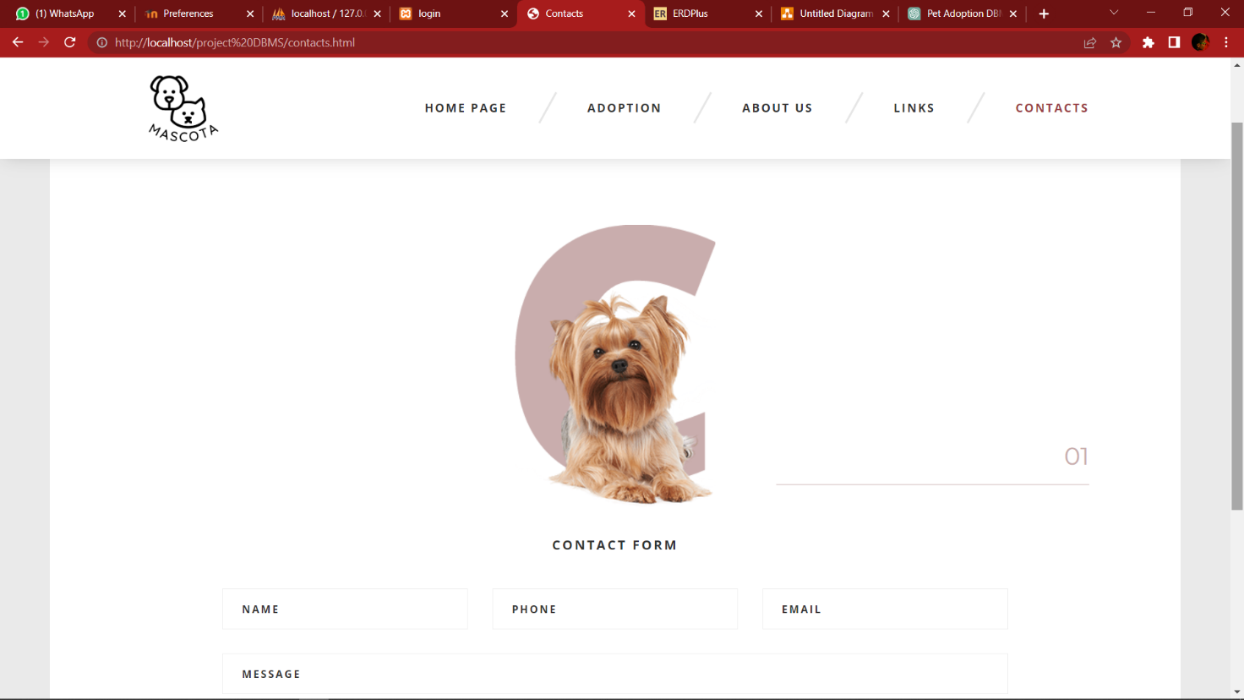

**Cart Page:**

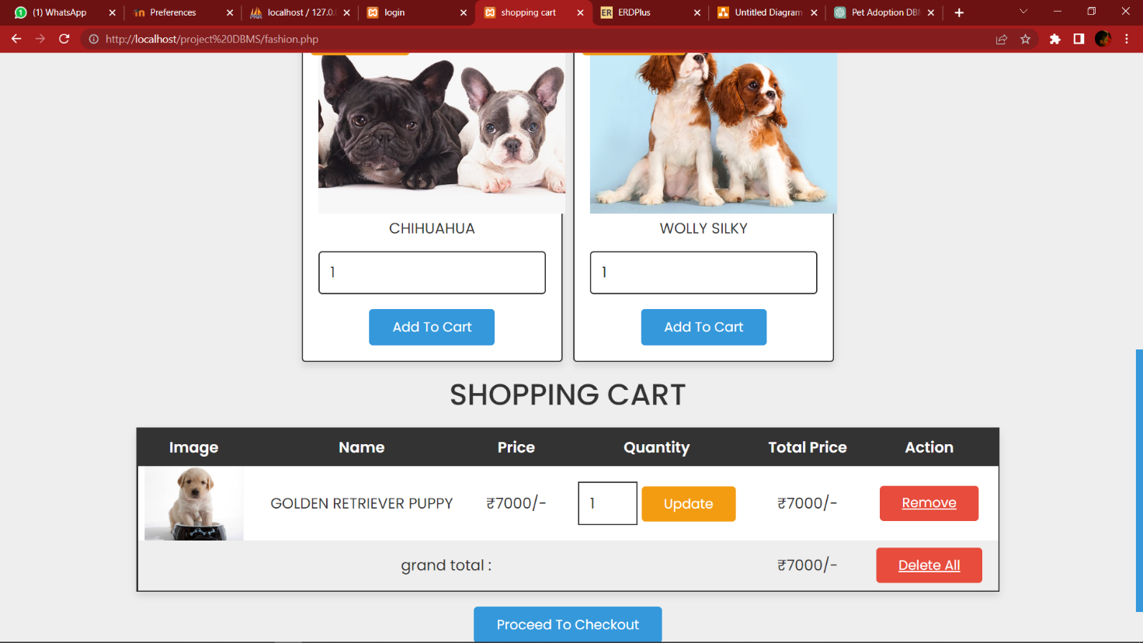

**Database View:**

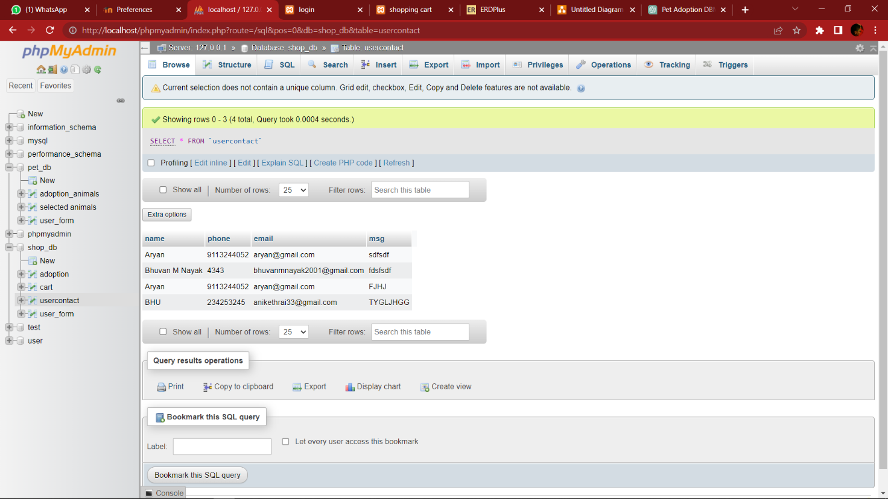

**CONCLUSION AND FUTURE SCOPE**

In this project we have implemented ‘Mascota’, which is a site that enables a smooth user interface for adoption of pets.

The DBMS helped to streamline and improve the efficiency of the pet adoption's operations and allowed to store and access a larger volume of data more easily.

The DBMS facilitated better decision-making by providing access to up-to-date and accurate data and helped to improve customer satisfaction by enabling faster and more accurate responses to customer inquiries and requests.

The future scope of the project would be

1. Expanding the system to include additional features and functionality, such as inventory, tracking and customer relationship management.
2. Integrating the DBMS with other business systems, such as point-of-sale (POS) systems and financial software.
3. Analyzing data stored in the DBMS to identify trends and patterns that can help in better adoption and also adopting of stray animals.
4. Implementing security measures to protect the data stored in the DBMS
5. .Developing custom reports and dashboards to help pet owners and manager to give feedback and give important insights on pets .

**REFERENCES**

[www.w3schools.com › html](https://r.search.yahoo.com/_ylt=Awrx_4n2h6JjJCkHL5y7HAx.;_ylu=Y29sbwNzZzMEcG9zAzEEdnRpZAMEc2VjA3Ny/RV=2/RE=1671624822/RO=10/RU=https%3a%2f%2fwww.w3schools.com%2fhtml%2f/RK=2/RS=ZjPD5nqcFycCC4FFFX4oxGwcWwI-)

[www.geeksforgeeks.org](https://r.search.yahoo.com/_ylt=Awr1TfsciKJjdxkHeZK7HAx.;_ylu=Y29sbwNzZzMEcG9zAzIEdnRpZAMEc2VjA3Ny/RV=2/RE=1671624860/RO=10/RU=https%3a%2f%2fwww.geeksforgeeks.org%2fcss-introduction%2f/RK=2/RS=G8_EU.60nTXP66sylKV8g_P5DkA-)

[www.php.ne](https://r.search.yahoo.com/_ylt=AwrPrCRDiKJjGnoG8Ca7HAx.;_ylu=Y29sbwNzZzMEcG9zAzIEdnRpZAMEc2VjA3Ny/RV=2/RE=1671624900/RO=10/RU=https%3a%2f%2fwww.php.net%2f/RK=2/RS=lERFlEQupp6lhRFEln_4fP4LqgA-)t