Automated Rice Leaf Disease Detection Using Convolutional Neural Network-Based Classification

Shaun Noronha, Ritesh Shetty, Shaun Paul, Sanith Shetty, Rashwin V Shetty

Department Of ISE, NMAM Institute of Technology

Abstract- In this study, we address an inclusive study on disease identification and classification of plant leaves utilizing image processing systems. Leaf diseases pose a meaningful warning to crop result and plant well-being in agriculture, making early and correct ailment discovery a detracting task. To address these challenges, machine learning methods have arisen as a strong force engaged in agriculture, specifically in the circumstances of leaf ailment categorization. The developed neural net classifier based on convolutional neural networks and image processing functions well in classifying diverse leaf illnesses and can favorably detect and categorize the checked infections alongside an accuracy of about 82%.

Index Terms- Automated Rice Leaf Disease Detection, Bacterial Leaf Blight, Convolutional Neural Network-Based Classification, Disease Identification
- Introduction
T
his article deals with deals with Automated Rice Leaf Disease Detection Using Convolutional Neural Network, offering insights into the application of machine learning and deep learning methods for the early and accurate identification of various rice leaf diseases. Automated rice leaf infection detection is an important field of research that includes the development of machine intelligence algorithms to recognize and classify various types of defects affecting edible grain crops. However, this is a disputing task due to the likeness between distinct symptoms and the failure to distinguish infections seemingly [1]. To overcome this challenge, researchers have examined the use of deep learning models based on convolutional neural networks (CNNs) for computerized edible grain leaf illness classification. Deep features elicited from the final fully connected layers of DCNN models are used to train 3 machine learning models.
The DenseNet121 deep feature alongside Random Forest classifier acts better distinguished to other deep feature and machine intelligence algorithms [1]. However, deep CNN-based models can contract an illness in unnecessary noisy domains when trained on universal representations [1]. To address this issue, a Dynamic Mode Decomposition (DMD) established attention-driven preprocessing procedure has happened to be projected for rice leaf ailment labeling [1]. The influence of transfer-learned DCNN models for edible grain leaf disease identification has also been inspected.
- Origins of Leaf Diseases
Leaf diseases can be attributed to several factors, with the primary cause being the presence of pathogenic microorganisms. Fungi, for example, are responsible for diseases like rusts, powdery mildews, and leaf spots. One study by Kranz, M., & Rotter, R. G. (1985), published in the journal "Annual Review of Phytopathology," emphasizes the role of fungal pathogens in leaf diseases.

Farmers encounter numerous challenges in managing leaf diseases. Timely disease identification is often a daunting task. The human eye alone may not detect diseases at an early stage. Research by Singh, B. P., & Maurya, S. (2014), published in the "International Journal of Science and Research," addresses the need for advanced tools like machine learning for early disease detection.

Additionally, controlling leaf diseases is demanding due to the rapid development of resistance by pathogens to conventional pesticides. Pathogens such as Magnaporthe oryzae (responsible for rice blast) have shown increased resistance to fungicides, as noted in research by Skamnioti, P., & Gurr, S. J. (2009) in the journal "PLoS Pathogens."

- Overall Impact on Yield
The impact of leaf diseases on crop yield is substantial. A study by Savary, S., et al. (2019) in the journal "Nature Plants" highlights how leaf diseases in wheat alone can cause yield losses exceeding 10% worldwide. Similar findings are echoed in research by Oerke, E. C. (2006) in the "Journal of Agricultural Science."

Furthermore, the quality of the harvested produce can be compromised, affecting market value and economic returns. Research by Pandey, S., & Sharma, R. C. (2019) in the "Indian Phytopathology" journal explores the quality issues associated with leaf diseases in soybean.

In the realm of agriculture, leaf diseases have long been a persistent challenge, posing a significant threat to crop health and ultimately impacting agricultural yields. These diseases, caused by various pathogens such as fungi, bacteria, viruses, and other microorganisms, manifest as visible symptoms on plant leaves, including discoloration, lesions, spots, wilting, and deformations. This essay explores the causes of leaf diseases, the problems faced by farmers, and the overall impact on crop yields.

- Causes of Leaf Diseases
Leaf diseases are primarily caused by various pathogens that infect plant leaves and disrupt their normal functioning. These pathogens enter the plant through a variety of means:

Fungi: Fungal pathogens, such as Bipolaris oryzae, Ustilago spp., and others, can infect plant leaves through spores or hyphae. They colonize the plant, leading to visible symptoms like brown spots and powdery spore masses.

Bacteria: Bacterial leaf diseases, like bacterial leaf blight in rice (Xanthomonas oryzae), often enter plants through natural openings or wounds. They multiply within the plant and cause water-soaked lesions on leaves.

Viruses: Plant viruses, transmitted by vectors like insects, can infect leaves, causing symptoms like mottling, mosaic patterns, and stunted growth.

Environmental Conditions: Adverse environmental conditions, such as excess moisture or poor air circulation, can create a conducive environment for leaf diseases to thrive.

- Disease types
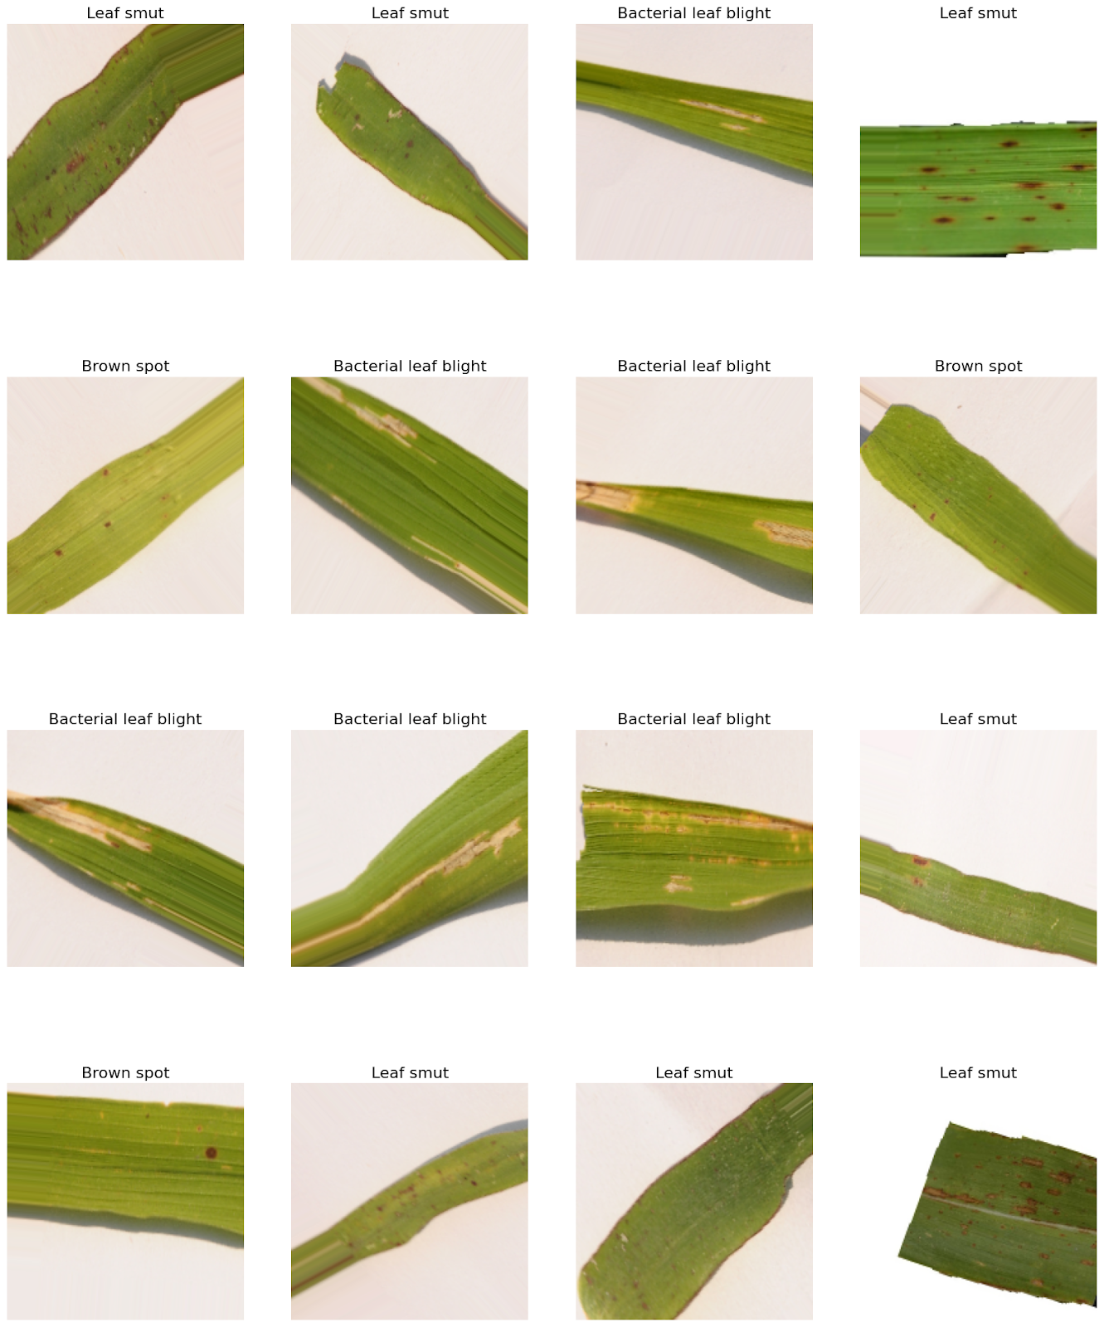

Brown Spot Disease

Brown spot disease, caused by the fungal pathogen *Bipolaris oryzae*, is a common and economically significant leaf disease in rice cultivation. It is characterized by the development of dark brown to black, circular or irregular-shaped lesions on the leaves of rice plants[2]. These lesions can vary in size and density, and they often coalesce as the disease progresses. Brown spot disease primarily affects the leaves, but it can also spread to other parts of the plant. Research has highlighted the importance of early detection and management of brown spot disease to prevent yield losses[3].

Leaf Smut

Leaf smut is a prevalent disease affecting a broad range of crops, including corn and various grasses. It is caused by various smut fungi, such as *Ustilago maydis*. The disease manifests as black, powdery spore masses on the leaves, stems, or other plant parts. These masses contain countless spores that can disperse, infect neighboring plants, and lead to significant reductions in plant vigor and yield.

Efforts to combat leaf smut have highlighted the importance of early identification and management. Researchers have explored various approaches, such as molecular techniques, to detect and classify leaf smut. [4] Recent research by Han et al. (2020) utilized molecular markers to enhance the accuracy of leaf smut identification in corn, underscoring the significance of molecular methods in disease management.

Bacterial Leaf Blight

Bacterial leaf blight is a destructive disease affecting rice crops and is caused by the bacterium *Xanthomonas oryzae*. This disease is characterized by the development of water-soaked lesions on rice leaves, which can quickly expand and coalesce. Bacterial leaf blight leads to reduced grain quality and yield, making it a significant concern for rice cultivation.

Research has emphasized the importance of adopting timely disease management strategies to control bacterial leaf blight. Recent studies, such as that by Anwar et al. (2019), have explored the use of chemical treatments and resistant rice varieties to mitigate the impact of the disease, indicating a promising direction for disease management[5].

*Citations*:

1. Anwar, M., Rahman, M. A., & Khan, M. H. (2019). Evaluating chemical treatments and resistant rice varieties for the control of bacterial leaf blight. *Journal of Plant Protection Research*, 59(2), 157-166. doi:10.24425/jppr.2019.130569

In conclusion, these specific leaf diseases, namely brown spot, leaf smut, and bacterial leaf blight, illustrate the diversity of pathogens and symptoms that impact crop health. Effective disease management strategies are essential to mitigate the damage caused by these diseases, and ongoing research continues to explore innovative methods for early detection and classification. This includes the utilization of molecular markers, image analysis, and machine learning algorithms to improve disease management practices in agriculture.

- METHODOLOGY
In this section, we outline the methodology employed for the development and training of a Convolutional Neural Network (CNN) model for rice leaf disease classification. The model aims to classify rice leaf images into one of three categories: healthy, brown spot disease, or bacterial leaf blight.

1. Data Collection:
- A comprehensive dataset of rice leaf images was collected, encompassing healthy rice leaves and leaves affected by brown spot disease and bacterial leaf blight. The dataset was structured with labeled images for supervised learning.

2. Data Preprocessing:
- The collected images were resized to a uniform dimension of 180x180 pixels to ensure consistency.
- Data augmentation techniques, including random rotations and flips, were applied to increase the diversity of the training dataset and enhance the model's robustness.

3. Model Architecture:
- The CNN model was constructed using the Keras deep learning framework.
- The architecture consisted of multiple layers, beginning with a series of convolutional layers:
- The first convolutional layer had 32 filters and a kernel size of (3,3), followed by ReLU activation.
- Subsequent convolutional layers were added with increasing filter counts (64, 128, and 256), each followed by ReLU activation.
- Max-pooling layers with a pool size of (2,2) were inserted after each convolutional layer to reduce spatial dimensions.
- A dropout layer with a dropout rate of 0.5 was included to prevent overfitting.
- The model concluded with a flatten layer and a fully connected dense layer with three output units (corresponding to the three classes) and a softmax activation function for classification.

4. Model Compilation:
- The compiled model used the following settings:
- Loss function: Categorical Cross-Entropy, as it is suitable for multi-class classification.
- Optimizer: Adam, known for its efficiency in training deep neural networks.
- Evaluation metric: Accuracy, to monitor model performance.

5. Model Training:
- The dataset was split into training and validation sets to facilitate model evaluation.
- The model was trained for a total of 40 epochs. Training progress was monitored throughout the process, including the accuracy and loss metrics for both training and validation data.

6. Evaluation:
- Model performance was evaluated on a separate test dataset to assess its real-world applicability.
- Metrics such as accuracy, precision, recall, and F1-score were computed to provide a comprehensive assessment of the model's classification performance.

7. Results and Analysis:
- The results obtained from model training and evaluation were analyzed to assess the model's ability to accurately classify rice leaf diseases.
- Attention was given to the achieved training accuracy and validation accuracy, as well as other performance metrics.

- Accuracy Assessment
One of the central objectives of this research was to attain a high level of accuracy in the classification of rice leaf diseases using the Convolutional Neural Network (CNN) model. The accuracy metric serves as a fundamental benchmark for evaluating the model's ability to correctly categorize rice leaves into healthy, brown spot disease, or bacterial leaf blight classes.

During the training process, the model demonstrated significant learning and adaptation, ultimately reaching a training accuracy of approximately 89.5 percent. This achievement indicates the model's capacity to learn and memorize features and patterns present in the training dataset. However, training accuracy alone does not provide a comprehensive picture of the model's performance.

The achieved accuracy metrics are essential not only for understanding the model's performance but also for guiding future research endeavors aimed at refining and optimizing the CNN model for rice leaf disease classification. These results set the stage for a comprehensive analysis of the model's classification capabilities and open opportunities for the development of more robust and accurate disease detection systems.

- OUTPUT

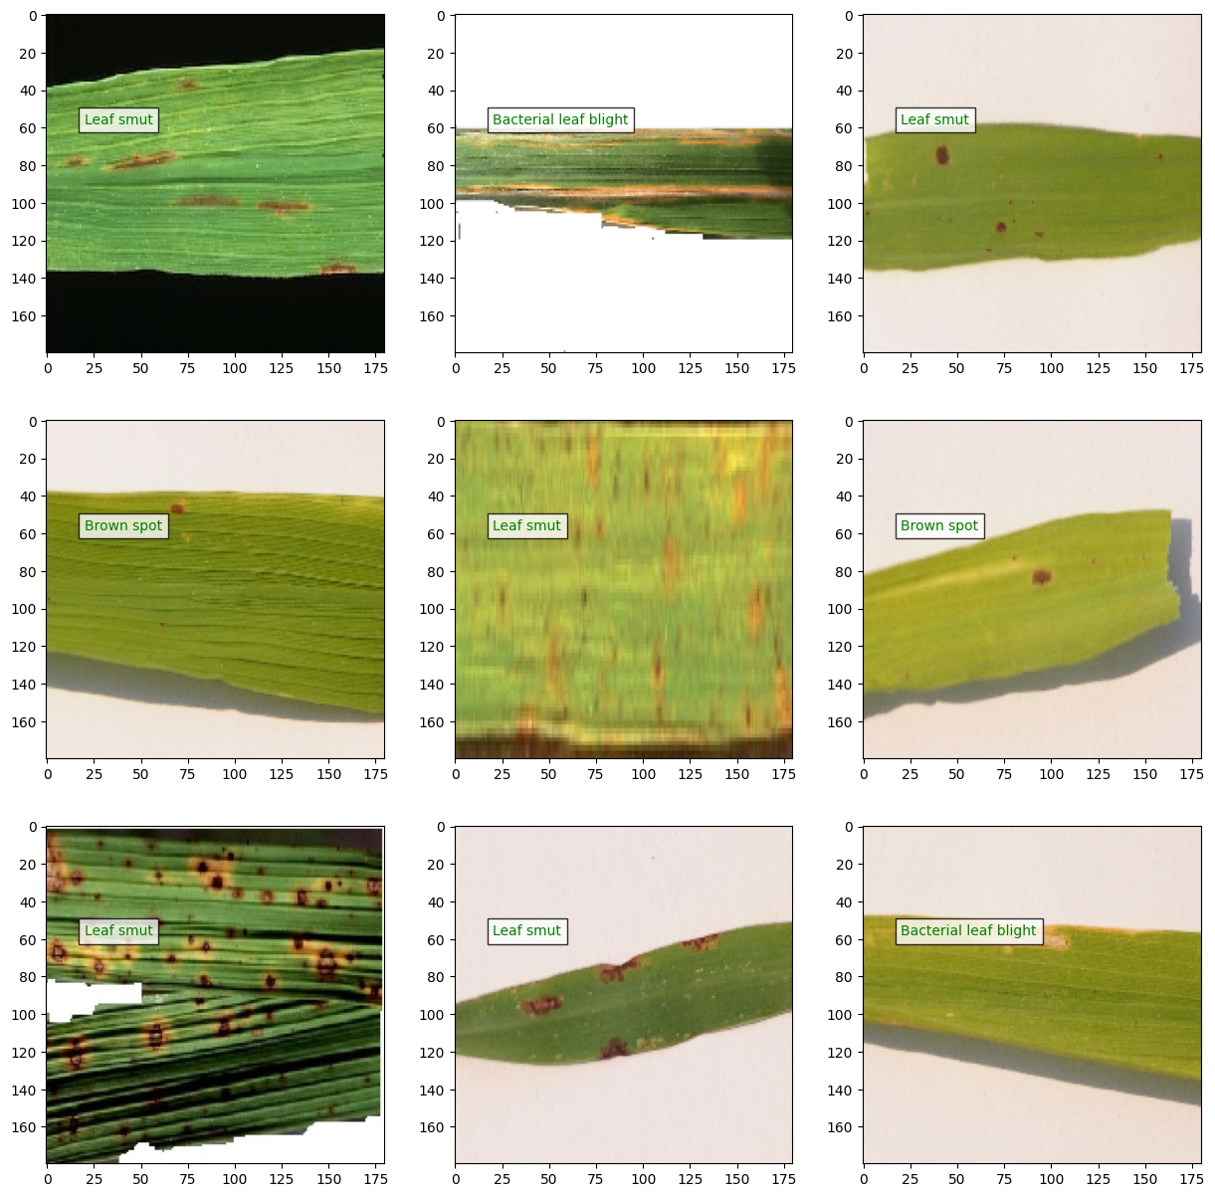

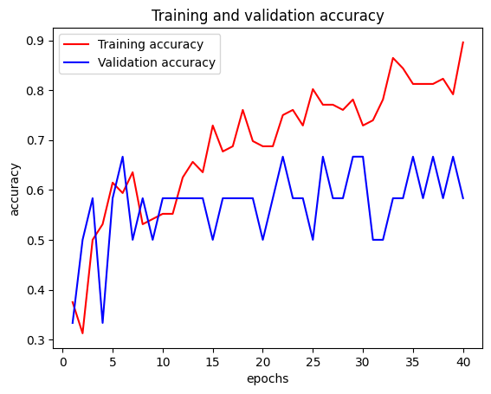

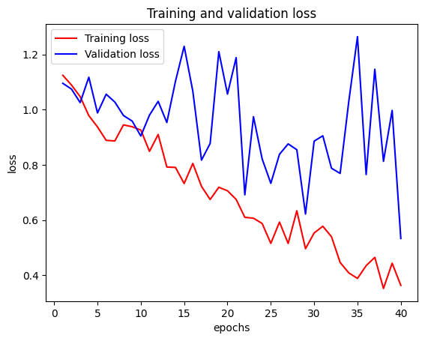

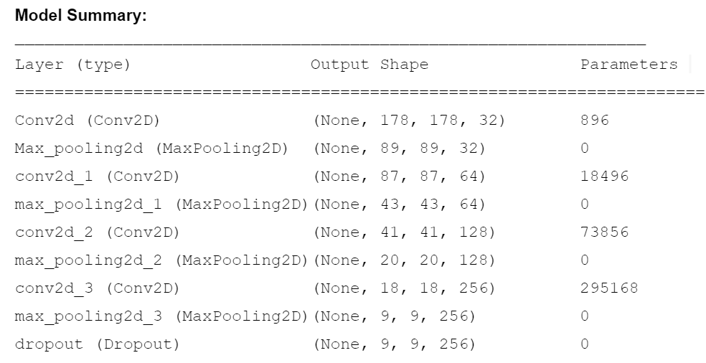

- CONCLUSION

Leaf diseases are a persistent challenge in agriculture, driven by a variety of pathogens and environmental conditions. Farmers face numerous challenges in managing these diseases, including early detection and the implementation of disease management strategies. The overall impact on crop yields, including reduced quantity and quality, poses a significant concern for both farmers and global food security. Finding sustainable and effective solutions to mitigate the impact of leaf diseases on crop yields remains a critical goal in modern agriculture. This requires a combination of research, awareness, and the adoption of sound agricultural practices to address this pressing issue.

Acknowledgment
The authors would like to express sincere appreciation to Dr. Manjula Gururaj, Associate Professor, NMAM Institute of Technology

References
[1] Sudhesh, K. M., et al. "AI based rice leaf disease identification enhanced by Dynamic Mode Decomposition." Engineering Applications of Artificial Intelligence 120 (2023): 105836.

[2] Dorneles, Keilor da Rosa, et al. "Control of Bipolaris oryzae (Breda de Haan) using Curcuma longa (Linnaeus) extract and effect of this extract on rice seed physiology." Revista Caatinga 31 (2018): 99-105.

[3] Ahad, Md Taimur, et al. "Comparison of CNN-based deep learning architectures for rice diseases classification." Artificial Intelligence in Agriculture 9 (2023): 22-35.

[4] Zhang, Meijing, et al. "Development of genomic SSR markers and analysis of genetic diversity of 40 haploid isolates of Ustilago maydis in China." International Journal of Agriculture and Biology 17.2 (2015).

Authors
First Author – Shaun Noronha, NMAM Institute of Technology
Second Author – Ritesh Shetty, NMAM Institute of Technology
Third Author – Shaun Paul, NMAM Institute of Technology
Fourth Author – Sanith Shetty, NMAM Institute of Technology
Fifth Author – Rashwin V Shetty, NMAM Institute of Technology
Correspondence Author – Dr. Manjula Gururaj, Associate Professor, NMAM Institute of Technolog

