Name:Ruhid

Surname:Shihkarimov.

Gender:Male

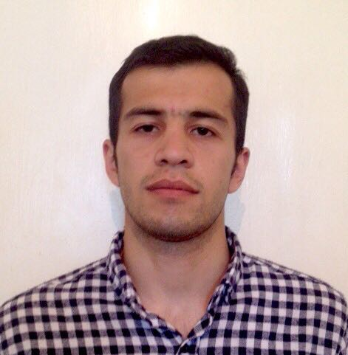Marital status:single

Citizenship:Azerbaijani

Date of birth:23rd November 1992

Address:Hil,Qusar,Azerbaijan,3800

Phone number:+994775413664/+994233892826

# Objective

Looking to join a company that offers long term career prospects

# Skills & Abilities

Language skills:

English-Advanced

Russian-fluent

Azerbaijan-native

Turkish-good for communication

Computer literacy:Microsoft office,,Html5 and Css3,PHP&mysql (learning Javascript&jQuery)

Good knowledge of math.

Hobbies:reading books

# Experience

|  |  |
| --- | --- |
| Anadolu restaurant(waiter) | 2011-2013 |
| KFC(cashier) | 2014 |
| Prepared entrants (in English )for entrance examinations | 2016-2017 |

# Education

|  |  |
| --- | --- |
| Azerbaijan Technological university Faculty of economics and management | 2013-2018 |

# Communication

I am a sociable,cheerful,hardworking and responsible person

I can handle the public's needs with care and consideration

Despite l have a bachelour in economics l change up my mind to work as a web developer..İf you give me an opportunity to pass through a probation(paid)period l promise you that in a short time l would be able to learn everything.(l was preparing for a scholarship program but because of hardships with getting a diplom this year l decided to go deeply into the İT field. l am fluent in english and l can prove it even via phone talk.Right now İ am looking for a company which would give me an opportunity in my career growth.

I promise you, until the end of this year l would be able to work with all frontend and backend programmes.