**E-COMMERCE**

**Assignment – 2**

**SQL Review**

Submitting By: Rupinder Kaur

**PART-1**

1. Using the order_details table, find the revenue (price * quantity) earned on each order.

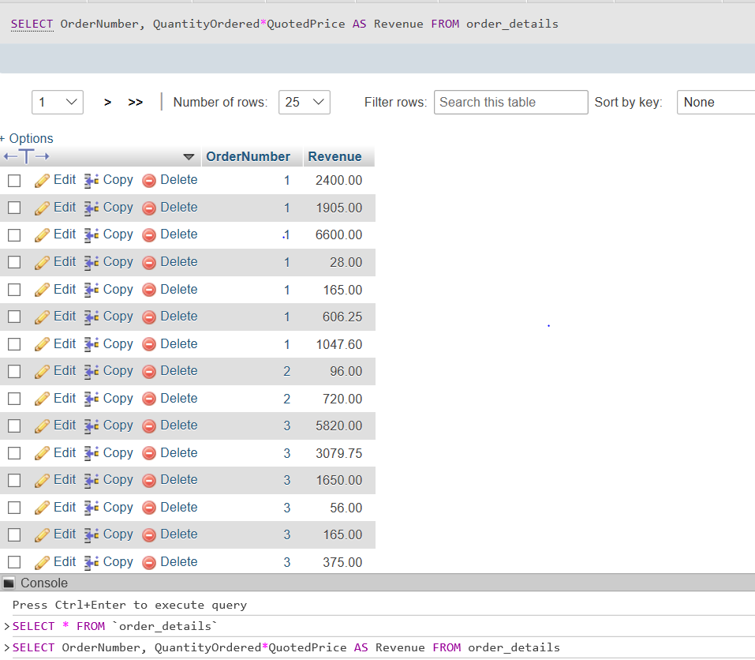

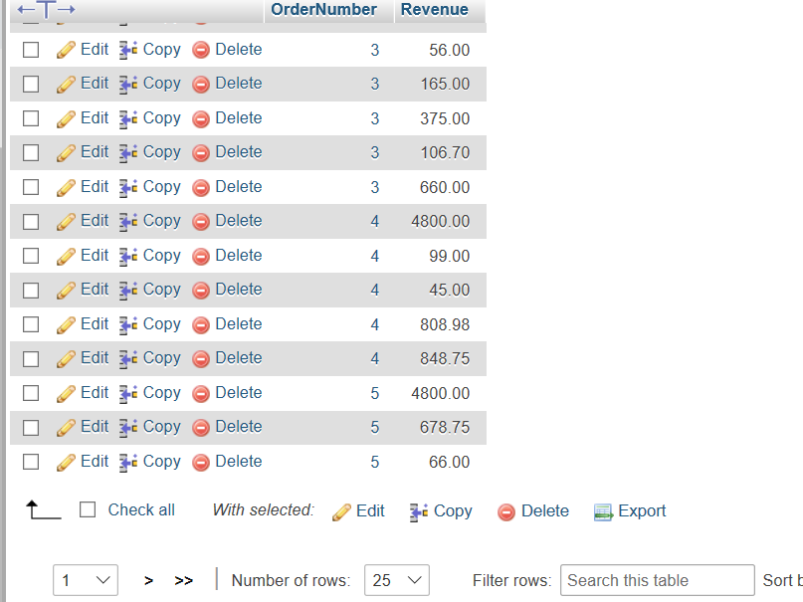

2) Using the employees table, find the age of each employee in years and order from youngest to oldest.

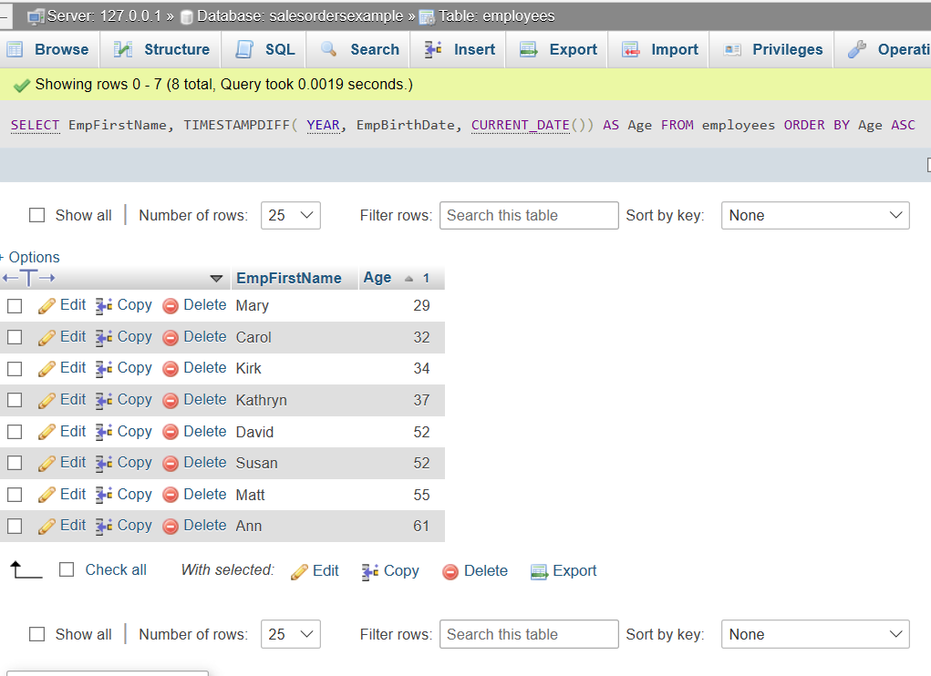

**PART-2**

1) Using the employees table, find all employees with a first name that contains an 'r' and a last name that does not contain a 'q’

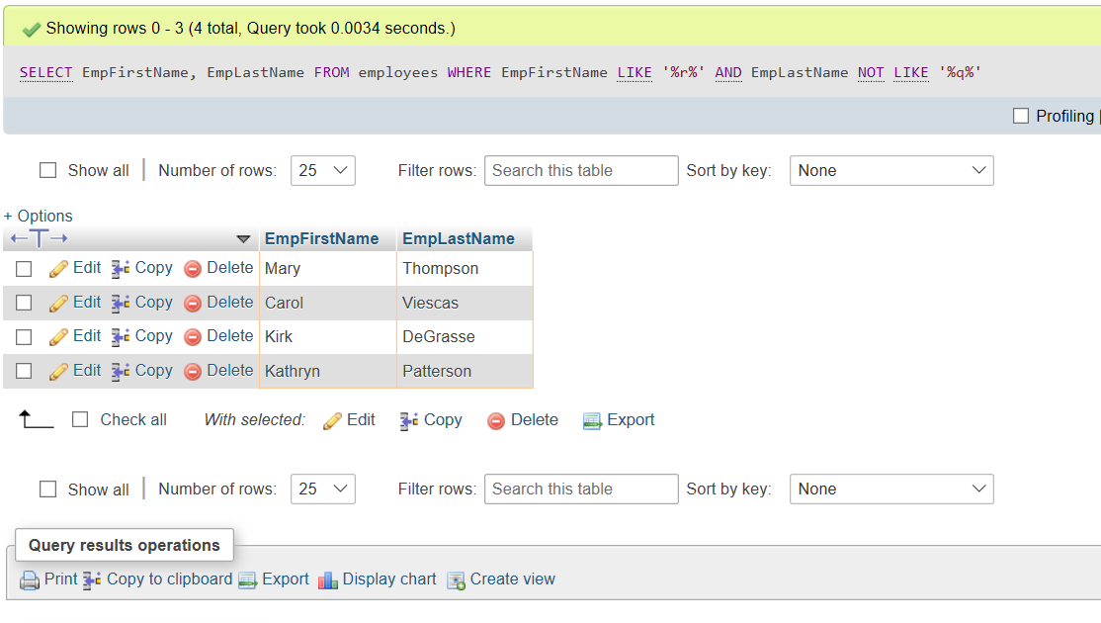

**PART-3**

1) Explain what is wrong with the following table and how you would fix it:

Answer:

The mistake in this table is that the phone number cannot be NULL.

**PART-4**

1) Find the first name and phone number of all customers who have ever ordered a helmet. HINT: Use the keyword DISTINCT:

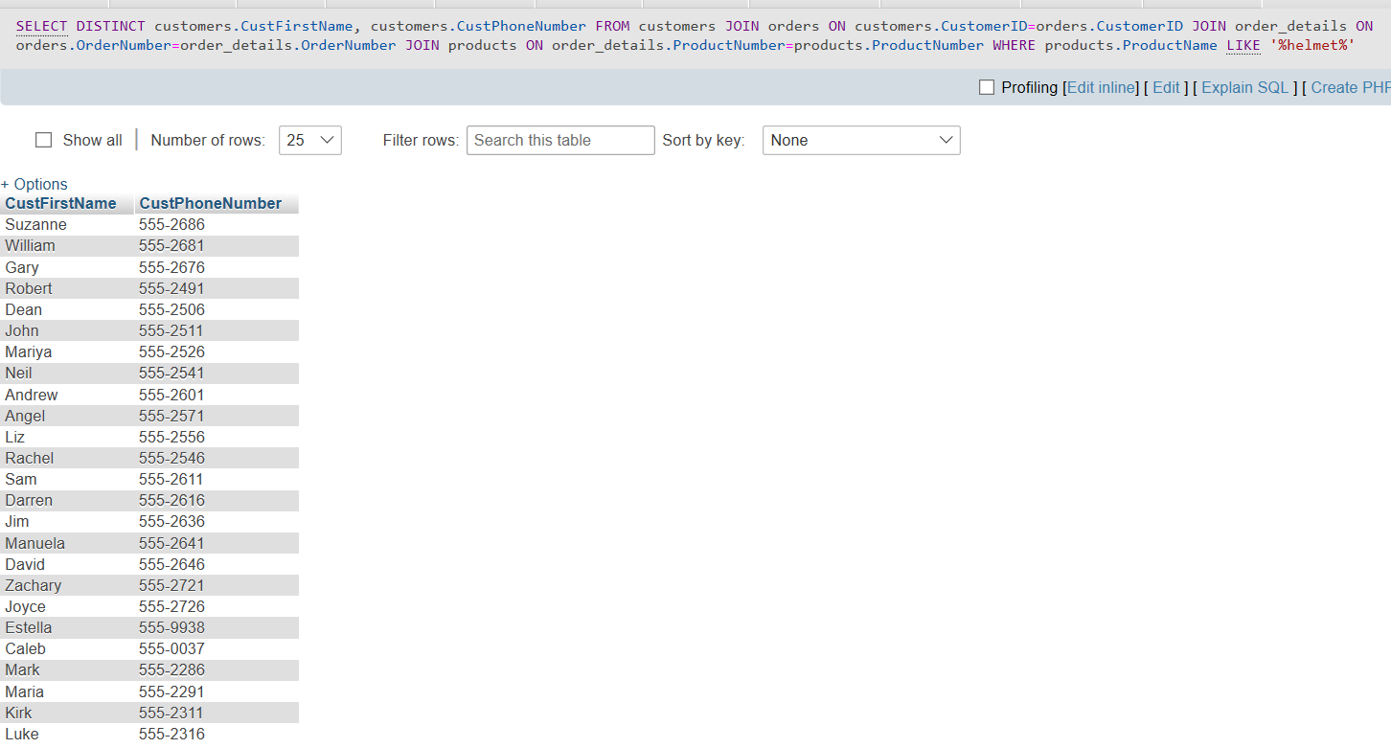

2) Display the first name of all customers who have the same first name as an employee:

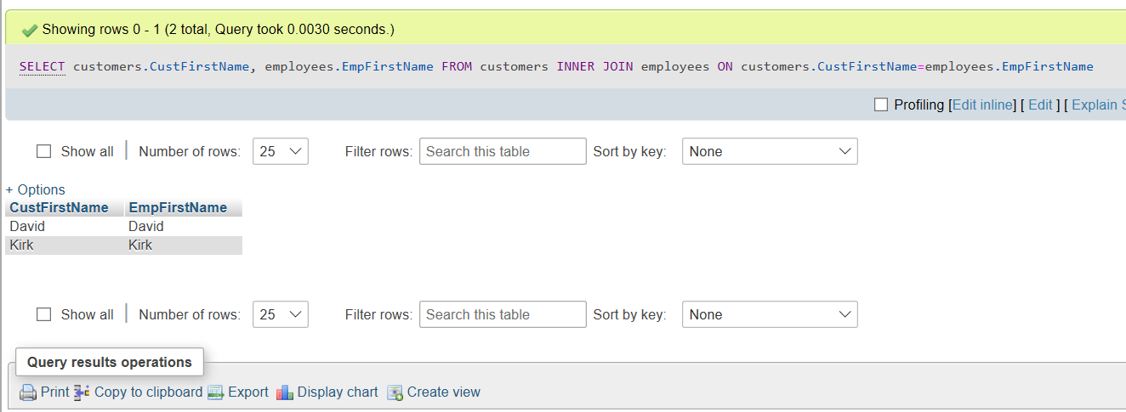

**PART-5**

1) Find the combined total value (QuantityOrdered*QuotedPrice*2) of all orders made by customers from the state of 'OR’

