Project
Title: Optimal path finder in a road network with time-varying predicted costs
Worked by: Amarildo Hazizi
Class: CEN 3

Introduction:
This project implements a time-varied intelligent path planning system for a road network. It utilizes machine learning and heuristic search techniques to compute the fastest route between two nodes, while accounting for time variance in traffic conditions.
Unlike shortest-path algorithms, which use static edge weights, this system predicts road-specific travel speeds as a function of time, using a Random Forest regression model trained on historical traffic data. These predicted speeds are then used to dynamically compute travel time during route planning.
The route planning is completed via an A* search algorithm, where the path cost is measured in time it takes to traverse it. The algorithm employs a heuristic based on shortest remaining time, assuming optimal conditions. This allows the search algorithm to prioritize promising paths toward the goal, while reducing unnecessary exploration.

Preparing the dataset:
The program reads the data from a csv file, and then separates the nodes from each other. Since in the original dataset, the nodes of the roads are in the format of “A-B”, the model separates each of them, and creates a graph linking the roads to the nodes they connect to. This ensures removing redundancy, helps in the later stages of the model to predict the route, and makes sure that roads can be used both ways, not just one way.

Below is how the graph should look like in practice:
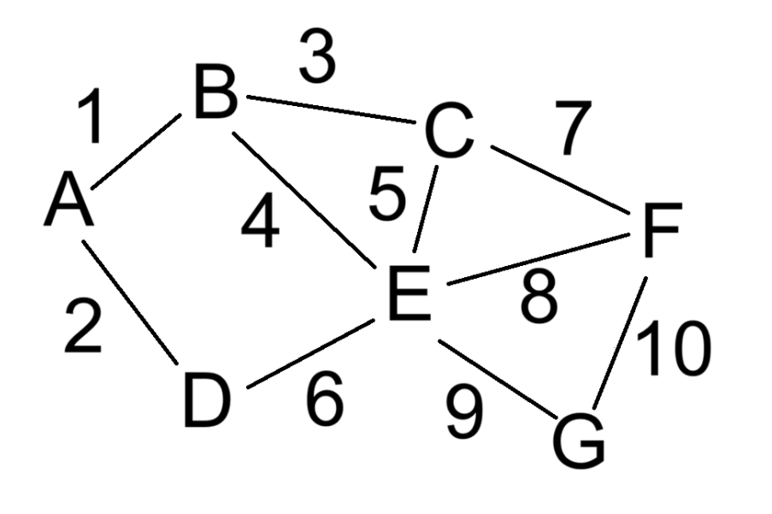
RF regression model:
The learning model used in this exercise is the RF Regression model structure. The Random Forest model combines decision trees together in order to form prediction for numeric values. As for why regression is important, it is because we are working with numerical values, as opposed to categories, which would require classification. From my testing, RF provided the best results to finding the real value, with an R² of 0,91. This was done in combination to making sure the data was clean and removing any cases where the average speed at a given time would be 0 (no cars), making the times of day cyclical, so the model could learn that 0 and 23 are in fact, much closer than they might seem at first, and utilizing the OneHotEncoder to help the model differentiate that the ‘road_id' is in fact a categorization, and not a numerical value it can learn something from. It helps to remove any confusion that might arise. The actual learning uses a number estimator of 300, with a max depth of 20. This was the optimal values in my testing, to finding the best accuracy for it, then it shows the accuracy using measures like RMSE and R2, to show the average deviation from the real value and the percentage accuracy.

Helper functions:
There are a couple helper functions that are used, in order to help with actually predicting the problem.
Predict speed function:
To start off with, there is the function of predicting speed. As the name implies, it is a model that gives uses the RF tree model to predict the speed of the current time. It takes the features from the previous datasets, combines them all in one row, then returns the value predicting by the RF model.
Heuristic function:
It returns the ideal, best-case scenario for the minimum time needed to reach the destination. This helps with the priority queue for the paths to take place guiding the search to explore the most promising paths first, reducing iterations.
Goal distance function:
It is a Dijkstra algorithm run backwards. It uses a priority queue to determine the shortest path, popping any that might be longer than the current path found to be shorter. At every node in travels to, it checks the neighboring nodes, to see if it is a faster way to reach said neighbor than the current ones, and dropped if not, or pushed if it is. At the end of it, it returns the shortest distance it found, to help with calculations.
A* search algorithm:
A* algorithm is used to find the fastest path from a starting node to the goal node determined by the user, using dynamically changing speeds based on the hour. It initializes a priority queue, with the parameters of total time so far, current time, node, and the path so far. For common sense, it keeps track of the visited nodes, so if the optimal path somehow involves going back where you came from, it does not use that as it would be illogical in practice. The main loop consists of popping the lowest f_score path and returning the path taken and current time at the end of the algorithm. In it also resides another loop determining the neighbors of the current node. This loop also serves several functions, which is the key of the A* searching algorithm. It calls the function to predict the speed for the current road at the specific time to calculate the time needed to travel this road. Afterwards, it calculates the total travel time from the start to the neighbor node, calls the heuristic function to determine the estimated minimal remaining time form neighbor to the goal, guiding the algorithm where to put this specific path in terms of priority. At the end, calculates the total estimated travel time if the path is taken, and puts it all into the priority queue. The function then returns None values if it can not find a path to the destination.

Interactive layout:
The interactive layout is a function which first, prints the available nodes to the user, then prompts the user for a starting location and a target destination. It then computes the distance in total to the goal, and A* search finds the fastest path based on the predicted speeds. Afterwards it iterates to print the information in a concise manner, giving the sequence of nodes and roads the algorithm took, the length of said road, predicted speed at the time, and the actual time it took to traverse the road. At the end, it gives the estimated total travel time in hours and minutes as well as the time of arrival at the destination.
Example output:
A - > G
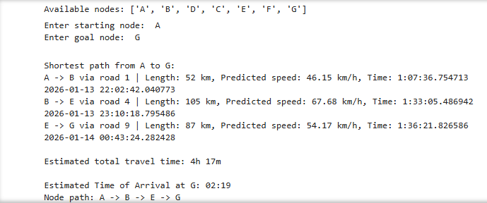
G -> A
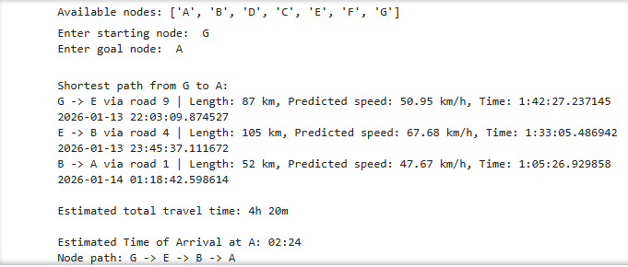
Ethical considerations
The data collected and used in route planning and traffic predictions come from real world people and vehicles. It has to be treated with the utmost privacy so that no personal data is leaked. In this project, the data used is imaginary, not indicative of a real-world scenario, but simply a simulation. Another cause of concern is the accuracy in predictability and the surrounding factors. It does not have a 100% predictability, as seen before with the aforementioned examples, where time calculated does vary. Plans by users should not be made with the goal of relying on a sure degree. The model also lacks predictability with weather conditions, events or festivals, or road blockages on the road. It can offer inaccurate predictions when any of these factors occur, and can even mislead self-driving cars, to taking wrong turns, or causing an accident that can harm others. Therefore, it is important to display the results responsibly, and emphasizing that predictions are merely estimates, and not guarantees.

