Name: RAUNAK RAJESH SHAH

**MySQL Assignment 1**

**Using UBUNTU**

* **Load Database using mysql client using CLI**

rs7@rs7-HP-ProBook-640-G1:~$ sudo mysql -u root

[sudo] password for rs7:

Welcome to the MySQL monitor. Commands end with ; or \g.

Your MySQL connection id is 10

Server version: 8.0.36-2ubuntu3 (Ubuntu)

Copyright (c) 2000, 2024, Oracle and/or its affiliates.

Oracle is a registered trademark of Oracle Corporation and/or its

affiliates. Other names may be trademarks of their respective

owners.

Type 'help;' or '\h' for help. Type '\c' to clear the current input statement.

mysql> use Products;

Database changed

**RUN classicmodels_customers.sql**

mysql> source /home/rs7/Downloads/classicmodels/classicmodels_customers.sql

Query OK, 0 rows affected (0.01 sec)

Query OK, 0 rows affected (0.00 sec)

Query OK, 0 rows affected (0.00 sec)

Query OK, 0 rows affected, 1 warning (0.00 sec)

Query OK, 0 rows affected (0.00 sec)

Query OK, 0 rows affected (0.00 sec)

Query OK, 0 rows affected (0.00 sec)

Query OK, 0 rows affected (0.00 sec)

Query OK, 0 rows affected (0.00 sec)

Query OK, 0 rows affected (0.00 sec)

Query OK, 0 rows affected (0.00 sec)

Query OK, 0 rows affected (0.00 sec)

Query OK, 0 rows affected (0.00 sec)

Query OK, 0 rows affected (0.04 sec)

Query OK, 0 rows affected, 1 warning (0.00 sec)

Query OK, 0 rows affected (0.00 sec)

Query OK, 0 rows affected (0.00 sec)

Query OK, 122 rows affected (0.01 sec)

Records: 122 Duplicates: 0 Warnings: 0

Query OK, 0 rows affected (0.00 sec)

Query OK, 0 rows affected (0.00 sec)

Query OK, 0 rows affected (0.00 sec)

Query OK, 0 rows affected (0.00 sec)

Query OK, 0 rows affected (0.00 sec)

Query OK, 0 rows affected (0.00 sec)

Query OK, 0 rows affected (0.01 sec)

Query OK, 0 rows affected (0.00 sec)

Query OK, 0 rows affected (0.00 sec)

Query OK, 0 rows affected (0.00 sec)

**RUN classicmodels_employees.sql**

mysql> source /home/rs7/Downloads/classicmodels/classicmodels_employees.sql

Query OK, 0 rows affected (0.00 sec)

Query OK, 0 rows affected (0.00 sec)

Query OK, 0 rows affected (0.00 sec)

Query OK, 0 rows affected, 1 warning (0.00 sec)

Query OK, 0 rows affected (0.00 sec)

Query OK, 0 rows affected (0.00 sec)

Query OK, 0 rows affected (0.00 sec)

Query OK, 0 rows affected (0.00 sec)

Query OK, 0 rows affected (0.00 sec)

Query OK, 0 rows affected (0.00 sec)

Query OK, 0 rows affected (0.00 sec)

Query OK, 0 rows affected (0.00 sec)

Query OK, 0 rows affected (0.00 sec)

Query OK, 0 rows affected (0.04 sec)

Query OK, 0 rows affected, 1 warning (0.00 sec)

Query OK, 0 rows affected (0.00 sec)

Query OK, 0 rows affected (0.00 sec)

Query OK, 23 rows affected (0.01 sec)

Records: 23 Duplicates: 0 Warnings: 0

Query OK, 0 rows affected (0.00 sec)

Query OK, 0 rows affected (0.00 sec)

Query OK, 0 rows affected (0.00 sec)

Query OK, 0 rows affected (0.00 sec)

Query OK, 0 rows affected (0.00 sec)

Query OK, 0 rows affected (0.00 sec)

Query OK, 0 rows affected (0.00 sec)

Query OK, 0 rows affected (0.00 sec)

Query OK, 0 rows affected (0.00 sec)

Query OK, 0 rows affected (0.00 sec)

**RUN classicmodels_offices.sql**

mysql> source /home/rs7/Downloads/classicmodels/classicmodels_offices.sql

Query OK, 0 rows affected (0.00 sec)

Query OK, 0 rows affected (0.00 sec)

Query OK, 0 rows affected (0.00 sec)

Query OK, 0 rows affected, 1 warning (0.00 sec)

Query OK, 0 rows affected (0.00 sec)

Query OK, 0 rows affected (0.00 sec)

Query OK, 0 rows affected (0.00 sec)

Query OK, 0 rows affected (0.00 sec)

Query OK, 0 rows affected (0.00 sec)

Query OK, 0 rows affected (0.00 sec)

Query OK, 0 rows affected (0.01 sec)

Query OK, 0 rows affected (0.00 sec)

Query OK, 0 rows affected (0.00 sec)

Query OK, 0 rows affected (0.02 sec)

Query OK, 0 rows affected, 1 warning (0.00 sec)

Query OK, 0 rows affected (0.00 sec)

Query OK, 0 rows affected (0.01 sec)

Query OK, 7 rows affected (0.00 sec)

Records: 7 Duplicates: 0 Warnings: 0

Query OK, 0 rows affected (0.00 sec)

Query OK, 0 rows affected (0.00 sec)

Query OK, 0 rows affected (0.01 sec)

Query OK, 0 rows affected (0.00 sec)

Query OK, 0 rows affected (0.00 sec)

Query OK, 0 rows affected (0.00 sec)

Query OK, 0 rows affected (0.00 sec)

Query OK, 0 rows affected (0.00 sec)

Query OK, 0 rows affected (0.00 sec)

Query OK, 0 rows affected (0.00 sec)

**RUN classicmodels_orderdetails.sql**

mysql> source /home/rs7/Downloads/classicmodels/classicmodels_orderdetails.sql

Query OK, 0 rows affected (0.01 sec)

Query OK, 0 rows affected (0.00 sec)

Query OK, 0 rows affected (0.00 sec)

Query OK, 0 rows affected, 1 warning (0.00 sec)

Query OK, 0 rows affected (0.00 sec)

Query OK, 0 rows affected (0.00 sec)

Query OK, 0 rows affected (0.00 sec)

Query OK, 0 rows affected (0.00 sec)

Query OK, 0 rows affected (0.00 sec)

Query OK, 0 rows affected (0.00 sec)

Query OK, 0 rows affected (0.00 sec)

Query OK, 0 rows affected (0.00 sec)

Query OK, 0 rows affected (0.00 sec)

Query OK, 0 rows affected (0.03 sec)

Query OK, 0 rows affected, 1 warning (0.00 sec)

Query OK, 0 rows affected (0.00 sec)

Query OK, 0 rows affected (0.00 sec)

Query OK, 2996 rows affected (0.07 sec)

Records: 2996 Duplicates: 0 Warnings: 0

Query OK, 0 rows affected (0.00 sec)

Query OK, 0 rows affected (0.00 sec)

Query OK, 0 rows affected (0.00 sec)

Query OK, 0 rows affected (0.00 sec)

Query OK, 0 rows affected (0.00 sec)

Query OK, 0 rows affected (0.00 sec)

Query OK, 0 rows affected (0.00 sec)

Query OK, 0 rows affected (0.00 sec)

Query OK, 0 rows affected (0.00 sec)

Query OK, 0 rows affected (0.00 sec)

**RUN classicmodels_orders.sql**

mysql> source /home/rs7/Downloads/classicmodels/classicmodels_orders.sql

Query OK, 0 rows affected (0.00 sec)

Query OK, 0 rows affected (0.00 sec)

Query OK, 0 rows affected (0.00 sec)

Query OK, 0 rows affected, 1 warning (0.00 sec)

Query OK, 0 rows affected (0.00 sec)

Query OK, 0 rows affected (0.00 sec)

Query OK, 0 rows affected (0.00 sec)

Query OK, 0 rows affected (0.00 sec)

Query OK, 0 rows affected (0.00 sec)

Query OK, 0 rows affected (0.00 sec)

Query OK, 0 rows affected (0.00 sec)

Query OK, 0 rows affected (0.00 sec)

Query OK, 0 rows affected (0.00 sec)

Query OK, 0 rows affected (0.04 sec)

Query OK, 0 rows affected, 1 warning (0.00 sec)

Query OK, 0 rows affected (0.00 sec)

Query OK, 0 rows affected (0.00 sec)

Query OK, 326 rows affected (0.01 sec)

Records: 326 Duplicates: 0 Warnings: 0

Query OK, 0 rows affected (0.01 sec)

Query OK, 0 rows affected (0.00 sec)

Query OK, 0 rows affected (0.00 sec)

Query OK, 0 rows affected (0.00 sec)

Query OK, 0 rows affected (0.00 sec)

Query OK, 0 rows affected (0.00 sec)

Query OK, 0 rows affected (0.00 sec)

Query OK, 0 rows affected (0.00 sec)

Query OK, 0 rows affected (0.00 sec)

Query OK, 0 rows affected (0.00 sec)

**RUN classicmodels_payments.sql**

mysql> source /home/rs7/Downloads/classicmodels/classicmodels_payments.sql

Query OK, 0 rows affected (0.00 sec)

Query OK, 0 rows affected (0.00 sec)

Query OK, 0 rows affected (0.00 sec)

Query OK, 0 rows affected, 1 warning (0.00 sec)

Query OK, 0 rows affected (0.00 sec)

Query OK, 0 rows affected (0.00 sec)

Query OK, 0 rows affected (0.00 sec)

Query OK, 0 rows affected (0.00 sec)

Query OK, 0 rows affected (0.00 sec)

Query OK, 0 rows affected (0.00 sec)

Query OK, 0 rows affected (0.00 sec)

Query OK, 0 rows affected (0.00 sec)

Query OK, 0 rows affected (0.00 sec)

Query OK, 0 rows affected (0.02 sec)

Query OK, 0 rows affected, 1 warning (0.00 sec)

Query OK, 0 rows affected (0.00 sec)

Query OK, 0 rows affected (0.01 sec)

Query OK, 273 rows affected (0.00 sec)

Records: 273 Duplicates: 0 Warnings: 0

Query OK, 0 rows affected (0.00 sec)

Query OK, 0 rows affected (0.00 sec)

Query OK, 0 rows affected (0.00 sec)

Query OK, 0 rows affected (0.00 sec)

Query OK, 0 rows affected (0.00 sec)

Query OK, 0 rows affected (0.00 sec)

Query OK, 0 rows affected (0.00 sec)

Query OK, 0 rows affected (0.00 sec)

Query OK, 0 rows affected (0.00 sec)

Query OK, 0 rows affected (0.00 sec)

**RUN classicmodels_productlines.sql**

mysql> source /home/rs7/Downloads/classicmodels/classicmodels_productlines.sql

Query OK, 0 rows affected (0.00 sec)

Query OK, 0 rows affected (0.00 sec)

Query OK, 0 rows affected (0.00 sec)

Query OK, 0 rows affected, 1 warning (0.00 sec)

Query OK, 0 rows affected (0.00 sec)

Query OK, 0 rows affected (0.00 sec)

Query OK, 0 rows affected (0.00 sec)

Query OK, 0 rows affected (0.00 sec)

Query OK, 0 rows affected (0.00 sec)

Query OK, 0 rows affected (0.00 sec)

Query OK, 0 rows affected (0.00 sec)

Query OK, 0 rows affected (0.00 sec)

Query OK, 0 rows affected (0.00 sec)

Query OK, 0 rows affected (0.02 sec)

Query OK, 0 rows affected, 1 warning (0.00 sec)

Query OK, 0 rows affected (0.00 sec)

Query OK, 0 rows affected (0.01 sec)

Query OK, 7 rows affected (0.00 sec)

Records: 7 Duplicates: 0 Warnings: 0

Query OK, 0 rows affected (0.00 sec)

Query OK, 0 rows affected (0.00 sec)

Query OK, 0 rows affected (0.00 sec)

Query OK, 0 rows affected (0.00 sec)

Query OK, 0 rows affected (0.00 sec)

Query OK, 0 rows affected (0.00 sec)

Query OK, 0 rows affected (0.00 sec)

Query OK, 0 rows affected (0.00 sec)

Query OK, 0 rows affected (0.00 sec)

Query OK, 0 rows affected (0.00 sec)

**RUN classicmodels_products.sql**

mysql> source /home/rs7/Downloads/classicmodels/classicmodels_products.sql

Query OK, 0 rows affected (0.00 sec)

Query OK, 0 rows affected (0.00 sec)

Query OK, 0 rows affected (0.01 sec)

Query OK, 0 rows affected, 1 warning (0.00 sec)

Query OK, 0 rows affected (0.00 sec)

Query OK, 0 rows affected (0.00 sec)

Query OK, 0 rows affected (0.00 sec)

Query OK, 0 rows affected (0.00 sec)

Query OK, 0 rows affected (0.00 sec)

Query OK, 0 rows affected (0.00 sec)

Query OK, 0 rows affected (0.00 sec)

Query OK, 0 rows affected (0.00 sec)

Query OK, 0 rows affected (0.00 sec)

Query OK, 0 rows affected (0.03 sec)

Query OK, 0 rows affected, 1 warning (0.00 sec)

Query OK, 0 rows affected (0.00 sec)

Query OK, 0 rows affected (0.00 sec)

Query OK, 110 rows affected (0.01 sec)

Records: 110 Duplicates: 0 Warnings: 0

Query OK, 0 rows affected (0.00 sec)

Query OK, 0 rows affected (0.00 sec)

Query OK, 0 rows affected (0.00 sec)

Query OK, 0 rows affected (0.00 sec)

Query OK, 0 rows affected (0.00 sec)

Query OK, 0 rows affected (0.00 sec)

Query OK, 0 rows affected (0.00 sec)

Query OK, 0 rows affected (0.00 sec)

Query OK, 0 rows affected (0.00 sec)

Query OK, 0 rows affected (0.00 sec)

**TABLES CREATED SHOWN IN WORKBENCH**

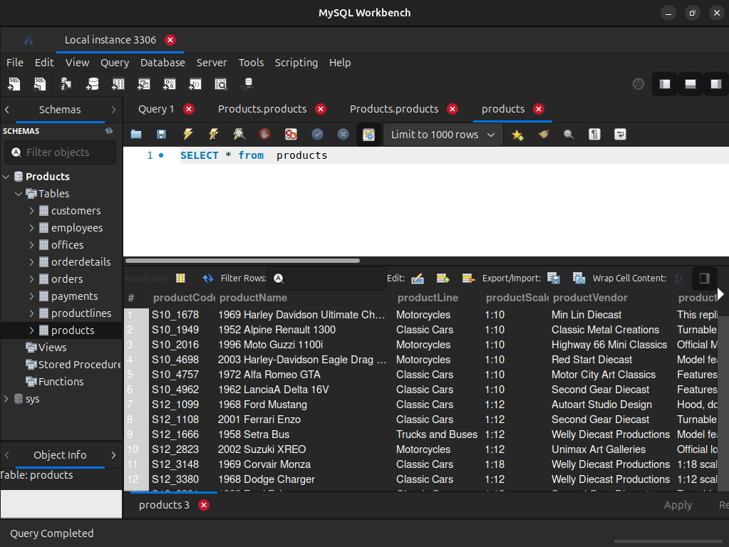

* **Execution of all the queries**
  1. **Write the query to get only the product Code and product name from the products table.**

**SELECT productCode, productName from products**

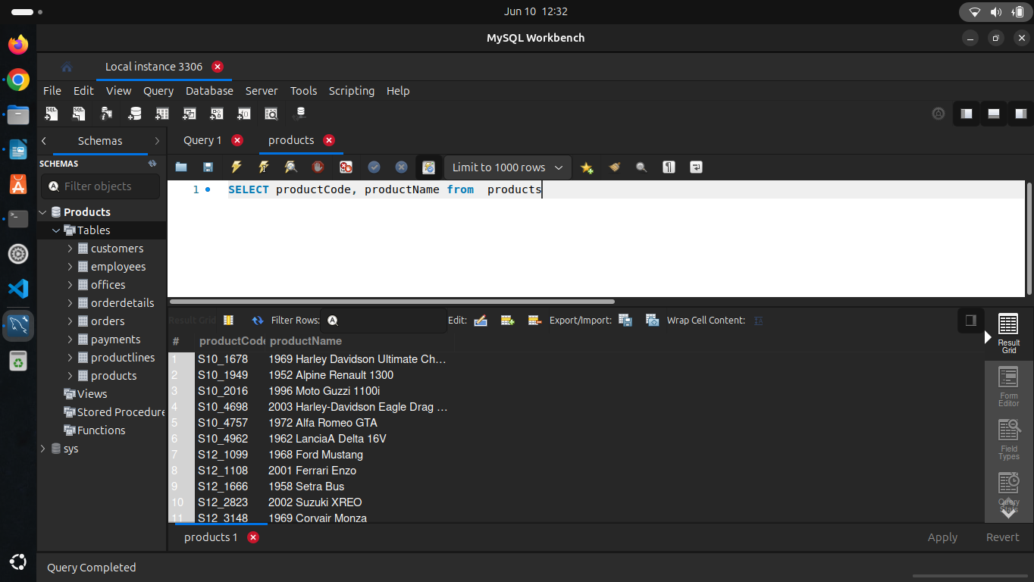

* 1. **Write the query to arrange the customer details based on the country name in descending order.**

**SELECT * from customers order by customerName DESC**

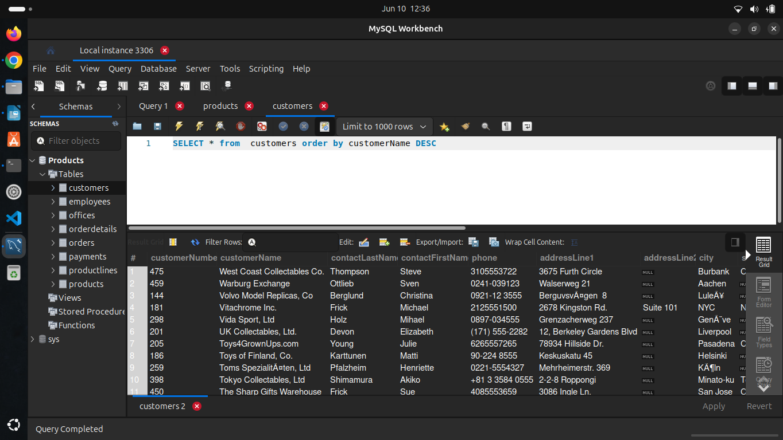

* 1. **Write the query to find the order number, order date, and status for the customers having comments about shipment**.

**SELECT orderNumber,orderDate,status FROM Products.orders WHERE comments LIKE '%shipment%';**

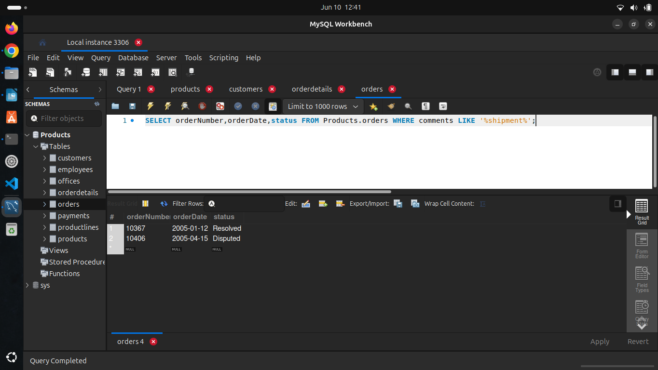

* 1. **Write the query to find the customer who has made the highest payment along with the payment date.**

**SELECT customerNumber, paymentDate, amount**

**FROM payments**

**WHERE amount = (SELECT MAX(amount) FROM payments);**

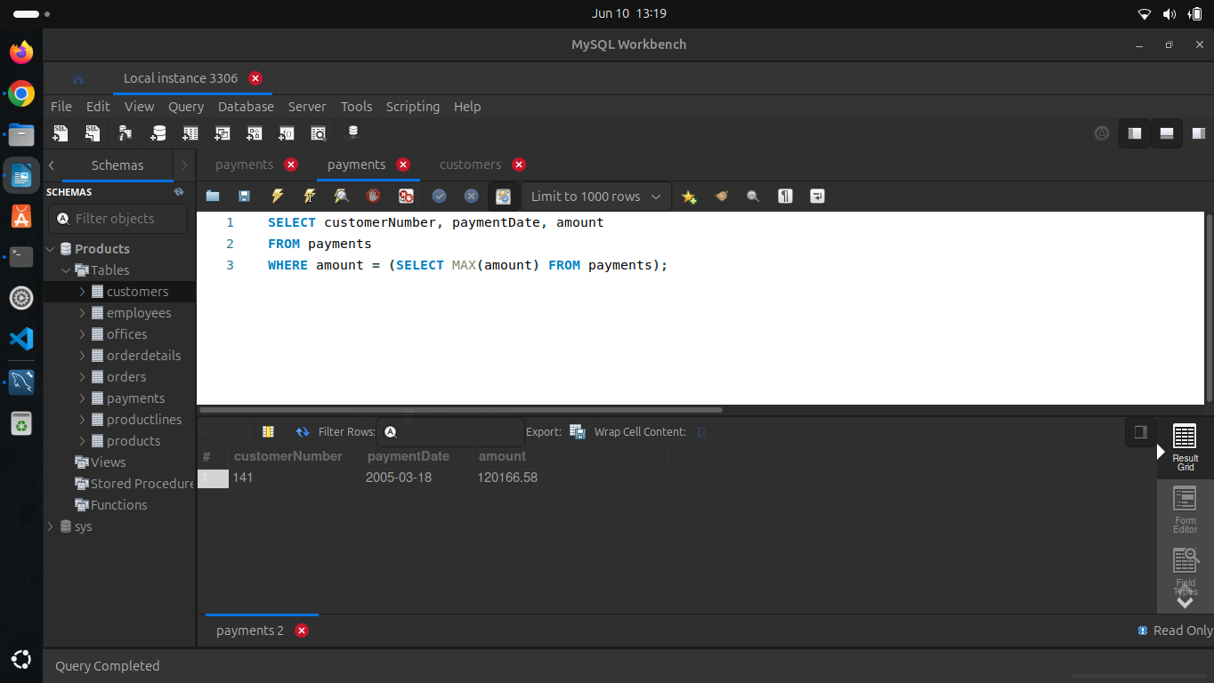

* 1. I have a list of the top five customers who made the highest payment and write a query to find the next top five customers who made the highest  
     payment.

**SELECT customerNumber, paymentDate, amount**

**FROM payments**

**ORDER BY amount DESC**

**LIMIT 5 OFFSET 5;**

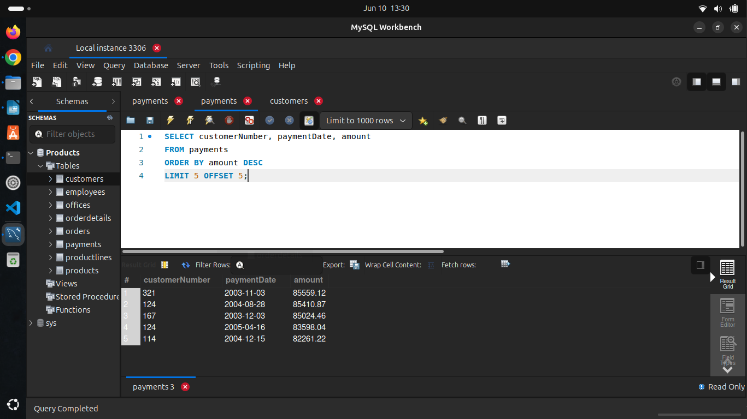

* 1. Write the query to find the customer details whose credit limit is between 10,000 to 1,00,000.

**SELECT * FROM Products.customers**

**WHERE creditLimit BETWEEN 10000 and 100000;**

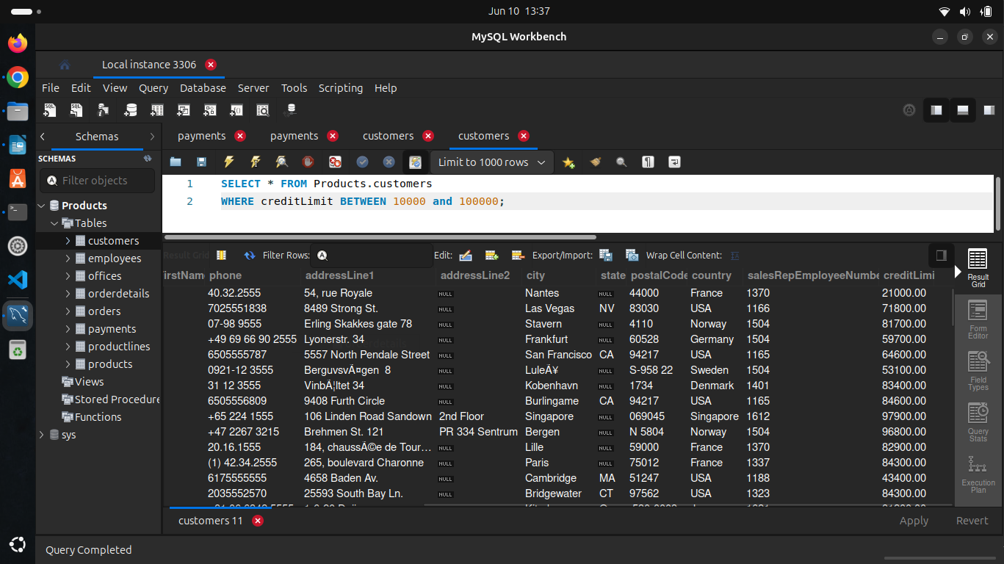

* 1. Write the query to get the Employee number, lastname, and first name from the employees' table whose last name starts with 'B'.

**SELECT employeeNumber, lastName, firstName**

**FROM Products.employees**

**WHERE lastName LIKE 'B%';**

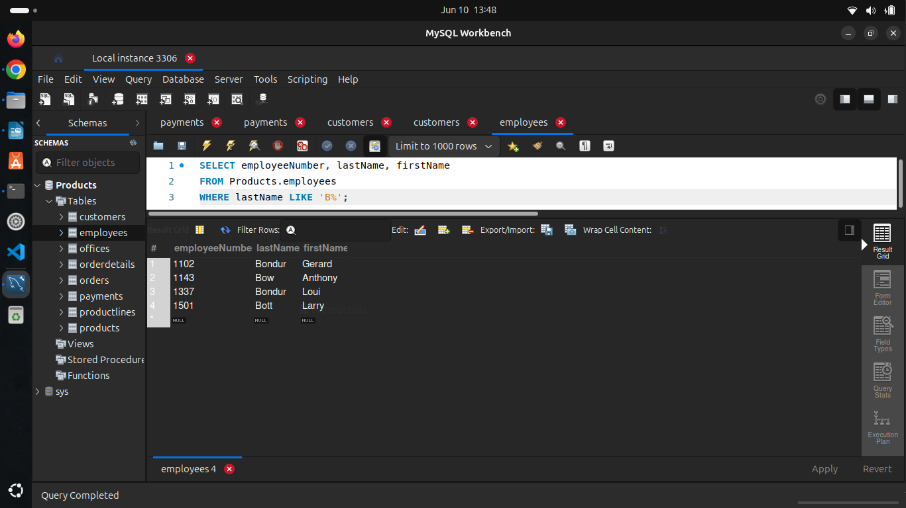

* 1. write a query to select the order whose total amount is greater than 50,000.

**SELECT o1.*, totalAmount FROM orderdetails o1**

**JOIN(**

**SELECT orderNumber, SUM(quantityOrdered*priceEach) as totalAmount FROM Products.orderdetails**

**GROUP BY orderNumber**

**HAVING SUM(quantityOrdered*priceEach) > 50000) sub**

**ON o1.orderNumber = sub.orderNumber;**

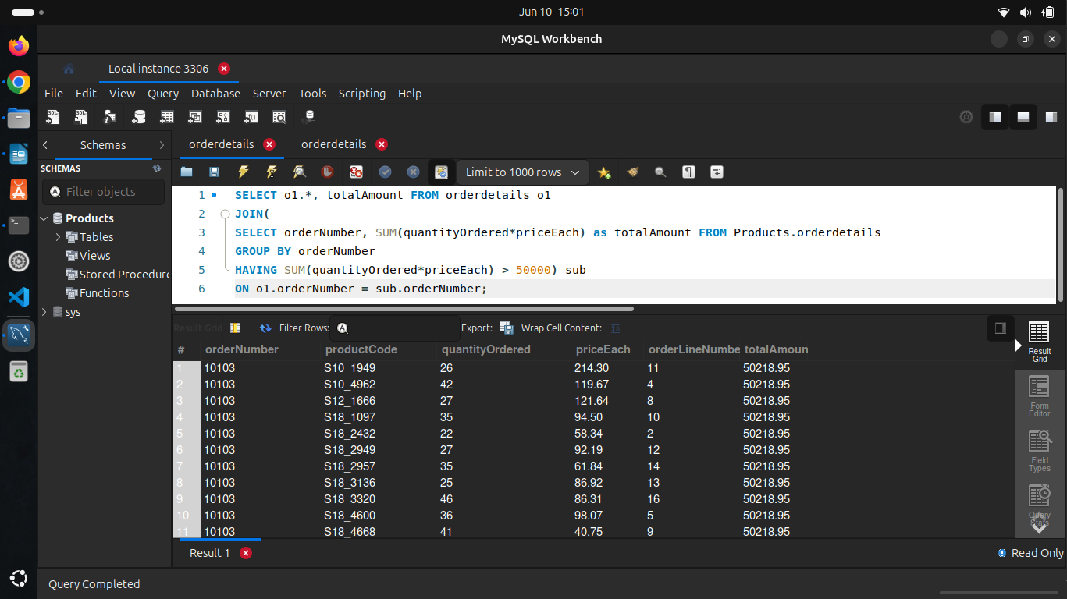

* 1. Write the query to find the productcode, product name & text description from the tables products and product lines.

**SELECT productCode, productName, textDescription**

**FROM Products.products**

**INNER JOIN Products.productlines;**

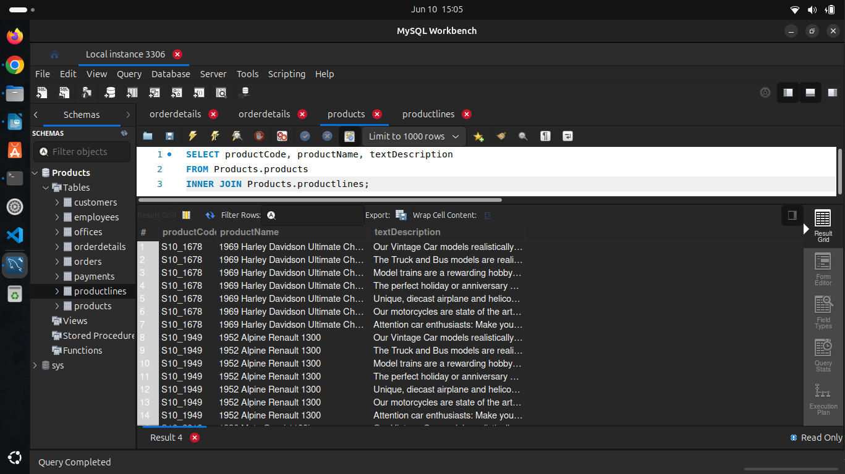

* 1. Write the query to get the customer number, customer name, order number, status from the tables order, payments, and customers who have no order.

**SELECT c1.customerNumber, customerName, orderNumber, status**

**FROM Products.customers c1**

**INNER JOIN Products.payments**

**INNER JOIN Products.orders**

