Name: RAUNAK RAJESH SHAH

**MySQL Assignment 2**

**Using WINDOWS**

# **TABLES CREATED SHOWN IN WORKBENCH**

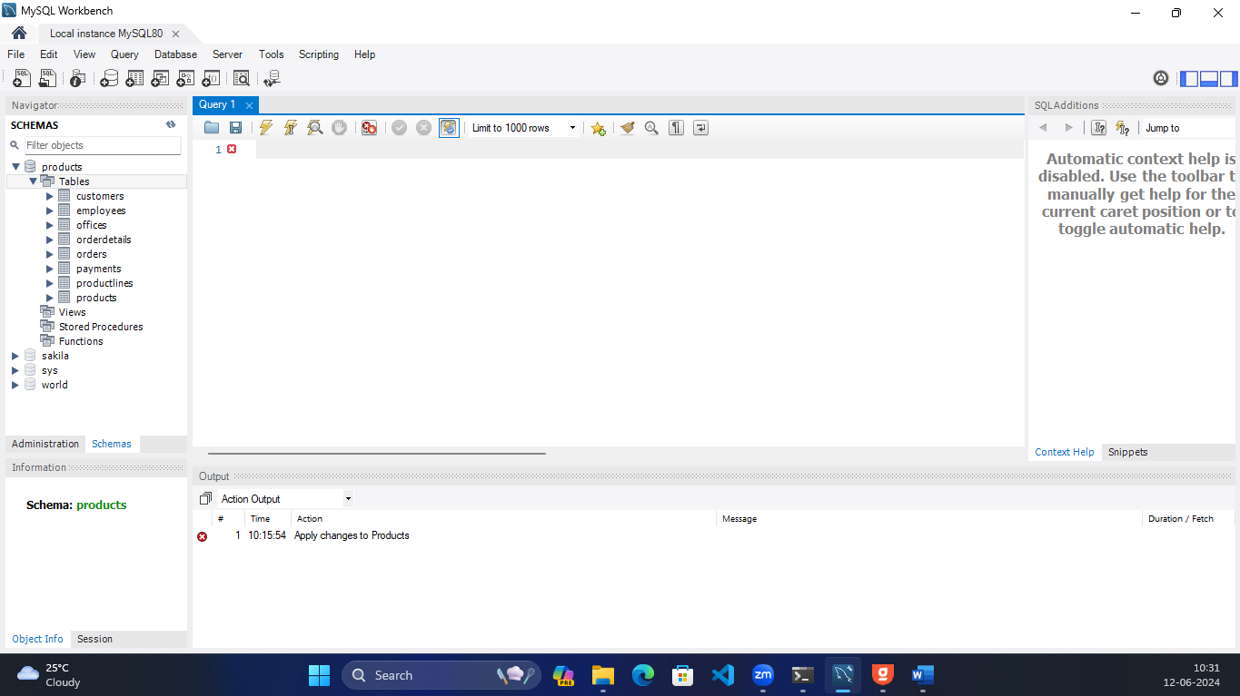

# **Execution of all the queries**

1. Write a query to calculate the total number of products in the database.

**SELECT COUNT(productCode) as TotalProducts FROM products.products**

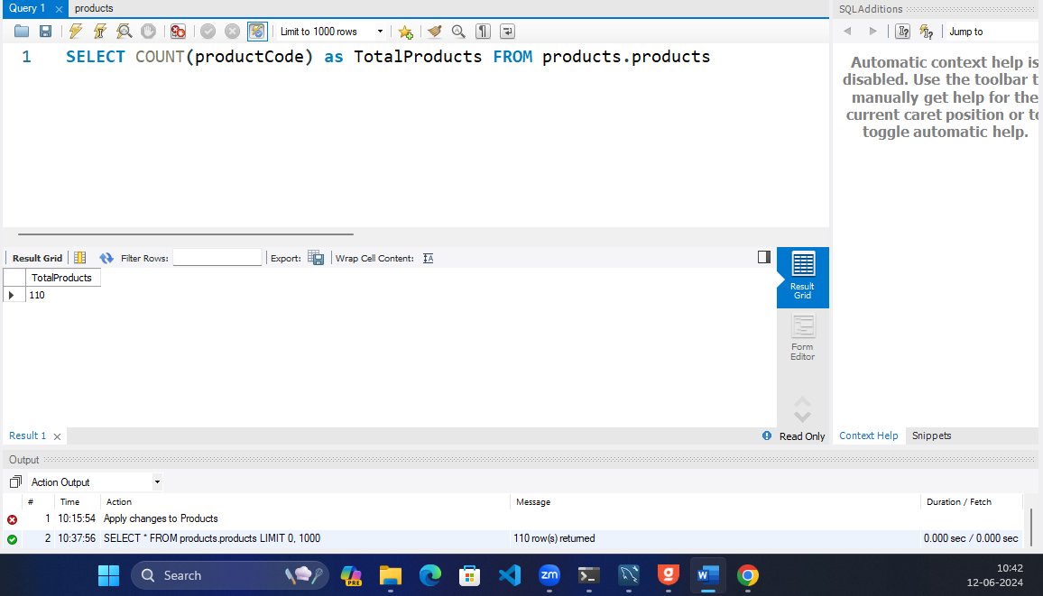

1. Write a query to find the average buy price of all products

**SELECT AVG(buyPrice) as AveragePrice FROM products.products**

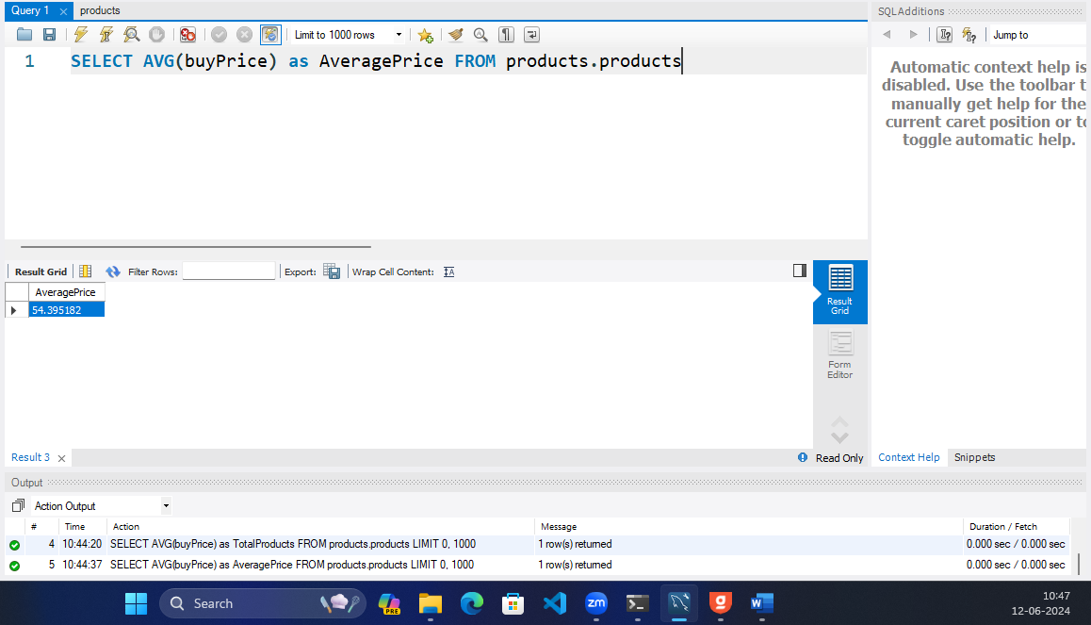

1. Write a query to determine the maximum quantity in stock across all products.

**SELECT MAX(quantityInStock) as MaxQuantity FROM products.products**

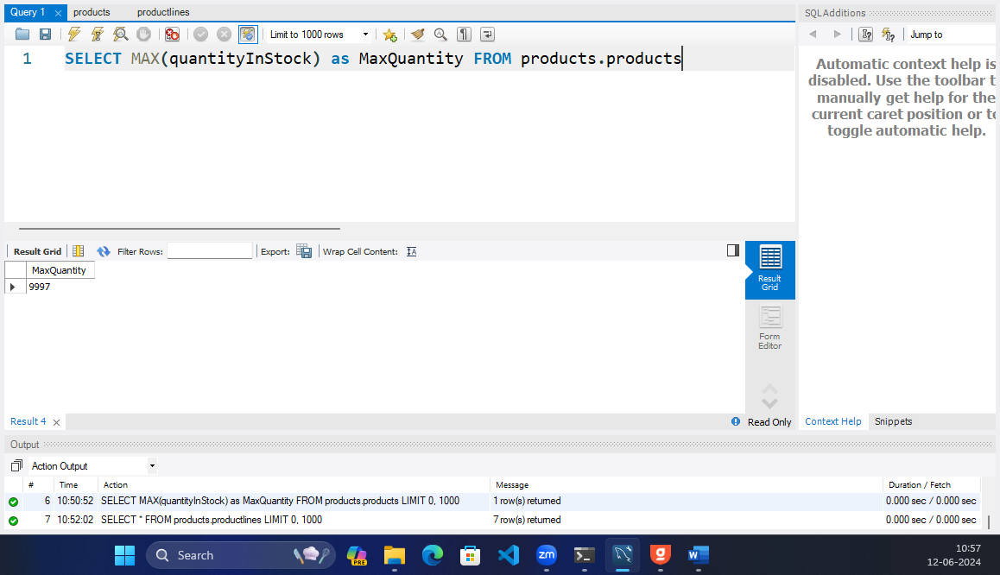

1. Write a query to calculate the total sales revenue for each product line.

**SELECT p.productLine, SUM(p.MSRP-p.buyPrice) as SalesRevenue**

**FROM products.products as p**

**GROUP BY p.productLine;**

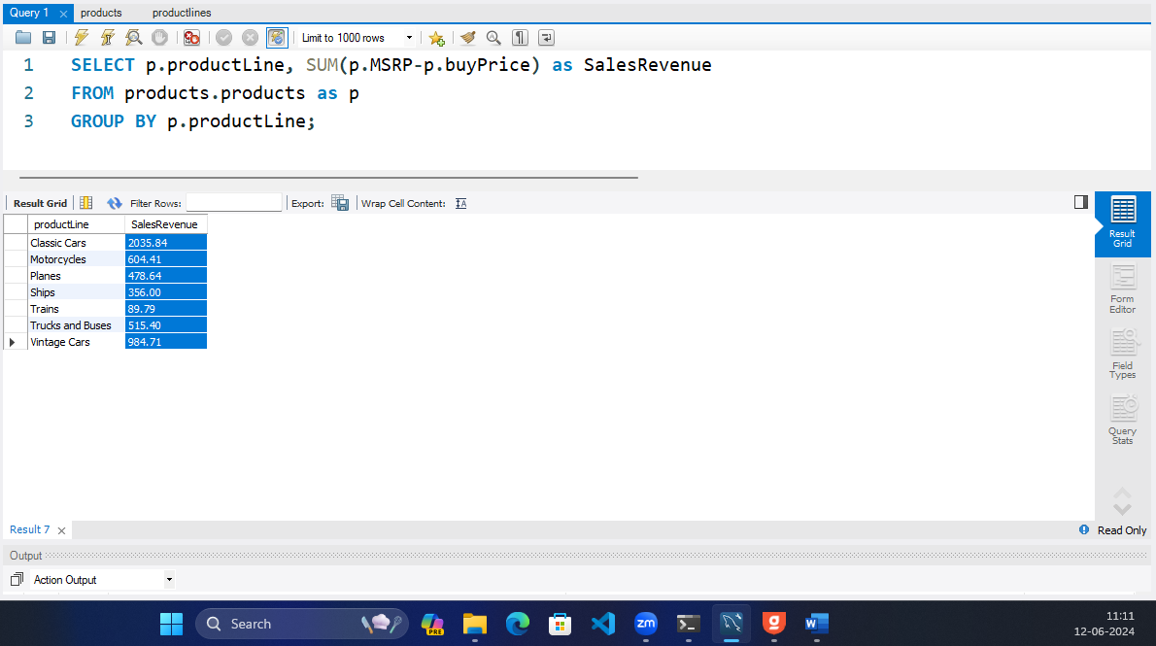

1. Write a query to determine the average credit limit for all customers.

**SELECT AVG(creditLimit) as AverageCredit FROM products.customers**

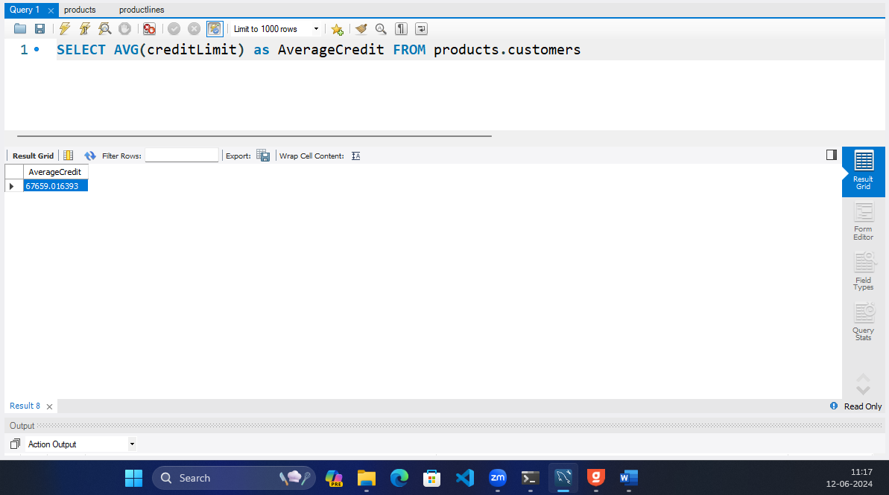

1. Write a query to find the highest payment amount made by a customer.

**SELECT MAX(amount) as HighestPayment FROM products.payments**

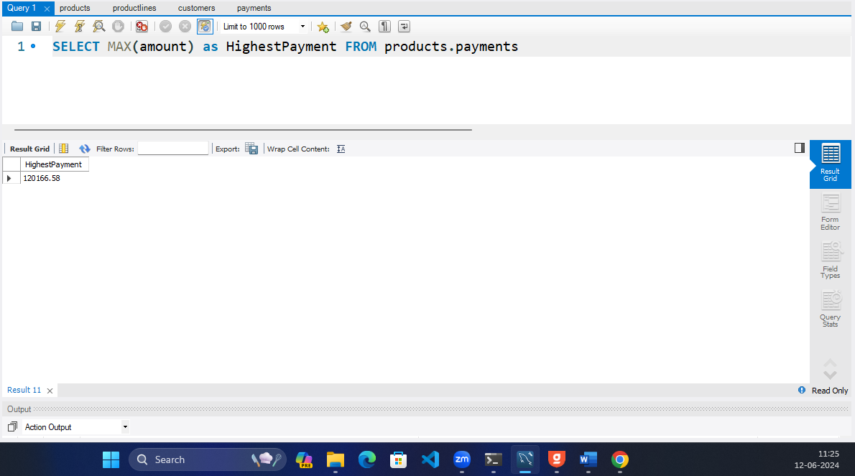

1. Write a query to calculate the total quantity ordered for each product.

**SELECT o.productCode, p.productName, SUM(o.quantityOrdered) as TotalQuantitiy**

**FROM products.orderdetails o**

**INNER JOIN products.products p WHERE p.productCode = o.productCode**

**GROUP BY productCode**

**ORDER BY productCode ASC;**

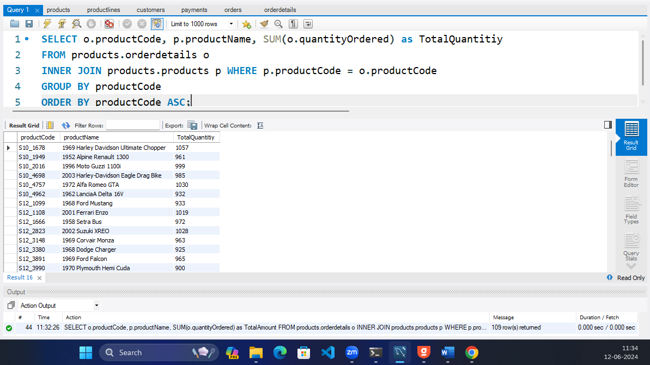

1. Write a query to determine the number of employees in each office.

**SELECT COUNT(employeeNumber) FROM products.employees**

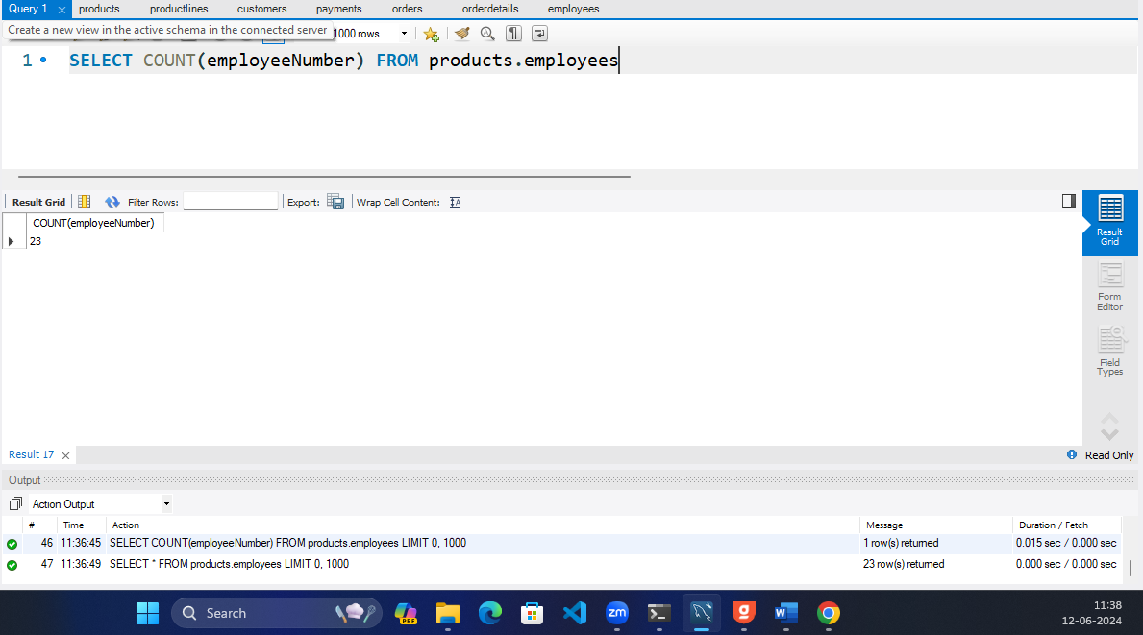

1. Write a query to calculate the average price for each order.

**SELECT orderNumber,AVG((quantityOrdered*priceEach)) as averagePrice**

**FROM products.orderdetails**

**GROUP BY orderNumber;**

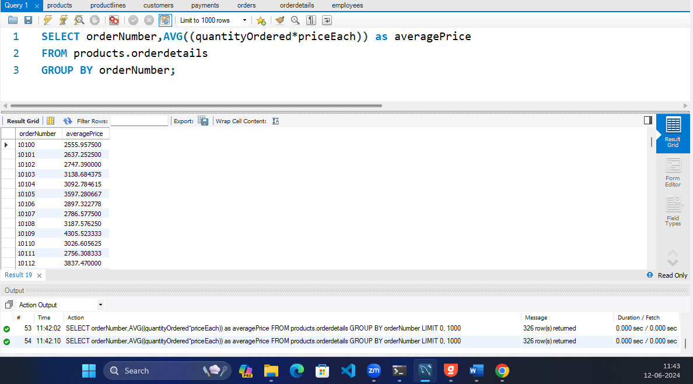

1. Write a query to determine the total sales revenue for each country.

**SELECT c.country, SUM((od.priceEach * od.quantityOrdered)) as SalesRevenue**

**FROM products.orderdetails od**

**LEFT JOIN products.orders o**

**ON od.orderNumber = o.orderNumber**

**RIGHT JOIN products.customers c**

**ON c.customerNumber = o.customerNumber**

**GROUP BY c.country;**

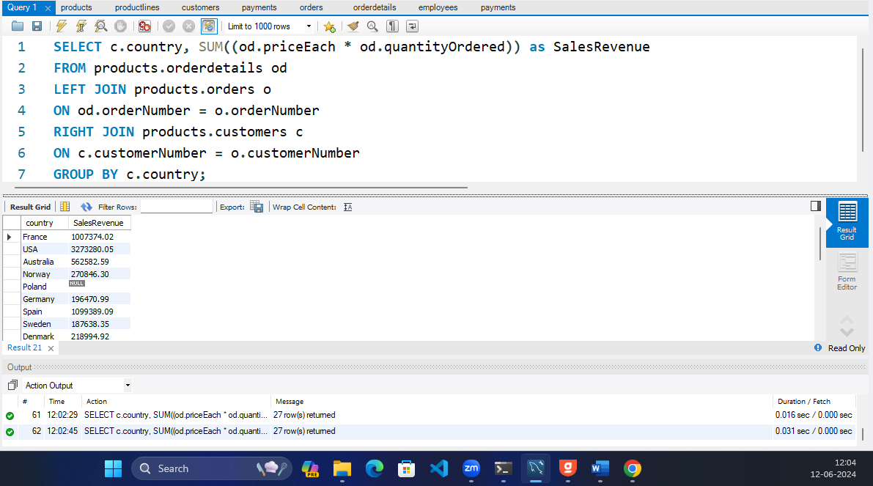

1. Write a query to calculate the average quantity in stock for each product line.

**SELECT productLine,AVG(quantityInStock) as AverageQuantity**

**FROM products.products**

**GROUP BY productLine;**

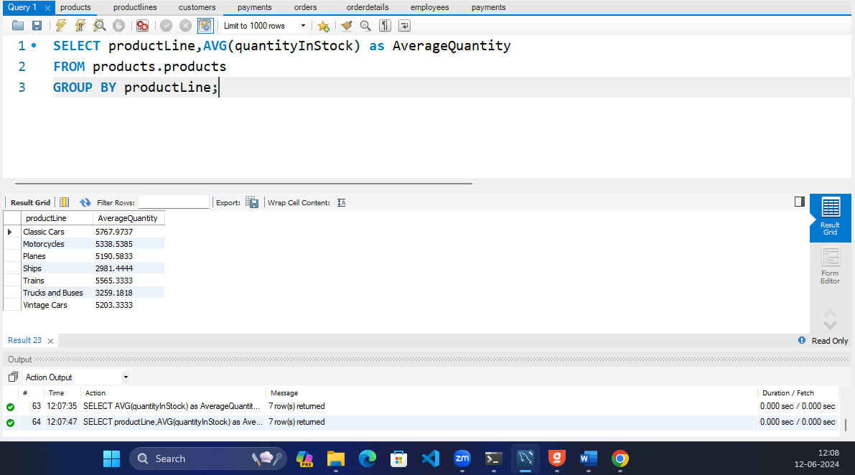

1. Write a query to determine the total number of orders placed by each customer.

**SELECT customerNumber ,COUNT(orderNumber) as NoOfOrders**

**FROM products.orders**

**GROUP BY customerNumber;**

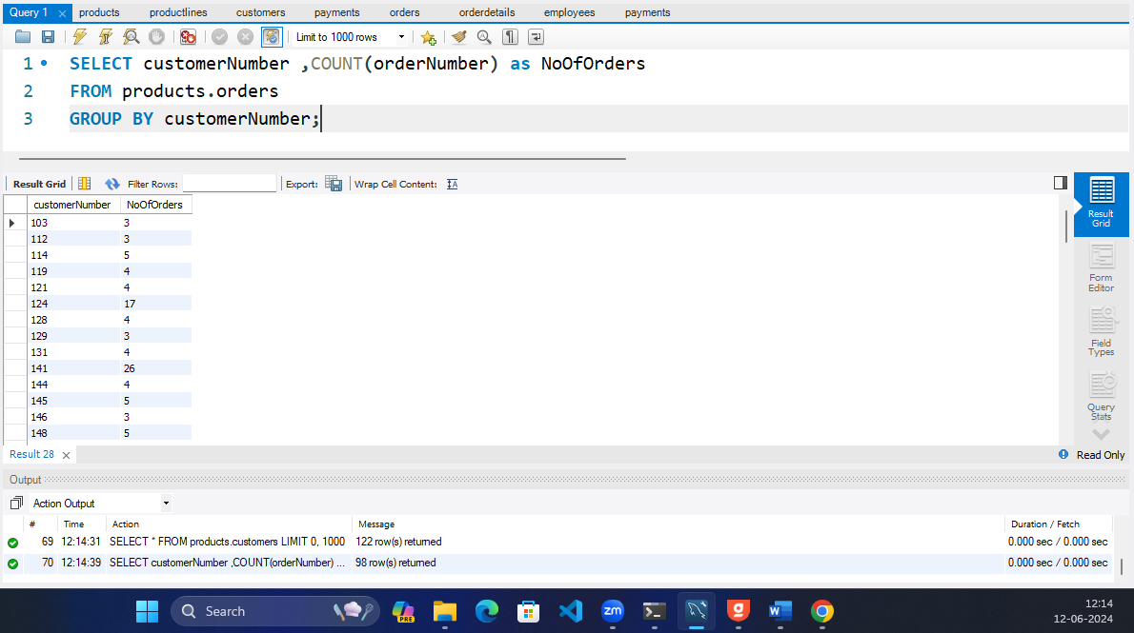

1. Write a query to find the maximum credit limit among all customers.

**SELECT MAX(creditLimit) FROM products.customers**

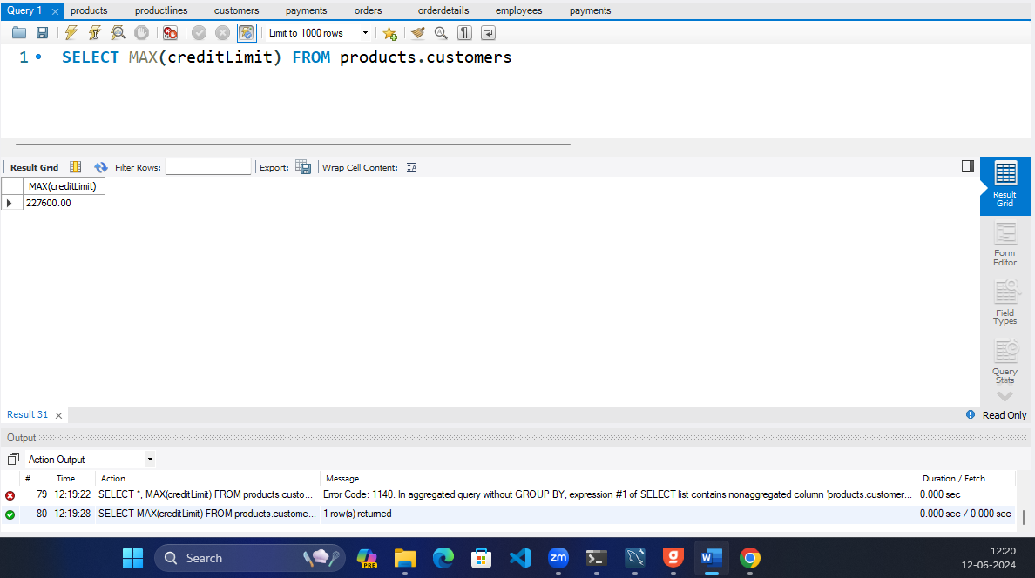

1. Write a query to count the number of offices in each country.

**SELECT country, COUNT(officeCode) FROM products.offices**

**GROUP BY country;**

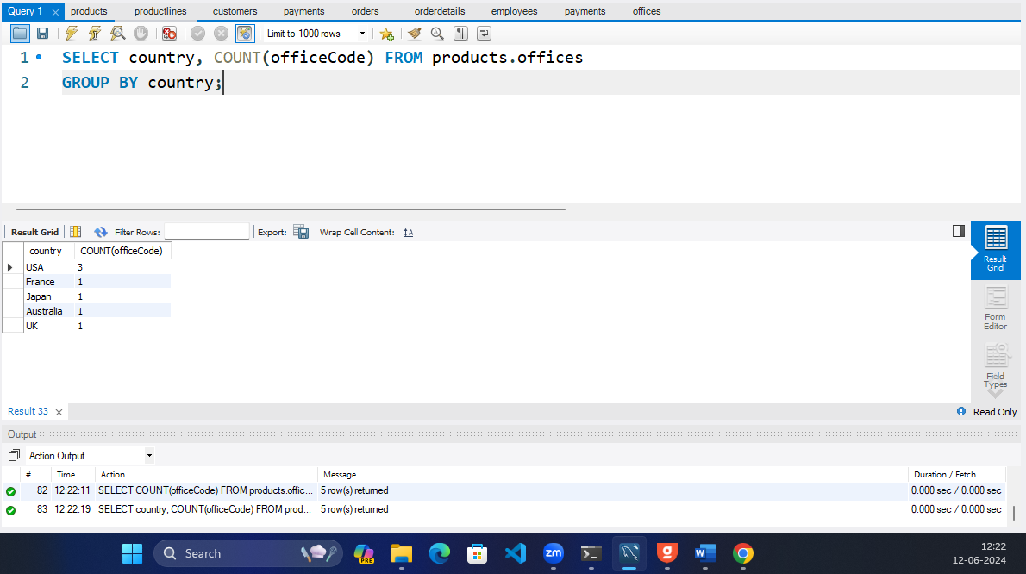

1. Write a query to calculate the average payment amount for each customer.

**SELECT customerNumber, AVG(amount) as AverageAmount**

**FROM products.payments**

**GROUP BY customerNumber;**

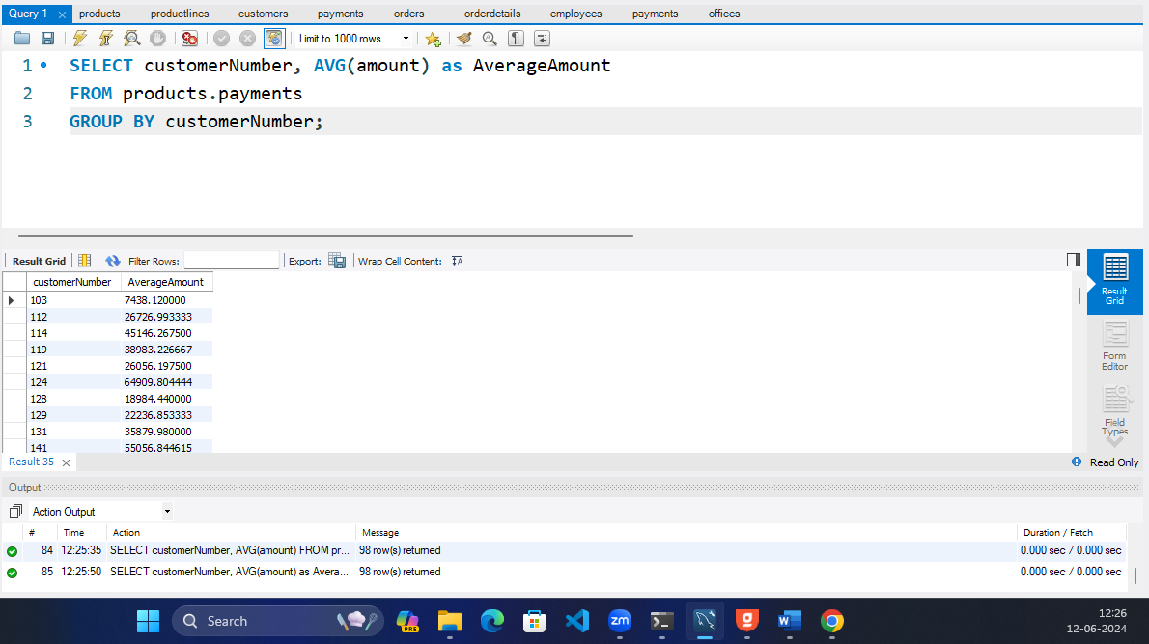

1. Write a query to determine the number of products in each product line.

**SELECT productLine ,COUNT(productName) as NumberOfProducts**

**FROM products.products**

**GROUP BY productLine;**

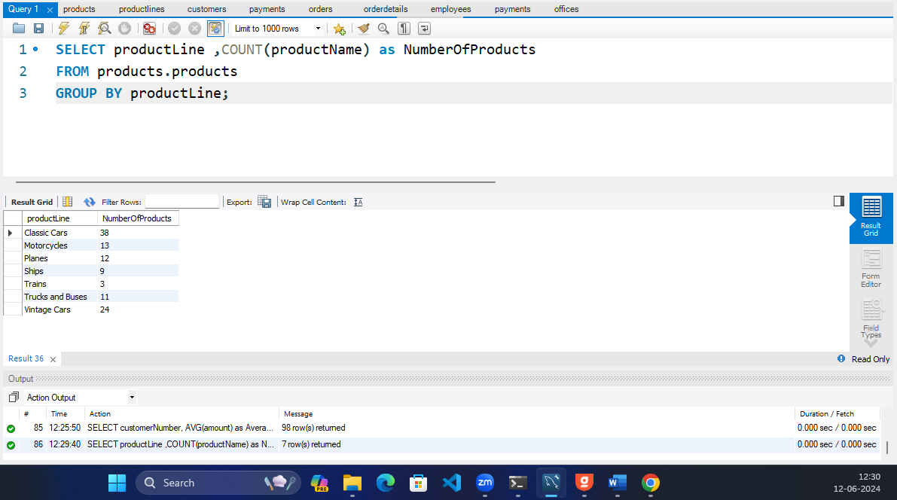

1. Write a query to count the number of customers in each state.

**SELECT state, COUNT(customerNumber) as NumberOfCustomers**

**FROM products.customers**

**GROUP BY state;**

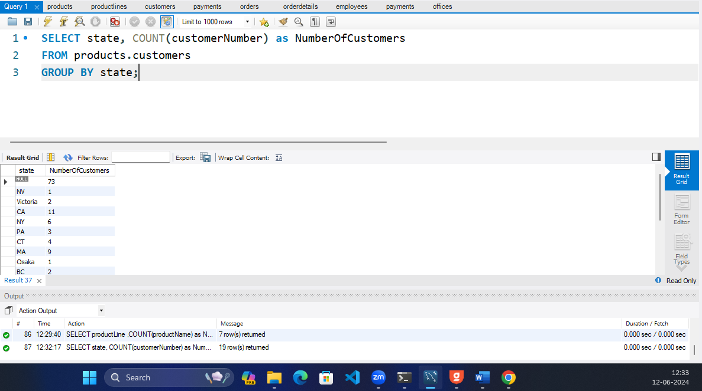

1. Write a query to find the minimum payment amount among all customers.

**SELECT MIN(amount) FROM products.payments**

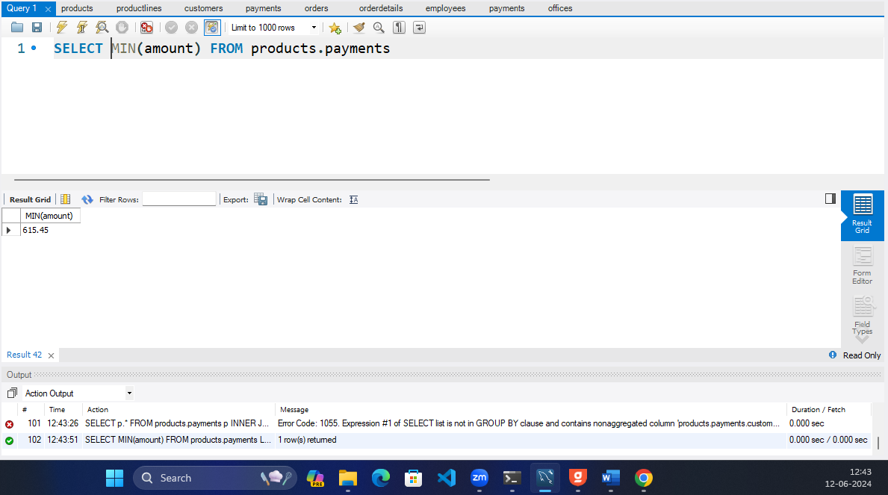

1. Write a query to calculate the average sales revenue per order.

**SELECT orderNumber, AVG((priceEach*quantityOrdered))**

**FROM products.orderdetails**

**GROUP BY orderNumber**

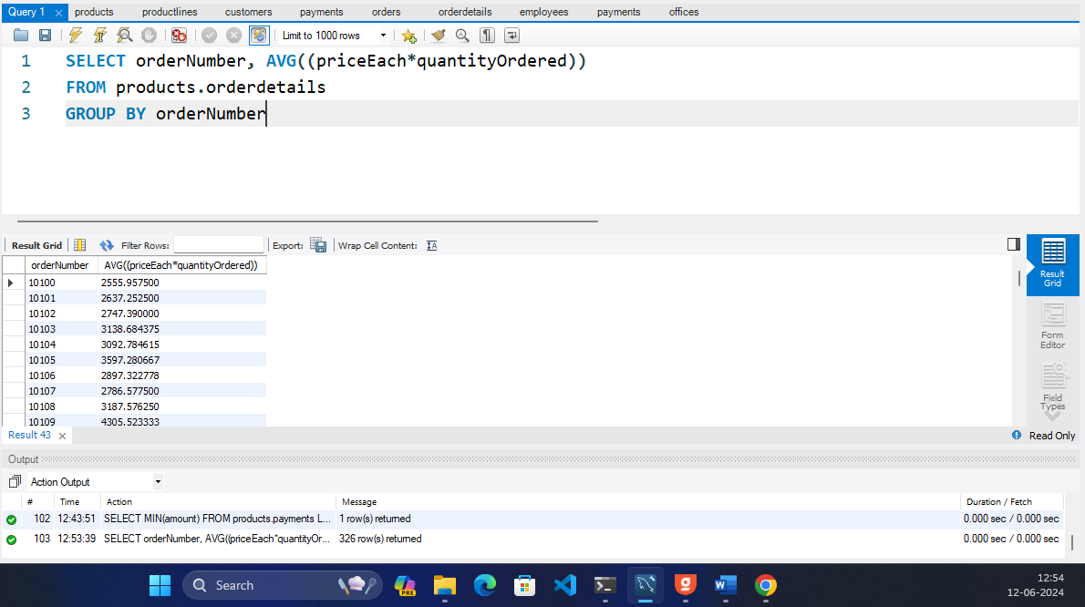

1. Write a query to determine the total quantity ordered for each product line.

**SELECT p.productLine, SUM(o.quantityOrdered) FROM products.orderdetails o**

**INNER JOIN products.products p**

**ON o.productCode = p.productCode**

**GROUP BY p.productLine;**

