Name: RAUNAK RAJESH SHAH

**MySQL Assignment 3**

**Using WINDOWS**

# **TABLES CREATED SHOWN IN WORKBENCH**

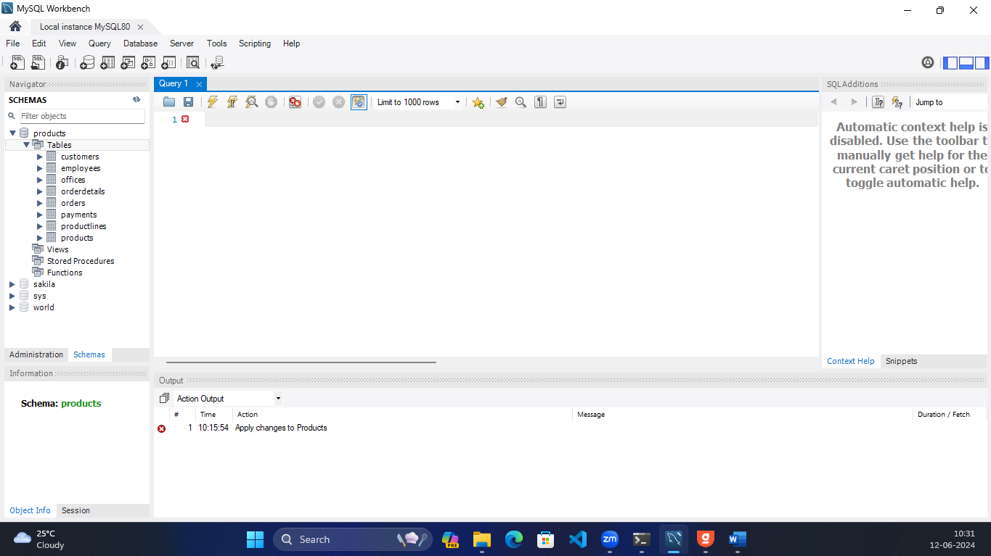

# **Execution of all the queries**

1. Write a query to retrieve the product details for order 10103.

**SELECT * FROM products.products p**

**INNER JOIN products.orderdetails o**

**ON o.productCode = p.productCode**

**WHERE o.orderNumber = 10103;**

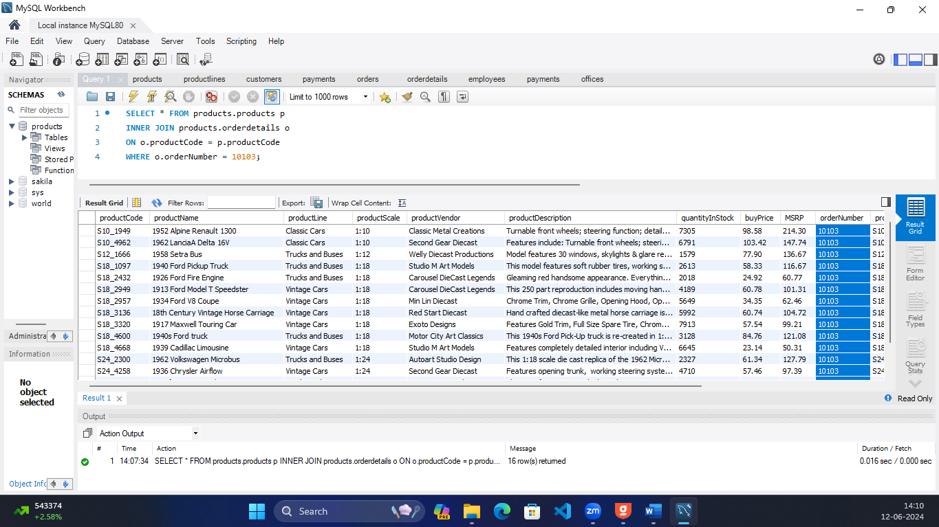

1. Write a query to get the customer information for order 10127

**SELECT * FROM products.customers c**

**INNER JOIN products.orders o**

**ON o.customerNumber = c.customerNumber**

**WHERE o.orderNumber = 10127;**

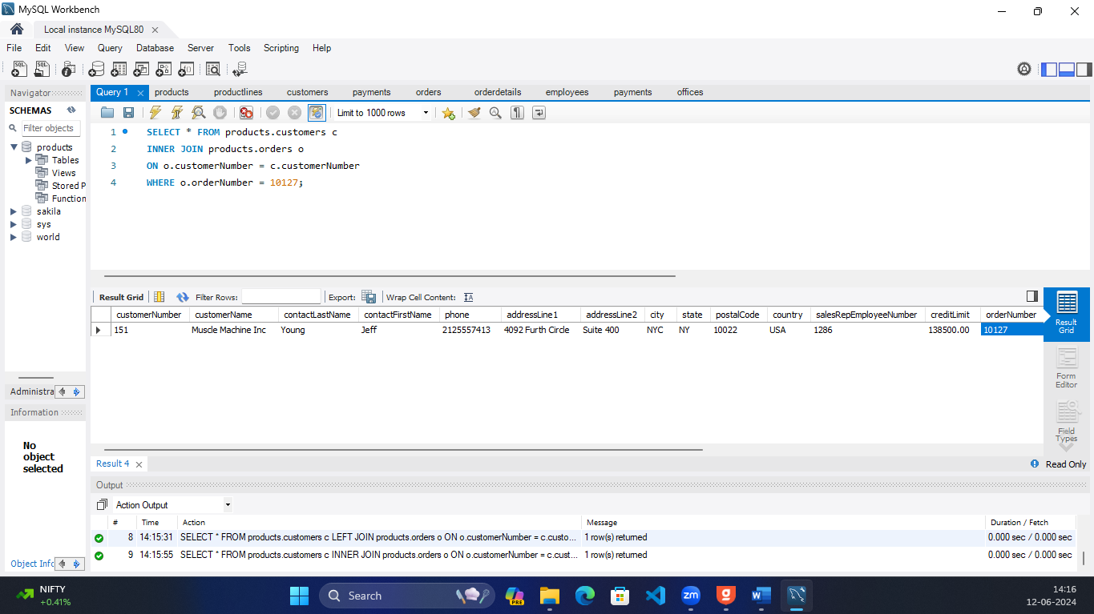

1. Write a query to retrieve the employee information for customer 166

**SELECT e.employeeNumber, e.lastName, e.firstName, e.extension, e.email, e.officeCode, e.reportsTo, e.jobTitle**

**FROM products.employees e**

**INNER JOIN products.customers c**

**ON e.employeeNumber = c.salesRepEmployeeNumber**

**WHERE c.customerNumber = 166;**

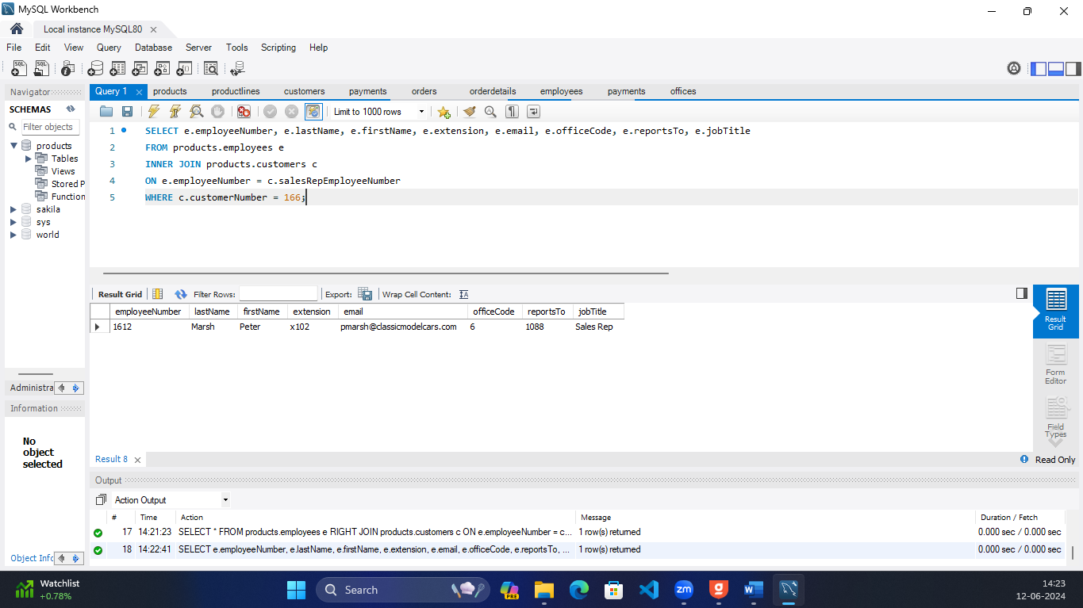

1. Write a query to get the official information for office code 4

**SELECT * FROM products.offices**

**WHERE officeCode = 4;**

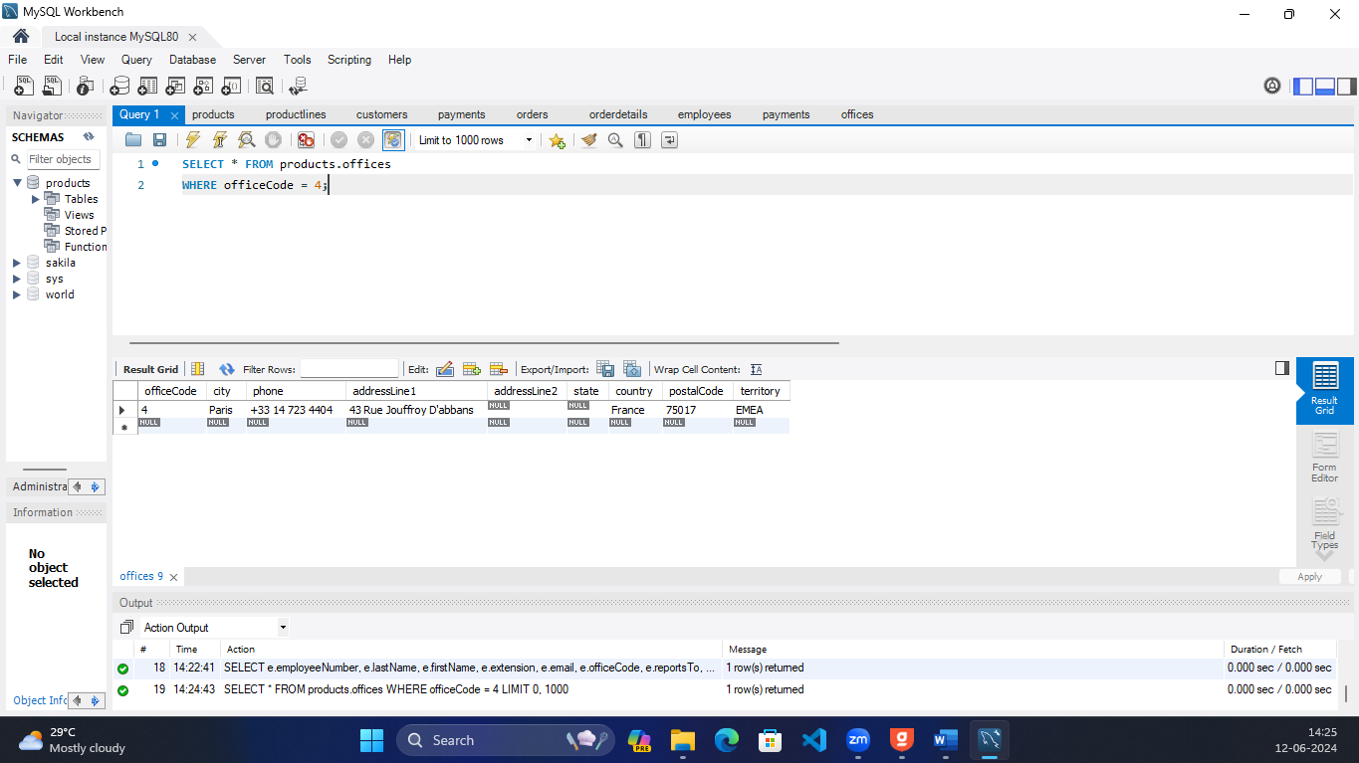

1. Write a query to retrieve the product line for each product in an order.

**SELECT * FROM products.products**

**ORDER BY productLine ASC;**

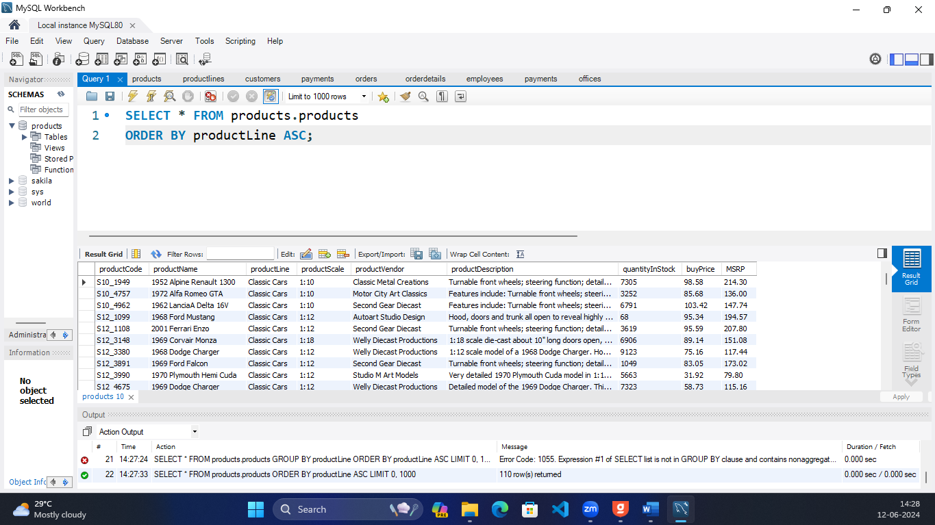

1. Write a query to get the customer information and order status for all orders that contain products belonging to the 'Classic Cars' product line.

**SELECT c.customerNumber, c.customerName, c.city, c.country, c.creditLimit, c.state, c.phone, o.status as OderStatus**

**FROM products.customers c**

**INNER JOIN products.orders o**

**ON o.customerNumber = c.customerNumber**

**INNER JOIN products.orderdetails od**

**ON od.orderNumber = o.orderNumber**

**INNER JOIN products.products p**

**ON od.productCode = p.productCode**

**WHERE p.productLine = 'Classic Cars';**

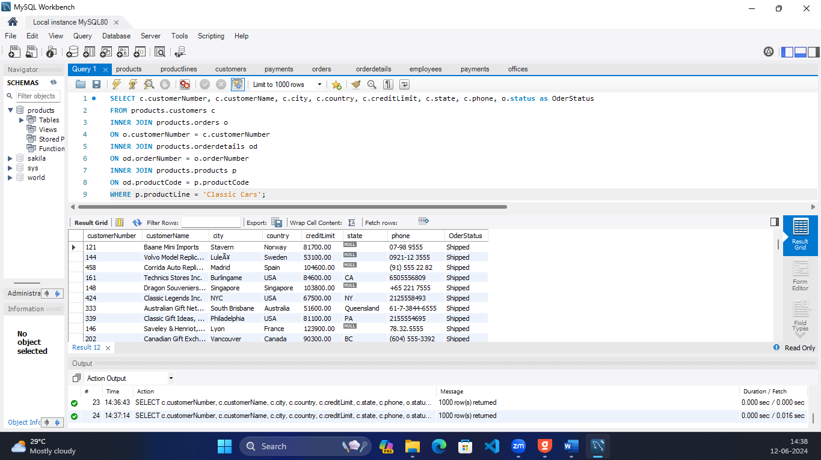

1. Write a query to retrieve the payment details and customer details of customer number 103

**SELECT c.customerNumber, c.customerName, c.city, c.state, c.country, c.creditLimit, p.amount as PaymentAmount, p.checkNumber, p.paymentDate**

**FROM products.customers c**

**INNER JOIN products.payments p**

**ON c.customerNumber = p.customerNumber**

**WHERE c.customerNumber = 103;**

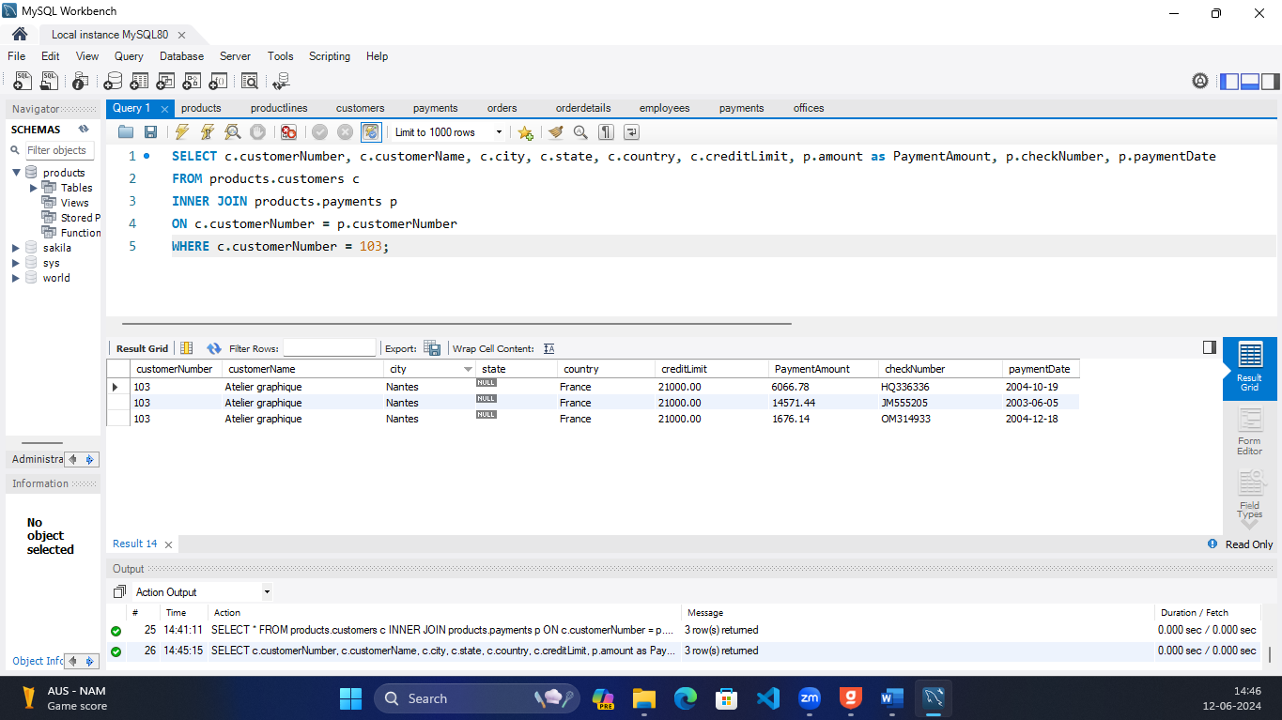

1. Write a query to get the orders and their corresponding payments to the same customer.

**SELECT c.customerNumber, o.orderNumber, o.orderDate, o.requiredDate, o.shippedDate, o.status, o.comments, p.amount as PaymentAmount, p.checkNumber, p.paymentDate**

**FROM products.customers c**

**INNER JOIN products.payments p**

**ON c.customerNumber = p.customerNumber**

**INNER JOIN products.orders o**

**ON o.customerNumber = p.customerNumber**

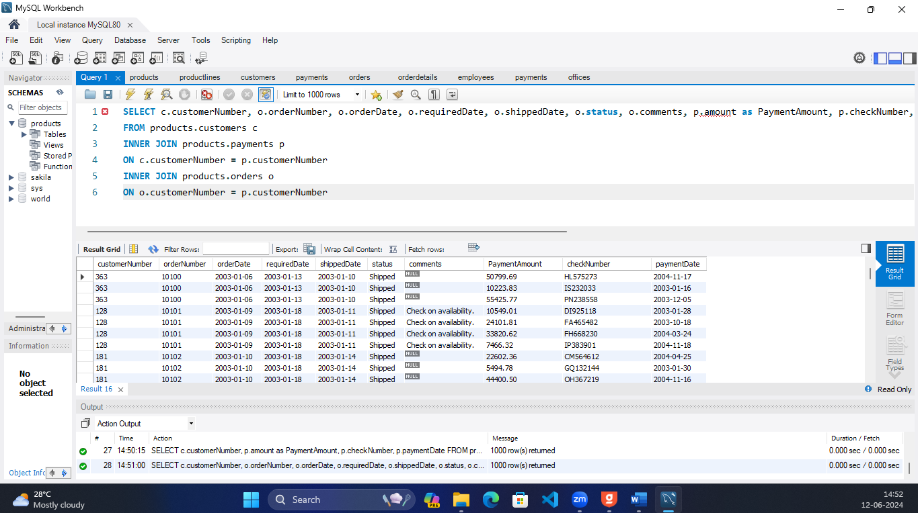

1. Write a query to retrieve the customers and their associated orders.

**SELECT * FROM products.customers c**

**INNER JOIN products.orders o**

**ON o.customerNumber = c.customerNumber**

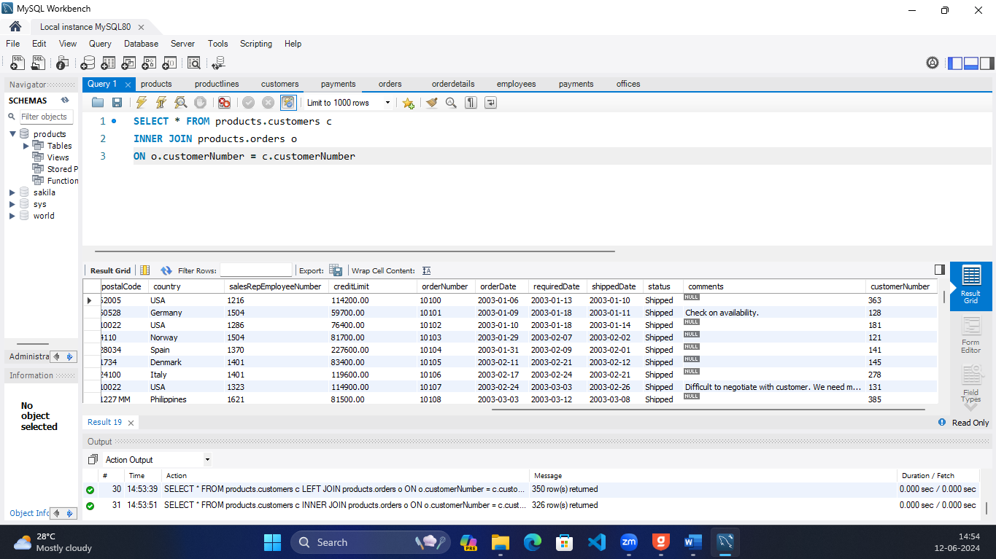

1. Write a query to get the products and their corresponding product lines.

**SELECT productCode, productName, productDescription, productLine**

**FROM products.products**;

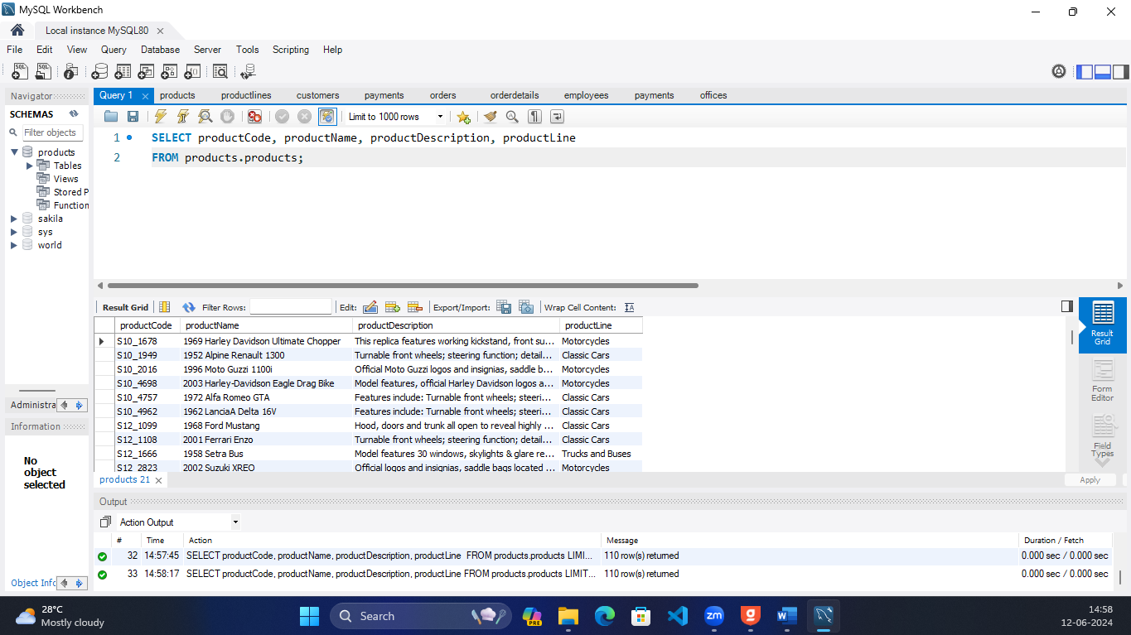

1. Write a query to retrieve the employees and their respective managers.

**SELECT * FROM products.employees e1**

**JOIN (SELECT employeeNumber as ManagerNumber, CONCAT(e.lastName, ' ', e.firstName) as ManagerName FROM products.employees e) AS e2**

**ON e2.ManagerNumber = e1.reportsTo**

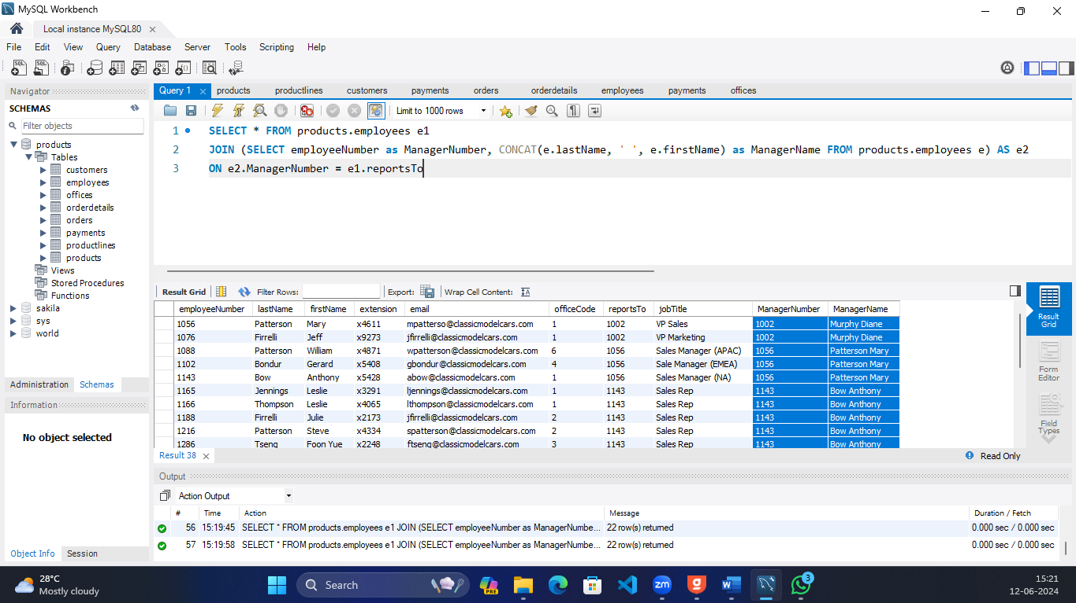

1. Write a query to retrieve the customers, their orders, and the corresponding product details.

**SELECT * FROM products.customers c**

**INNER JOIN products.orders o**

**ON c.customerNumber = o.customerNumber**

**INNER JOIN products.orderdetails od**

**ON o.orderNumber = od.orderNumber**

**INNER JOIN products.products p**

**ON od.productCode = p.productCode;**

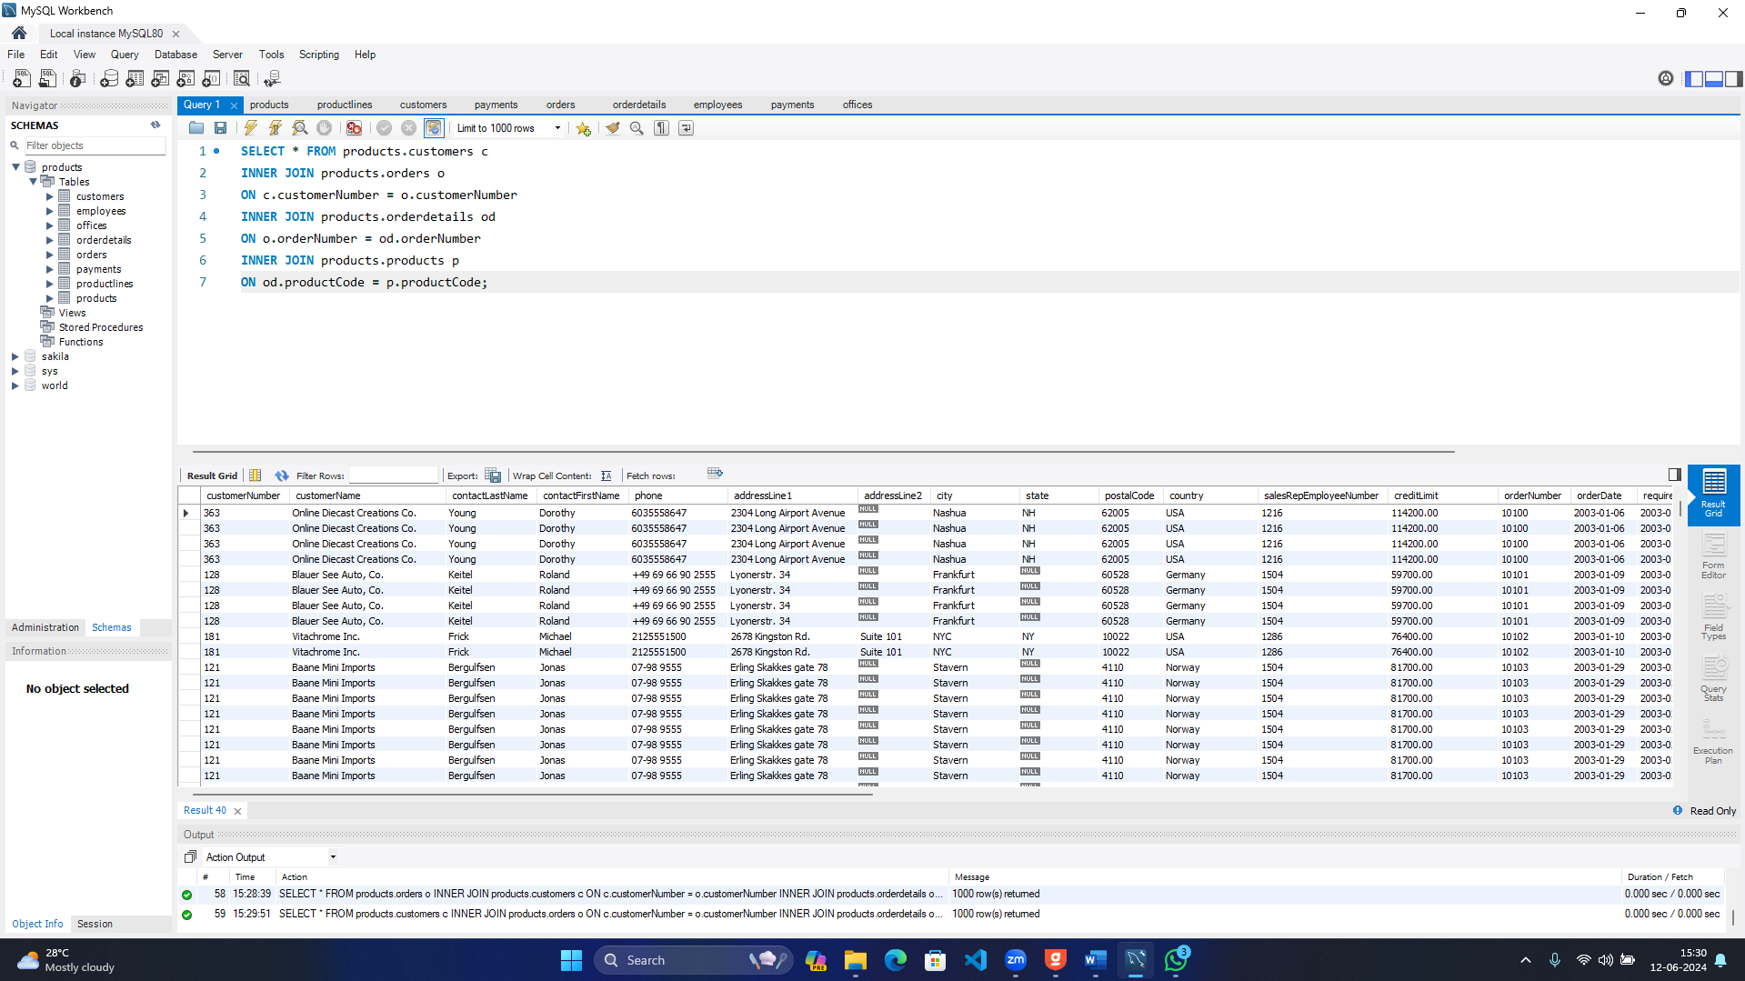

1. Write a query to get the payment details, order details, and the associated products.

**SELECT * FROM products.payments p**

**INNER JOIN products.orderdetails od**

**INNER JOIN products.orders o**

**ON p.customerNumber = o.customerNumber**

**INNER JOIN products.products pr**

**ON od.productCode = pr.productCode;**

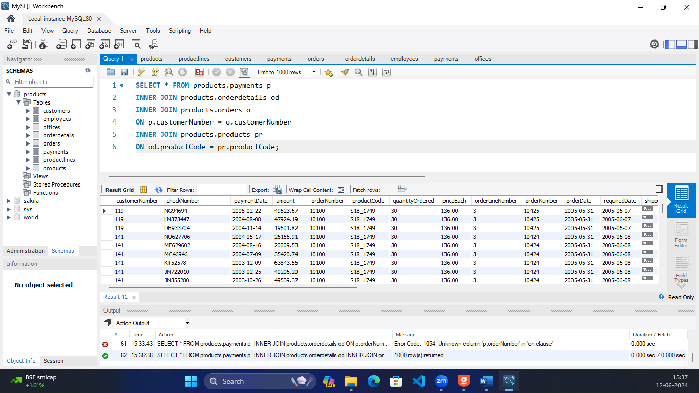

1. Write a query to retrieve the payment details and the customer information for the check number - JM555205

**SELECT * FROM products.payments p**

**INNER JOIN products.customers c**

**ON p.customerNumber = c.customerNumber**

**WHERE p.checkNumber = 'JM555205'**

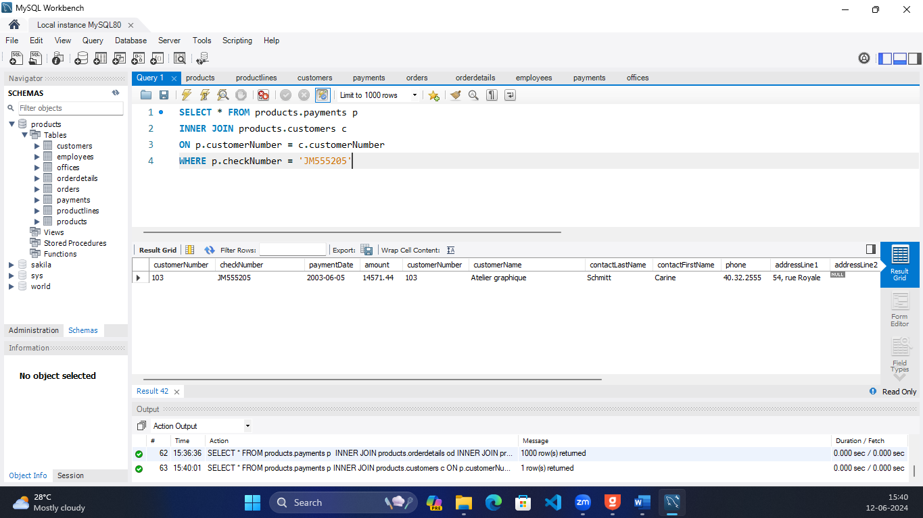

1. Write a query to retrieve the orders and their corresponding customer and employee information for a canceled status.

**SELECT * FROM products.orders o**

**INNER JOIN products.customers c**

**ON o.customerNumber = c.customerNumber**

**INNER JOIN products.employees e**

**ON e.employeeNumber = c.salesRepEmployeeNumber**

**WHERE o.status = 'Cancelled';**

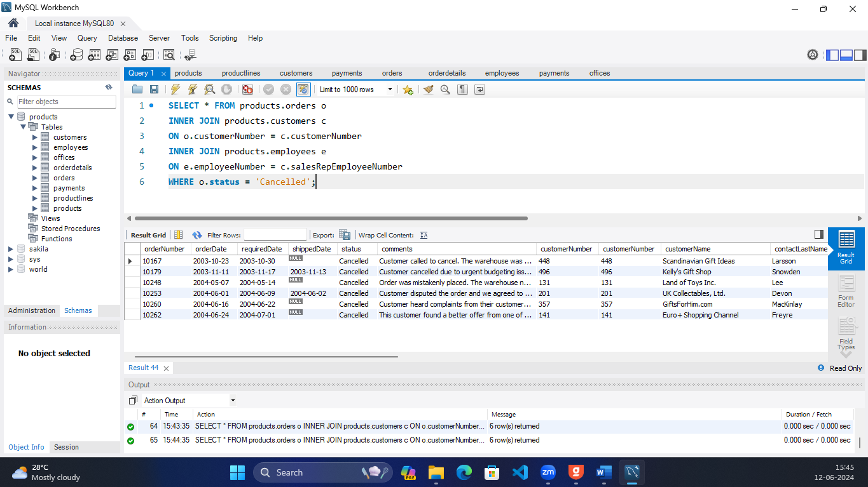

1. Write a query to get the payments, order details, and associated product information for the payment date - 2004-12-17

**SELECT * FROM products.payments p**

**INNER JOIN products.orderdetails od**

**INNER JOIN products.products pr**

**ON pr.productCode = od.productCode**

**WHERE p.paymentDate = '2004-12-17';**

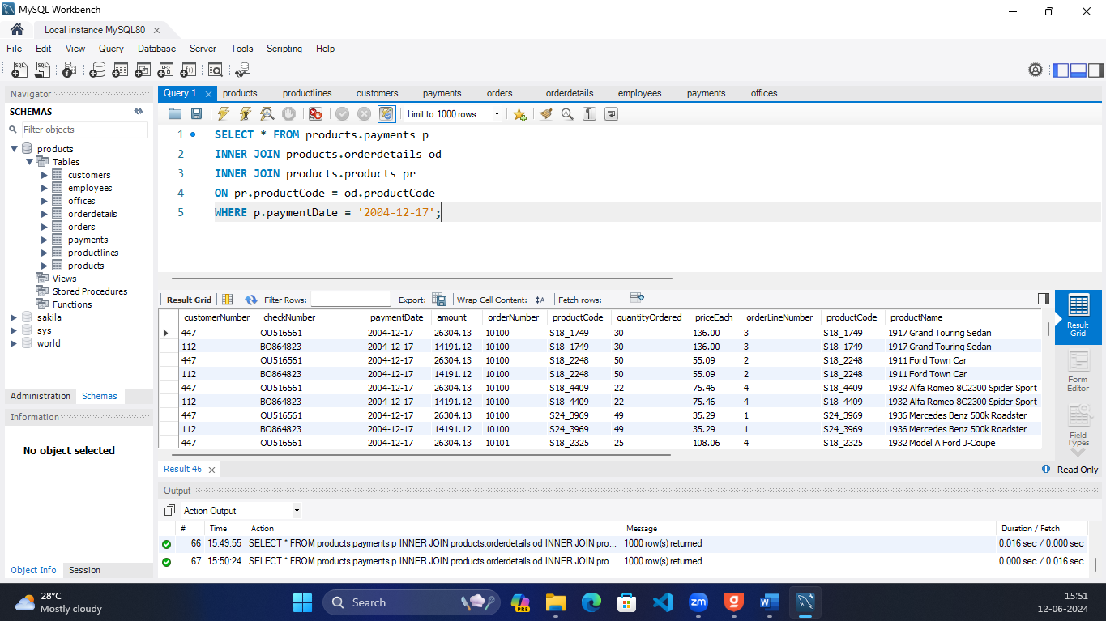

1. Write a query to retrieve the products, order details, and corresponding customer information for customer 112

**SELECT * FROM products.products pr**

**INNER JOIN products.orderdetails od**

**INNER JOIN products.orders o**

**ON od.productCode = pr.productCode**

**INNER JOIN products.customers c**

**ON c.customerNumber = o.customerNumber**

**WHERE c.customerNumber = 112;**

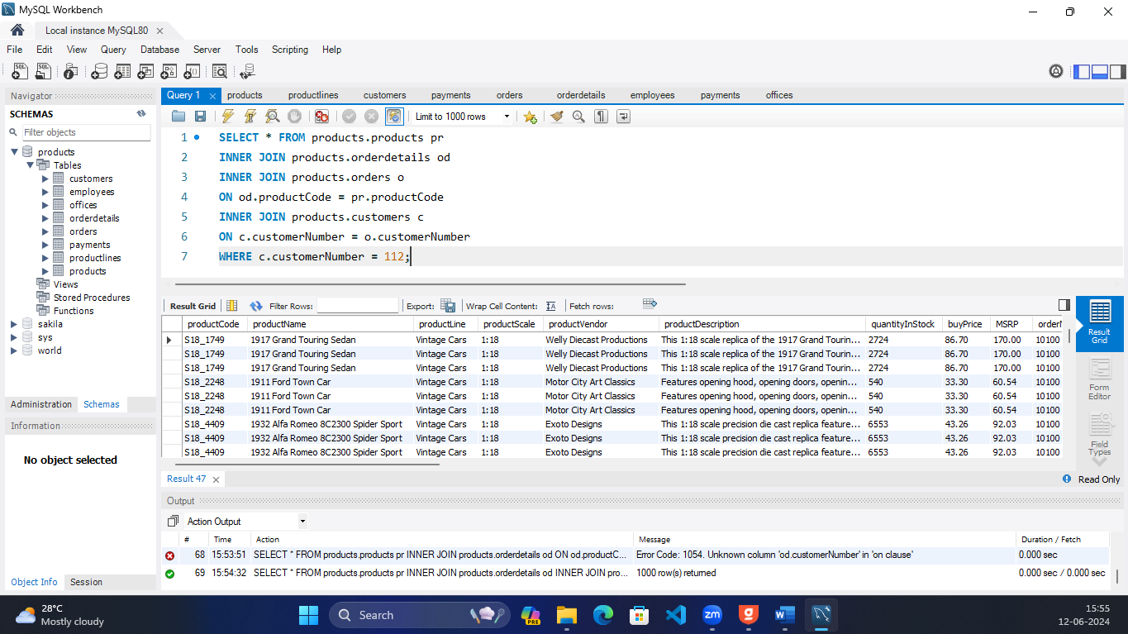

1. Write a query to retrieve the customers, their orders, and the associated product line information for the customers who are all from Boston.

**SELECT pr.productLine,c.*,o.* FROM products.customers c**

**INNER JOIN products.orders o**

**ON o.customerNumber = c.customerNumber**

**INNER JOIN products.productlines pl**

**INNER JOIN products.orderdetails od**

**ON od.orderNumber = o.orderNumber**

**INNER JOIN products.products pr**

**ON pr.productCode = od.productCode**

**WHERE c.city = 'Boston';**

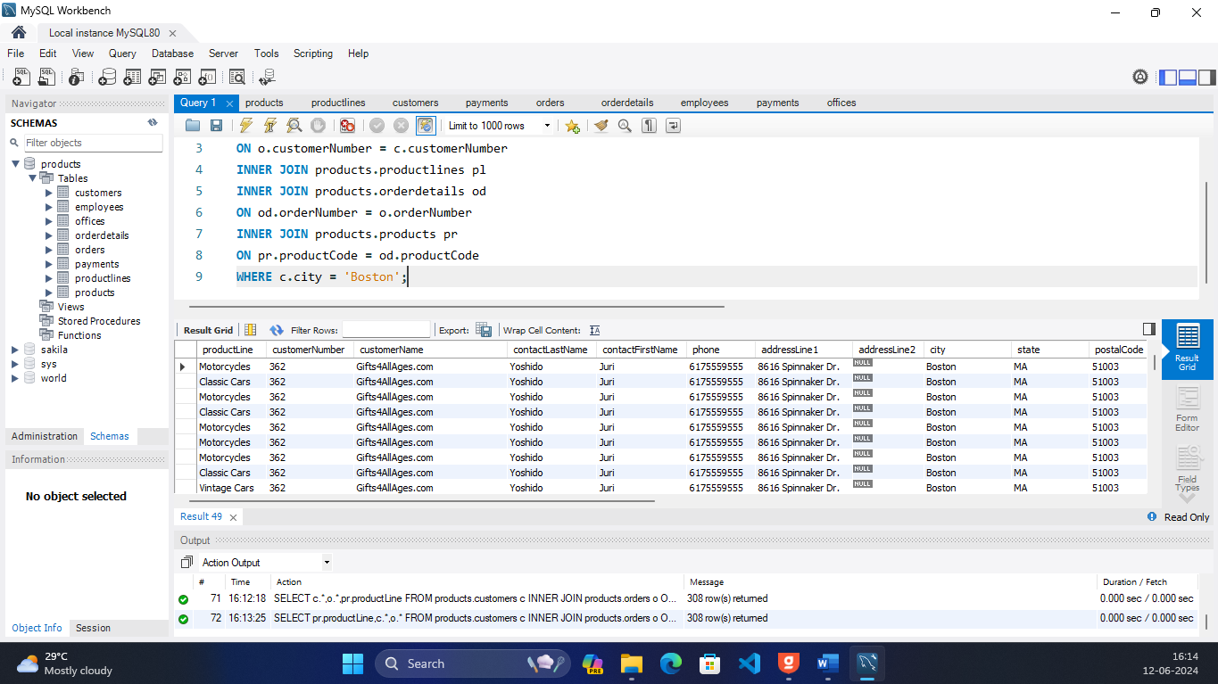

1. Write a query to get the employees, their respective managers, and the corresponding office details of the Sales Rep.

**SELECT e1.*,e2.ManagerNumber, e2.ManagerName, o.\***

**FROM products.employees e1**

**JOIN (SELECT employeeNumber as ManagerNumber, CONCAT(e.lastName, ' ', e.firstName) as ManagerName FROM products.employees e) AS e2**

**ON e2.ManagerNumber = e1.reportsTo**

**INNER JOIN products.offices o**

**ON e1.officeCode = o.officeCode;**

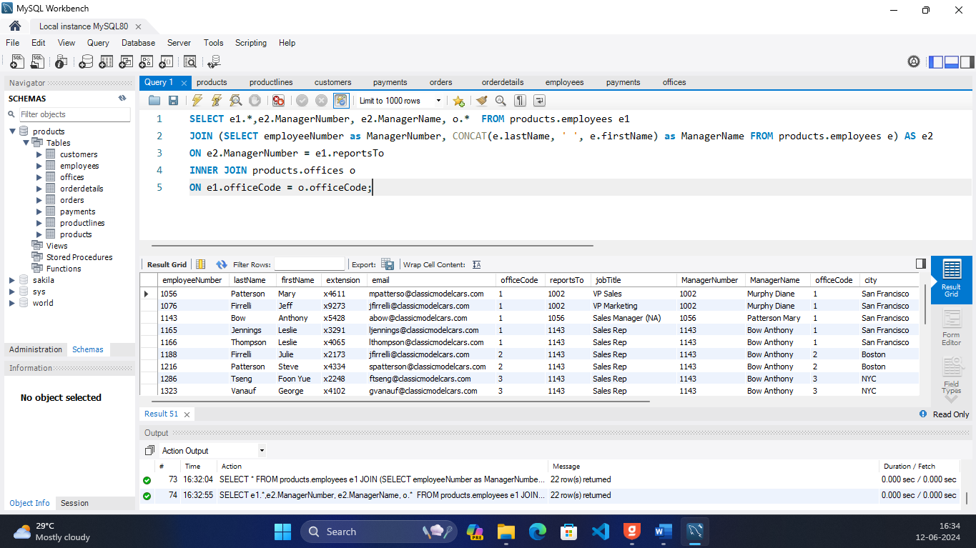

1. Write a query to retrieve the product lines, products, and the corresponding customer information for Vintage Cars.

**SELECT pr.*,c.* From products.products pr**

**INNER JOIN products.customers c**

**INNER JOIN products.orders o**

**ON c.customerNumber = o.customerNumber**

**INNER JOIN products.orderdetails od**

**ON o.orderNumber = od.orderNumber**

**ON pr.productCode = od.productCode**

**WHERE pr.productLine = 'Vintage Cars';**

