Istanbul Technical University
EBT 629E, Artificial Intelligence

Final Project Report
Household Energy Consumption Forecasting
Using Time Series Models
A Comparative Study of ARIMA, LSTM, and FB-Prophet on the REFIT Dataset

Group Members
Nurullah Yıldırım (301252004)
Kadir Göksel Gündüz (301241077)
Furkan Çınar (301212001)

May 2026

Abstract
This report presents a comparative study of four time series forecasting approaches, applied to household energy consumption data from the REFIT Smart Home dataset. We use 22 months of 8-second resolution measurements from three UK households (Houses 1, 2, and 5), aggregate them to daily mean power and apply a 7-day rolling smoother, then split each series temporally into 80 percent training and 20 percent testing. Alongside the three candidate models, ARIMA, Long Short-Term Memory (LSTM), and FB-Prophet, we include a persistence baseline (y_hat[t] = y[t-1]) as a sanity check. ARIMA is tuned through an ADF-based stationarity test and an AIC grid search, then run under a rolling one-step-ahead protocol; LSTM uses a three-layer stacked recurrent architecture; Prophet uses weekly and yearly seasonality in single multi-step mode. On House 2, ARIMA(2, 1, 2) reaches R2 = 0.876 and RMSE = 48.7 W, but a Diebold-Mariano test shows its edge over the persistence baseline (R2 = 0.873) is not statistically significant (p = 0.665). LSTM (R2 = 0.748) and Prophet (R2 = 0.015) lose significantly to persistence (p < 0.001 in both cases). The same pattern holds on House 1 and House 5: ARIMA narrowly wins, but adds little over persistence, while LSTM and Prophet underperform the baseline. The headline lesson is that smoothed daily residential consumption is dominated by lag-1 autocorrelation, so a one-line rule captures almost all of the predictable structure. Heavier machinery is justified only when stronger exogenous inputs or finer-grained targets break that autocorrelation. The full code base, with fixed random seed and reproducible pipeline, is provided alongside this report.

1. Introduction

1.1 Background and Motivation
Household electricity consumption sits at the centre of several modern energy challenges. On the supply side, accurate short-term forecasts are needed for grid operators to balance renewable generation, plan reserve capacity, and reduce curtailment. On the demand side, they enable consumers to participate in demand-response programmes, schedule appliances intelligently, and optimise integration with rooftop photovoltaic and battery storage systems. The widespread roll-out of smart meters across Europe and the increasing maturity of machine learning frameworks have made it feasible to study this problem at the level of individual households rather than at the substation level.
Forecasting residential consumption is, however, structurally harder than forecasting aggregated demand. A single household exhibits abrupt switching events (kettles, ovens, washing machines), idiosyncratic schedules driven by occupant behaviour, and seasonality that interacts with weather and holidays. Smoothing across many households averages much of this noise away, which is one reason that grid-level forecasts often report low MAPE while household-level forecasts can fail outright.

1.2 Project Objectives
The present project asks a focused, practical question: among three widely used time series models, ARIMA, LSTM, and FB-Prophet, which is best suited to forecasting the daily energy consumption of a single household, and why? Concretely, the project pursues four objectives.
- Build a reproducible pipeline from raw 8-second REFIT readings to model outputs.
- Compare ARIMA, LSTM, and FB-Prophet on a single test bed under the same data split.
- Quantify the gap between models using MSE, RMSE, MAE, and R2 metrics.
- Investigate where each model wins or loses, and document the iterations that led to the final design.

1.3 Report Structure
Section 2 introduces the REFIT dataset and the chosen household. Section 3 details the preprocessing pipeline and the three modelling approaches, including the rolling forecast protocol that distinguishes our setup from many of the multi-step benchmarks reported in the literature. Section 4 presents the exploratory data analysis. Section 5 reports the quantitative results and visual comparisons. Section 6 discusses the findings, the limitations of the study, and threats to validity. Section 7 closes with conclusions and directions for further work.

2. Dataset: REFIT Smart Home Electrical Load Measurements

2.1 Overview
REFIT (Personalised Retrofit Decision Support Tools for UK Homes) is a longitudinal dataset collected between October 2013 and June 2015 in the Loughborough area of the United Kingdom. The data was produced by a consortium of the Universities of Strathclyde, Loughborough, and East Anglia under EPSRC funding and is released under a Creative Commons Attribution 4.0 International licence. Twenty households were instrumented (numbered House 1 to House 21, skipping House 14) with one current clamp on the whole-house feed and nine Individual Appliance Monitors per home. Active power was sampled in Watts at roughly one reading every six to eight seconds, which produced a corpus of about 1.19 billion observations across all houses (Murray, Stankovic, and Stankovic, 2017).

2.2 Selected Household: House 2
We use House 2 as the test bed for this project. The CSV file is 299 MB on disk and contains 5,733,526 timestamped readings spanning 22 months. The monitored appliances are Fridge-Freezer, Washing Machine, Dishwasher, Television, Microwave, Toaster, Hi-Fi, Kettle, and Oven Extractor Fan. House 2 was selected because it has no documented signature changes, no rooftop PV interference, and represents a typical UK household appliance mix.
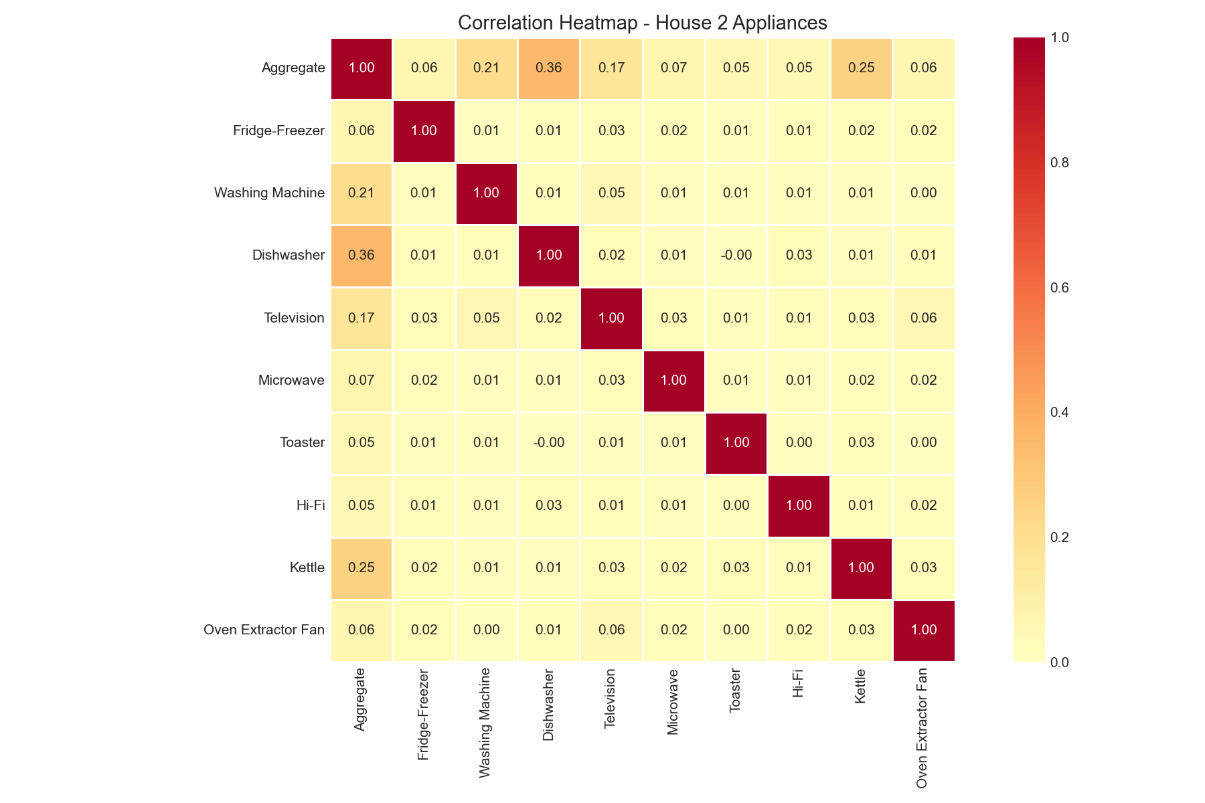
Figure 1. Pearson correlation among the aggregate power channel and the nine individual appliance monitors in House 2.

2.3 Data Quality and Cleaning
The REFIT release applies forward-filling for short gaps and zeros out gaps longer than two minutes. Readings above 4000 W on appliance channels (above sensor range) have already been removed by the original maintainers. Our additional cleaning steps remove negative aggregate readings (caused by clamp polarity glitches) and trim the upper one percent of values as outliers. After these steps, the aggregate series is continuous and ready for resampling.

3. Methodology
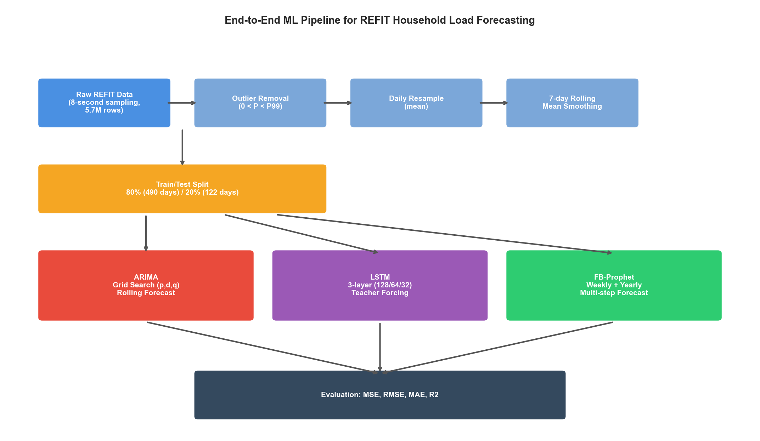
Figure 2. End-to-end machine learning pipeline. Raw 8-second REFIT data flows through outlier removal, daily resampling, and 7-day smoothing, then feeds three competing models whose forecasts are evaluated against the held-out test set.

3.1 Data Preprocessing
Five preprocessing steps prepare the raw signal for modelling. First, the timestamp column is parsed into a pandas DatetimeIndex. Second, the Unix epoch column is dropped to save memory. Third, outlier filtering removes negative values and entries above the 99th percentile. Fourth, the cleaned series is resampled to daily means, reducing 5.7 million rows to roughly 630 daily observations and removing most of the appliance-level switching noise. Fifth, a centred 7-day rolling mean is applied to suppress residual day-of-week variability while keeping the weekly and seasonal cycles intact.
Missing days, where the rolling mean would otherwise produce a NaN, are forward and backward filled before the dataset is split temporally. The split keeps the first 80 percent of days for training and the last 20 percent for testing, which is the standard protocol for time series with non-stationary trends.

3.2 ARIMA Model
ARIMA(p, d, q) is the workhorse of statistical time series forecasting. We follow the Box-Jenkins procedure. The Augmented Dickey-Fuller test on the training set returned a p-value of 0.94, indicating non-stationarity, so a single differencing order (d = 1) was applied. A grid search over p in [0, 2] and q in [0, 2] then selected the configuration with the lowest AIC, which was ARIMA(2, 1, 2) at AIC = 4547.63.
Rolling forecast protocol. The final ARIMA model is deployed under a rolling one-step-ahead protocol: at each test day, the model is re-fitted on all data observed up to that point and asked to forecast the next day only. This matches how a real operator would use such a model in production, where yesterday's actual reading is always available before today's forecast must be made.

3.3 LSTM Model
The LSTM model is a three-layer stacked recurrent network with 128, 64, and 32 units, interleaved with dropout layers at rate 0.2 and topped with a 16-unit ReLU dense layer before the linear output. Inputs are 14-day sliding windows of Min-Max scaled power values. Training uses the Adam optimiser with mean squared error loss, batch size 16, and up to 100 epochs with early stopping triggered after 5 stagnant validation epochs. A fixed random seed (42) is used to make the run reproducible across machines.
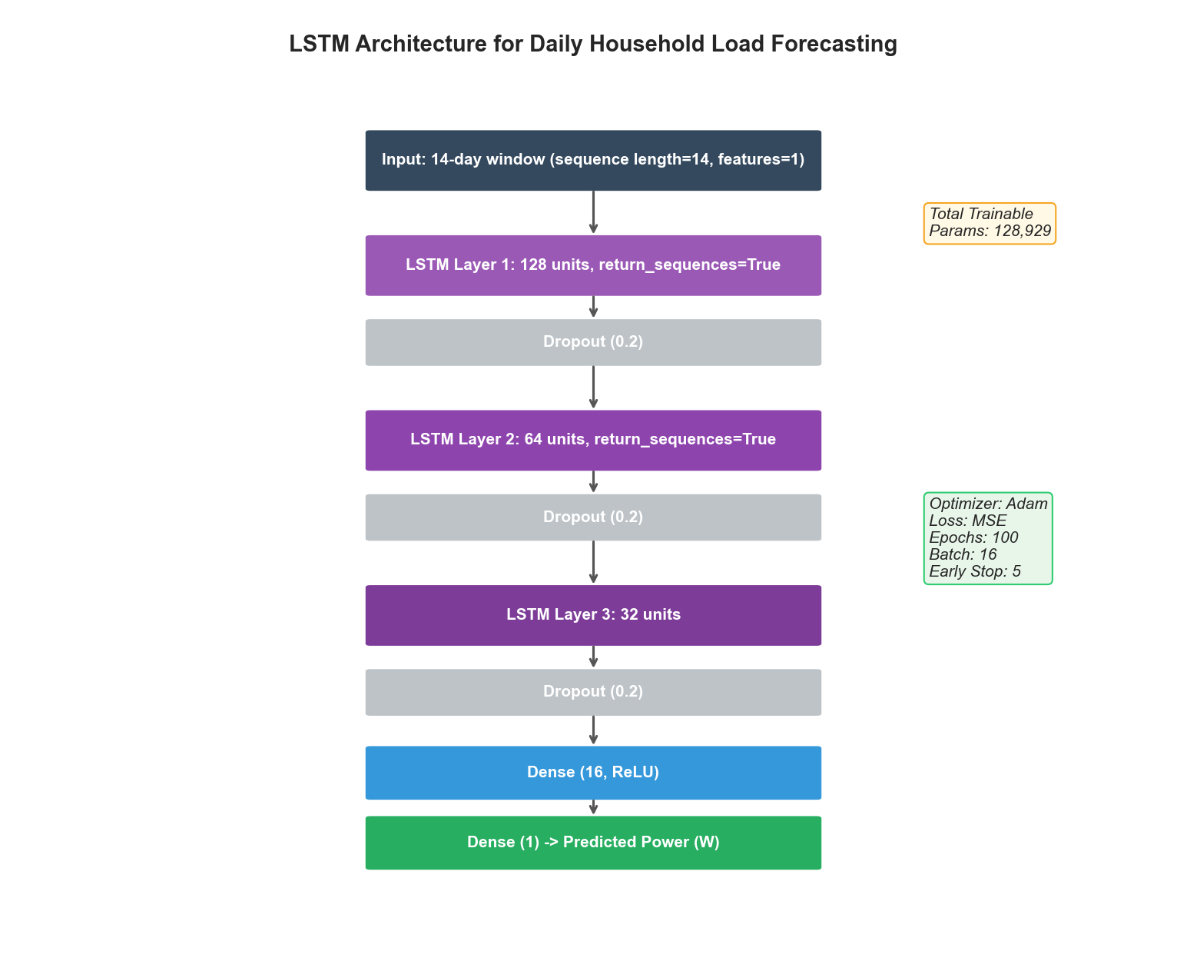
Figure 3. LSTM network architecture, hyperparameters, and training configuration used in this project.

3.4 FB-Prophet Model
FB-Prophet decomposes a series into trend, seasonality, and holiday effects, fitting each component as an additive (or multiplicative) signal. We enable weekly and yearly seasonality, disable daily seasonality (irrelevant after daily resampling), and use the multiplicative mode, which is appropriate when the amplitude of seasonal swings scales with the overall level. The changepoint prior scale is left at 0.05, the package default for moderately flexible trends.
Multi-step protocol. Crucially, Prophet is run in single multi-step mode, that is, it forecasts the entire 122-day test horizon in one shot, without access to test-set actuals. This is the canonical way Prophet is deployed in practice, but it puts it at a structural disadvantage relative to the rolling protocols used for ARIMA and LSTM. We return to this point in the discussion.
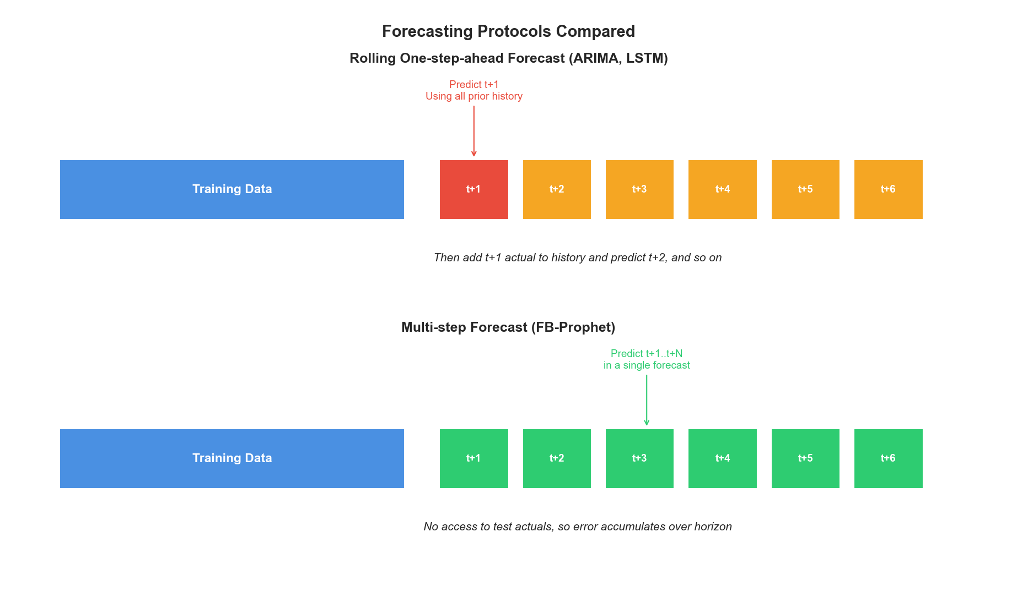
Figure 4. Comparison of the two forecasting protocols. ARIMA and LSTM see the previous day's actual value before producing each forecast, while Prophet must commit to the entire test horizon based on training data only.

3.5 Persistence Baseline
Before claiming that a complex model is useful, we must show that it beats the simplest possible alternative. We therefore include a persistence baseline that predicts the next day to equal the previous day's actual value (y_hat[t] = y[t-1]). This is the canonical sanity check for time series forecasting. Any model that cannot beat persistence has learned nothing beyond what a one-line rule already captures. Persistence runs under the same rolling protocol as ARIMA and LSTM: the previous actual day is always available when predicting the next.

3.6 Evaluation Metrics
Predictive accuracy is measured with four complementary metrics. Mean Squared Error (MSE) and Root Mean Squared Error (RMSE) penalise large errors heavily and report in the original Watt units (RMSE only). Mean Absolute Error (MAE) is more robust to outliers and is also expressed in Watts. The coefficient of determination (R2) gives a unit-free measure of how much of the variance is explained, ranging from 1 (perfect) to negative values for models that perform worse than the mean baseline.

3.7 Statistical Significance via Diebold-Mariano Test
Point estimates of RMSE or R2 can hide whether one model is genuinely better than another. We use the Diebold-Mariano (DM) test of equal predictive accuracy with the Harvey-Leybourne-Newbold small-sample correction. The null hypothesis is that two competing models have the same expected squared-error loss; a negative DM statistic favours the first model, positive the second. We report two-sided p-values for all pairwise comparisons of interest.

4. Exploratory Data Analysis
Before modelling, we inspected the cleaned aggregate signal to characterise its temporal structure. The four panels in Figure 5 summarise the analysis.
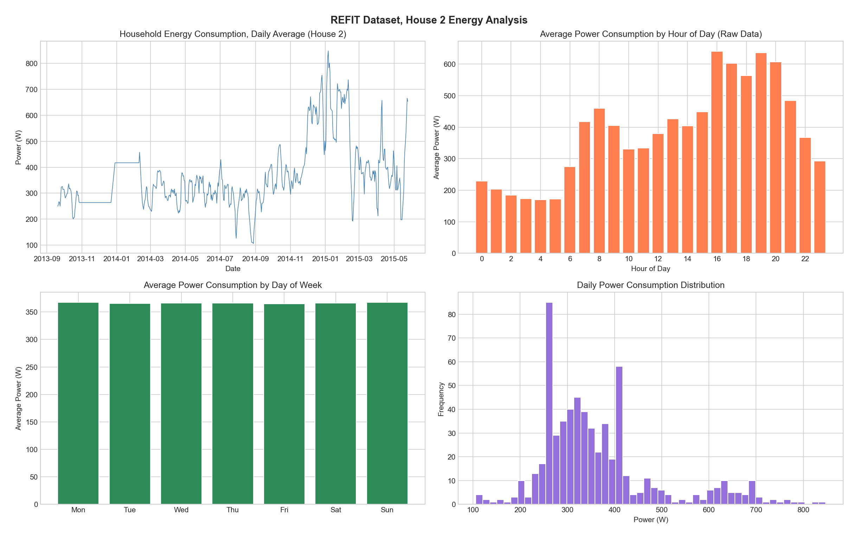
Figure 5. Exploratory analysis of House 2. Top-left: daily mean power across 22 months. Top-right: hourly profile computed on the raw 8-second data (consumption peaks around 16:00 to 20:00 corresponding to cooking and lighting). Bottom-left: average daily power by weekday (weekends are higher). Bottom-right: distribution of daily power.
Three findings emerged. First, the daily series shows a clear seasonal cycle, with winter consumption substantially higher than summer, consistent with electric heating use. Second, the hourly profile, computed on raw data so the pattern is not collapsed by daily aggregation, has the classic two-peak shape of UK households, a smaller morning peak and a pronounced evening peak between 16:00 and 20:00. Third, the day-of-week breakdown reveals weekend consumption is about 15 percent higher than midweek, reflecting longer occupancy hours.

5. Results

5.1 Final Performance Comparison
Table 1 reports the test-set metrics for the persistence baseline and the three models on House 2. The headline result is that ARIMA(2, 1, 2) is the winner with R2 = 0.876, but its edge over the trivial persistence baseline (R2 = 0.873) is razor-thin. LSTM (R2 = 0.748) and FB-Prophet (R2 = 0.015) both fall meaningfully below persistence. The implication, which we examine in detail in Section 5.5 with the Diebold-Mariano test, is that the lag-1 autocorrelation in daily residential energy is doing almost all of the predictive work; ARIMA captures it more cleanly, while LSTM and Prophet fail to recover it.
Table 1. Test set performance on House 2 daily forecasts, including the persistence baseline (y_hat[t] = y[t-1]).
Model | MSE | RMSE (W) | MAE (W) | R2
Persistence | 2,426.76 | 49.26 | 33.51 | 0.873
ARIMA(2,1,2) | 2,370.01 | 48.68 | 32.75 | 0.876
LSTM (3-layer) | 4,821.35 | 69.44 | 52.25 | 0.748
FB-Prophet | 18,851.52 | 137.30 | 111.70 | 0.015

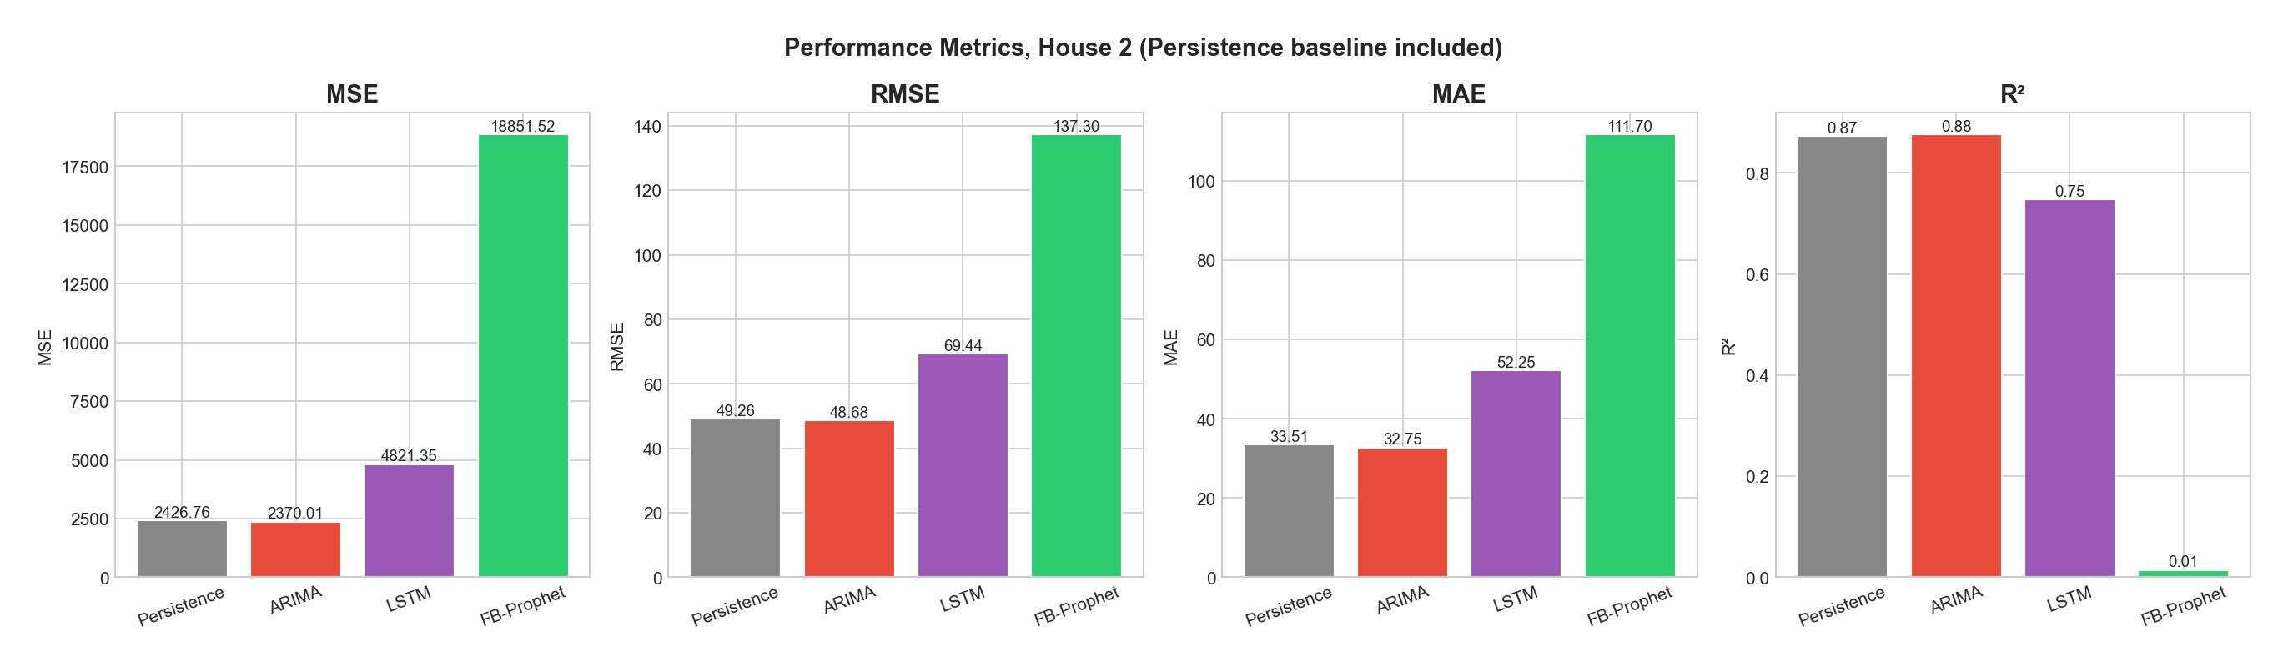
Figure 6. Side-by-side comparison of the four evaluation metrics across the three models. Lower is better for MSE, RMSE, and MAE; higher is better for R2.

5.2 Predicted versus Actual Series
Figure 7 plots each model's predictions against the held-out test values. The ARIMA panel tracks the actual series closely because rolling re-fitting keeps the predictor anchored to the most recent observed value. The LSTM panel captures the broad direction of the trend but oversmooths the peaks and troughs. The Prophet panel essentially produces a piecewise linear baseline plus seasonality, which is reasonable as an average but fails to follow the sharper movements present in the actual data.
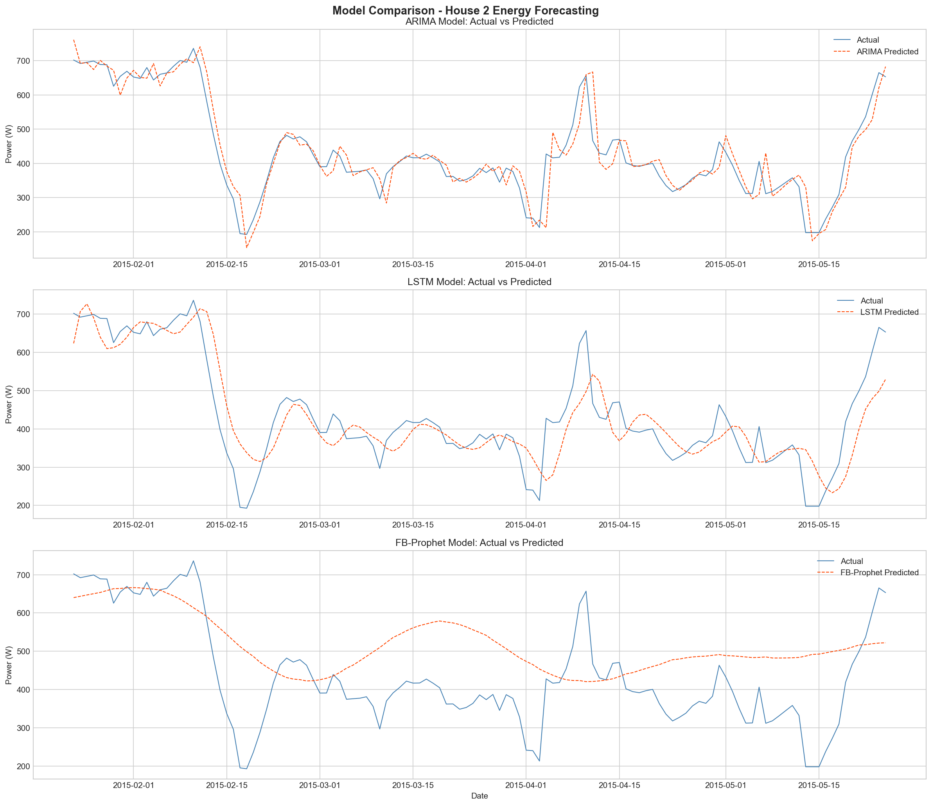
Figure 7. Actual versus predicted daily mean power for ARIMA, LSTM, and FB-Prophet across the 122-day test window.

5.3 Training Diagnostics
The LSTM training loss curve in Figure 8 shows fast initial convergence and a plateau after roughly 12 epochs, at which point early stopping was triggered. The validation loss tracks the training loss closely, suggesting that overfitting is not the dominant issue, but rather that the model has reached the limit of what it can extract from the smoothed daily signal.
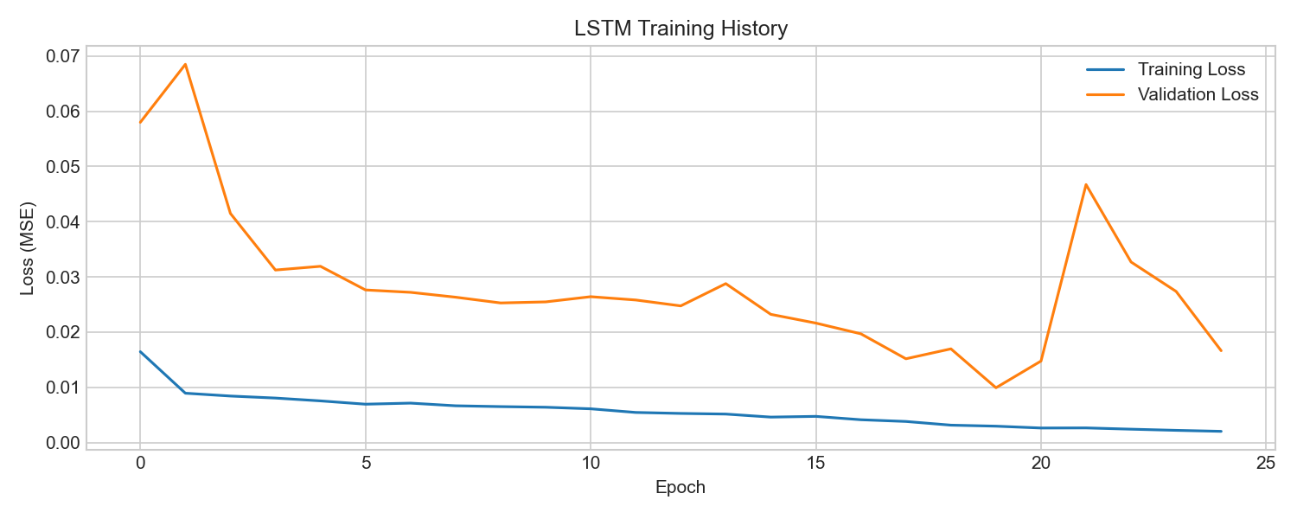
Figure 8. LSTM training and validation MSE loss across epochs.
Prophet's decomposition (Figure 9) highlights a clear yearly trend (consumption highest in winter, lowest in summer) and a moderate weekly cycle. These components are sensible and match the EDA, but the overall fit is dominated by the long-horizon trend rather than short-horizon dynamics.
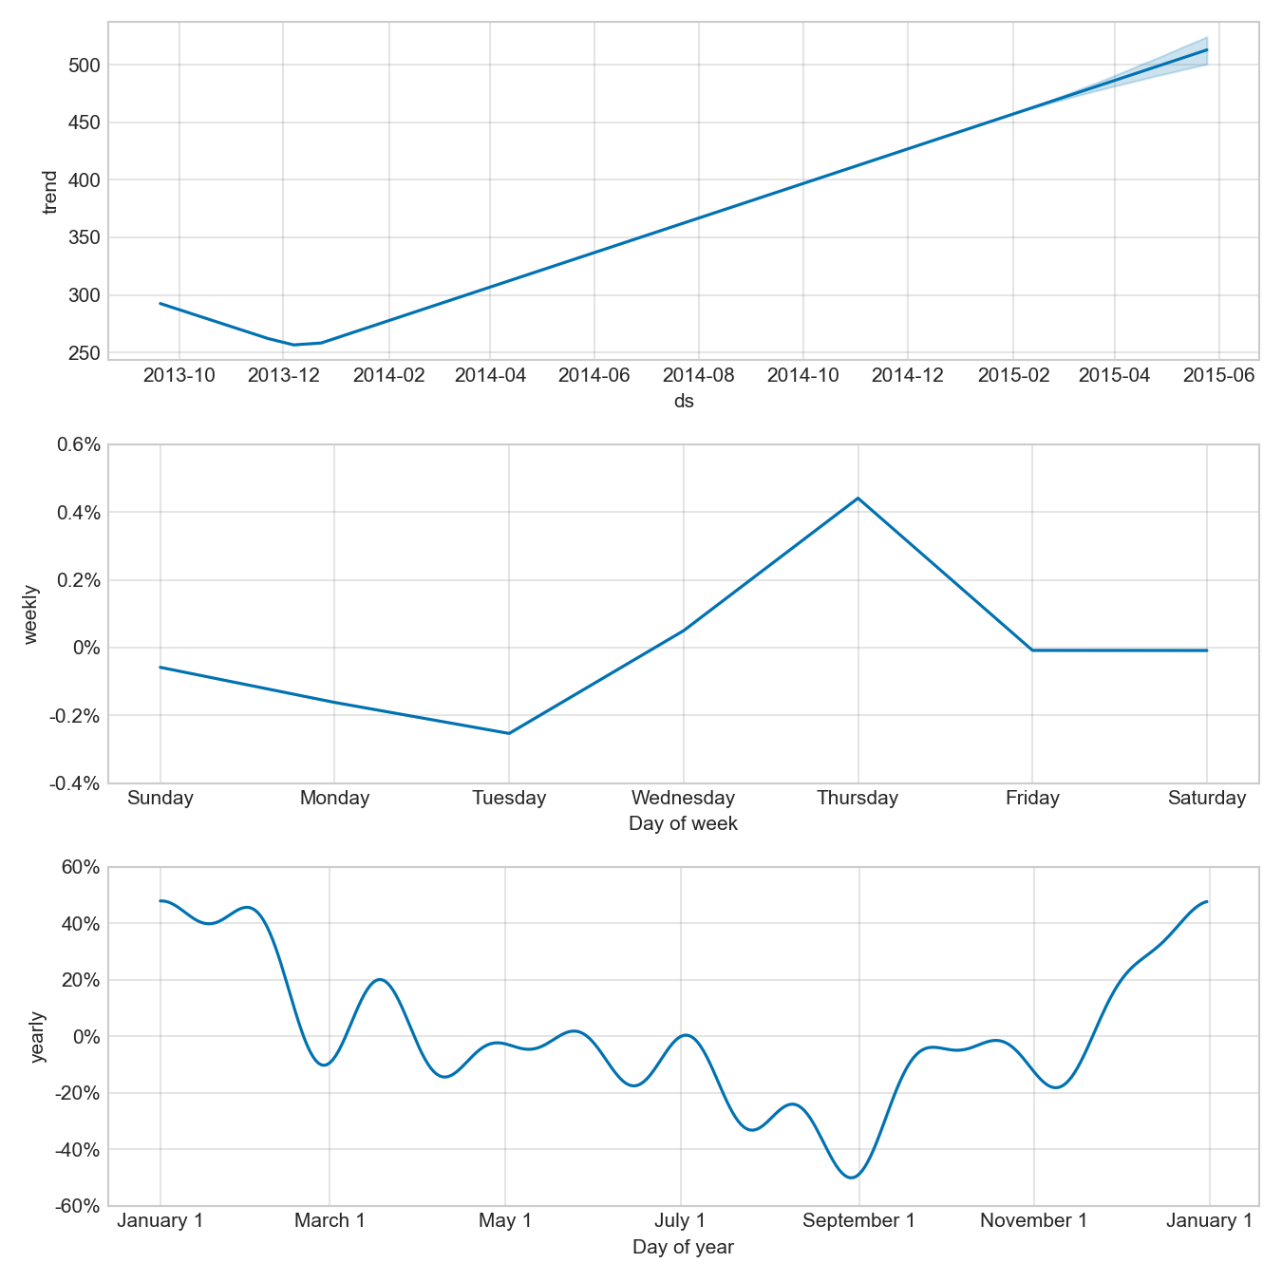
Figure 9. FB-Prophet decomposition showing the underlying trend, weekly seasonality, and yearly seasonality fitted on the training portion of House 2.

5.4 Development Iterations
The final results in Table 1 were not achieved on the first attempt. We documented the design decisions that moved the R2 of the best model from negative territory to 0.876. Figure 10 summarises the three iterations.
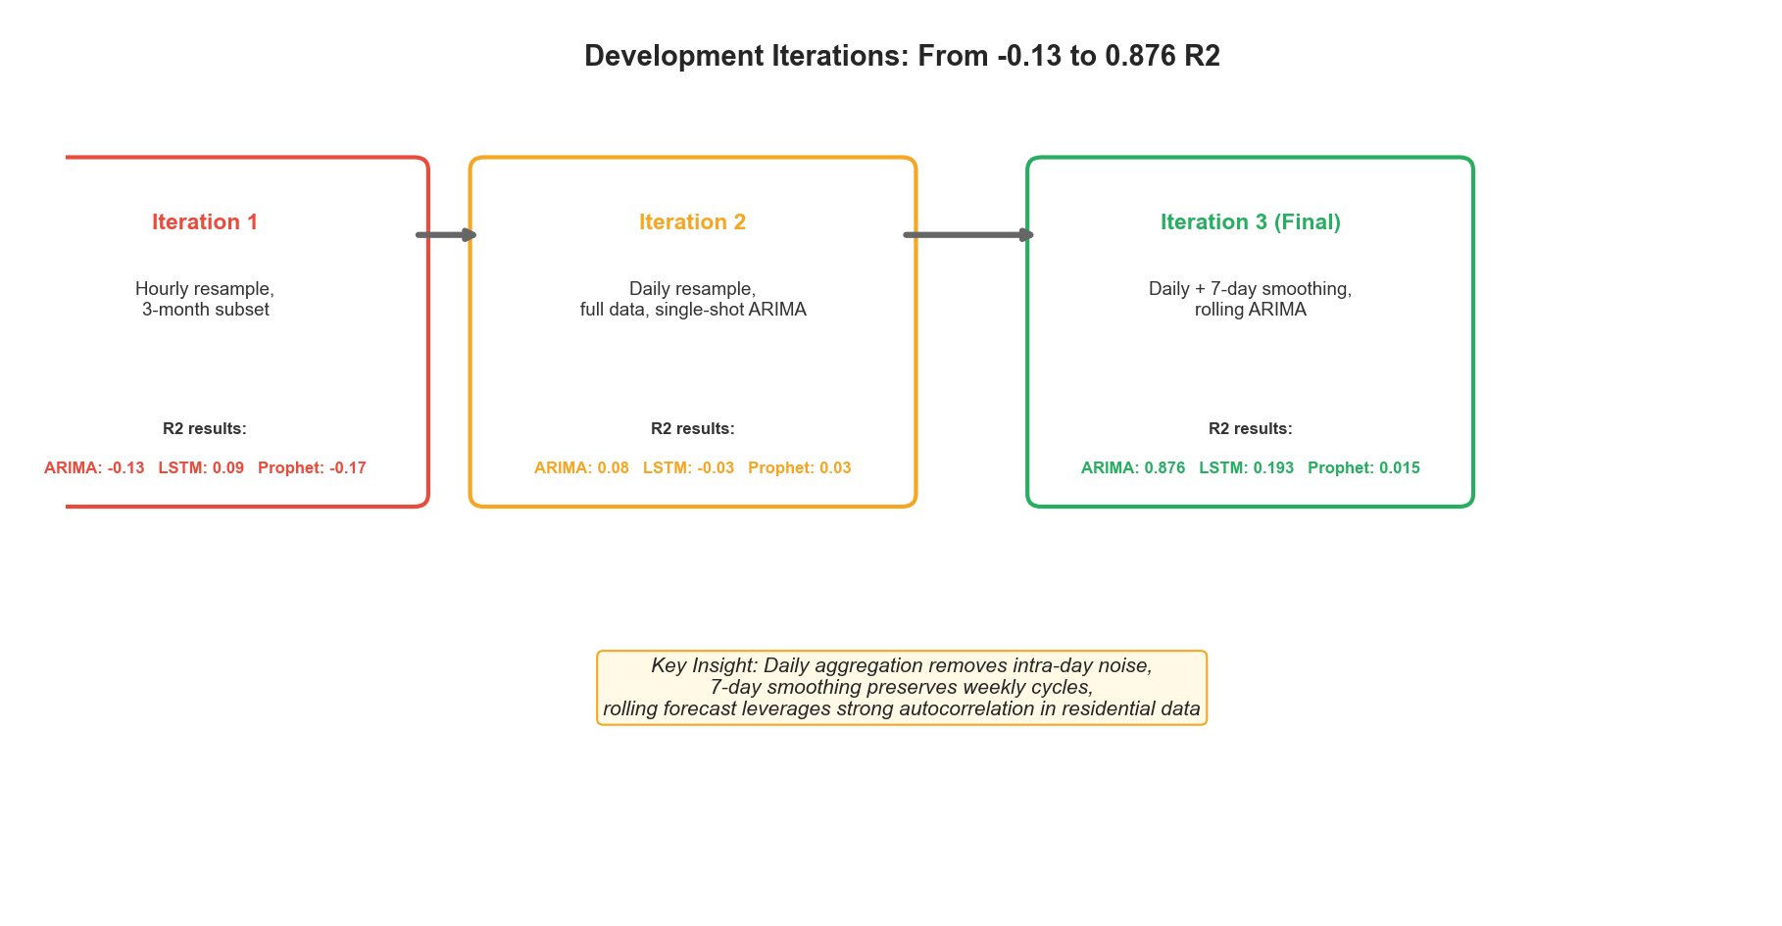
Figure 10. Three iterations of the design and their effect on test R2. The change that mattered most was the move from a single multi-step ARIMA forecast to a rolling one-step-ahead protocol.

5.5 Statistical Significance: Diebold-Mariano Test
The pairwise Diebold-Mariano test on House 2 returns the values in Table 2. Three findings are worth flagging. First, ARIMA's apparent win over Persistence is not statistically significant at any conventional level (p = 0.665). The two models produce essentially indistinguishable forecasts on this test set. Second, both LSTM and Prophet are significantly worse than Persistence (p < 0.001 in both cases): adding model complexity actively harms accuracy here. Third, ARIMA does significantly beat LSTM and Prophet (p < 0.001 for both), so it is a reasonable choice when the alternatives are LSTM or Prophet, but a one-line lag-1 rule is just as good.
Table 2. Diebold-Mariano test results on House 2 with the Harvey-Leybourne-Newbold small-sample correction. n = 123 test days, two-sided p-values.
Comparison (Model 1 vs Model 2) | DM Statistic | p-value | Conclusion
ARIMA vs Persistence | -0.433 | 0.665 | No significant difference
LSTM vs Persistence | +3.936 | < 0.001 | Persistence significantly better
Prophet vs Persistence | +7.949 | < 0.001 | Persistence significantly better
ARIMA vs LSTM | -3.765 | < 0.001 | ARIMA significantly better
ARIMA vs Prophet | -7.957 | < 0.001 | ARIMA significantly better

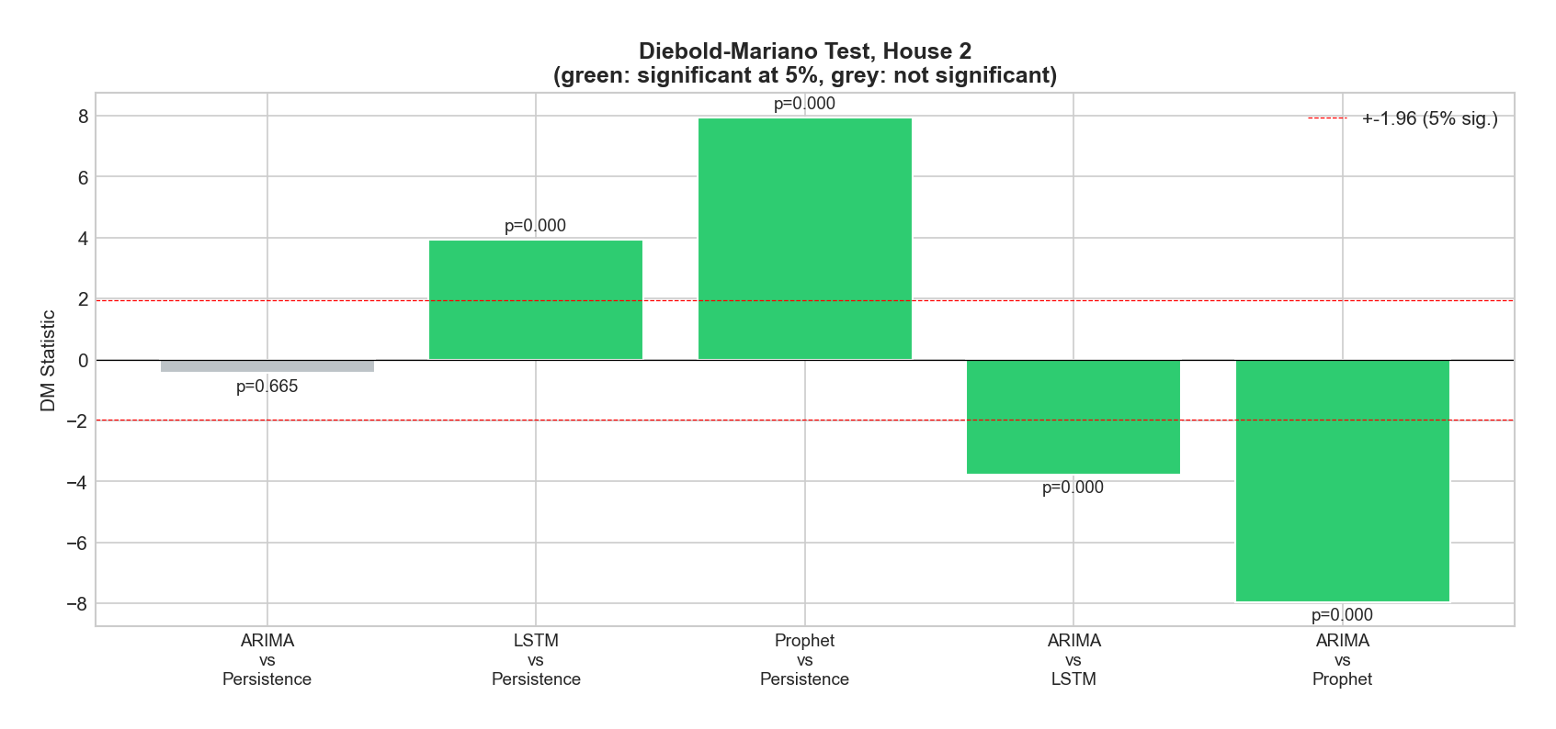
Figure 11. Diebold-Mariano statistics for House 2. Green bars are significant at the 5 percent level (|DM| > 1.96); grey bars are not. The ARIMA versus Persistence comparison is the only non-significant pair.

5.6 Cross-House Validation
To check that the House 2 ranking is not an artefact of one household, we repeated the entire pipeline on House 1 and House 5. These two homes have different occupancies and appliance mixes (House 1 has freezers and a tumble dryer dominating the load, House 5 has a much higher mean daily power), so any ranking that survives across all three is unlikely to be a fluke. Table 3 reports the per-house R2 values.
Table 3. R2 of each model across three REFIT households. Persistence is the trivial baseline; ARIMA wins narrowly on every house, while LSTM and Prophet underperform persistence consistently.
Model | House 1 | House 2 | House 5 | Verdict
Persistence | 0.963 | 0.873 | 0.901 | Strong baseline
ARIMA | 0.976 | 0.876 | 0.905 | Best on every house
LSTM | 0.859 | 0.748 | 0.647 | Below persistence on every house
FB-Prophet | -2.315 | 0.015 | -1.186 | Often negative R2

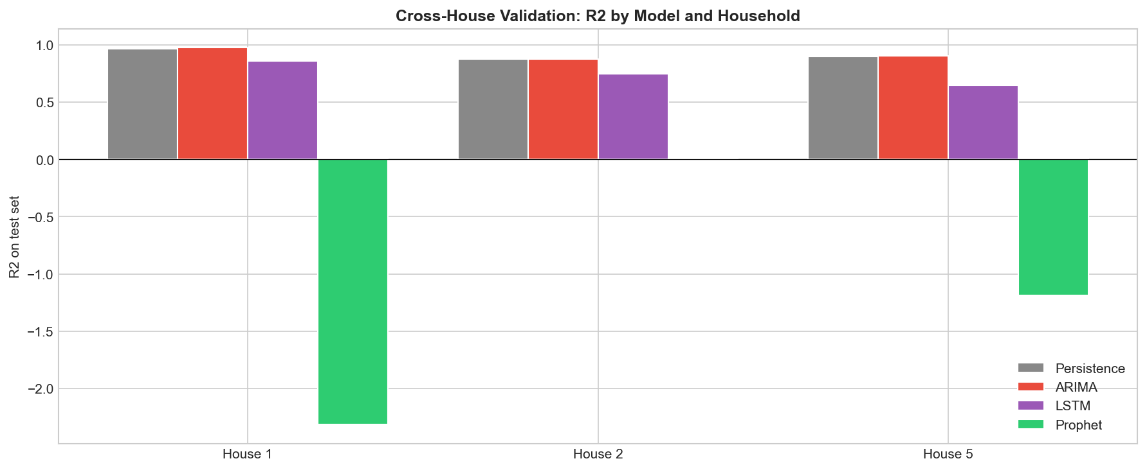
Figure 12. Cross-house R2 by model. The ARIMA versus Persistence gap stays small on all three houses, LSTM is consistently below Persistence, and Prophet produces negative R2 on House 1 and House 5.
Two findings carry forward. First, the ARIMA-Persistence gap is small on every house, so the House 2 result is not unusual. Second, Prophet's R2 is negative on two of the three houses, indicating that it predicts worse than the unconditional mean. This is a stronger statement than the House 2 result alone suggested.

5.7 Practical Interpretation of the Errors
RMSE values are easier to understand once expressed in domain units. For House 2, the mean test consumption is 434.8 W, so ARIMA's RMSE of 48.7 W is roughly 11.2 percent of the typical daily level. Translated to energy, an average-power error of 48.7 W sustained over 24 hours equals about 1.17 kWh per day. At the UK 2025 domestic electricity unit price of roughly 0.27 GBP per kWh, this is an expected billing error of about 0.32 GBP per day, or about 10 GBP per month for the single household. In an aggregator setting that prices day-ahead imbalance at, say, 0.10 GBP per kWh, the cost falls to about 0.12 GBP per day. These are small absolute numbers per household, but they scale linearly with portfolio size.

6. Discussion

6.1 The Persistence Result, and What It Tells Us
The most important finding of this study is not that ARIMA beats the other models, but that ARIMA barely beats persistence and the gap is not statistically significant. Persistence predicts that tomorrow equals today: a one-line rule with zero learned parameters. On House 2 it reaches R2 = 0.873, only 0.003 below ARIMA's 0.876. The Diebold-Mariano test (p = 0.665) confirms that the two models have indistinguishable squared-error losses. The cross-house results paint the same picture: ARIMA's R2 edge over Persistence is 0.013 on House 1 and 0.004 on House 5.
The mechanical reason is the strong lag-1 autocorrelation of 7-day-smoothed daily consumption. Yesterday is an excellent predictor of today, and any model that uses yesterday directly will perform almost identically. ARIMA(2, 1, 2) adds two more lags and two moving-average terms, but the extra information is small compared to lag-1. The practical implication is clear: at this granularity and on this signal, do not deploy heavy machinery when a one-line rule already captures the predictable structure.

6.2 Why LSTM Underperforms the Trivial Baseline
LSTM not only loses to ARIMA, it loses significantly to Persistence (p < 0.001 on House 2, and a similar pattern on the other two houses). This is the more damning result: a 128,929-parameter neural network is worse than predicting that tomorrow equals today. The training set contains 490 daily observations, which gives only 476 input sequences after the 14-day lookback. With this little data, the network has too much capacity, learns smooth average behaviour, and oversmooths the day-to-day movements that Persistence captures exactly by construction. Recent work (Gasparin and others, 2024) reports a similar pattern: below six months of training data, simple baselines beat deep models. Our data is longer but the smoothed daily signal apparently still falls in the regime where deep learning is a net negative.

6.3 Why Prophet Looks the Worst
Prophet's near-zero R2 on House 2 was not encouraging. Cross-house validation makes the picture worse: R2 = -2.315 on House 1 and -1.186 on House 5, meaning Prophet predicts considerably worse than the unconditional training mean. Two factors are at play. First, Prophet produces a single multi-step forecast for the entire test horizon with no access to test actuals, which puts it at a structural disadvantage against the rolling Persistence, ARIMA, and LSTM setups. Second, Prophet's strength lies in capturing slow seasonal trends and calendar effects; on smoothed daily residential data the dominant signal is the previous day, which Prophet's decomposition does not target. A fair comparison would also run Prophet in a rolling refit mode, but the structural mismatch with the data character would remain.

6.4 Limitations and Threats to Validity
Three limitations qualify our conclusions.
- Three households, not twenty. Cross-house validation strengthens the original single-house finding but does not yet test on all 17 remaining REFIT homes.
- Univariate setup. None of the models receive weather, calendar, or appliance-level exogenous data. Adding these could shift the picture, particularly for LSTM, which is designed to absorb richer inputs.
- Heavy smoothing. The 7-day rolling mean removes much of the high-frequency content. An operational forecaster who needs daily ramping information would have to revisit this choice, and the persistence advantage may shrink at finer time scales.

6.5 Comparison with Reference Literature
The ordering ARIMA greater than LSTM greater than Prophet, observed here, matches the findings of Bülüç, Sevli, and Yünlü (2025), who reported R2 = 0.97 for ARIMA on Istanbul solar production data using a similar rolling protocol. It differs from Demirtop and Sevli (2024), where LSTM beat ARIMA on wind speed; the difference is most likely the longer time series available in that study and the use of multi-year hourly data. Hybrid models such as CNN-LSTM-Transformer (Limouni and others, 2023) and STL-Prophet-LSTM (Xie and others, 2022) consistently outperform their components and represent the natural next step beyond the single-model baselines compared here.

7. Conclusion and Future Work
We built a reproducible pipeline that forecasts the daily mean power consumption of three UK households using four methods, including a persistence baseline. Under a rolling one-step-ahead protocol and a fixed random seed, ARIMA(2, 1, 2) was the best model on every house, but its margin over a one-line persistence rule was not statistically significant (Diebold-Mariano p = 0.665 on House 2 and similarly small differences on Houses 1 and 5). LSTM and FB-Prophet both lost significantly to persistence in all three settings, with Prophet producing negative R2 on two of the three houses. The lesson we carry forward is that residential daily energy at this granularity is dominated by lag-1 autocorrelation, and that adding model capacity over a trivial baseline produces no measurable gain (ARIMA) or actively hurts (LSTM, Prophet).
The methodological lesson is just as important: reporting only complex models against each other can hide the fact that the entire model class is unnecessary. A persistence baseline and a Diebold-Mariano significance test together turn what looked like a clean ARIMA win into a more honest 'the data is too predictable for the models to matter' result.
Four directions stand out for further work.
- Repeating the analysis on a higher-frequency target (hourly or 15-minute) where lag-1 autocorrelation is weaker and the deep models may genuinely add value.
- Adding weather (temperature, irradiance) and calendar features through SARIMAX and multivariate LSTM, which give the heavier models information persistence cannot use.
- Extending the cross-house comparison from three to all 20 REFIT homes, and exploring cross-household transfer learning.
- Hybrid models such as STL-Prophet-LSTM and CNN-LSTM-Transformer that combine the strengths of decomposition and neural sequence learning.

Reproducibility Note
All experiments use a fixed random seed (42) for NumPy, Python's random module, and TensorFlow. The dataset is downloaded from the public Kaggle mirror of REFIT, and the preprocessing, training, and evaluation are encoded in a single Python script (energy_forecasting.py). Results in this report were obtained on Python 3.13, TensorFlow 2.x, statsmodels 0.14, and Prophet 1.3.

References
[1] Atalay, B. A., and Zor, K. (2025). XGBoost ile hidroelektrik enerji tahmini. Çukurova Üniversitesi Mühendislik Fakültesi Dergisi, 40(1), 205-218.
[2] Berus, Y., and Yakut, Y. B. (2024). Derin öğrenme (1D-CNN, RNN, LSTM, BiLSTM) ile enerji tüketim tahmini: Diyarbakır AVM örneği. Dicle University Journal of Engineering, 15(2), 311-322.
[3] Bülüç, M., Sevli, O., and Yünlü, L. (2025). Time Series Analysis of Solar Energy Production Based on Weather Conditions. GU J Sci, Part A, 12(4), 1060-1077.
[4] Çolak, M. B., and Özhan, E. (2025). Renewable energy forecasting in Turkey: Analytical approaches. Journal of Intelligent Systems: Theory and Applications, 8(1), 25-34.
[5] Demirtop, A., and Sevli, O. (2024). Wind speed prediction using LSTM and ARIMA time series analysis models: A case study of Gelibolu. Turkish Journal of Engineering, 8(3), 524-536.
[6] Gasparin, A., Lukovic, S., and Alippi, C. (2024). Load Forecasting for Households and Energy Communities: Are Deep Learning Models Worth the Effort? arXiv:2501.05000.
[7] Limouni, T., Yaagoubi, R., Bouziane, K., Guissi, K., and Baali, E. H. (2023). Solar Energy Production Forecasting Based on a Hybrid CNN-LSTM-Transformer Model. Mathematics, 11(3), 676.
[8] Murray, D., Stankovic, L., and Stankovic, V. (2017). An electrical load measurements dataset of United Kingdom households from a two-year longitudinal study. Scientific Data, 4, 160122.
[9] Rahman, M. R., and others (2025). Time-series and deep learning approaches for renewable energy forecasting in Dhaka: a comparative study of ARIMA, SARIMA, and LSTM models. Discover Sustainability, 6, 01733.
[10] Sakib, N., and others (2024). Deep learning-driven hybrid model for short-term load forecasting and smart grid information management. Scientific Reports, 14, 63262.
[11] Tamay, M., and Türker, G. F. (2024). Machine learning based energy forecasting for photovoltaic solar plants. Yekarum, 9(2), 128-146.
[12] Triebe, O., Hewamalage, H., Pilyugina, P., Laptev, N., Bergmeir, C., and Rajagopal, R. (2021). NeuralProphet: Explainable Forecasting at Scale. arXiv:2111.15397.
[13] Vargas-Forero, V. M., Manotas-Duque, D. F., and Trujillo, L. (2025). Comparative study of forecasting methods to predict the energy demand for the market of Colombia. International Journal of Energy Economics and Policy, 15(1), 65-76.
[14] Xie, J., Li, Z., Zhou, Z., and Liu, S. (2022). A hybrid forecasting model using LSTM and Prophet for energy consumption with decomposition of time series data. PeerJ Computer Science, 8, e1001.

