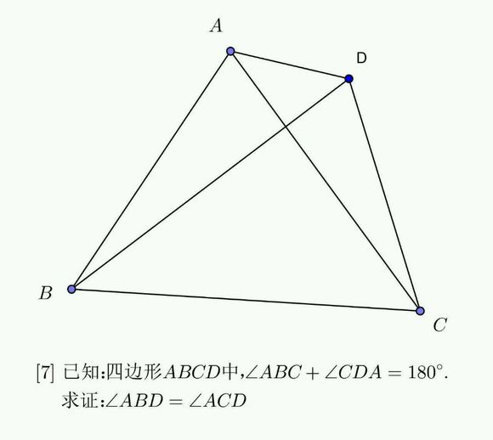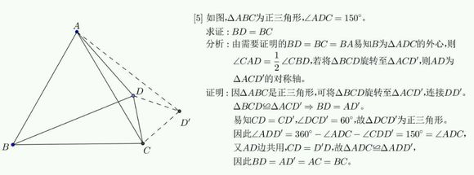

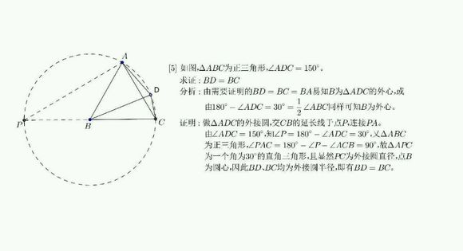

对于任意三角形，任何一边的[平方](http://baike.baidu.com/item/%E5%B9%B3%E6%96%B9)等于其他两边平方的和减去这两边与它们夹角的余弦的两倍积，若三边为a，b，c 三角为A，B，C ，则满足性质——

https://imgsa.baidu.com/baike/s%3D158/sign=8a05aab0d62a283447a6320e63b4c92e/a2cc7cd98d1001e9d35daea2ba0e7bec54e7973e.jpghttps://imgsa.baidu.com/baike/s%3D162/sign=1a74c50df403738dda4a0824811ab073/503d269759ee3d6df68e3d6641166d224e4aded7.jpghttps://imgsa.baidu.com/baike/s%3D160/sign=aeb6739e9045d688a702b6a294c37dab/b219ebc4b74543a9ef6d40611c178a82b901142c.jpg

https://imgsa.baidu.com/baike/s%3D136/sign=aa2479b9ba99a9013f355f352b940a58/f31fbe096b63f624de749cae8544ebf81a4ca376.jpghttps://imgsa.baidu.com/baike/s%3D135/sign=6125cc8b6f224f4a539977103cf69044/11385343fbf2b21140cd3fe3c88065380dd78eb8.jpghttps://imgsa.baidu.com/baike/s%3D137/sign=2ad7b45a9d3df8dca23d8b92fa1072bf/43a7d933c895d143f7535e8e71f082025aaf0771.jpg

正弦定理：在一个三角形中，各边和它所对角的正弦的比相等，并且都等于该三角形外接圆的直径，即：http://ziyuan.wmw.cn/BD/beida/FileLibrary/directions/g1k3sxb443aa01/g1k3sxb443aa01.files/image004.gif=http://ziyuan.wmw.cn/BD/beida/FileLibrary/directions/g1k3sxb443aa01/g1k3sxb443aa01.files/image006.gif=http://ziyuan.wmw.cn/BD/beida/FileLibrary/directions/g1k3sxb443aa01/g1k3sxb443aa01.files/image008.gif=2R