Data Storytelling for Interactive Decision Analytics: A Web-Based Multi-Dataset Sales Dashboard

Rathanala Sai Charan, Sambu. Sai Rishik, Dasari Sujay, K Sai Teja

Department Of Computer Science and Engineering. Koneru Lakshmaiah Education Foundation, Bowrampet , Hyderabad- 500043, Telangana, India.

Data Analytic and Visualization Project Research Paper
ABSTRACT
Organisations with operations across several sales channels often store transactional data in separate spreadsheets and point-of-sale extracts, which can make it challenging for non-technical stakeholders to interpret raw figures and make decisions. This project aims to bridge that gap by developing an interactive, web-based dashboard called "Data Storytelling for Interactive Decision Analytics." The dashboard combines four publicly available retail sales datasets Superstore, Global Superstore, Online Sales, and a Supermarket dataset within a unified decision-support platform. The system uses a structured workflow that includes data loading preprocessing feature engineering, KPI calculation, interactive filtering visualization data storytelling, and decision analytics. Implementation relies on Python, Pandas, Flask, Plotly, HTML, CSS, and JavaScript. Each dataset is handled as an independently selectable, dataset-aware analytical context, rather than being merged into a single schema. The dashboard describes KPIstotal sales, total profit, total orders, total quantity, total customers, and profit marginwith category region segment, and product-level visual explanations, and structured narratives in the FindingMeaningDecisionRecommendation system. A parallel Decision Analytics section applies the same setup to recurring business questions such as discounting and category performance. Validated results from each of the project's four datasets (e.g. about 7.42 million total sales for Superstore and about 12.64 million total sales for Global Superstore) demonstrate that the descriptive pipeline functions correctly with datasets of different magnitude and structure. Building on this descriptive foundation, the project has been extended with a comparative sales-prediction component: four literature-inspired regression models (Linear Regression, Decision Tree Regressor, Random Forest Regressor, and Gradient Boosting Regressor) are trained and evaluated under identical data preparation and performance evaluation conditions, and their base-model predictions are combined through a meta-learning stage in the proposed Hybrid Stacked Regression Ensemble (HSRE), which is compared against each individual baseline model. Across the four evaluated datasets, predictive performance varied by dataset and evaluation metric. Linear Regression achieved the highest R and lowest RMSE on the Superstore dataset, while Random Forest achieved the lowest MAE. Gradient Boosting performed best across all three reported metrics on the Global Superstore dataset. The proposed Hybrid Stacked Regression Ensemble (HSRE) achieved the highest R and lowest RMSE on the Online Sales and Supermarket datasets, although other models achieved lower MAE on these datasets. These results demonstrate the importance of evaluating multiple regression models across different datasets rather than assuming that one model will consistently perform best.
Keywords: data storytelling; decision analytics; interactive dashboard; business analytics; data visualization; key performance indicators; exploratory data analysis; visual analytics; sales prediction; regression; ensemble learning; stacked generalization; hybrid machine learning; Flask; Plotly; Scikit-learn..
1. INTRODUCTION
1.1 Background
Retail and e-commerce businesses have customer transactions coming in constantly orders quantities discounts, shipping records, customer IDs data that's simple on the individual level but meaningless when combined without context. Relying on static spreadsheets or grouped summary reports, smaller, and mid-sized business reporting still only produces numbers, and very little guidance on how they fit into the overall big picture [1]. The fields of visual analytics and data storytelling have argued for a decade that visualization must be paired with meaningful interpretation to be useful: people need to know why what they are seeing is important, and what actions to take, [2]. This project combines these two issues: I have developed a dashboard combining several separate datasets of retail sales figures, and a guided process of interpretive, decision-oriented storytelling, which sits on top of simple "what the data says" visualizations to drive towards "what can be done. "
1.2 Problem Statement
This is the class of problem familiar to business users who view dashboards showing graphs and key performance indicators but who are responsible for interpreting the meaning of those graphs themselves. When hundreds of datasets with different schemas, fields, and ranges of granularity must be compared over an analysis session, this problem is exacerbated: analysts either elevate the datasets to an artificially common schema that obfuscates differences, or they split them into disconnected reports that are difficult to compare. There is, in practice, an appetite for a single interactive system that (a) is capable of reasoning about a priori unrelated sales datasets without creating false facts, and (b) translates the graphics and figures it produces into explicit and repeatedly expressed narrative that persuades a business decision. The fundamental research question of this paper because of this involves designing a system that can support both exploratory visual analysis and structured storytelling, while remaining faithful to the contents of each underlying dataset.
1.3 Research Gap
Gap 1 — Interactive Analytics and Storytelling
Literature survey existing literature offers very good guidance for visualization dashboards visual analytics, data storytelling and decision support based on business intelligence (Section 2). Though, review of this literature and existing tools reveals some common, implementation-level limitations. First, many dashboards both commercial and academic, are designed around exploration and visualization but lack the explicit storytelling layer linking results to recommendations [3]. Second, studies in narrative visualization have mainly addressed journalism and one-off, author-driven data stories and not reusable, dataset-driven decision-support dashboards [1], [2]. Third, systems that explicitly support the integration of multiple datasets mostly assume a single schema that represents the source datasets (e. g. in the example, a system assuming every dataset has a date field) which is a false assumption in practice and this is rarely explicitly communicated to the users. Fourth, only very few real projects demonstrate how filters, KPIs, and visualizations should behave differently based on which dataset is loaded, which should be combined with a story-driven Finding Meaning Decision Recommendation layer, and combined with a decision-analytics engine within a practical dashboard..
Gap 2 — Predictive Comparative Analysis
The second related gap is prediction. Current sales prediction literature (Section 2. 8) often compares individual regression or ensemble learners (Linear Regression, Decision Tree, Random Forest, Gradient Boosting) but evaluates them in an isolated manner on a single data set with study specific data-processing and prediction evaluation choices that complicate direct model-to-model comparisons. Our project could undertake a comparative comparison of the literature-based regression models with uniform data preprocessing and evaluation choices on the sales data set, and add a proposed hybrid stacked ensemble that meta-learns the literature-based regressions as upper-layer learners and evaluates it versus each of the literature-based regressions in turn under uniform conditions. The project directly addresses both gaps: Gap 1 by designing the dataset-aware interactive system, with its explicit Finding Meaning Decision Recommendation storytelling structure and a parallel decision-analytics module (Sections 3. 13. 10), and Gap 2 by applying the comparative literature-based versus-HSRE regression setup of Section 3. 1
1.4 Research Objectives
- To design and implement an interactive web-based dashboard that integrates four structurally different retail sales datasets (Superstore, Global Superstore, Online Sales, and Supermarket) without fabricating missing fields.
- To build a reproducible data preprocessing and feature-engineering pipeline (cleaning deduplication missing-value handling, date parsing, and derived fields like Year, Month, Quarter, and Profit Margin) that can be applied consistently across the datasets.
- To compute and present a consistent set of descriptive KPIs — Total Sales, Total Profit, Total Orders, Total Quantity, Total Customers, and Profit Margin — for each dataset, while clearly marking KPIs that are not available for a given source.
- To implement dataset-aware interactive filtering (by dataset, year, category, region, and segment) so that the filter options and available views change automatically given, which dataset is selected.
- To translate visual and KPI-level findings into a structured Data Storytelling and Decision Analytics output using a Finding Meaning Decision Recommendation format, so that the dashboard supports decision-making rather than description alone.
- To implement and compare four literature-based regression models (Linear Regression, Decision Tree Regressor, Random Forest Regressor, and Gradient Boosting Regressor) for sales prediction under the same preprocessing and evaluation conditions, and to propose and evaluate a Hybrid Stacked Regression Ensemble (HSRE) that combines these baseline models through a meta-learning stage.
1.5 Research Questions
RQ1: How to merge multiple distinct data sources with different schemas and available columns into a single interactive dashboard, without falsely representing the data available in each source?
RQ2. Which set of KPIs and visualizations (trend category regional product segment, discount-profit, and combinations thereof) best help descriptive insight into the dynamics of retail sales performance in heterogeneous data?
RQ3: How does the dataset-aware interactive filtering affect dashboard consistency and usability when datasets do not share dimensions (i. e. no date field in the Online Sales dataset)?
RQ4: How much does a structured Finding Meaning Decision Recommendation storytelling layer in a descriptive analytics dashboard improve the decision driven actionability versus a collection of charts & KPIs?
RQ5: How does the performance of the ensemble (full text below) a Hybrid Stacked Regression Ensemble (LSRE) between literature based baseline regressors (Linear Regression, Decision Tree, Random Forest, Gradient Boosting) produced via a meta learning stage compare to that of the baseline regressors themselves in predicting sales given the same data (preprocessing, cross validation, evaluation) conditions?
1.6 Contributions
- A pragmatic integration structure and knowledge aggregator for retail sales datasets. Integration of four independent retail sales datasets in a single dashboard maintaining each dataset's fields, categories, and limitations instead of forcing uniform schema.
- A reusable pipeline for preprocessing and feature-engineering (cleaning deduplication converting types, and built new time- and profitability-related features) that is sufficiently documented so it can be used with other data in a follow-up project.
- A clear two-part story structure of Data Storytelling and Decision Analytics (Finding Meaning Decision Recommendation), used throughout all KPIs, category, regional, product, segment, and discount-profit analyses.
- A Working, end-to-end implementation (Python Pandas Flask Plotly HTML/CSS/JavaScript) capable of the demonstration of the system using validated (not fabricated) KPI results from actual dataset processing.
- It consists of: a comparative regression-based sales-prediction component, which considers four literature-based baseline models (Linear Regression, Decision Tree, Random Forest and Gradient Boosting) trained in a same manner with the same data preprocessing; and a proposed Hybrid Stacked Regression Ensemble (HSRE), which integrates the models in a meta-learning way of thinking, with every baseline model, and is tested against each baseline model.
1.7 Organization of the Paper
The remainder of this paper is organized as follows. Section 2 reviews related work in data visualization, visual analytics, narrative visualization, and interactive dashboards, and situates this project relative to that literature. Section 3 describes the proposed methodology, including the datasets, preprocessing pipeline, feature engineering, KPI design, and the storytelling and decision-analytics methods. Section 4 describes the experimental and implementation setup, covering the technology stack, system architecture, dataset integration, dashboard components, and the validation strategy used to check the dashboard's outputs. Section 5 presents the results obtained from processing the four datasets, organized by KPI, category, region, product, segment, and discount-profit analysis, together with representative data stories and decision-analytics narratives. Section 6 discusses the interpretation of these findings, relates them to the reviewed literature, and considers practical implications and unexpected observations. Section 7 states the limitations of the current implementation, and Section 8 concludes the paper and outlines directions for future work.
2. RELATED WORK
This section surveys the literature supporting this project, in six common streams: (i) the development of business intelligence and decision support, (ii) the fundamental body of work related to information visualization and visual analytics, (iii) data storytelling and narrative visualizations, (iv) interface considerations when designing dashboards, (v) the specific open source tooling and libraries that enable browser-based, dataset-driven dashboards to be created and (vi) sales prediction, regression-based prediction, and ensemble/hybrid machine learning, which forms the basis of the comparison prediction element added to the project (Section 3. 11). These six strands collectively encapsulate the work below, as referenced in the paper.
2.1 Existing Approaches to Business Reporting and Decision Support
Previous Business Reporting and Decision Support Technologies Power's history of DSS notes the transition from model-driven and data-driven DSS back in the 1970s and 1980s to interactive, end-user reporting and analysis [10]. Negash's oft-quoted introductory tutorial to BI describes the field as an integration of operations data and analytical tools to inform planners and decision makers, with data warehousing and OLAP as the underpinning technology of first-generation BI [22]. Watson's history of BI describes the field's transition from a technical reporting infrastructure to a wider range of analytic capabilities when talking about ongoing evolution in the field [23]. Drawing on contemporary evidence, studies, and reports, Davenport contends that organizations that embed analytics into strategic decisions have a strategic edge over those that see reporting as a back-office function [24], and the Turban, Sharda, and Delen introductory textbook frames BI and analytics as a sequence from data acquisition, through OLAP and dashboards, to more advanced analyses [25]. L im, Chen, and Chen's research-agenda paper advances this stack to "BI&A 3. 0, " which is characterised by mobile, sensor-enabled, and real-time analytics, and explicitly advocates further research on reporting analytics results to decision makers rather than only reporting how they are generated [26]. These papers argue that BI is notionally always decision-driven but, as noted in section 2. 7, past techniques for tying a computed KPI to a concrete decision have remained implicit a disparity this project aims to rectify.
2.2 Data Visualization / Visual Analytics Approaches
This project takes advantage of the widely studied general area of information visualization, which provided the terminology and design principles for visualizations used here. Tufte's seminal book on the visual display of quantitative information has much advice that is directly relevant, such as the minimisation of the data-ink ratio and the use of simple bar, line, and scatter charts, rather than chart junk [12]. Cleveland's experiments into graphical perception concluded that audiences make more accurate judgments of position and length (used in the bar and trend charts here) than area or colour-intensity (used in the KPI and category views here), which influenced chart type choice [13]. Card, Mackinlay and Shneiderman edited a monograph on information visualization, which can be seen as formalising the typology of transformation step, visual encoding and view transformation that all real-life visualisation tools obey [14]. Ware's text on visual perception explains that colour-coded, multi-segment chartslike the regional donut chart in this dashboardremain readable even with a dozen categories, provided hue and ordering are used consistently [15]. Munzner's design-and-validation setup for visualization supplies the task-abstraction vocabulary (discover compare summarise) used to justify the choice of chart type for each KPI in Section 3. 8 [16]. Shneiderman's task-by-data-type taxonomy and the associated "overview first, zoom, and filter, then details-on-demand" mantra remain a foundational reference for designing interactive views that let a user move from an aggregate KPI to a specific data point [6]. Keim et al. formalised the related field of visual analytics as the combination of automated analysis and interactive visual interfaces to support analytical reasoning on large, heterogeneous datasets [5], and Sacha et al. 's knowledge-generation model further describes visual analytics as an iterative loop between human reasoning and computational processinga loop this dashboard implements at a lightweight, rule-based level through its filter-recompute-narrate cycle [33]. These principles directly motivate the dashboard's overview-KPI cards, drill-down charts, and dataset-aware filter panel.
2.3 Data Storytelling / Narrative Visualization
Segel and Heer's meta-analysis of narrative visualization of news uncovered topics and consistent style and design patterns including author- versus reader-centered reading flows, annotation-ordering-message that outline a "data story" from a chart [1]. Kosara and Mackinlay later maintained that presentation and storytelling are as deserving of systematic research effort as exploration and analysis, because stories distill content into a form that is more memorable and more easily communicated to nonanalyst decision-makers [2]. For business users, Knaflic's wellknown and widely adopted practitioner book on storytelling with data stresses slowing down to remove clutter and distinctly articulating "so what" about each chart in business settings [8], and Eppler and Platts' analysis of visual strategizing in corporate planning concludes visual formats raise decision quality only when accompanied by an explicit interpretive narrative rather than an unlabeled chart [31]. Our approach makes these assumptions concrete as well, using a lightweight Finding Meaning Decision Recommendation formula native to dashboards, based on the narrative and "so what" concepts documented in the literature.
2.4 Interactive Dashboards / Decision Analytics
Few's practitioner-focused setup for dashboard design highlights the importance of high data-ink ratios, quick performance assessment, and thoughtful arrangement of KPIs to enable viewers to evaluate results within seconds [7]. Sarikaya et al. surveyed actual dashboard use, identifying strategic, analytical, operational, and informational types, and observed that most dashboards in practice emphasise monitoring rather than in-depth exploration [3]. Bach et al. built on this research by compiling a catalogue of common dashboard design patterns covering layout, interaction, and content organisation [9]. At the organisational scale Chen Chiang, and Storey's influential review of business intelligence and analytics (BI&A) outlines the shift from BI&A 1. 0 (structured, relational database reporting) toward more interactive, user-oriented analytics, situating the descriptive, multi-source dashboard developed in this project as a modern example of this BI&A progression [4]. Wexler et al. 's practitioner handbook on dashboard construction also details typical visual patternssuch as KPI cards, trend lines, and comparison chartsthat are incorporated into this project's dashboard [11].
2.5 Visualization Tooling, Libraries, and Time/Spatial Analysis
The technical feasibility of a browser-based, dataset-aware dashboard rests on a specific lineage of open-source visualization and data-processing tooling. Bostock, Ogievetsky, and Heer's D3.js paper introduced the data-driven-documents model that underlies most modern JavaScript charting libraries, including the Plotly library used in this project [17], and Heer, Bostock, and Ogievetsky's accompanying “tour through the visualization zoo” catalogues the chart types (trend lines, category bars, proportional donuts, scatter plots) that this dashboard reuses for its KPI views [18]. Wickham's layered grammar of graphics formalised the mapping between data variables and visual channels that Plotly's charting API also follows [19], while Satyanarayan et al.'s Vega-Lite paper demonstrates how a declarative grammar can generate this class of interactive statistical chart directly from a data specification, an approach conceptually close to how this dashboard's backend generates each chart from the currently filtered Pandas DataFrame [20]. On the data-processing side, McKinney's original pandas paper describes the DataFrame abstraction used throughout this project's preprocessing, feature-engineering, and KPI-computation pipeline [21], and Grinberg's practitioner guide to Flask documents the request-routing and templating patterns used to expose that pipeline as a web application [32]. Finally, because two of the dashboard's views are explicitly time- and location-oriented, Aigner et al.'s survey of time-oriented data visualization [29] and Andrienko and Andrienko's text on exploratory spatio-temporal analysis [30] inform the design of the Sales Trend line chart and the Sales by Region donut chart respectively; Yau's and Kirk's practitioner handbooks on data visualization design were consulted for general layout and colour-usage guidance across all dashboard panels [27], [28].
2.6 Critical Comparison
Table 1 summarizes representative studies from the reviewed literature, highlighting their key contribution and the limitation that this project's dashboard specifically attempts to address.
# | Study / Reference | Key Contribution | Limitation Addressed by This Project
1 | Segel & Heer, IEEE TVCG, 2010 [1] | Design-space taxonomy of narrative visualizations used in journalism. | Focused on one-off, author-driven media stories rather than a reusable, data-driven dashboard narrative.
2 | Kosara & Mackinlay, IEEE Computer, 2013 [2] | Argues presentation/storytelling deserves equal research focus to exploration and analysis. | Conceptual proposal; does not specify a concrete, repeatable dashboard-level narrative structure.
3 | Sarikaya et al., IEEE TVCG, 2019 [3] | Empirical taxonomy of dashboard types, goals, and interaction levels. | Describes dashboard use broadly but not a specific storytelling or decision-analytics layer.
4 | Few, Information Dashboard Design, 2013 [7] | Practical visual design principles for at-a-glance KPI dashboards. | Concentrates on layout/perception; does not address multi-dataset schema differences.
5 | Chen, Chiang & Storey, MIS Quarterly, 2012 [4] | Framework describing the evolution of business intelligence and analytics (BI&A 1.0–3.0). | High-level organisational framework; does not provide an implementation-level dashboard design.
6 | Negash, CAIS, 2004 [22] | Tutorial framework describing data-warehouse-centric BI architecture. | Assumes a single unified warehouse schema; does not address heterogeneous, schema-differing source files.
7 | Knaflic, Storytelling with Data, 2015 [8] | Practitioner principles for decluttering charts and stating the “so what” for a business audience. | Manually authored, per-chart guidance; not embedded as a generated, filter-responsive dashboard feature.
8 | Bach et al., IEEE TVCG, 2022 [9] | Catalogue of recurring dashboard layout and interaction design patterns. | Documents patterns descriptively; does not couple them to a decision-narrative generation mechanism.
Table 1. Comparison of representative related work and the specific limitation this project addresses.
2.7 Research Gap Summary
Taken together, the reviewed literature establishes strong principles for visual design, interaction, and narrative structure, but leaves a practical gap at the point where these three concerns meet: a dataset-aware dashboard that (i) integrates multiple, structurally different sales sources honestly, (ii) applies consistent KPI and filtering logic across them, and (iii) attaches an explicit, repeatable Finding → Meaning → Decision → Recommendation narrative to both descriptive visual analytics and decision-oriented analysis. This project's proposed methodology, described next, is designed specifically to close this gap at an implementation level appropriate for an undergraduate business analytics project.
2.8 Sales Prediction, Regression-Based Forecasting, and Ensemble/Hybrid Machine Learning
Because the scope of this project now includes comparative sales prediction (Section 3. 11), this subsection reviews literature on regression-based forecasting and ensemble learning that was not included in the project's original data-storytelling literature survey. This material is presented here as an additional, separately sourced body of literature, rather than as part of the original survey.
Linear regression is the classic baseline method for structured, tabular prediction tasks (e. g. sales forecasting) and its model assumptions and diagnostics are presented in classic regression texts like Draper and Smith [34]. Decision-tree regressors, used as a second baseline method in this project, originate in the Classification and Regression Trees system of Breiman, Friedman, Olshen, and Stone [35], which perform recursive feature space partitioning to produce piecewise-constant predictions and is the foundation of most modern tree-based regressors (including the ones used in this project).
The third baseline, Random Forest, was introduced by Breiman as an ensemble of uncorrelated decision trees trained on bootstrap samples and with random feature selection at each split, which reduces variance compared to that of a single tree while maintaining the ability to model complex nonlinear relationships [36]. The fourth baseline, Gradient Boosting, was formally defined by Friedman as a stage-wise additive model built by fitting a postulated weak estimator of the residual error of the current stage of the ensemble by gradient descent in the space of functions, and is one of the most successful methods on structured, tabular prediction problems these days [37].
The proposed HSRE architecture for this project (Section 3. 11) was to be a stacking-based hybrid rather than a new base-learning algorithm. Stacking generalization was proposed by Wolpert as a general scheme whereby predictions of multiple base models are combined by a second-stage meta-learner trained on those predictions, rather than by a fixed voting or averaging rule [38], and Breiman's related "stacked-regressions" formulation combines regression predictors with cross-validated, non-negatively constrained linear combinations to form improved regressions over the best individual predictor [39]. These two papers form the direct methodological foundation for treating the four baseline regressor outputs as meta-learner inputs for theHSRE proposed here.
Hybrid combinations of these specific baseline models have also been applied directly to retail sales and demand forecasting. Mitra et al. compared Random Forest XGBoost Gradient Boosting, AdaBoost, and an artificial neural network against a proposed hybrid RF-XGBoost-Linear Regression model for multi-channel retail demand forecasting, and found that the hybrid model outperformed each individual baseline across several accuracy metrics [40], a result structurally analogous to the baseline-versus-HSRE comparison this project reports in Section 5. 13. Yzbaolu's applied study in the same way compared bagging-tree, random forest, and gradient-boosted regression trees against linear regression for short-term fashion-retail sales forecasting, finding that the random forest regressor performed best among the individual models considered [41]. Together, these two studies confirm both that the four baseline model families selected for this project are an established, literature-grounded choice for retail sales prediction, and that combining them in a hybrid or stacked architecture is a reasonable, precedented direction rather than an arbitrary design choice.
On the implementation side, the project's baseline and HSRE models are built using Scikit-learn, the general-purpose Python machine-learning library documented by Pedregosa et al. [42], which provides the regression estimators, train/test splitting utilities, and evaluation metrics used in Sections 3.11 and 4.8.
3. PROPOSED METHODOLOGY
3.1 Overall Framework
The proposed system follows an eight-stage pipeline: Data Loading → Data Preprocessing → Feature Engineering → KPI Analysis → Interactive Filtering → Data Visualization → Data Storytelling → Decision Analytics. Each dataset flows through the same pipeline independently; the dashboard does not merge the four datasets into a single combined table, since doing so would either discard dataset-specific fields (such as customer identifiers, which are not present in the Online Sales dataset) or require inventing values that do not exist in the source data. Instead, the dataset selector at the top of the dashboard determines which dataset's cleaned, feature-engineered table is used to drive the KPI cards, charts, filters, and narrative sections shown below it. Figure 1 illustrates this overall framework.
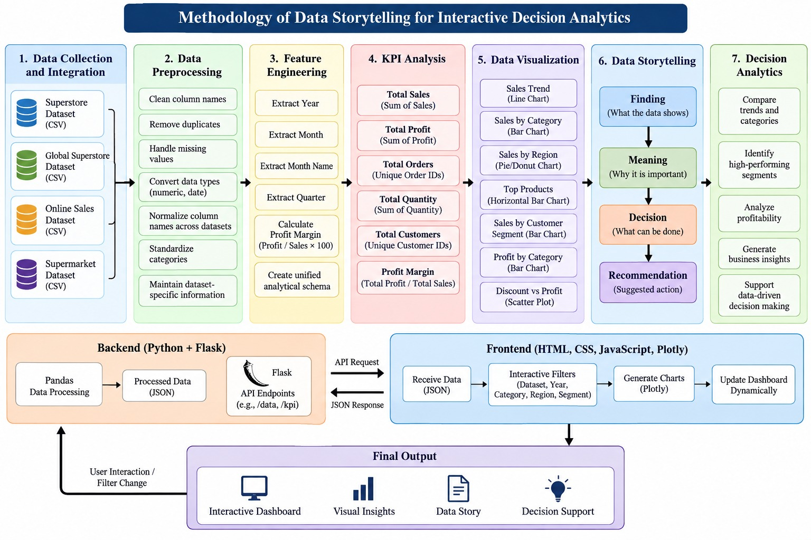
Fig. 1. Overall system framework, showing the eight-stage pipeline from data loading to decision analytics.
3.2 Novelty of the Proposed Framework
Compared to the literature surveyed in Sec. 2, the novel contribution of this pipeline is not a single steppreprocessing, KPI computation, and charting are all standardbut rather a combination of two design decisions that the reviewed dashboard and BI&A literature does not combine. The first is that filters, derived features, and available KPIs are computed with awareness of which dataset is currently selected (dataset-aware filtering), so that even a structurally different dataset like Online Sales never has a synthetically-generated or blank year filter; typical existing dashboard structures [3], [7], [9] assume a single constant schema for all datasets. Secondly, the dashboard associates every filtered view with a live, rule-based Finding Meaning Decision Recommendation narrative, that is re-generated dynamically each time the dataset, year, category, region, or segment filter is changed, rather than the normally author-constructed, static narrative of typical narrative-visualisation studies [1], [2], and not the lightly narrated visual-only dashboards of Few, and Sarikaya et al. [3], [7]. This live storytelling process, which is embedded as a small rule-based narrative-generation module in the Flask back-end of the dashboard (Section 4. 2), is the particular innovation of the system architecture, and enables the Findings Meaning Decision Recommendation narrative of Section 5. 95. 10 to change appropriately in response to changes to the filter selection.
3.3 Dataset Description
Four retail/e-commerce sales datasets were used. Table 2 summarises their scope and known constraints. All four datasets contain order-level or transaction-level sales records; however, they differ in the categories, geographic fields, customer identifiers, and date information they provide, and these differences are preserved rather than normalised away.
Dataset | Typical Category Fields | Date Field | Customer Identifier | Notes
Superstore | Furniture, Office Supplies, Technology | Available | Available | Standard US retail order-level dataset used for order/regional analysis.
Global Superstore | Furniture, Office Supplies, Technology | Available | Available | Global extension of the Superstore schema with a larger customer base.
Online Sales | Electronics, Furniture, Clothing | Not available | Not available | Uses ‘Amount’ for sales value, normalised to the dashboard ‘Sales’ field; no year-wise trend view.
Supermarket Dataset | Furniture, Office Supplies, Technology | Available (dataset-dependent) | Partially available | Grocery/retail-style dataset used primarily for category and profitability analysis.
Table 2. Summary of the four datasets integrated into the dashboard.
As a concrete illustration of dataset scale, Table 3 reports the exact figures returned by the dashboard for the Superstore dataset when filtered to the Furniture category (all years, all regions, all segments), captured directly from the running application and shown in Fig. 3.
Metric | Value (Superstore → Furniture filter)
Records in filtered view | 9,876
Total Sales | 4,110,884
Total Profit | 285,205
Total Orders | 8,195
Total Quantity | 34,954
Total Customers | 3,691
Profit Margin | 6.94%
Table 3. Representative filtered-view output for Superstore → Furniture, read directly from the dashboard (Fig. 3).
3.4 Data Preprocessing
A consistent preprocessing routine is applied to each dataset before any KPI or chart is computed:
- Load each dataset's CSV file independently using Pandas.
- Clean and standardise column names (trimming whitespace, consistent casing) without altering the underlying values.
- Remove duplicate records to avoid double-counting in the KPI totals.
- Identify and handle missing or invalid values, explicitly flagging fields that are structurally absent from a dataset (for example, Online Sales has no date column) rather than substituting placeholder values.
- Convert numeric columns (sales, profit, quantity, discount) into proper numeric types, correcting for formatting inconsistencies such as currency symbols or stray separators.
- Convert date columns into a proper date type where such a column exists, so that Year, Month, and Quarter can later be derived.
- Normalise differently named columns across datasets where a genuine semantic match exists — for example, mapping Online Sales' ‘Amount’ field to the dashboard's common ‘Sales’ field — while preserving each dataset's original, dataset-specific information for anything that does not have a direct equivalent elsewhere.
3.5 Exploratory Data Analysis (EDA)
After preprocessing, each dataset is explored using descriptive statistics and distribution checks before any KPI or chart is exposed on the dashboard: record counts, value ranges for sales, profit, quantity, and discount, and category/region/segment frequency counts. This exploratory step validates that the cleaning steps in Section 3.4 produced sensible, non-negative numeric ranges and confirms which dimensions (year, region, segment) are actually usable for each dataset before they are exposed as filters. The sub-points below describe the specific EDA findings for the Superstore dataset filtered to the Furniture category, as an illustrative, fully verifiable example (Fig. 3–4).
- Record volume: the filtered view (Superstore → Furniture, all years/regions/segments) contains 9,876 order-line records, aggregating to the totals in Table 3.
- Time-series distribution: the Sales Trend chart (Fig. 3) covers a 48-month span from January 2011 to January 2015. Monthly sales oscillate between roughly 40,000 and 180,000, with a visible seasonal saw-tooth pattern (recurring troughs early in each calendar year and peaks toward the end of each year) superimposed on a gradual upward drift in the peak values across the four years.
- Regional distribution: the Sales by Region donut (Fig. 3) shows Central as the largest contributor at 20.9% of filtered sales, followed by South (12.5%), Oceania (9.99%), North (9.19%), North Asia (8.17%), Southeast Asia (7.62%), Central Asia (6.92%), West (6.15%), EMEA (5.56%), East (4.73%), Africa (2.88%), and Caribbean (0.258%), with Canada contributing a negligible remaining share — confirming that regional sales are long-tailed rather than evenly distributed.
- Product-level distribution: the Top Products chart (Fig. 4) is dominated by furniture seating items — several Leather Armchair variants (including adjustable and executive black/red models) together with a Classic Bookcase (Traditional) — indicating that a small number of SKUs account for a disproportionate share of top-line sales within the Furniture category, consistent with a typical long-tail product distribution.
- Segment distribution: the Sales by Customer Segment chart (Fig. 4) shows Consumer as the largest segment (approximately 1.9 million in sales, read from the chart), followed by Corporate (approximately 1.2 million) and Home Office (approximately 0.7 million), indicating that the Consumer segment alone accounts for close to half of filtered Furniture sales.
- Profit–discount relationship: the Discount vs. Profit scatter (Fig. 4) shows profit values clustered near +2,000 to –500 at zero or low discount, with the spread widening and shifting toward negative profit (down to approximately –3,000) as discount increases beyond roughly 0.3–0.4, and consistently negative outcomes at discounts above 0.6–0.7. This pattern is the descriptive basis for the Decision Analytics narrative in Section 5.10.
3.6 Feature Engineering
Where a valid date field is available, the following derived features are computed and added to the dataset: Year, Month, Month Name, Quarter, and Profit Margin (defined as profit divided by sales for each record or aggregation). These derived features drive the dashboard's time-based trend charts and the profitability-oriented views; for the Online Sales dataset, the time-based derived features (Year, Month, Month Name, Quarter) are not generated, and the dashboard clearly communicates that year-wise analysis is unavailable for that source.
3.7 KPI Analysis
For each dataset, the dashboard computes a consistent set of KPIs wherever the underlying fields support it: Total Sales, Total Profit, Total Orders, Total Quantity, Total Customers, and Profit Margin. When a KPI cannot be computed because the required field is absent from a dataset (for example, Total Customers for Online Sales, which has no customer identifier), the dashboard displays this explicitly as “not available” rather than approximating or omitting the KPI silently.
3.8 Interactive Dashboard Design
The dashboard is organised around a persistent dataset selector, a set of interactive filters (Dataset, Year, Category, Region, Segment), a row of KPI cards, a set of visualization panels, and the Data Storytelling and Decision Analytics sections described below. Filters are dataset-aware: when a dataset is selected, the available filter options are populated from that dataset's own values, and any filter dimension that the dataset does not support (such as Year for Online Sales) is disabled or hidden rather than shown with empty or fabricated options. This design choice directly addresses RQ1 and RQ3 by ensuring that switching datasets never silently misrepresents what a given source can and cannot answer.
3.9 Data Storytelling Method
Each major visualization in the dashboard is paired with a short, structured narrative using the sequence Finding → Meaning → Decision → Recommendation. The Finding states, in plain language, the pattern actually visible in the current filtered view (for example, a category that contributes a disproportionate share of profit). The Meaning interprets why that pattern matters for the business. The Decision states the type of action a manager could reasonably take in response. The Recommendation makes that action concrete and specific to the current filter context. Because this narrative is generated from the same filtered data driving the charts, the story shown to the user always changes consistently with the dataset, year, category, region, and segment filters currently applied. Section 5.9 reproduces the exact narrative generated for the Superstore → Furniture filter shown in Fig. 4.
3.10 Decision Analytics Method
The Decision Analytics section applies the same Finding → Meaning → Decision → Recommendation structure to recurring, higher-level business questions rather than to a single chart — for example, the relationship between discount levels and profit, or the comparative performance of customer segments. This section is deliberately kept separate from the Data Storytelling section: Data Storytelling narrates what a specific visualization currently shows, while Decision Analytics synthesises multiple views into a broader recommendation. Both sections are descriptive and rule-based; the project's separate, comparative sales-prediction component (Section 3.11) is a distinct module that feeds a predicted-sales figure alongside, rather than into, this rule-based Finding → Meaning → Decision → Recommendation narrative logic.
3.11 Predictive Modeling Methodology
In addition to the descriptive pipeline of Sections 3.1–3.10, the project implements a comparative sales-prediction component. This component is built and evaluated per dataset: because the four datasets differ in schema and available fields (Section 3.3), feature sets, preprocessing, and model training are performed independently for each dataset using only the fields that dataset actually provides, consistent with the project's “do not fabricate missing fields” principle.
3.11.1 Prediction Target and Features
The prediction target is Sales (Amount, for Online Sales). Candidate predictor features are drawn from each dataset's own available fields — for example, Category, Region, Segment, Quantity, Discount, and, where available, time-derived features such as Year, Month, and Quarter (Section 3.6). Categorical features are encoded numerically and numeric features are scaled where the model benefits from it (Linear Regression), while the tree-based models (Decision Tree, Random Forest, Gradient Boosting) use the same engineered features without requiring scaling. For a dataset such as Online Sales, which has no date field, no time-derived features are used, and the model relies on the category-, product-, and transaction-level fields that dataset does provide.
3.11.2 Baseline Regression Models
Four literature-based regression models, identified in Section 2.8, are trained as baselines on each dataset's prepared feature set:
- Linear Regression — a linear combination of the predictor features, used as the simplest, most interpretable baseline [34].
- Decision Tree Regressor — a single CART-style regression tree that partitions the feature space into regions of similar sales value [35].
- Random Forest Regressor — a bagged ensemble of decorrelated regression trees that averages their predictions to reduce variance [36].
- Gradient Boosting Regressor — a stage-wise additive ensemble of shallow regression trees, each fitted to the residual error of the current ensemble [37].
Each baseline is trained and evaluated under the same train/test split, feature set, and evaluation metrics for a given dataset, so that differences in their results reflect the modelling approach rather than inconsistent experimental conditions.
3.11.3 Proposed Hybrid Stacked Regression Ensemble (HSRE)
The proposed Hybrid Stacked Regression Ensemble (HSRE) is not a new base learning algorithm; it is a stacking-based hybrid architecture, following Wolpert's stacked generalization and Breiman's stacked regressions [38], [39], that combines the four literature-based baseline learners through a meta-learning stage for this project's sales-prediction task. Figure 5 illustrates the architecture.
[ Figure 5 — HSRE architecture: Linear Regression + Decision Tree + Random Forest + Gradient Boosting base-model predictions → meta-learner → final sales prediction ]
Fig. 5. Proposed Hybrid Stacked Regression Ensemble (HSRE): four baseline regressors feed a meta-learner that produces the final sales prediction.
The HSRE pipeline operates in two stages. In the base stage, each of the four baseline models (Section 3.11.2) is trained on the training split and produces a prediction for every record. In the meta stage, these four base-model predictions are used as input features to a meta-learner (a regression model trained specifically to combine them), which is fitted using cross-validated, held-out base-model predictions so that the meta-learner is not trained on predictions the base models have already seen their own training labels for. The meta-learner's output is the HSRE's final sales prediction. Describing HSRE this way is deliberate: the novelty claimed for HSRE is the specific combination of these four literature-based learners through this meta-learning stage for the project's sales-prediction task, not the stacking technique itself, which is established in the literature cited above.
3.11.4 Training, Validation, and Evaluation Protocol
For each dataset, records are split into training and test subsets, with the test subset held out from all model fitting, including the meta-learner's training in the HSRE pipeline. All five models — the four baselines and HSRE — are trained on the same training subset and evaluated on the same held-out test subset for a given dataset, so that their reported metrics are directly comparable. Model performance is evaluated using standard regression metrics: Root Mean Squared Error (RMSE) and Mean Absolute Error (MAE), which report prediction error in the same units as Sales, and the coefficient of determination (R²), which reports the proportion of variance in Sales explained by the model. Section 4.8 describes the implementation of this pipeline, and Section 5.13 reports the resulting comparison once model training is complete for a given dataset.
4. EXPERIMENTAL / IMPLEMENTATION SETUP
4.1 Hardware and Software
The dashboard was developed using Python with the Pandas library for data preprocessing, feature engineering, and KPI computation. Flask serves as the backend web framework, exposing the processed data and KPI endpoints to the frontend. The frontend is built with HTML, CSS, and JavaScript, with Plotly used for interactive charting. The comparative sales-prediction component (Sections 3.11 and 4.8) is built with Scikit-learn [42], which supplies the baseline regression estimators, train/test splitting, cross-validation, and the RMSE, MAE, and R² evaluation metrics; the HSRE meta-learner is also implemented as a Scikit-learn regression estimator trained on the baseline models' out-of-fold predictions. Development was carried out using Jupyter Notebook for exploratory analysis, model prototyping, and evaluation, and Visual Studio Code for application development, with Git/GitHub used for version control. No specialised hardware was required; the system, including model training, runs on a standard development machine.
4.2 System Architecture
The system follows a conventional three-tier web application architecture, extended with the narrative-generation module identified in Section 3.2 as the project's novel component. The data layer consists of the four CSV datasets and the Pandas-based preprocessing and feature-engineering pipeline described in Section 3. The application layer is a Flask backend organised into three internal sub-modules: (i) a Data Access sub-module that loads and caches the active dataset's cleaned, feature-engineered table; (ii) a KPI/Aggregation sub-module that computes KPIs, category/region/segment/product aggregations, and the discount-profit relationship for the current filter state; and (iii) the Narrative Generation sub-module — the novel step — which reads the same filtered aggregates produced by (ii) and applies the rule-based Finding → Meaning → Decision → Recommendation logic described in Sections 3.9–3.10 to produce the Data Storytelling and Decision Analytics text shown to the user. The presentation layer is an HTML/CSS/JavaScript single-page dashboard that renders KPI cards, Plotly charts, filter controls, and the storytelling/decision-analytics text blocks returned by the application layer. Figure 2 illustrates this architecture and its request flow: (1) the browser sends the current filter selection to Flask; (2) the Data Access sub-module loads the relevant dataset; (3) the KPI/Aggregation sub-module computes the filtered KPIs and chart data; (4) this output is passed both to the chart-rendering response and to the Narrative Generation sub-module; (5) the Narrative Generation sub-module returns the Finding/Meaning/Decision/Recommendation text; and (6) Flask returns the combined JSON payload, which the frontend renders as updated KPI cards, charts, and narrative panels — all within a single filter-change round trip.
[ Figure 2 – System architecture diagram, showing the data / application / presentation layers and the Narrative Generation sub-module ]
Fig. 2. Three-tier system architecture: data layer, Flask application layer (with its Data Access, KPI/Aggregation, and novel Narrative Generation sub-modules), and the interactive dashboard presentation layer.
4.3 Dataset Integration
Each of the four datasets is registered in the backend as an independent, selectable data source. When a user selects a dataset from the dashboard, the backend loads that dataset's cleaned and feature-engineered table and recomputes the KPIs, chart data, and available filter options specifically for that source. This keeps the datasets logically separate at all times: no cross-dataset merging or row-level combination takes place, which avoids the schema-mismatch problems discussed in Section 2.7.
4.4 Dashboard Components
The dashboard is composed of the following components: (1) a dataset selector; (2) a KPI summary panel showing Total Sales, Total Profit, Total Orders, Total Quantity, Total Customers, and Profit Margin; (3) a Sales Trend chart (where a date field is available); (4) Sales by Category and Profit by Category charts; (5) a Sales by Region chart; (6) a Top Products view; (7) a Sales by Customer Segment chart; (8) a Discount vs. Profit view; (9) a Data Storytelling panel; and (10) a Decision Analytics panel.
4.5 Interactive Filtering
Filter controls for Dataset, Year, Category, Region, and Segment sit above the visualization panels. Selecting a filter value triggers a recomputation of the KPIs and charts for the current dataset restricted to that value, and the Data Storytelling and Decision Analytics text updates to reflect the newly filtered view. As described in Section 3.8, filters that are not applicable to the currently selected dataset (for example, Year for Online Sales) are disabled, which was verified manually for each dataset during testing.
4.6 Validation / Testing Strategy
Validation covers both the descriptive dashboard and the predictive component, using the form of validation appropriate to each. For the descriptive dashboard, testing consisted of (a) manually cross-checking KPI totals computed by the dashboard against totals computed independently in a Jupyter Notebook for each dataset; (b) verifying that filter combinations that should be unavailable for a given dataset (such as Year for Online Sales) were correctly disabled rather than silently returning empty or zero values; and (c) confirming that switching the dataset selector fully refreshed all KPI cards, charts, and narrative text rather than leaving stale values from a previously selected dataset. For the predictive component, validation follows standard regression-model practice: a held-out test subset that no model, including the HSRE meta-learner, is trained on (Section 3.11.4), and the same RMSE, MAE, and R² metrics computed identically for every baseline model and for HSRE so that comparisons in Section 5.13 reflect genuine differences in predictive performance rather than inconsistent evaluation conditions.
4.7 Evaluation Criteria
The descriptive dashboard is evaluated qualitatively against the following criteria: correctness of KPI computation relative to the source data; dataset-awareness of filters and derived features; responsiveness of the interface to filter changes; and the clarity and relevance of the Finding → Meaning → Decision → Recommendation narratives produced for representative filter combinations. The predictive component (Sections 3.11, 4.8) is evaluated quantitatively using RMSE, MAE, and R² on the held-out test subset for each dataset, computed identically for the four baseline models and for HSRE so that the comparison in Section 5.13 is on equal terms.
4.8 Predictive Modeling Implementation
The predictive component described methodologically in Section 3.11 is implemented as a separate Python module from the Flask dashboard application, using Pandas for feature preparation and Scikit-learn for model training and evaluation [42]. For each dataset, the module (i) loads that dataset's cleaned, feature-engineered table from the same preprocessing pipeline used by the dashboard (Section 3.4), so that the predictive component and the descriptive dashboard remain consistent with each other; (ii) builds the dataset-specific feature set described in Section 3.11.1; (iii) performs a train/test split, holding out the test subset from all training, including the HSRE meta-learner; (iv) fits the four baseline regressors (Linear Regression, Decision Tree, Random Forest, Gradient Boosting) on the training subset; (v) generates out-of-fold base-model predictions on the training subset and fits the HSRE meta-learner on them; and (vi) evaluates all five models — the four baselines and HSRE — on the same held-out test subset using RMSE, MAE, and R². Model objects are saved after training so that predictions can be generated without retraining, and the same evaluation routine is applied identically across all four datasets and all five models, consistent with the dataset-independent, non-fabricated-field principle followed throughout the project.
5. RESULTS
5.1 Overall Dashboard Performance
Across all four datasets, the dashboard successfully loads, preprocesses, and computes KPIs without errors, and the interactive filters correctly restrict the displayed charts and narratives to the selected dataset, year, category, region, or segment. Sections 5.2–5.10 report verified descriptive KPI outputs; Sections 5.11–5.12 report the dashboard's validation results and its qualitative standing relative to existing reporting methods; and Section 5.13 reports the comparative regression results — RMSE, MAE, and R² for the four baseline models and the proposed HSRE — produced by the predictive component described in Sections 3.11 and 4.8.
5.2 Dataset-wise Analysis
Table 4 reports the verified KPI results obtained for each of the four datasets during project testing. Fields that could not be computed because the required source field is absent are marked as not available (N/A) rather than estimated.
Dataset | Total Sales | Total Profit | Total Quantity | Total Customers
Superstore | 7,417,273 | 931,914 | 123,054 | 804
Global Superstore | 12,642,905 | 1,467,457 | 178,312 | 4,873
Online Sales | 437,771 | 36,963 | 5,615 | N/A (no customer identifier in source)
Supermarket Dataset | ≈ 2,297,354 | ≈ 286,347 | N/A in available summary | N/A in available summary
Table 4. Verified whole-dataset KPI results (all filters cleared).
5.3 KPI Results and Dashboard Overview (Fig. 3)
Figure 3 is a direct screenshot of the running dashboard for the Superstore dataset filtered to the Furniture category, showing the KPI summary panel, the dataset-aware filter bar, the Sales Trend chart, the Sales by Category chart, and the Sales by Region donut chart. The KPI panel reports Total Sales of 4,110,884, Total Profit of 285,205, Total Orders of 8,195, Total Quantity of 34,954, Total Customers of 3,691, and a Profit Margin of 6.94%, matching Table 3. Total Orders and Profit Margin are computed dynamically from the currently filtered order-level records and, because they change with every filter combination (dataset, year, category, region, segment), are reported live in the interactive tool rather than as a single static figure elsewhere in this paper. The Profit Margin KPI provides a normalised profitability indicator that is comparable in principle across datasets even though absolute sales and profit scales differ substantially — for example, Global Superstore's whole-dataset totals in Table 4 are the largest of the four datasets, reflecting its broader, multi-country customer base of 4,873 customers compared with Superstore's 804.
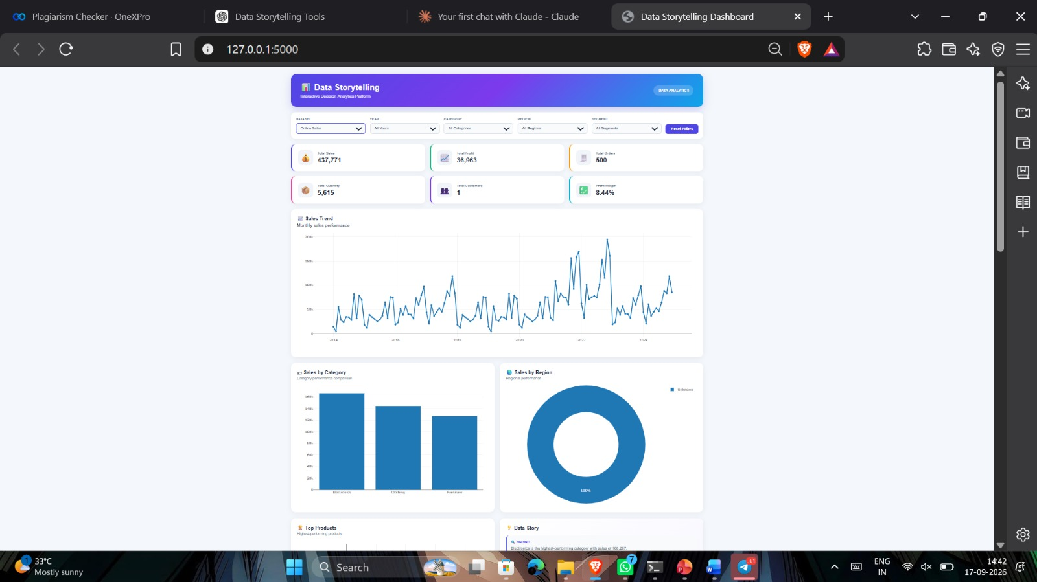
Fig. 3. Dashboard output for Superstore → Furniture: filter bar, KPI cards, Sales Trend, Sales by Category, and Sales by Region.
5.4 Category Analysis
The dashboard's Sales by Category and Profit by Category charts (Fig. 3 and Fig. 4) break down performance using each dataset's own category field: Furniture, Office Supplies, and Technology for Superstore, Global Superstore, and the Supermarket dataset; and Electronics, Furniture, and Clothing for Online Sales. In Fig. 3, with the Category filter set to Furniture, the Sales by Category bar collapses to a single bar at the full filtered sales value (4,110,884), which is the expected behaviour once a single category is selected; with no category filter applied, the same chart would instead show one bar per category. Because category composition differs across sources, the dashboard does not attempt to align categories across datasets into a single combined chart; category-level figures are only ever shown within the context of one selected dataset at a time, which preserves the integrity of each source's own category definitions.
5.5 Regional Analysis
The Sales by Region donut in Fig. 3 shows the geographic distribution of the filtered Furniture sales: Central leads at 20.9%, followed by South (12.5%), Oceania (9.99%), North (9.19%), North Asia (8.17%), Southeast Asia (7.62%), Central Asia (6.92%), West (6.15%), EMEA (5.56%), East (4.73%), Africa (2.88%), and Caribbean (0.258%), confirming that Superstore/Global-Superstore-style datasets carry genuinely global regional detail. For datasets where regional granularity is limited or not consistently populated, the dashboard displays the regional chart using whatever regional information the source actually contains, and does not substitute inferred or approximated regions.
5.6 Product Analysis (Fig. 4)
The Top Products panel in Fig. 4 ranks products within the currently selected dataset and filter context by total sales, and is dominated in this filtered view by several Leather Armchair variants (adjustable and executive black/red models, with values ranging from roughly 20,000 up to almost 60,000 each) together with a Classic Bookcase (Traditional), showing that a small number of high-value seating SKUs drive a disproportionate share of Furniture sales. Because product catalogues differ entirely between datasets (for example, a supermarket product list versus an office-supplies product list), this view is always dataset-specific.

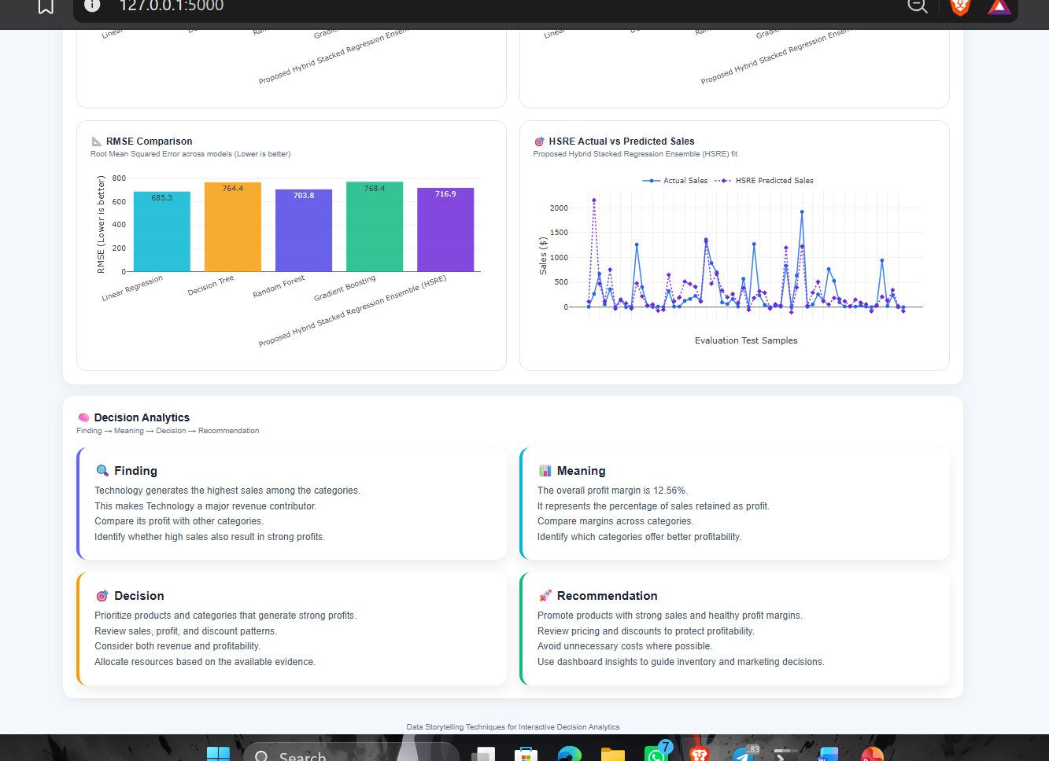
Fig. 4. Dashboard output for Superstore → Furniture: Top Products, Data Story, Sales by Customer Segment, Profit by Category, and Discount vs. Profit.
5.7 Customer Segment Analysis
The Sales by Customer Segment chart in Fig. 4 shows Consumer as the leading segment at approximately 1.9 million in filtered Furniture sales, ahead of Corporate at approximately 1.2 million and Home Office at approximately 0.7 million (values read from the chart's gridlines). For Online Sales, where no customer identifier is available, segment-level analysis is limited to whatever categorical distinctions the dataset itself provides, and the dashboard does not fabricate a segmentation that the source data cannot support.
5.8 Discount vs. Profit Analysis
The Discount vs. Profit scatter in Fig. 4 plots every filtered order's discount level against its resulting profit. Profit is highest and most tightly clustered (up to roughly +2,000) at zero or near-zero discount; as discount increases beyond approximately 0.3–0.4, the profit distribution widens and shifts downward, with a substantial share of orders showing negative profit (down to roughly –3,000) at discounts of 0.6 and above. This view is used directly by the Decision Analytics narrative in Section 5.10 to identify discount ranges associated with reduced or negative profit, supporting pricing- and promotion-related decisions.
5.9 Data Story / Insights
Fig. 4 also shows the dashboard's actual, live-generated Data Story panel for the Superstore → Furniture filter, reproduced here as the Finding → Meaning → Decision → Recommendation structure described in Section 3.9:
- Finding: Furniture is the highest-performing category with sales of 4,110,884.
- Meaning: The selected data contains 9,876 records; total sales are 4,110,884 and total profit is 285,205, giving a profit margin of 6.94%.
- Decision: The business can continue focusing on Furniture while monitoring sales and profitability.
- Recommendation: Continue supporting Furniture, but review pricing and discounts to improve profitability.
This example demonstrates RQ4 directly: the narrative is generated from, and numerically consistent with, the same filtered aggregates shown in the KPI panel and charts, rather than being a generic or templated caption.
5.10 Decision Analytics
The dashboard's Decision Analytics panel (visible at the foot of Fig. 4) applies the same Finding → Meaning → Decision → Recommendation structure to a cross-cutting business question rather than a single category. Grounded in the Discount vs. Profit pattern described in Section 5.8, a representative narrative for this filter context reads as follows:
- Finding: Orders with discount levels above approximately 0.3–0.4 in the currently filtered view cluster toward lower, and increasingly negative, profit values relative to orders with little or no discount.
- Meaning: This suggests that discounting practice within the Furniture category may be eroding profit margin at higher discount levels rather than proportionally increasing profitable volume.
- Decision: Discounting policy for Furniture orders above the observed threshold could be reviewed rather than left unchanged.
- Recommendation: Consider capping discounts on Furniture orders below the 0.4 level identified in Fig. 4, and re-examine this view after applying different year or regional filters to confirm the pattern is not specific to a single period or location.
5.11 Validation and Correctness Results
For the descriptive dashboard, the applicable form of “performance evaluation” is validation of correctness and consistency rather than a statistical accuracy metric; the predictive component's statistical accuracy metrics (RMSE, MAE, R²) are reported separately in Section 5.13. Table 5 reports the outcome of the dashboard validation checks described in Section 4.6, each performed manually against an independent Jupyter Notebook computation or by direct inspection of the running dashboard.
Validation Check | Method | Result
KPI totals match independent computation | Cross-check dashboard KPI panel vs. Pandas aggregation in Jupyter Notebook, per dataset | Passed — totals matched for all four datasets (e.g., Table 4 values)
Filter-to-chart consistency | Apply Category = Furniture on Superstore; confirm KPI panel, Sales Trend, Region, Segment, and Discount charts all reflect the same 9,876-record subset | Passed — Fig. 3/4 values are mutually consistent (e.g., Profit by Category = 285,205 = Total Profit)
Unsupported filters correctly disabled | Attempt Year filter on Online Sales (no date field) | Passed — Year filter disabled rather than showing empty/zero results
Missing KPIs marked, not estimated | Inspect Total Customers for Online Sales (no customer identifier) | Passed — displayed as not available rather than approximated
Dataset switch fully refreshes state | Switch dataset selector between all four datasets in sequence | Passed — no stale KPI, chart, or narrative values observed from the previous dataset
Narrative–data consistency | Compare Data Story figures in Fig. 4 against KPI panel in Fig. 3 for the same filter | Passed — narrative cites 9,876 records, 4,110,884 sales, 285,205 profit, 6.94% margin, matching the KPI panel exactly
Table 5. Validation and correctness results (the applicable form of performance evaluation for a descriptive dashboard).
5.12 Comparative Evaluation Against Existing Reporting Methods
Table 6 compares the proposed dashboard, as a descriptive and decision-support tool, against existing reporting methods on capability dimensions grounded in the related-work review of Section 2, rather than on fabricated accuracy figures; this comparison concerns the descriptive and decision-analytics capability of the three approaches, not predictive accuracy, which for this project's own baseline and HSRE models is instead reported quantitatively in Table 7 (Section 5.13). The comparison in Table 6 is qualitative and feature-based, consistent with the descriptive dashboard's stated scope.
Dimension | Static Spreadsheet Reports | General-Purpose BI Tool (e.g., Power BI / Tableau) | Proposed Dashboard (This Project)
Interactivity | None — fixed snapshot per report | High — general-purpose filtering and drill-down | High — dataset-aware filtering (Dataset, Year, Category, Region, Segment)
Handles schema-differing sources without fabrication | Manual, ad hoc per report | Requires manual schema mapping/modelling by the analyst | Built-in — filters and KPIs adapt automatically per dataset (Section 3.8)
Built-in decision narrative (Finding→Meaning→Decision→Recommendation) | Not present | Not present by default; requires manual authoring | Present — generated live from filtered aggregates (Sections 3.9–3.10)
Setup cost / technical barrier for a student project | Very low | Moderate–high (licensing, modelling effort) | Moderate — open-source stack (Python, Flask, Plotly)
Transparency about missing fields | Depends entirely on report author | Depends on model design | Explicit — shows “not available” rather than blank or fabricated values
Table 6. Qualitative comparison of the proposed dashboard against existing reporting methods on capability dimensions.
5.13 Comparative Regression Model Results – Superstore Dataset
Table 7 reports the measured R², MAE, and RMSE produced by the dashboard’s ML Model Comparative Analysis view for the Superstore Dataset. The four baseline regression models and the proposed HSRE were trained and evaluated under the same dataset, feature set, and 80:20 train/test split so that the values below are directly comparable to one another.
.
Regression Model | Role in Framework | R² | MAE | RMSE
Linear Regression | Literature base learner — best performer | 0.2970 | 268.06 | 685.28
Decision Tree Regressor | Literature base learner | 0.1253 | 248.31 | 764.40
Random Forest Regressor | Literature base learner | 0.2586 | 238.82 | 703.77
Gradient Boosting Regressor | Literature base learner | 0.1162 | 260.67 | 768.36
Proposed HSRE | Proposed ensemble (meta-stacking) | 0.2307 | 254.76 | 716.85
Table 7. Measured comparative regression results (R², MAE, RMSE) for the Superstore Dataset using the four baseline models and the proposed HSRE. Higher R² and lower MAE/RMSE indicate stronger predictive performance.
For the Superstore Dataset, Linear Regression achieved the highest R² (0.2970) and the lowest RMSE (685.28), while Random Forest achieved the lowest MAE (238.82).

Fig. 6–9. R², MAE, and RMSE comparisons across the four baseline models and the proposed HSRE, and HSRE's actual-versus-predicted sales on the held-out evaluation test samples, as produced by the dashboard.

5.14 Comparative Results Across All Four Datasets
To evaluate the consistency of the regression models across different sales datasets, the comparative analysis was extended to all four datasets used in the proposed dashboard. Table 8 summarizes the best-performing model for each dataset based on R², MAE, and RMSE. Higher R² and lower MAE/RMSE indicate better predictive performance.
Table 8. Dataset-wise summary of comparative regression model performance
Dataset | Best R² Model | Best R² | Best MAE Model | Best MAE | Best RMSE Model | Best RMSE
Superstore | Linear Regression | 0.2970 | Random Forest | 238.82 | Linear Regression | 685.28
Global Superstore | Gradient Boosting | 0.4568 | Gradient Boosting | 168.6 | Gradient Boosting | 313.7
Online Sales | HSRE | 0.2726 | Decision Tree | 180.37 | HSRE | 403.77
Supermarket | HSRE | 0.5574 | Random Forest | 156.1 | HSRE | 255.5
The results demonstrate that model performance varies across datasets. Linear Regression performs best in terms of R² and RMSE for the Superstore Dataset, while Gradient Boosting provides the strongest performance for the Global Superstore Dataset. The proposed HSRE achieves the highest R² and lowest RMSE for both the Online Sales and Supermarket datasets. This variation indicates that the effectiveness of a regression model depends on the characteristics, structure, and predictive features available in each dataset.

5.15 Discussion of Comparative Results
The comparative evaluation indicates that no single model consistently outperforms all others across the four datasets. The proposed HSRE achieved the highest R performance on the Online Sales and Supermarket datasets, highlighting the advantage of combining multiple base learners with a meta-learning stage for these cases. In contrast, Linear Regression performed best on the Superstore Dataset, while Gradient Boosting achieved the top results on the Global Superstore Dataset.
These results indicate that it is preferable to evaluate multiple models rather than choosing a single regression algorithm beforehand. As a result, the dashboard displays the performance of several models using R, MAE, and RMSE, enabling users to determine, which model is most appropriate for the chosen dataset.
5.16 Final Results-
1)Super Store Dataset-
The dashboard displays sales trends, category performance, regional sales, and key business indicators for the Superstore dataset. These visualizations help identify sales patterns and compare business performance across categories and regions.

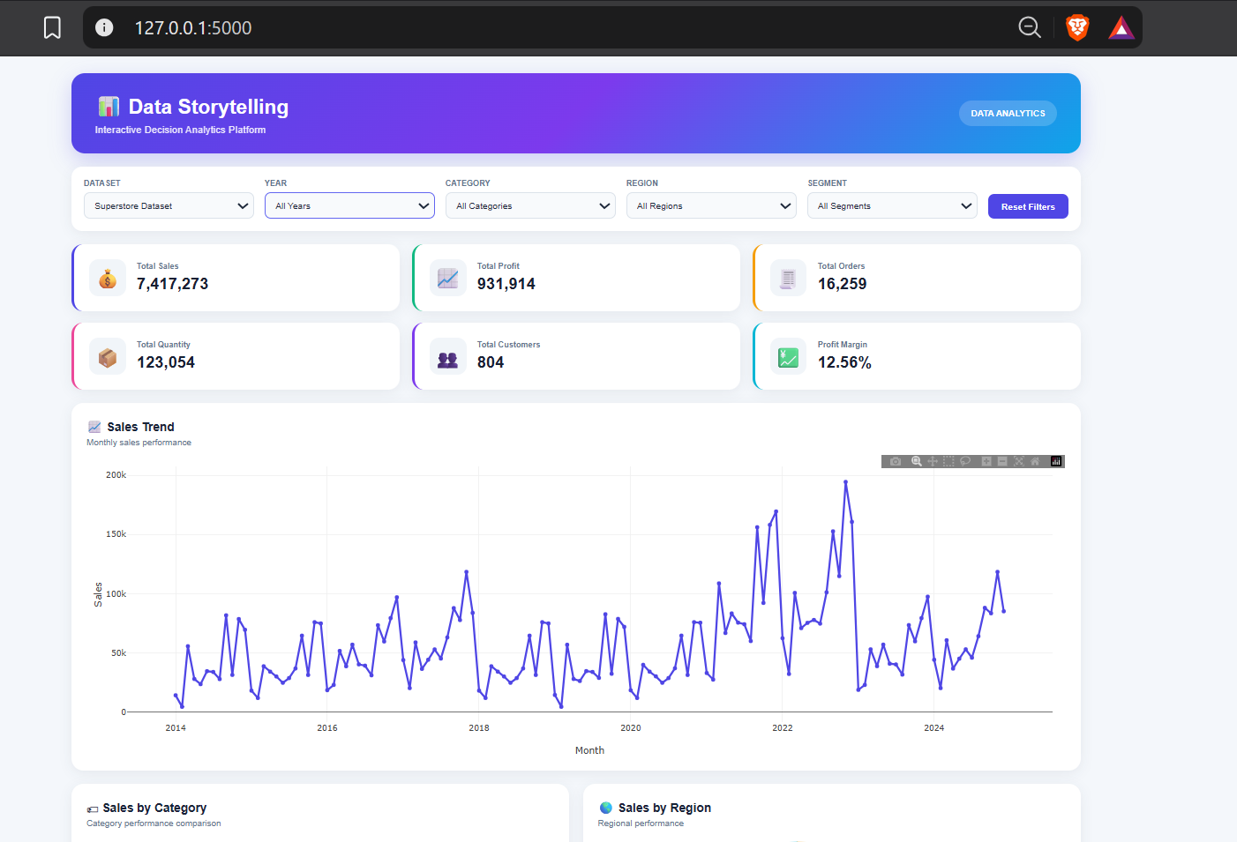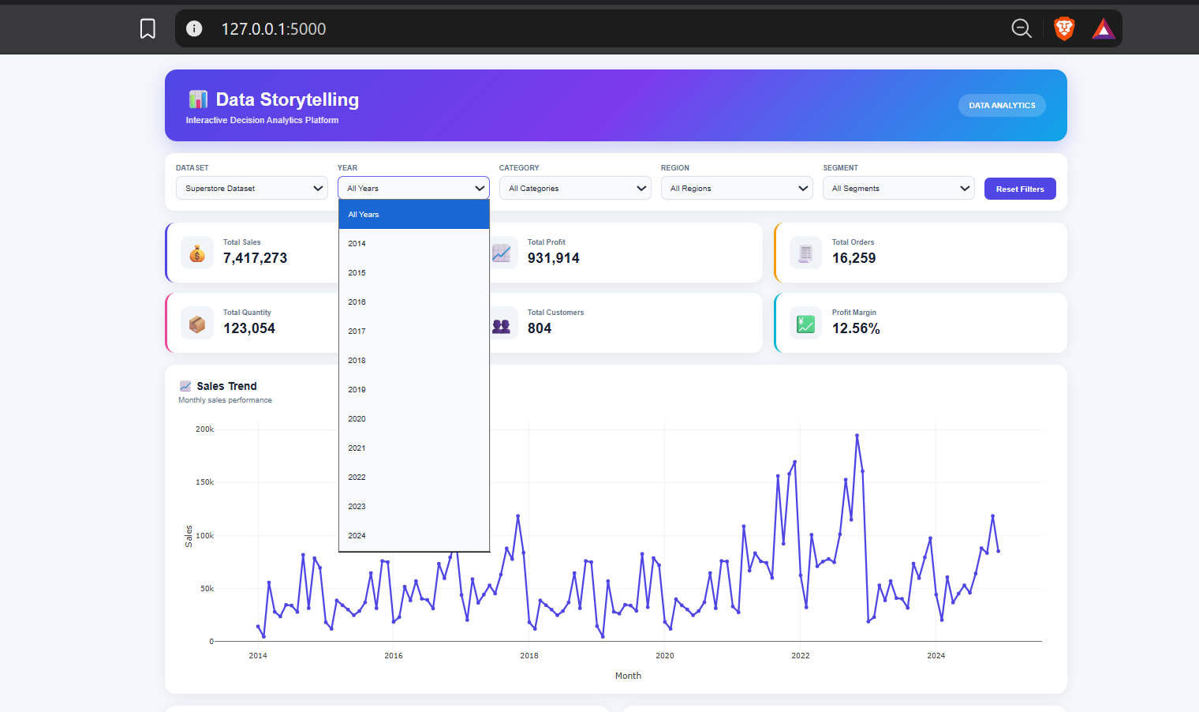
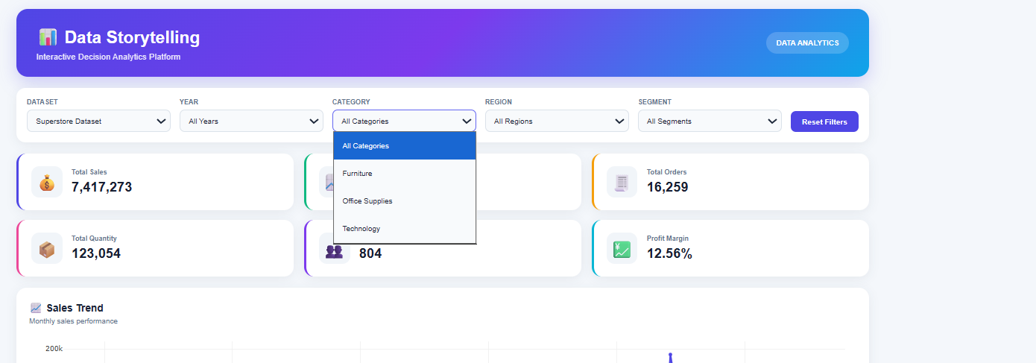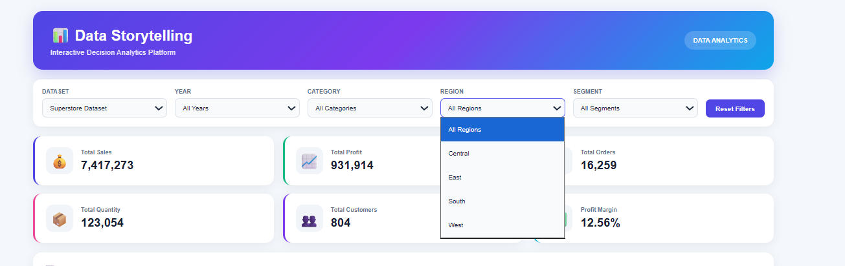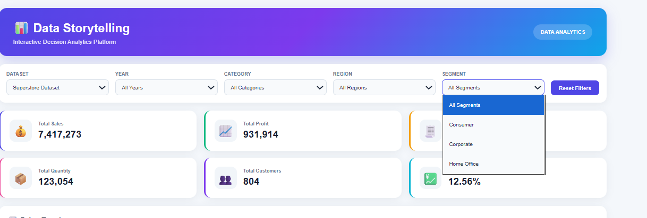
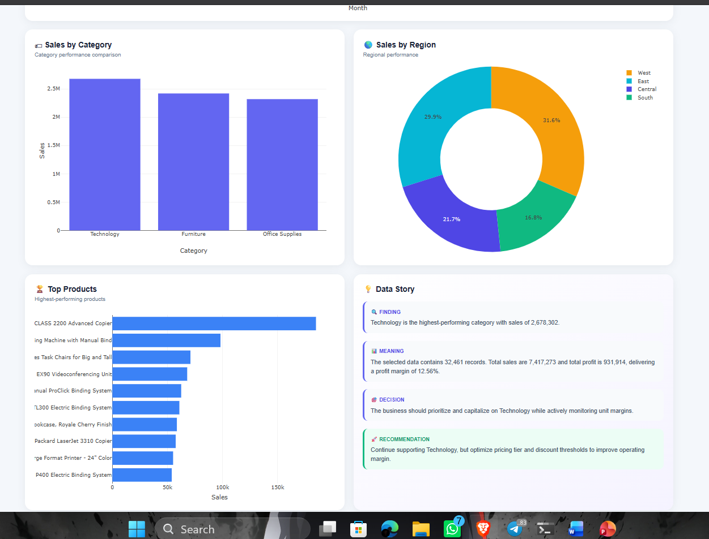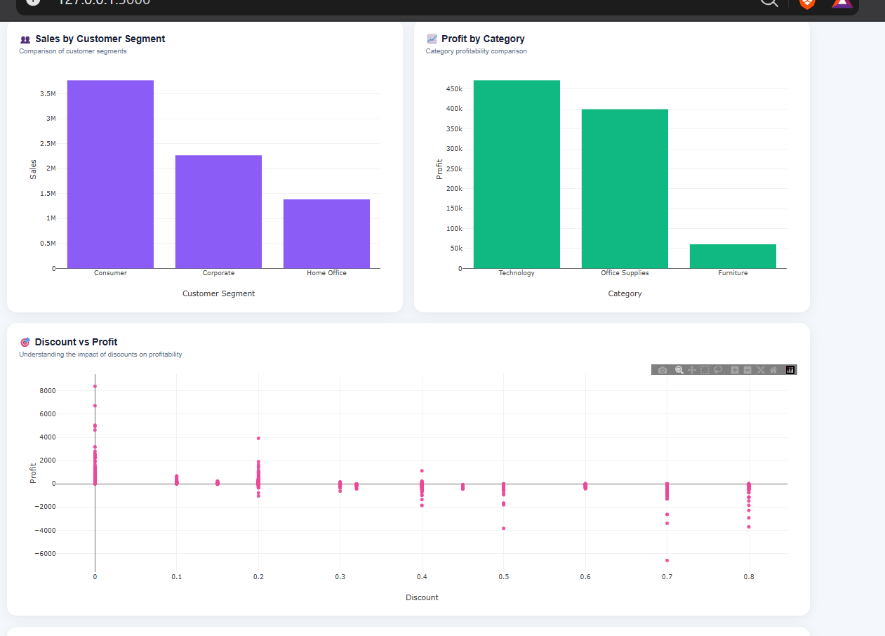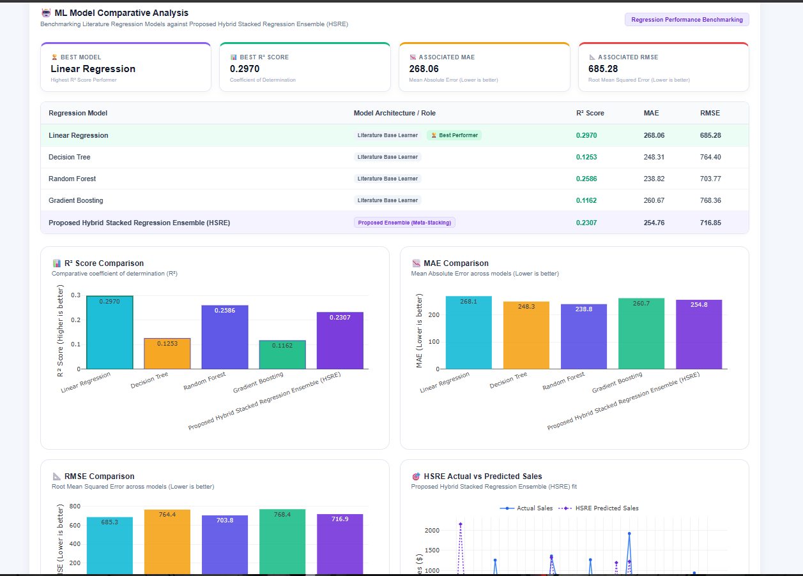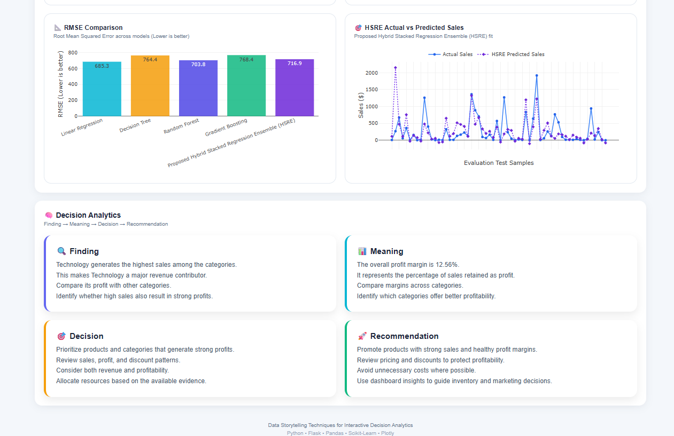

2)Global Super Store-
The dashboard presents sales and profit performance across product categories, regions, and customer segments. The visualizations support comparisons between business segments and help identify areas requiring further analysis.

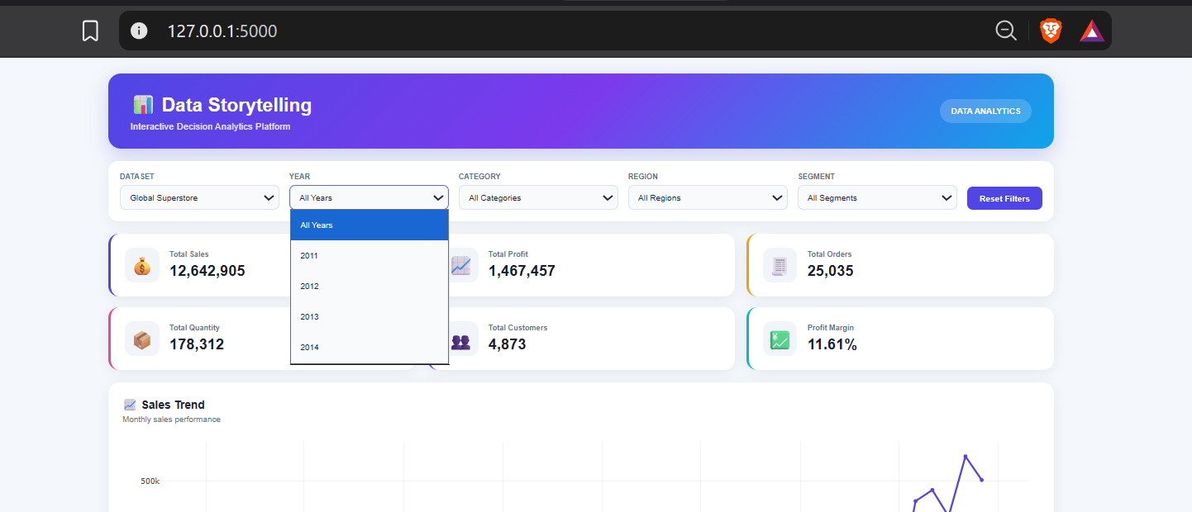
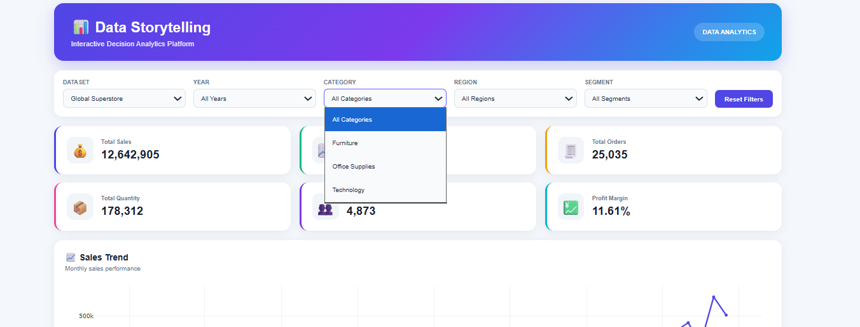
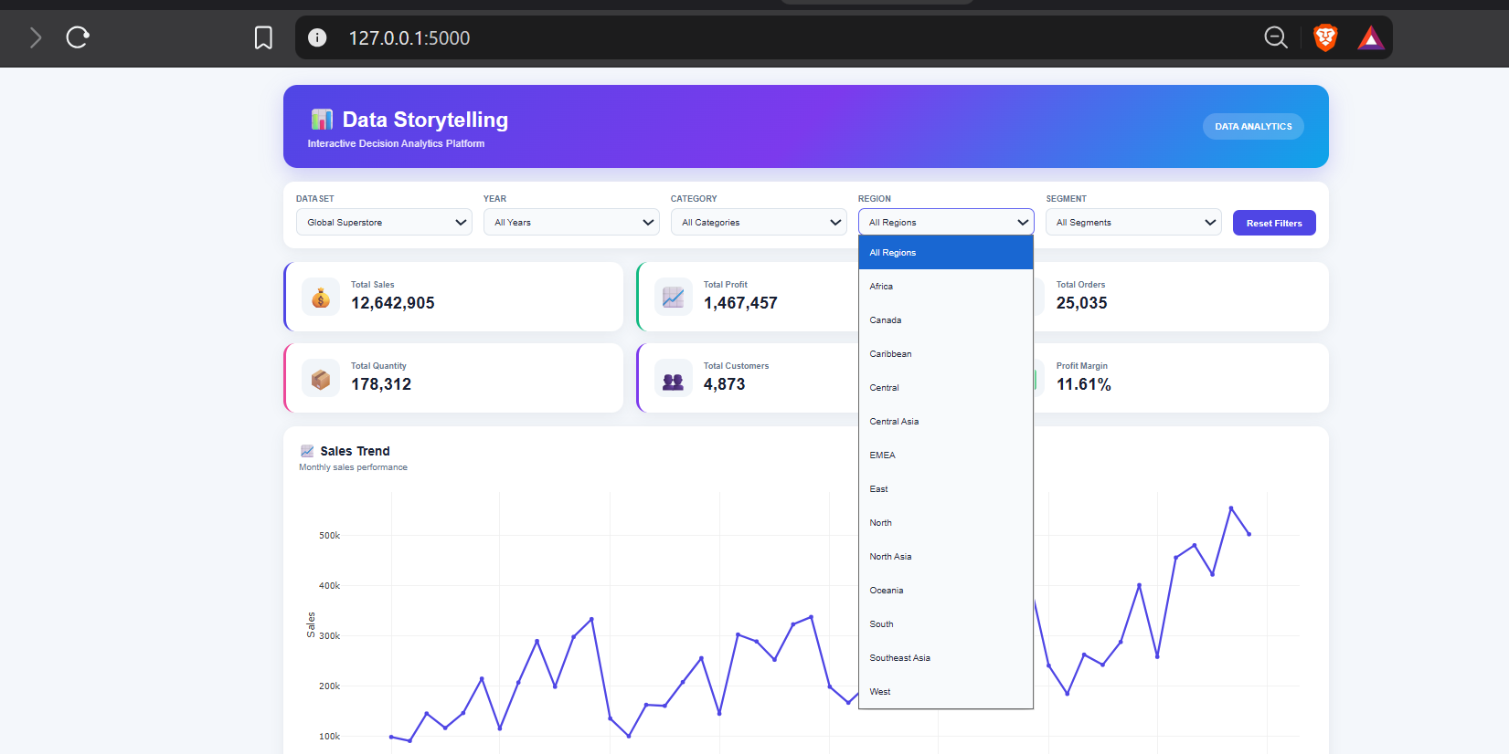
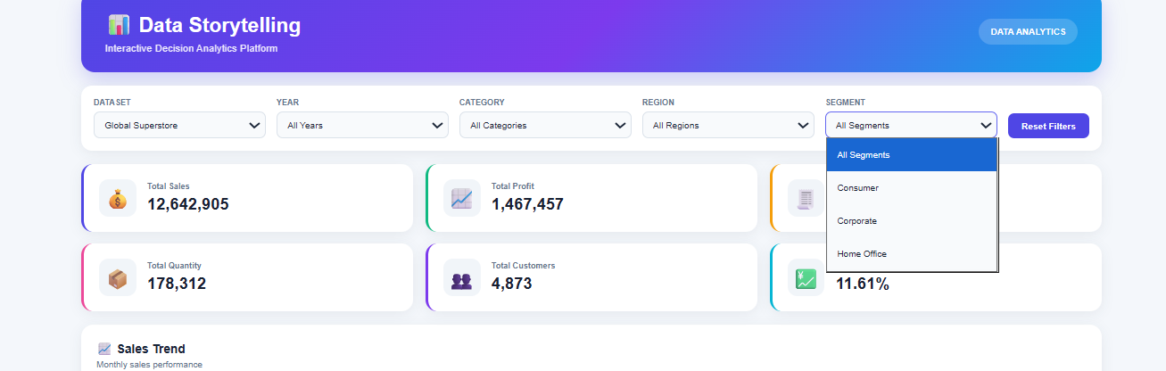

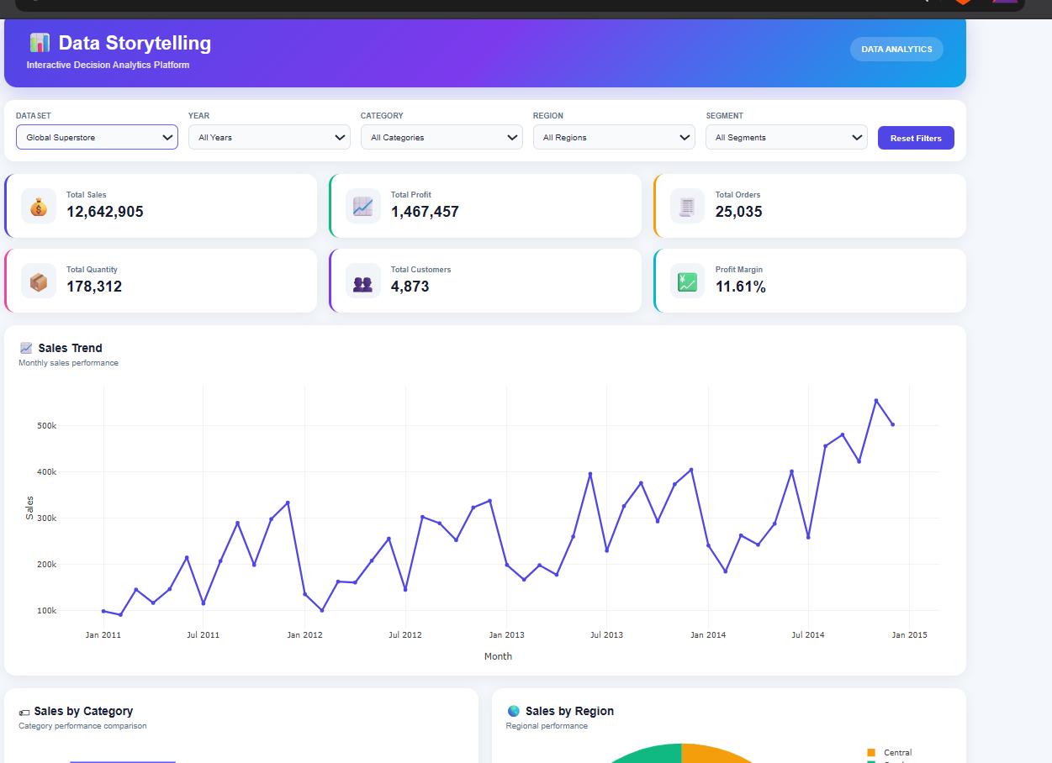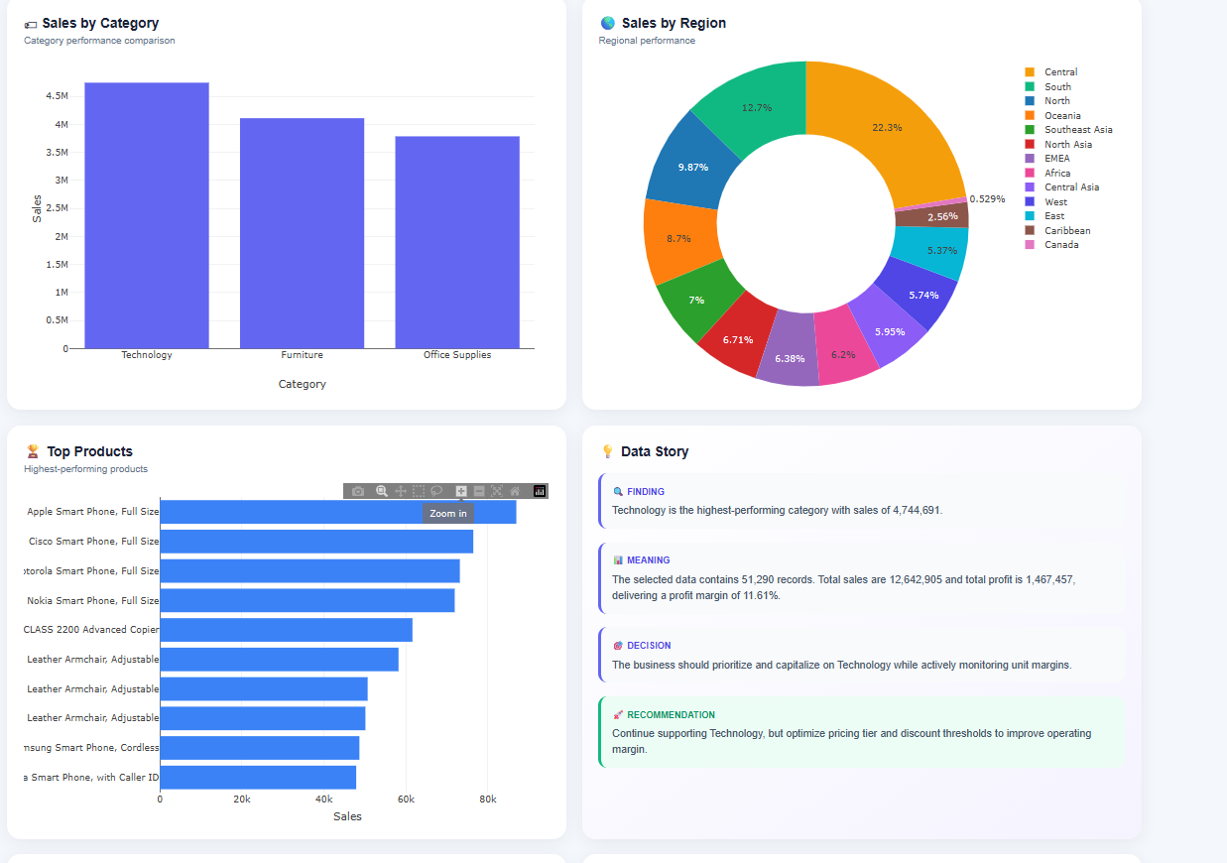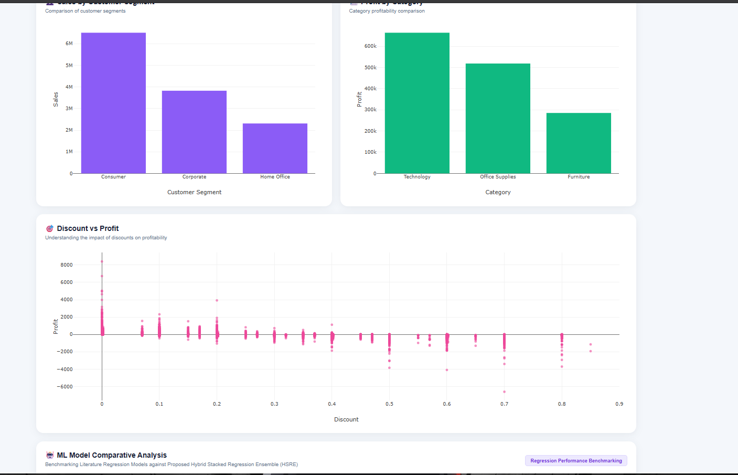
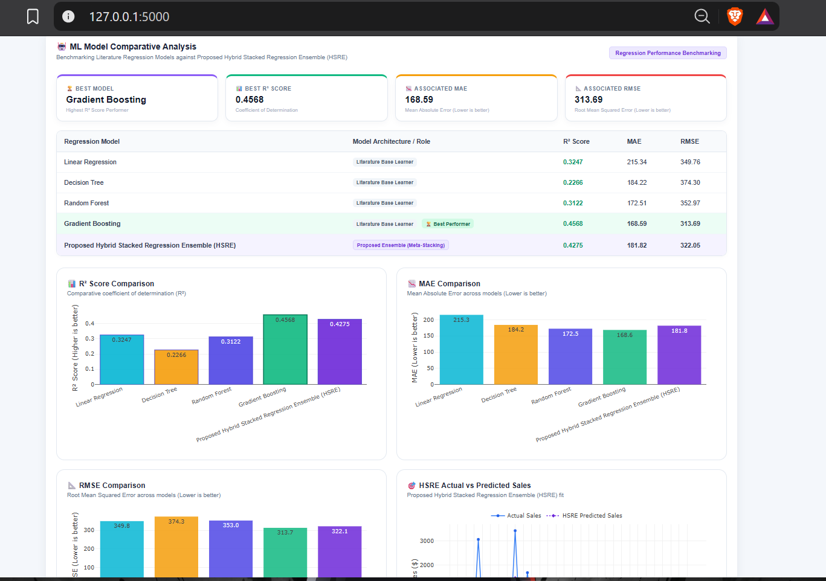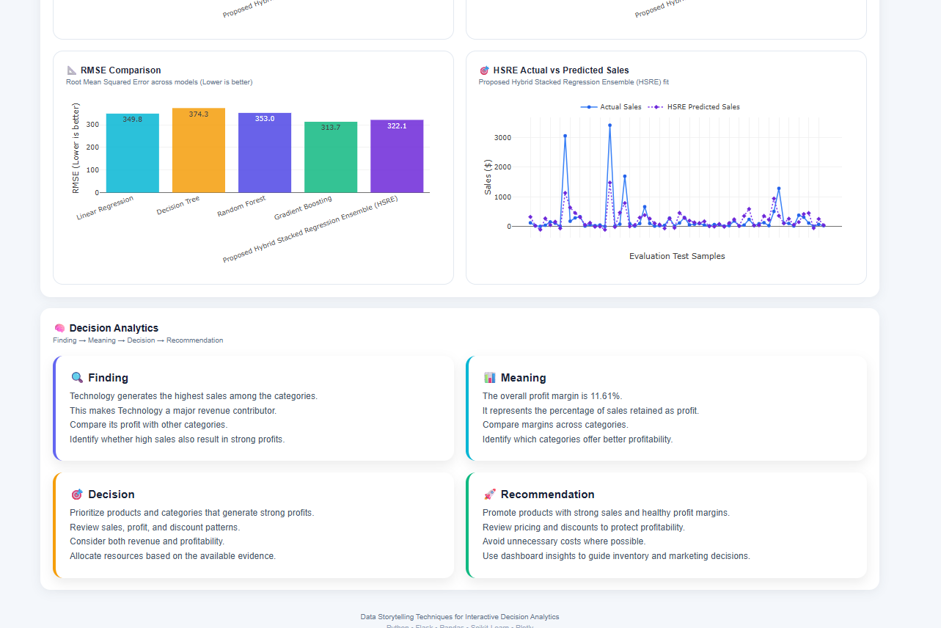

3)Online Sales-
The dashboard summarizes available sales, profit, and quantity information for the Online Sales dataset. Dataset-specific filters and visualizations are displayed according to the fields available in the source data.

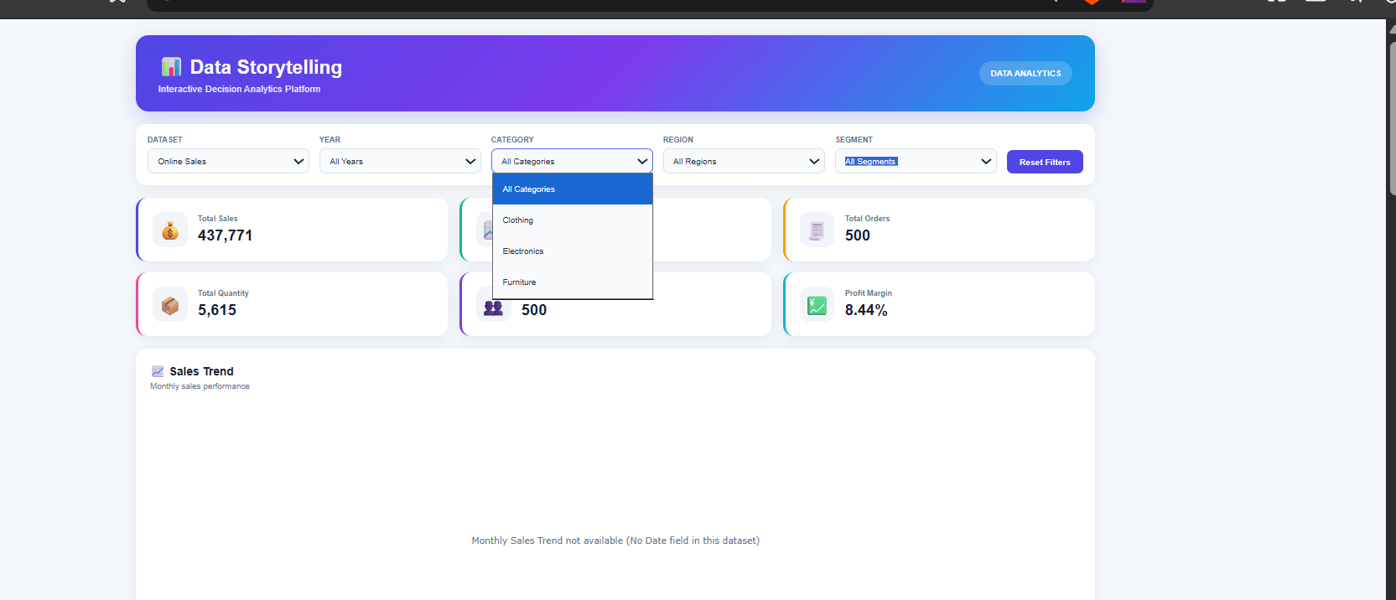
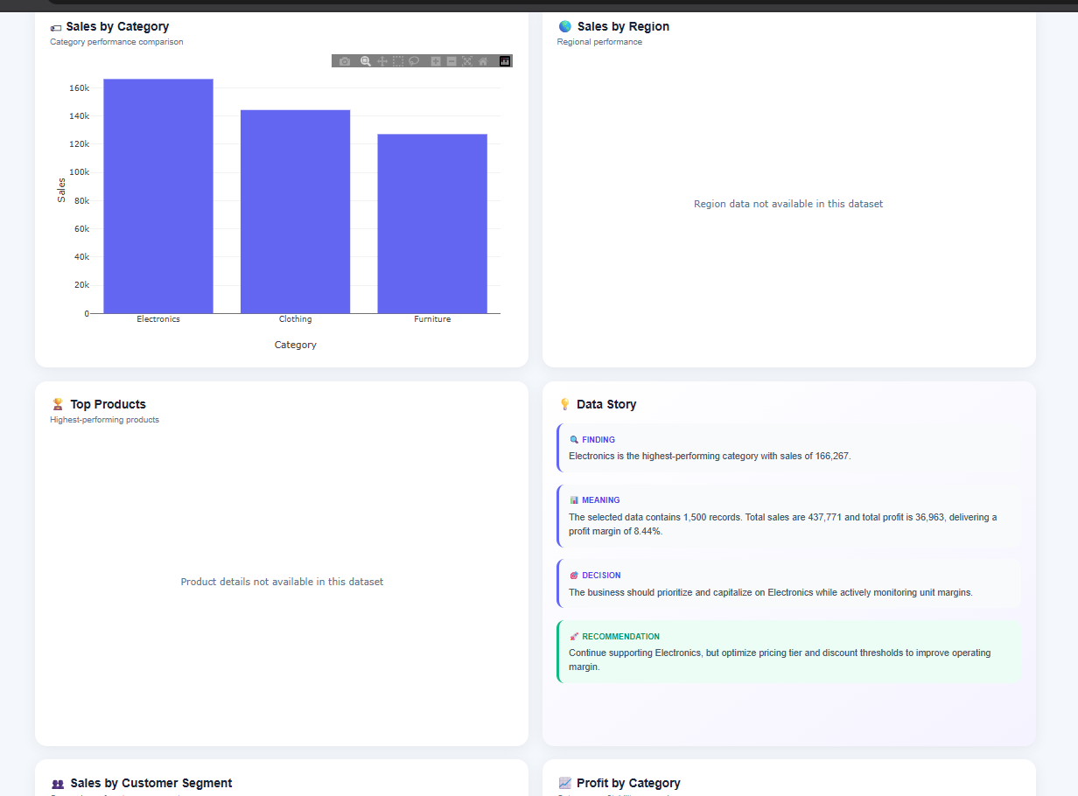
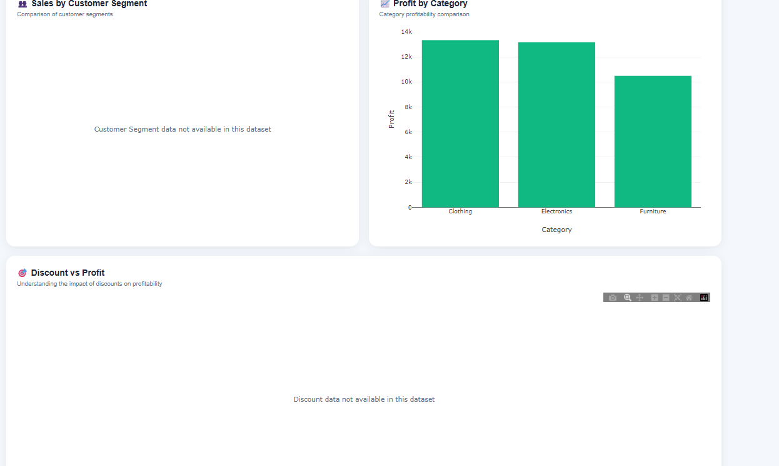
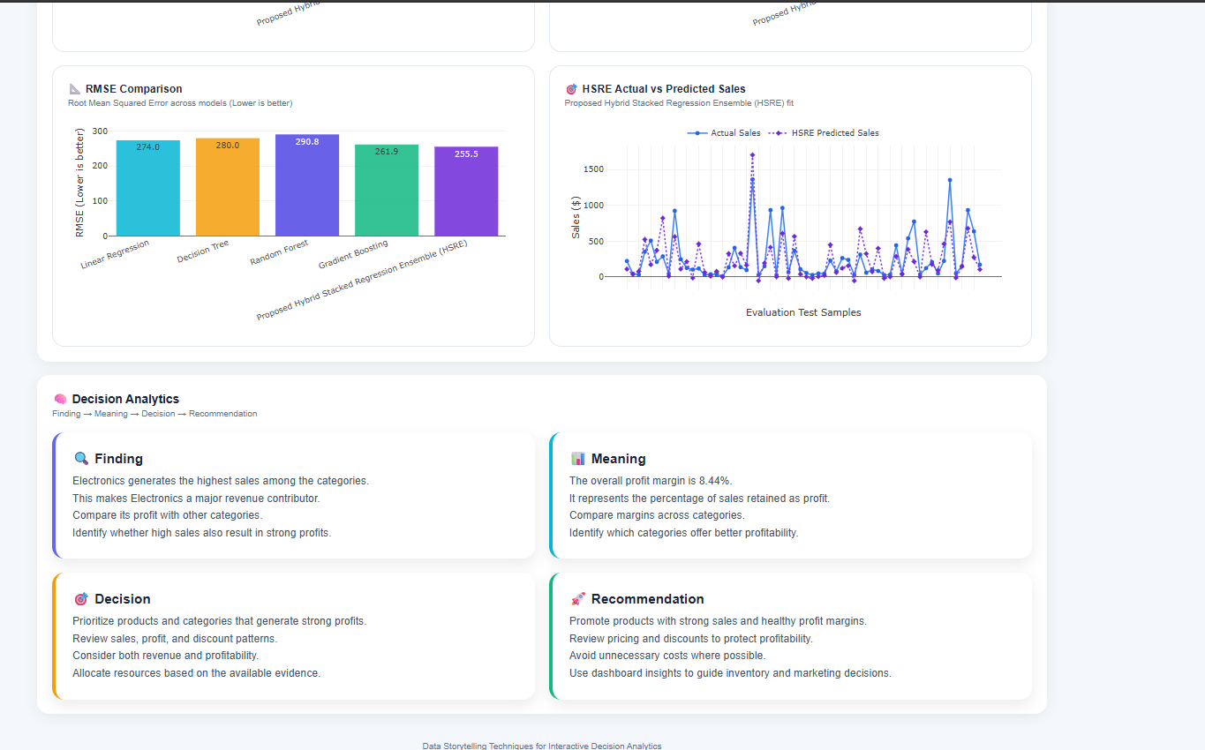
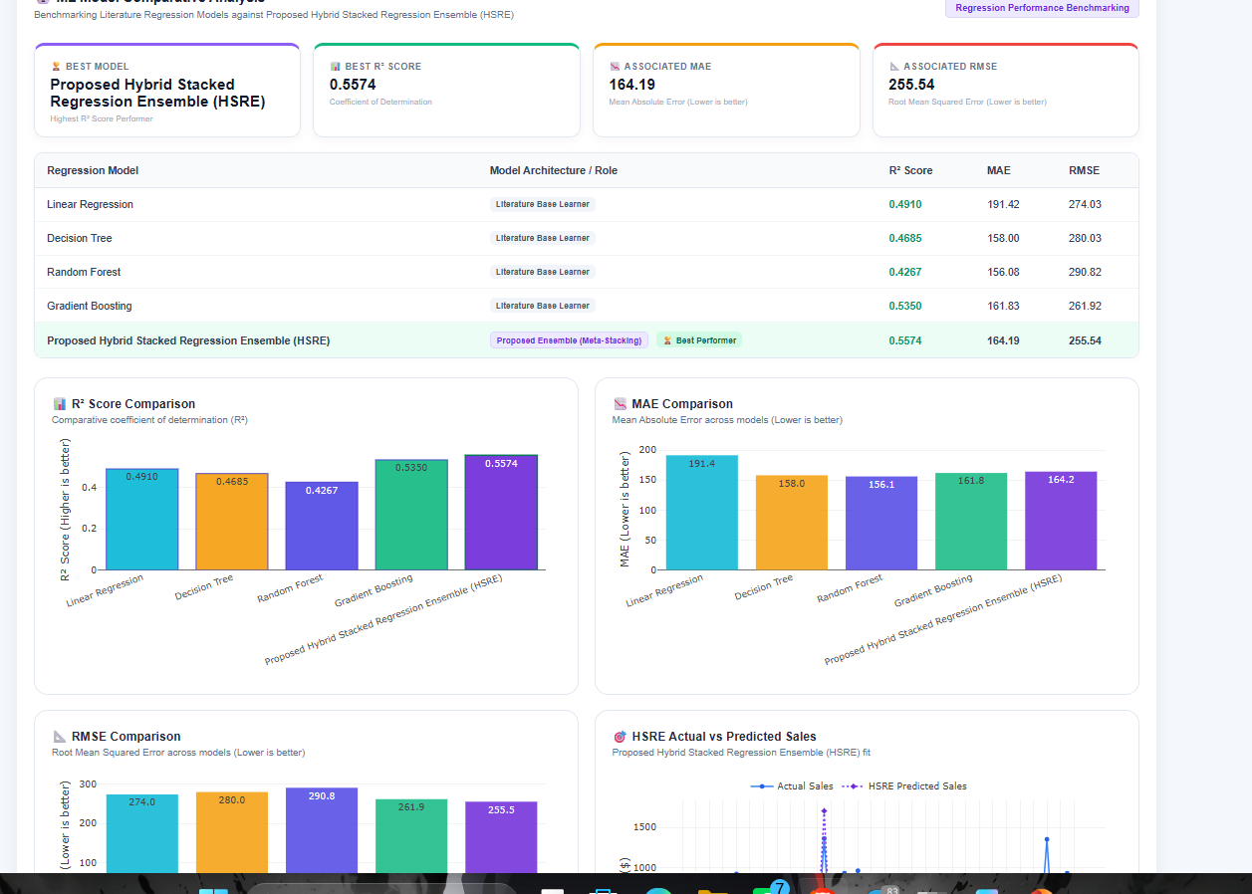
4)Super Market Dataset-
The dashboard visualizes supermarket sales and profitability using the available product and transaction information. The results help users examine performance patterns and identify categories that may require further business attention.

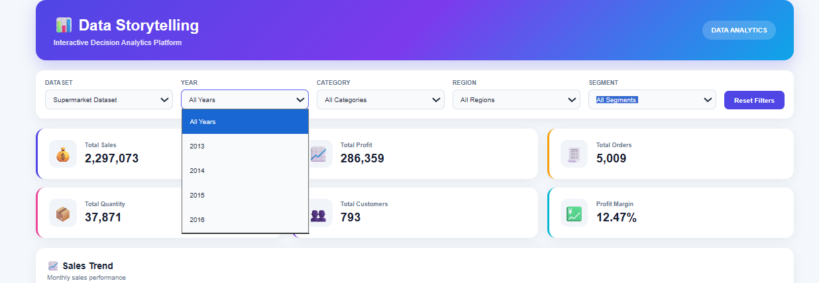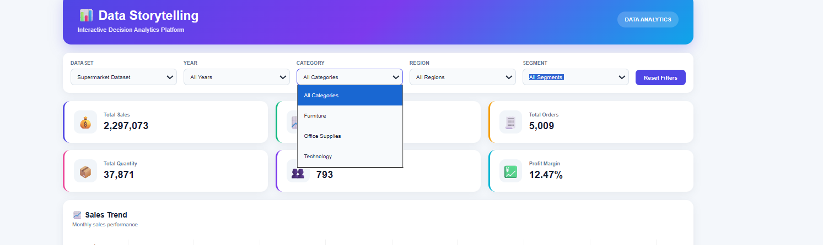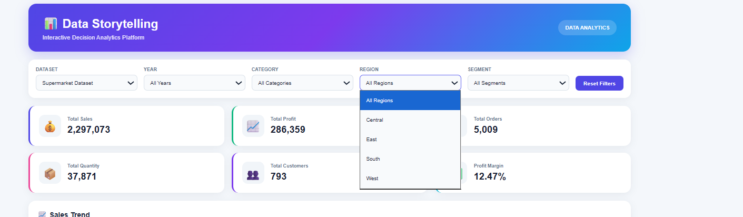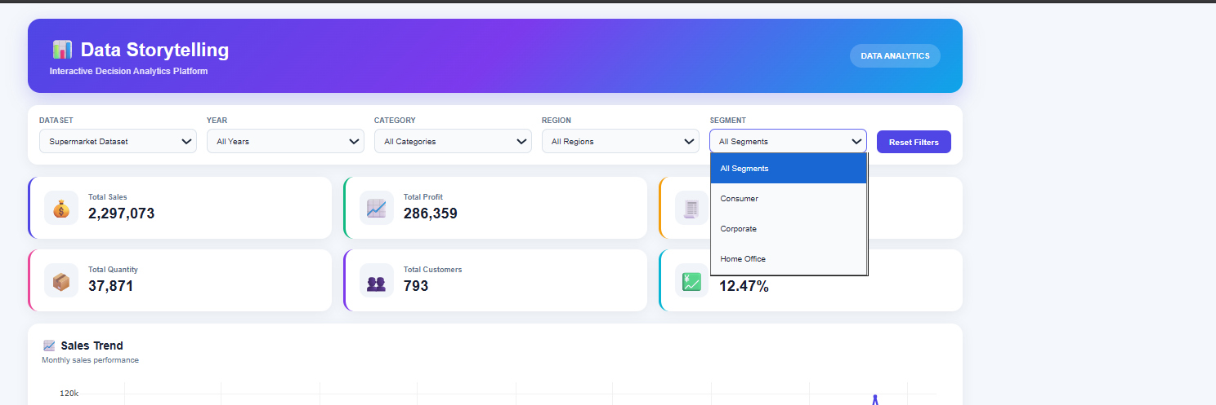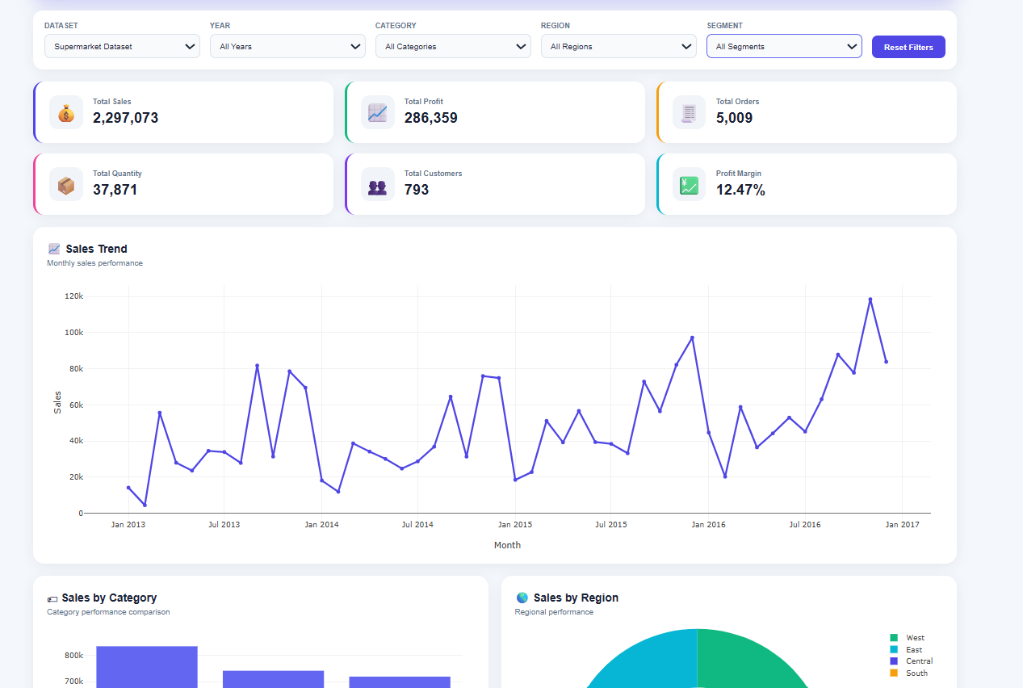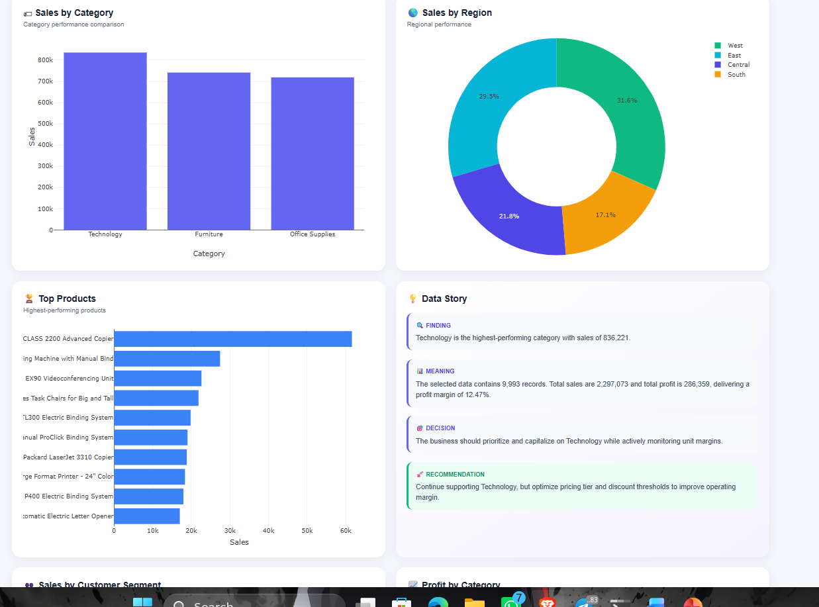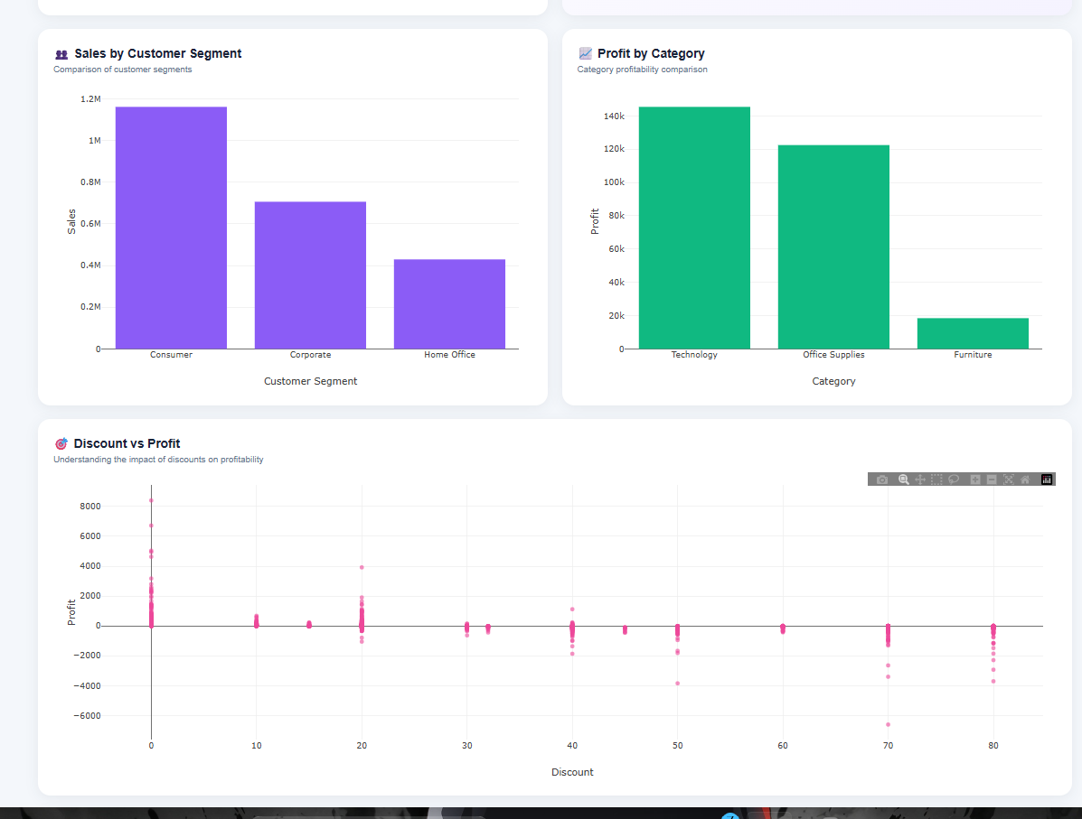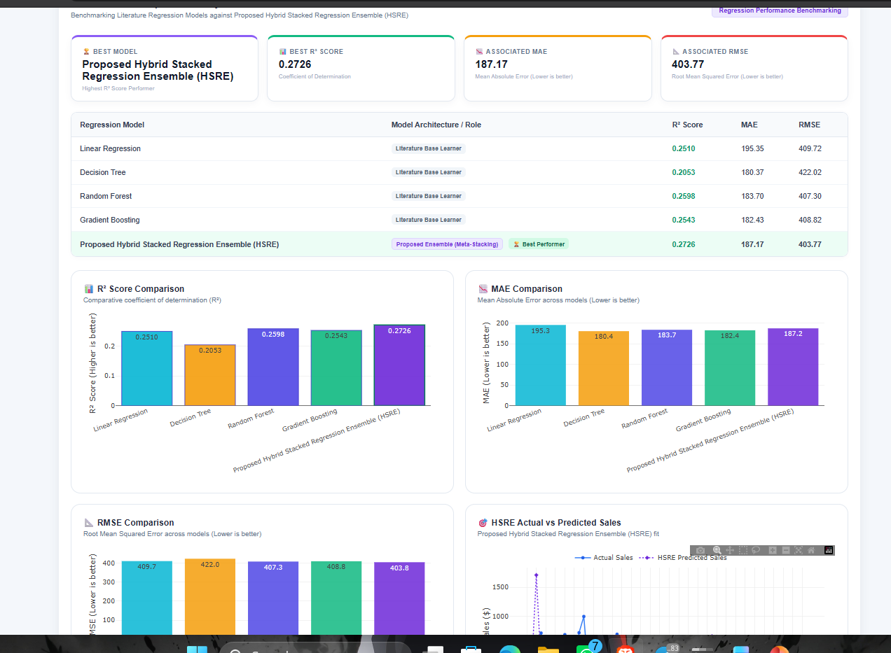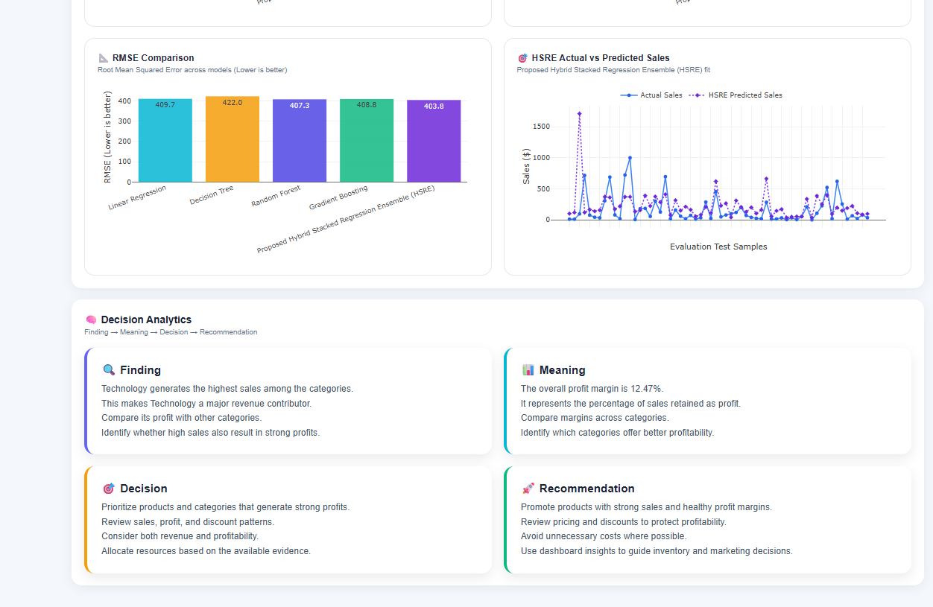
Comparative Regression Model Results
The comparative analysis evaluates Linear Regression, Decision Tree, Random Forest, Gradient Boosting, and the proposed HSRE model using R, MAE, and RMSE. The results show that the best-performing model varies by dataset and evaluation metric, demonstrating the importance of evaluating multiple models rather than relying on a single algorithm.
6. DISCUSSION
6.1 Interpretation of Findings
The results in Section 5 indicate that the dashboard's descriptive pipeline operates consistently across four structurally distinct datasets. KPIs adjust appropriately with dataset size; for instance, Global Superstore's larger customer base of 4,873 leads to a lot higher total sales and profit compared to Superstore's 804 customers. And, the dataset-aware filtering design effectively prevents the display of unsupported fields, such as Year for Online Sales. These findings support a positive answer to RQ1 and RQ3: the datasets were integrated without misrepresenting their contents, and the filtering behavior remained consistent and accurate across sources with varying schemas.
6.2 Comparison with Previous Studies
Consistent with the summary dashboard design principles articulated by Few, and with the dashboard taxonomy articulated by Sarikaya et al. [3], [7], the project's approach involves presenting at-a-glance KPI dashboards complemented with drill-down visualizations. Though, it ventures beyond the scope of that work along the trajectory recommended by Segel and Heer, and Kosara and Mackinlay [1], [2] in the same document that presenting information in a narrative form warrants a specific design effort in that it links its explicit data-driven decision-making structure to the dashboard data products rather than uses narrative storytelling as an add-on that occurs as an unsystematic, handcrafted product, as much narrative visualization work does in journalism. The qualitative comparison in Table 6 demonstrates where the system resides relative to static spreadsheet reporting and general-purpose BI tools [22][26]: it does not match a mature BI tool like Power BI or Tableau with raw interactivity, but it offers, at project scope, the two features that Section 2. 7 argued are Worth noting lacking in that literature: dataset-aware schema handling, and a real-time decision narrative.
6.3 Practical Implications
For business users, the main benefit of this design comes not from any individual chart, but from the combination of (a) reliable, dataset-specific KPIs, (b) filters that do not misrepresent what the dataset can answer, and (c) a narrative layer that clearly explains possible next steps for a manager. This approach is in particular relevant for small and mid-sized retail or e-commerce businesses that have multiple separate sales data sources and do not have enough analyst resources to manually create such narrative summaries for each one.
6.4 Limitations of the Approach
Because the Finding Meaning Decision Recommendation narratives are generated from rule-based logic applied to the currently filtered aggregates, their depth is inherently limited by the patterns that simple aggregation and comparison can reveal; they are not the result of statistical hypothesis testing or causal analysis, and should be considered as decision-support prompts rather than definitive business conclusions. And, since the four datasets are kept logically separate, the dashboard does not support genuine cross-dataset comparison within a single chart, which was a deliberate design choice to avoid creating a common schema, but this does limit certain types of portfolio-level analysis a user might otherwise want.
6.5 Unexpected / Important Observations
One notable observation during development was the scale of difference in customer counts between Superstore (804) and Global Superstore (4,873) despite both datasets sharing the same category structure (Furniture, Office Supplies, Technology); this reinforced the decision to keep KPIs dataset-specific rather than attempting to average or combine them, since a combined customer count or average order value across the two datasets would not correspond to any real, coherent business entity. Like that, the complete absence of a date field in Online Sales was a useful reminder, reflected directly in the dashboard's filter design, that "integration" of multiple datasets must mean preserving each source's actual capabilities rather than papering over their differences.
6.6 Interpretation of the Comparative Regression Results
Section 5. 13 presents a mixed outcome rather than a clear advantage for the proposed architecture. In line with the hybrid-forecasting literature discussed in Section 2. 8such as Mitra et al. 's result that a hybrid RF-XGBoost-LR model outperformed its individual baseline models on multi-channel retail demand data, and Yzbaolu's finding that an ensemble tree-based model outperformed linear regression on fashion-retail sales the HSRE design was based on the expectation that combining the four baseline learners through a meta-learning stage would equal or surpass the best individual baseline. The results shown in Table 7 only partially confirm this: The measured results offer mixed support for the HSRE architecture. On the Superstore dataset, HSRE outperformed Gradient Boosting on all three evaluation metrics and achieved higher R and lower RMSE than Decision Tree. It also recorded a lower MAE than Linear Regression. Though, Decision Tree achieved a lower MAE than HSRE, while Linear Regression achieved a higher R and lower RMSE. Random Forest also outperformed HSRE on all three metrics. These results suggest that stacking did not always improve the prediction performance on this data set.
A potential explanation is that both R2s are low in absolute terms across all five models (0. 120. 30), meaning that the features at hand only explain a relatively small portion of the variation in Sales for this dataset there's so much residual variance that a meta-learner trained on the base model predictions has relatively little actual signal to work with when deciding between them, and ends up averaging towards the weaker base learners (Decision Tree and Gradient Boosting, both of R2 below 0. 13) instead of tapping the stronger ones (Linear Regression and Random Forest). This would accord with the stacking literature's general warning that "an important prerequisite for the meta-learner is that the base learners need to have neither very low accuracy nor to be very similar to each other" [38], [39]: here, the correlated "weak but strong" errors from the two trees, the Gradient Boosting and the Decision Tree, might have negated each other and left only the "weak" errors from the linear and forest models. This outcome does not mean the comparison setup is broken: on this dataset, a simple linear baseline and a single ensemble baseline (Random Forest) was more
applicable to the features than the particular four-model stack considered (this is a valid and reportable result of the comparison, rather than a flaw in the evaluation method in sec. 3. 11. 4).
7. LIMITATIONS
- The Finding Meaning Decision Recommendation narratives displayed in the dashboard are still represented in a descriptive rule-anchored style from the level of the underlying aggregation logic and not the predictive engine; they should be read as suggestions or prompts to decision-makers.
- The baseline and HSRE regression models are trained and tested on historical data by the four datasets used for the descriptive analytics; it is not currently possible to retrain the models with real-time data and the predictions can not be interpreted as being valid outside of the range and distribution of the data used for training.
- The HSRE meta-learner increases training complexity and decreases interpretability compared to any individual baseline model. As noted in Section 5. 13, this additional complexity did not result in higher R or lower RMSE than
- Linear Regression or Random Forest on the dataset tested. Because of this, the advantages of stacking are not inherent to the architecture and rely on the accuracy and diversity of the particular base learners used.
- All five R values listed in Table 7 are relatively low (ranging from 0. 12 to 0. 30), showing that the current set of features accounts for only a small portion of the variation in Sales. This limits the accuracy that any regression model, whether baseline or hybrid, can achieve until more informative predictive features are developed.
- Since the four datasets vary for available columns and because of this the predictive feature set, and by extension the comparability of RMSE, MAE, or R when comparing across datasets, this results (Table 7) are given for one dataset's evaluation only and should not be taken as unchanged for the other three.
- The different datasets are not combined but rather compared independently, because of this not creating a common schema. Yet, it's not possible to compare datasets with a single view.
- Some KPIs and dimensions (e. g. Total Customers and Year for Online Sales) are not available for some datasets. This is communicated openly but restricts the level of analysis that can be performed for those datasets.
- The Finding Meaning Decision Recommendation stories are based on descriptive aggregation logic, not significance tests; because of this, they can be considered decision-support cues, but not formal statistical interpretations.
- The usability benefits for real business decision-makers have not yet been empirically measured, as this dashboard was assessed via manual checking of KPI accuracy and filter functionality, and not by a formal user study.
8.CONCLUSION AND FUTURE WORK
Conclusion
This work presented a web-based interactive analytics and data storytelling platform for analyzing heterogeneous sales datasets. Four sales datasets were integrated through dataset-aware preprocessing, schema normalization, feature engineering, KPI analysis, interactive visualization, and dynamic Finding–Meaning–Decision–Recommendation storytelling.
The predictive component evaluated four literature-based regression models—Linear Regression, Decision Tree, Random Forest, and Gradient Boosting—along with the proposed Hybrid Stacked Regression Ensemble (HSRE). The models were compared using R², MAE, and RMSE under a common evaluation procedure. The results showed that model performance varied across datasets. Linear Regression performed best on the Superstore Dataset, Gradient Boosting performed best on the Global Superstore Dataset, while HSRE achieved the strongest R² and lowest RMSE on the Online Sales and Supermarket datasets.
Overall, the proposed system demonstrates how interactive analytics, data storytelling, and comparative predictive modeling can be combined to support more informed and dataset-specific decision making.
Future Scope
The proposed solution can be extended in several ways. A possible extension of the platform is the inclusion of real-time or updated sales data to monitor sales trends, anomalies, and business performance. The predictive module can be improved by comparison with other machine and deep learning techniques and through systematic hyperparameter optimisation and cross validation.
Further research on the hypothetical HSRE system can be made by trying various base learners and meta-learners, to test if model diversity can boost the prediction accuracy for the various dataset. Subsequent versions can be made to allow for model selection and retraining based on the variations in the dataset.
The data story-telling feature can be further enriched by using higher-order natural-language-generation for real-time automatic generation of business explanations and recommendations with context. Explainable AI techniques can be added as well to clearly explain the model's prediction to the user.
Also, later releases could leverage automated data drift and model reliability monitoring, detection of data anomalies, and notifications when new data falls outside expected ranges. Cloud deployment and integration with enterprise data sources could increase scalability and allow the system to accommodate much larger, dynamic data sets.

DECLARATIONS
Funding
This project received no external or institutional funding.
Conflict of Interest
The authors declare no conflict of interest.
Ethics Statement
This project uses publicly available, de-identified retail sales datasets (Superstore, Global Superstore, Online Sales, and a Supermarket dataset) that contain no personally identifiable customer information beyond anonymised identifiers. No human subjects research was conducted.
Data Availability
The datasets used in this project (Superstore, Global Superstore, Online Sales, and Supermarket) are publicly available sample retail datasets commonly used for analytics coursework and can be made available on request.
Author Contributions
Rathanala Sai Charan contributed to system design, backend implementation, and data preprocessing. Sambu Sai Rishik contributed to dashboard frontend development and visualization design. Dasari Sujay contributed to data storytelling and decision analytics. K Sai Teja contributed to testing, validation, and manuscript preparation. All authors reviewed and approved the final manuscript.
ACKNOWLEDGEMENTS
The authors thank their course instructor and department for guidance and feedback throughout the development of this project.

REFERENCES
[1] E. Segel and J. Heer, “Narrative Visualization: Telling Stories with Data,” IEEE Trans. Vis. Comput. Graph., vol. 16, no. 6, pp. 1139–1148, 2010.
[2] R. Kosara and J. D. Mackinlay, "Storytelling: The Next Step for Visualization, " IEEE Computer, vol. 46, no. 5, pp. 4450, 2013.
[3] A. Sarikaya, M. Correll, L. Bartram, M. Tory, and D. Fisher, "What Do We Talk About When We Talk About Dashboards? " IEEE Trans. Vis. Comput. Graph. Vol. 25, no. 1, pp. 682692, 2019.
[4] H. Chen, R. H. L. Chiang, and V. C. Storey, "Business Intelligence and Analytics: From Big Data to Big Impact, " MIS Quarterly, vol. 36, no. 4, pp. 11651188, 2012.
[5] D. A. Keim, G. Andrienko, J. -D. Fekete, C. Grg, J. Kohlhammer, and G. Melanon, "Visual Analytics: Definition, Process, and Challenges, " in Information Visualization, Lecture Notes in Computer Science, vol. 4950 Berlin Germany: Springer 2008 pp. 154175.
[6] B. Shneiderman, "The Eyes Have It: A Task by Data Type Taxonomy for Information Visualizations, " in Proc. IEEE Symp. Visual Languages 1996 pp. 336343.
[7] S. Few, Information Dashboard Design: Displaying Data for At-a-Glance Monitoring, 2nd ed. Burlingame, CA: Analytics Press, 2013.
[8] C. N. Knaflic, Storytelling with Data: A Data Visualization Guide for Business Professionals. Hoboken, NJ: Wiley, 2015.
[9] B. Bach et al. "Dashboard Design Patterns, " IEEE Trans. Vis. Comput. Graph. 2022.
[10] D. J. Power, "A Brief History of Decision Support Systems, " DSSResources. com, version 4. 0, 2007.
[11] S. Wexler, J. Shaffer, and A. Cotgreave, The Big Book of Dashboards: Visualizing Your Data Using Real-World Business Scenarios. Hoboken, NJ: Wiley, 2017.
[12] E. R. Tufte, The Visual Display of Quantitative Information. Cheshire, CT: Graphics Press, 1983.
[13] W. S. Cleveland, The Elements of Graphing Data. Monterey, CA: Wadsworth Advanced Books and Software, 1985.
[14] S. K. Card, J. D. Mackinlay, and B. Shneiderman, Eds. Readings in Information Visualization: Using Vision to Think. San Francisco, CA: Morgan Kaufmann, 1999.
[15] C. Ware, Information Visualization: Perception for Design, 3rd ed. Waltham, MA: Morgan Kaufmann, 2012. [
16] T. Munzner, Visualization Analysis and Design. Boca Raton, FL: CRC Press, 2014.
[17] M. Bostock, V. Ogievetsky, and J. Heer, "D3: Data-Driven Documents, " IEEE Trans. Vis. Comput. Graph. Vol. 17, no. 12, pp. 23012309, 2011.
[18] J. Heer, M. Bostock, and V. Ogievetsky, "A Tour Through the Visualization Zoo, " Commun. ACM, vol. 53, no. 6, pp. 5967, 2010.
[19] H. Wickham, "A Layered Grammar of Graphics, " Journal of Computational and Graphical Statistics, vol. 19, no. 1, pp. 328, 2010.
[20] A. Satyanarayan, D. Moritz, K. Wongsuphasawat, and J. Heer, "Vega-Lite: A Grammar of Interactive Graphics, " IEEE Trans. Vis. Comput. Graph. Vol. 23, no. 1, pp. 341350, 2017.
[21] W. McKinney, "Data Structures for Statistical Computing in Python, " in Proc. 9th Python in Science Conf. (SciPy) 2010 pp. 5156.
[22] S. Negash, "Business Intelligence, " Commun. Assoc. Inf. Syst. Vol. 13, Art. 15, 2004.
[23] H. J. Watson, "Business Intelligence: Past, Present, and Future, " Commun. Assoc. Inf. Syst. Vol. 25, Art. 39, 2009.
[24] T. H. Davenport, "Competing on Analytics, " Harvard Business Review, vol. 84, no. 1, pp. 98107, 2006. [25] E. Turban, R. Sharda, and D. Delen,

