AI-Powered Handwritten Text Recognition System

A Project Report Submitted in
the partial fulfillment of the requirements for the award of the degree of

BACHELOR OF TECHNOLOGY
In

DEPARTMENT OF CSE
By
M. Satya Charan Reddy | 2420030166
R. Sai Charan | 2420030140
S. Sai Rishik | 2420030121

Under the Esteemed Guidance of

Dr. N. Sunanda
Associate Professor

Department of CSE

AY- 2026

Semester: ODD SEM


K L (Deemed to be) University
DEPARTMENT OF COMPUTER SCIENCE ENGINEERING

Declaration

We hereby declare that the project report entitled "Handwritten Digit/Character Recognition" is a record of the work carried out by Sai Charan (2420030140), Sai Rishik (2420030121), and M. Satya Charan Reddy (2420030166), submitted in partial fulfillment of the requirements for the award of the degree of Bachelor of Technology in Computer Science and Engineering at K L (Deemed to be) University.
We further declare that the work presented in this report is prepared by our project team. All external sources, research papers, datasets, libraries, and other resources used during the development of this project have been acknowledged appropriately.
The results and information presented in this report represent our project work and have not been submitted elsewhere for the award of any other degree or qualification.

Sai Charan – 2420030140
Sai Rishik – 2420030121
M. Satya Charan Reddy – 2420030166

K L (Deemed to be) University
DEPARTMENT OF COMPUTER SCIENCE ENGINEERING

CERTIFICATE

This is to certify that the project report entitled "Handwritten Digit/Character Recognition" is a bonafide work carried out and submitted by Sai Charan (2420030140), Sai Rishik (2420030121), and M. Satya Charan Reddy (2420030166), in partial fulfillment of the requirements for the award of the degree of Bachelor of Technology in Computer Science and Engineering at K L (Deemed to be) University during the academic year 2026–2027.

_____________________  Project Guide  Dr. N. Sunanda  Associate Professor, CSE | _____________________  Course Coordinator  Dr. N. Sunanda  Department of CSE | _____________________  Head of the Department  Dr.P. Venkateswara Rao  Department of CSE

ACKNOWLEDGEMENT

The success in this project would not have been possible but for the timely help and guidance rendered by many people. Our wish to express my sincere thanks to all those who has assisted us in one way or the other for the completion of my project.
Our greatest appreciation to my Course Coordinator and my guide Dr. N. Sunanda, Department of CSE which cannot be expressed in words for his/her tremendous support, encouragement and guidance for this project.
We express our gratitude to Dr.P. Venkateswara Rao, Head of the Department of Computer Science and Engineering for providing us with adequate facilities, ways and means by which we are able to complete this project-based Lab.
We thank all the members of teaching and non-teaching staff members, and also who have assisted me directly or indirectly for successful completion of this project. Finally, I sincerely thank my parents, friends and classmates for their kind help and cooperation during my work.

Sai Charan – 2420030140
Sai Rishik – 2420030121
M. Satya Charan Reddy – 2420030166

Abstract
Handwritten Digit/Character Recognition is an artificial intelligence-based project designed to identify handwritten digits and characters from image inputs and convert them into digital text. Handwritten information is commonly found in educational notes, examination papers, forms, and other documents. Manually converting such information into digital form is time-consuming and may result in errors.
The proposed system uses image processing and deep learning techniques to recognize handwritten digits and characters. Initially, the user uploads an image containing handwritten content. The uploaded image undergoes preprocessing operations such as grayscale conversion, noise removal, resizing, and normalization to improve the quality of the input before recognition.
A Convolutional Neural Network (CNN) is used to learn the visual patterns of handwritten digits and characters. The model identifies important features such as edges, curves, shapes, and strokes to classify the input image into the appropriate character or digit category. The system also aims to display a confidence score for each prediction so that users can understand how strongly the model supports its prediction.
An interactive user interface is planned to allow users to upload images and view the predicted characters along with their confidence levels. The project uses Python and technologies such as TensorFlow/Keras, OpenCV, NumPy, Pandas, Scikit-learn, Matplotlib, and Streamlit.
The proposed system aims to reduce manual effort, improve the speed of handwritten character recognition, and support the conversion of handwritten information into digital form. In the future, the system can be extended to recognize complete words, sentences, and paragraphs.
Keywords: Handwritten Character Recognition, Digit Recognition, Artificial Intelligence, Deep Learning, CNN, Image Processing, Python.

Index
S. No. | Chapters | Topics | Page.no
 |  | Acknowledgement
 |  | Abstract
1 | Introduction | 1.1 Background of the project  1.2 Problem statement  1.3 Scope of the project  1.4 Objective(s)  1.5 Importance of the application  1.6 Target users/audience | 1-10
2 | System Requirements | 2.1 Hardware requirements  2.2 Software requirements  2.3 Development tools and frameworks | 11-20
3 | Technology Stack | 3.1 Front-end (e.g., React.js, Angular, HTML/CSS)  3.2 Back-end (e.g., Node.js, Django, Spring Boot)  3.3 Database (e.g., MongoDB, MySQL, PostgreSQL)  3.4 Version Control (e.g., Git, GitHub)  3.5 APIs or External services (e.g., Firebase, Stripe) | 21-30
4 | System Architecture | 4.1 High-level architecture diagram  4.2 Description of each layer (frontend, backend, database)  4.3 Deployment architecture (e.g., cloud, local, CI/CD pipelines) | 31-35
5 | Design | 5.1 Wireframes or mockups  5.2 ER Diagram / Database schema | 36-42
6 | Implementation | 6.1 Module-wise implementation  6.2 Front-end logic (UI rendering, state management)  6.3 Backend logic (routes, controllers, business logic)  6.4 Database connectivity  6.5 API integration  6.6 Authentication & Authorization | 43-55
7 | Features | 7.1 List of main features  7.2 How each feature works (user perspective + technical description) | 56-60
8 | Testing | 8.1 Postman testing (frontend/backend)  8.2 Integration testing  8.3 Tools used for testing  8.4 Test cases and results | 61-67
9 | Deployment | 9.1 Steps to deploy  9.2 Environment configuration  9.3 Hosting of frontend and backend | 68-73
10 | Challenges & Limitations | 10.1 Issues faced during development  10.2 Solutions applied  10.3 Current limitations or known bugs | 74-80
11 | Future Enhancements | 11.1 Planned features  11.2 Possible integrations or optimizations | 81-88
12 | Conclusion | 12.1 Summary of the project  12.2 What was achieved  12.3 Skills learned during development | 89-100
13 | References | - Books, tutorials, APIs, documentation sites used
14 | Appendices | - Screenshots of the app  - Sample code snippets  - Installation/setup instructions  - User manual or guide  -certifications

CHAPTER 1
Introduction
1.1 Background of the Project
Handwriting is one of the most common methods of recording information. Even with the development of digital technology, handwritten documents are widely used in schools, colleges, offices, banks, and other organizations. These documents contain valuable information that may need to be converted into digital format for storage, editing, searching, and further processing.
Optical Character Recognition (OCR) is a technology used to convert text present in images into machine-readable text. However, recognizing handwritten text is more difficult than recognizing printed text because handwriting differs from person to person. The same character may be written in different shapes, sizes, orientations, and styles.
Handwritten Digit/Character Recognition uses artificial intelligence and deep learning techniques to identify handwritten characters automatically. In this project, a Convolutional Neural Network (CNN) is used to learn the patterns and features of handwritten digits and characters from image data.
The system accepts an image as input, performs preprocessing operations, and passes the processed image to the trained recognition model. The model predicts the corresponding digit or character and displays the result to the user.
The main purpose of this project is to reduce manual transcription effort and provide an efficient method for recognizing handwritten digits and characters.

1.2 Problem Statement
Recognizing handwritten digits and characters manually is a time-consuming process, especially when dealing with a large number of handwritten documents. Handwriting varies significantly between individuals in terms of shape, size, spacing, alignment, and writing style. These variations make automatic recognition difficult.
Traditional OCR systems may not provide accurate results when processing irregular handwriting, unclear images, or characters with similar visual structures.
Therefore, there is a need for an intelligent system that can automatically recognize handwritten digits and characters using image processing and deep learning techniques.
The proposed project addresses this problem by developing a CNN-based recognition system that processes handwritten image inputs and predicts the corresponding characters or digits.
1.3 Scope of the Project
The scope of the project is to develop an AI-based application that recognizes handwritten digits and characters from uploaded images.
The project includes the following functionalities:
- Uploading handwritten digit or character images.
- Processing images using image preprocessing techniques.
- Removing unnecessary noise and standardizing image dimensions.
- Recognizing handwritten patterns using a CNN model.
- Predicting the corresponding digit or character.
- Displaying the predicted output to the user.
- Showing prediction confidence where supported by the implementation.
The current project focuses on individual handwritten digits and characters. Recognition of complete words, sentences, and paragraphs can be considered as future enhancements.
1.4 Objectives
The major objectives of the project are:
- To develop an automated system for handwritten digit and character recognition.
- To preprocess handwritten images using suitable image processing techniques.
- To implement or integrate a Convolutional Neural Network for character classification.
- To identify handwritten patterns and classify them into appropriate categories.
- To display the predicted digit or character through an interactive interface.
- To evaluate the model using suitable performance metrics.
- To reduce manual effort involved in converting handwritten information into digital form.
1.5 Importance of the Application
Handwritten Digit/Character Recognition is useful because handwritten information is still widely used in many fields. Manually entering handwritten information into computers requires time and effort.
An automated recognition system can help reduce repetitive manual work and make handwritten information easier to process.
The application can be useful in:
- Educational institutions for digitizing handwritten notes and examination material.
- Offices for processing handwritten forms and records.
- Research applications involving handwritten data.
- Digital document management systems.
- Applications that require handwritten digit or character identification.
1.6 Target Users / Audience
The target users of this application include:
- Students: To convert handwritten digits and characters into digital information.
- Teachers and Educational Institutions: To support digitization of handwritten educational material.
- Researchers: To experiment with handwritten image recognition techniques.
- Organizations: To reduce manual effort in processing handwritten records.
- Developers: To understand and integrate deep learning-based character recognition systems.

CHAPTER 2

SOFTWARE REQUIREMENTS
2.1 Problem Statement
Recognizing handwritten digits and characters is challenging because handwriting differs from person to person. Manual conversion of handwritten information into digital text requires time and may result in errors. Therefore, an AI-based system is developed to identify handwritten digits and characters from uploaded images using image preprocessing and Convolutional Neural Networks (CNN).
2.2 Technologies used
1. Python
Python is the primary programming language used in this project. It provides libraries for image processing, machine learning, and deep learning.
2. TensorFlow and Keras
TensorFlow and Keras are used to develop and train the CNN model. The model learns handwriting patterns and predicts the corresponding digit or character.
3. OpenCV
OpenCV is used for image processing operations such as grayscale conversion, resizing, and noise reduction.
4. NumPy
NumPy is used for numerical calculations and handling image pixel values.
5. Pandas
Pandas is used for organizing and managing dataset information.
6. Matplotlib
Matplotlib is used to visualize images, training performance, and model evaluation results.
7. Streamlit
Streamlit is used to create an interactive application where users can upload handwritten images and view recognition results.
2.3 Software Used
2.3.1 Visual Studio Code (Code Editor)
Visual Studio Code is used as the development environment for writing, editing, and executing Python code. It supports Python extensions, debugging, and terminal operations, making project development easier.
2.3.2 Anaconda
Anaconda is used to manage the Python environment and install the required libraries for machine learning and image processing.
2.3.3 Jupyter Notebook
Jupyter Notebook can be used for experimenting with datasets, developing the CNN model, and testing image preprocessing operations.

CHAPTER 3

TECHNOLOGY STACK

The AI-Powered Handwritten Text Recognition System uses a combination of frontend technologies, backend frameworks, deep-learning models, and external services. These technologies work together to process handwritten images and convert them into digital text.
3.1 Front-end
The frontend is developed using the following technologies:
- HTML5: Used to structure the web application and create input and output sections.
- CSS3: Used to design the interface and provide styling.
- JavaScript: Handles user interactions, image uploading, camera input, canvas drawing, and displaying recognition results.
- Tailwind CSS: Used for responsive styling and interface design.
3.2 Back-end
The backend is developed using Python and Flask.
- Python: The primary programming language used for image processing and integration of the recognition model.
- Flask: A lightweight web framework used to handle image uploads, backend processing, and communication between the frontend and recognition model.
- Flask-CORS: Enables communication between the frontend and backend.
- Pillow (PIL): Used for loading and handling uploaded images.
- PyTorch: Used to execute the pretrained Transformer-based TrOCR model.
3.3 Database
The current system does not use a relational or NoSQL database.
- Uploaded images are processed in memory.
- Recognized text is returned to the user without permanently storing uploaded images.
- Evaluation samples and their corresponding labels are maintained using local files.
- A database such as MySQL or MongoDB can be integrated in the future to maintain user accounts and recognition history.
3.4 Version Control
- Git: Used to track source-code changes and manage different versions of the project.
- GitHub: Used to store the project repository, maintain source code, and support collaboration among team members.
3.5 APIs or External Services
The project uses the following external services and integrations:
- Hugging Face Hub: Used to download the pretrained Microsoft TrOCR model (microsoft/trocr-small-handwritten).
- Hugging Face Datasets: Used to access the IAM-line handwritten text dataset for model evaluation.
- Ollama with Qwen 2.5: An optional local AI service that can refine recognized text by correcting contextual spelling errors while preserving the original meaning.
- Internal REST API: Flask provides API endpoints that allow the frontend to send handwritten images to the backend and receive recognized text in JSON format.
These technologies provide an integrated environment for handwritten text recognition, image processing, model execution, and digital text generation.

CHAPTER 4
SYSTEM ARCHITECTURE
4. 4.1 High-Level Architecture Diagram
The proposed AI-Powered Handwritten Text Recognition System follows a layered architecture to convert handwritten images into digital text. The system consists of a frontend interface, backend processing module, image preprocessing module, Transformer-based HTR model, and output generation module.
The user provides handwritten input through image upload, drawing canvas, or camera input. The frontend sends the image to the Flask backend, where the image is validated and processed. The TrOCR model uses a Vision Transformer encoder and Transformer decoder to recognize the handwritten text. The extracted text is then post-processed and returned to the frontend for display.
4.2 Description of Each Layer
1. Presentation Layer (Frontend)
The presentation layer provides the user interface. It allows users to upload handwritten images, draw handwriting using a canvas, or capture text through a camera. It also displays image previews and recognized text.
2. Application Layer (Backend)
The application layer is developed using Python and Flask. It receives image data, validates the input, communicates with the OCR module, and returns the recognition results in JSON format.
3. Model Layer
The model layer uses the pretrained TrOCR model. Its Vision Transformer encoder extracts visual features from the input image, while the Transformer decoder generates the recognized text sequence.
4. Data Layer
The system does not use a relational or NoSQL database. Evaluation samples, labels, and the IAM-line dataset are used for model evaluation and performance measurement.
4.3 Deployment Architecture
The application is currently deployed locally. The Flask backend, TrOCR model, and optional Ollama service run on the same computer. Users access the application through a web browser.
The pretrained model is downloaded from Hugging Face during the initial setup and can subsequently run locally without depending on a paid cloud API. In the future, the application can be deployed using Docker, cloud platforms, and CI/CD pipelines.
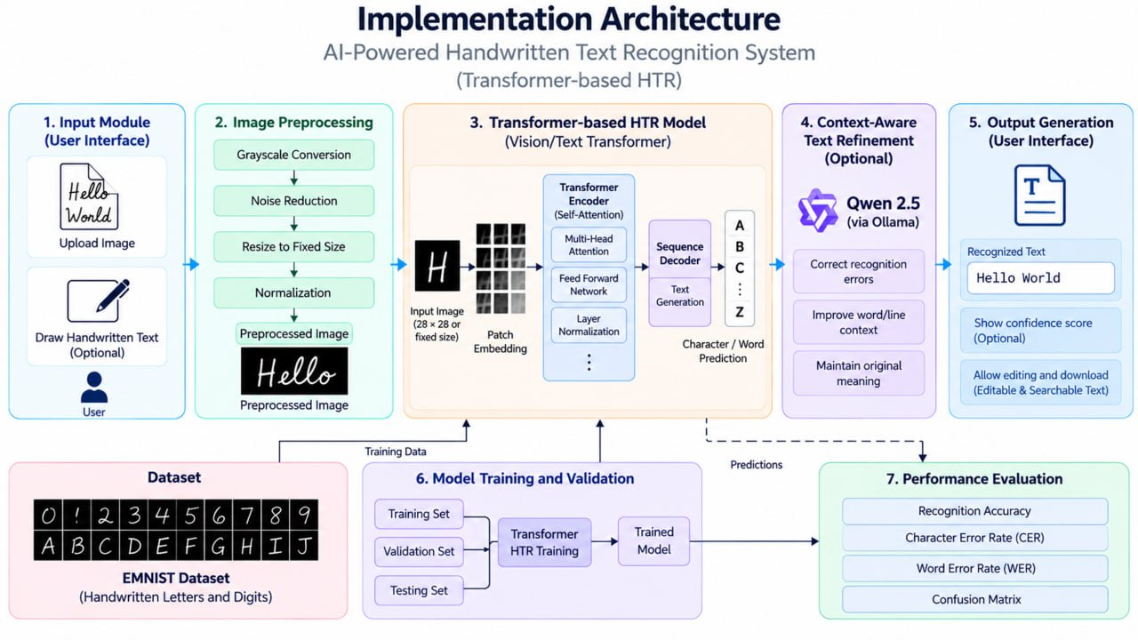

CHAPTER 5
DESIGN
5.1 Wireframes or Mockups
The system interface is designed to provide a simple and user-friendly experience. The main screen contains a title section and three input modes: Upload, Canvas, and Vision.
Main Interface Components:
- Header Section: Displays the application name and navigation options.
- Input Mode Selection: Allows users to select Upload, Canvas, or Vision mode.
- Source Module: Displays the uploaded image, captured camera frame, or drawn handwriting.
- Extraction Array: Displays the text recognized by the TrOCR model.
- Copy Option: Allows users to copy the extracted text.
- Result Section: Displays the final recognition output.
The wireframe helps define the arrangement of the input and output components before implementing the complete interface.
5.2 ER Diagram / Database Schema
The current application does not use a traditional database because uploaded images are processed in memory and are not permanently stored.
Therefore, a conventional Entity Relationship (ER) diagram is not required.
The logical data flow consists of the following components:
- User Input: Contains the uploaded image, canvas drawing, or camera frame.
- Image Data: Contains the image information transferred to the backend.
- Recognition Result: Contains the extracted text and confidence information.
- Evaluation Data: Contains labelled sample images and corresponding reference text.
- Evaluation Output: Contains CER and WER results generated during testing.
The evaluation samples are maintained using local files and labels.json. A database can be integrated in the future to maintain user accounts and recognition history.

CHAPTER 6
Implementation

6.1 Module-Wise Implementation
The system is divided into different modules to simplify development, testing, and integration.
1. Frontend Module
Provides the user interface and supports image upload, drawing canvas, camera input, and display of extracted text.
2. Image Input Module
Accepts handwritten images from the user through file upload, canvas drawing, or camera capture.
3. OCR Engine Module
Implemented in ocr.py. It validates input images, performs preprocessing, loads the TrOCR model, and generates recognized text.
4. Image Preprocessing Module
Prepares the input image by resizing, converting it into the required image format, and normalizing it before recognition.
5. Text Recognition Module
Uses the pretrained TrOCR model, consisting of a Vision Transformer encoder and Transformer decoder, to recognize handwritten text.
6. Text Post-processing Module
Processes the recognized output to improve formatting and readability. Optional Qwen 2.5 integration through Ollama can be used for contextual correction.
7. Evaluation Module
Uses evaluate.py and stream_evaluate.py to calculate Character Error Rate and Word Error Rate using labelled samples and the IAM-line dataset.
6.2 Front-End Logic (UI Rendering and State Management)
The frontend is developed using HTML, CSS, JavaScript, and Tailwind CSS.
The interface provides three input modes:
- Upload Mode: Allows users to select handwritten images from their computer.
- Canvas Mode: Allows users to write directly using a drawing canvas.
- Vision Mode: Allows users to capture handwritten text using a camera.
JavaScript handles user interactions, image preview, Base64 conversion, and communication with the backend using the Fetch API.
The application displays a loading indicator while recognition is in progress. Once the response is received, the extracted text is displayed in the result section with an option to copy it.
6.3 Backend Logic (Routes, Controllers, Business Logic)
The backend is developed using Python and Flask.
The backend performs the following operations:
- Receives image data from the frontend.
- Validates the image format and request size.
- Decodes the Base64 image data.
- Calls the OCR recognition function.
- Loads the TrOCR model if it has not already been loaded.
- Performs image preprocessing and text recognition.
- Generates the extracted text and confidence information.
- Returns the result to the frontend in JSON format.
The model is loaded once and reused for subsequent recognition requests to reduce processing overhead.
6.4 Database Connectivity
The current application does not require database connectivity.
Uploaded images are processed in memory and discarded after the response is generated. Evaluation data is maintained through local sample images and JSON labels.
In future versions, SQLite or MongoDB can be integrated to store user accounts and previous recognition results.
6.5 API Integration
The frontend communicates with the Flask backend through internal REST-style API endpoints.
The browser sends the image data in JSON format using Base64 encoding. The backend processes the image and returns the recognized text and confidence information.
The project also integrates the following services:
- Hugging Face Hub for downloading the pretrained TrOCR model.
- Hugging Face Datasets for accessing the IAM-line evaluation dataset.
- Ollama with Qwen 2.5 as an optional local text-refinement service.
6.6 Authentication and Authorization
The current application is designed as a single-user local application. Therefore, user login and role-based authorization are not implemented.
Basic security measures are included through image validation, file-size restrictions, pixel limits, and in-memory image processing.
If the application is extended for multiple users, token-based authentication using JWT or API keys and request rate limiting can be introduced.
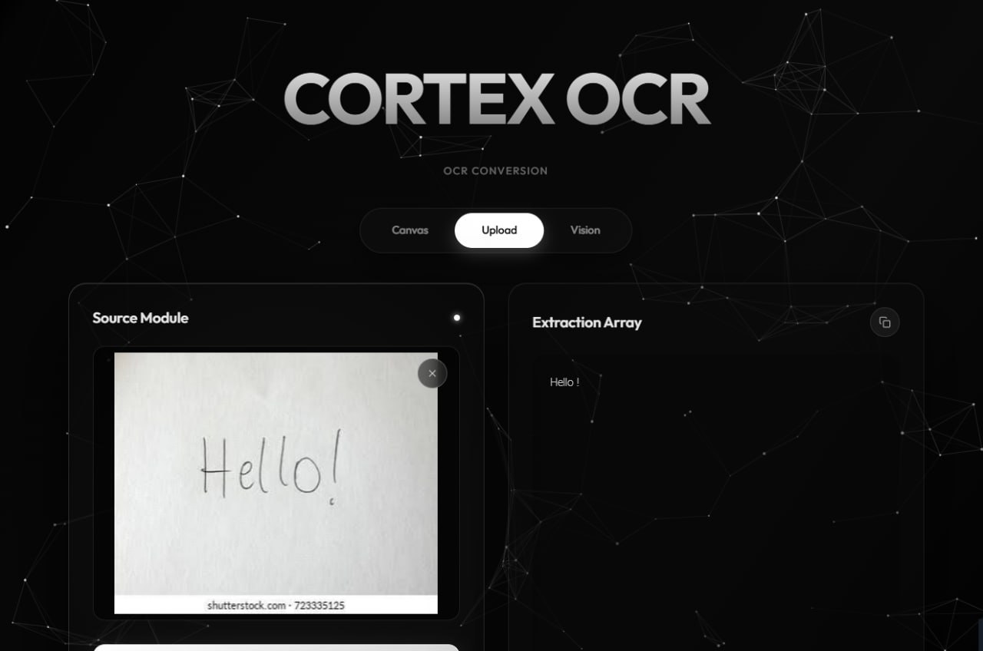

CHAPTER 7
FEATURES
7.1 List of Main Features
The proposed system provides the following features:
- Image Upload: Allows users to upload handwritten or printed text images.
- Transformer-Based Text Recognition: Uses the TrOCR model to recognize handwritten text.
- Image Preprocessing: Performs resizing, normalization, and image preparation.
- Text Extraction: Converts handwritten content into editable digital text.
- Live Camera Input: Allows users to capture handwritten text directly using a camera.
- Drawing Canvas: Allows users to write handwriting directly on the application.
- Text Post-processing: Improves the readability and formatting of recognized text.
- Optional AI Correction: Uses Qwen 2.5 through Ollama for contextual text correction.
- Model Evaluation: Measures recognition performance using CER and WER.
- Copy to Clipboard: Allows users to copy the extracted text.
7.2 How Each Feature Works
1. Image Upload
The user selects an image from the computer. The application displays a preview and sends the image to the backend for recognition.
2. Handwritten Text Recognition
The TrOCR model processes the input image. The Vision Transformer encoder extracts visual features, and the Transformer decoder generates the corresponding text.
3. Image Preprocessing
The system prepares the image by converting it into the required format, resizing it, and normalizing it before passing it to the model.
4. Text Extraction
The predicted tokens are converted into readable text. The extracted result is displayed in the application interface.
5. Live Camera Input
The user captures handwritten text using the camera. The captured frame follows the same preprocessing and recognition pipeline.
6. Drawing Canvas
The user writes directly on the canvas. The drawing is exported as an image and sent to the backend.
7. Text Post-processing
The recognized text is formatted and normalized. Optional Qwen 2.5 integration can help correct contextual spelling errors.
8. Model Evaluation
The evaluation scripts compare the predicted text with reference text and calculate CER and WER.
9. Performance Analysis
The system measures processing time and analyzes recognition errors to understand model performance.
10. Copy to Clipboard
Users can copy the extracted text for further editing, storage, or use in other applications.

CHAPTER 8
TESTING
The frontend and backend of the application are tested to verify that all components work correctly.
Frontend Testing:
The frontend is tested using a web browser to verify the following operations:
- Checking image upload functionality.
- Verifying image preview.
- Testing the drawing canvas.
- Checking camera input functionality.
- Verifying the display of extracted text.
- Testing the copy-to-clipboard option.
Backend Testing:
The Flask backend is tested by running the application and checking the API responses.
Python scripts and browser developer tools are used to identify errors, verify image processing, and check communication between the frontend and backend.
8.2 Integration Testing
Integration testing verifies the complete communication between the frontend, backend, and OCR model.
The testing process includes:
- Selecting or capturing a handwritten image.
- Converting the image into Base64 format.
- Sending the image to the Flask backend.
- Validating and preprocessing the image.
- Performing recognition using the TrOCR model.
- Returning the extracted text to the browser.
- Displaying the final output.
The optional Ollama integration is also checked to ensure that the main TrOCR recognition result remains available when the Ollama service is not running.
8.3 Tools Used for Testing
The following tools are used for testing and debugging:
- Web Browser: Tests the application interface and user interactions.
- Browser Developer Tools: Identifies frontend errors and monitors network communication.
- Python: Executes backend testing and evaluation scripts.
- evaluate.py: Evaluates recognition performance using labelled sample images.
- stream_evaluate.py: Evaluates the model using the streamed IAM-line test dataset.
- Python Logging: Helps identify model loading, preprocessing, and inference errors.
8.4 Test Cases and Results
The following test cases are used to verify the application.
Test ID | Test Scenario | Expected Result | Status
TC1 | Upload handwritten image | Recognized text displayed | Pass
TC2 | Upload unsupported file | Error message displayed | To be recorded
TC3 | Upload image larger than 8 MB | Request rejected | To be recorded
TC4 | Upload very small image | Validation error displayed | To be recorded
TC5 | Upload corrupted image data | Decoding error displayed | To be recorded
TC6 | Write on drawing canvas | Recognized text displayed | To be recorded
TC7 | Capture image using camera | Recognized text displayed | To be recorded
TC8 | Run accuracy evaluation | CER and WER values reported | To be recorded
The test cases help verify the correctness, reliability, and error-handling capabilities of the application. Final status values are updated after executing each test.

CHAPTER 9
DEPLOYMENT
The application is deployed locally using Python and Flask. The following steps are required to run the project:
- Install Python 3.10 or later and Git.
- Clone the project repository from GitHub.
- Open the project folder in Visual Studio Code.
- Create and activate a Python virtual environment.
- Install the required dependencies, including PyTorch, Transformers, Pillow, NumPy, Flask, Flask-CORS, and other required packages.
- Configure the environment variables using a .env file.
- Run the Flask application using the server.py file.
- Allow the TrOCR model to download during the first execution.
- Open the local server address displayed in the terminal using a web browser.
- Upload or capture a handwritten image and view the recognition result.
9.2 Environment Configuration
The project uses a .env file to maintain environment-specific configuration values.
The configuration includes the Flask server port and optional Ollama service address.
The application also maintains input restrictions to ensure safe processing:
- Supported image formats: PNG, JPG, JPEG, WEBP, BMP, and GIF.
- Maximum file size: 8 MB.
- Maximum image dimensions: 20 million pixels.
- Minimum image side: 8 pixels.
- Maximum processed text lines: 20.
- Minimum line confidence threshold: 0.40.
The .env file is excluded from Git version control to avoid exposing environment-specific configuration.
9.3 Hosting of Front-end and Back-end
The frontend and backend are hosted together through the Flask server.
The frontend files are maintained in the public folder, while the Flask backend handles image processing and TrOCR recognition.
The current application runs locally on the user's computer. In future, the application can be deployed on a cloud virtual machine or container platform. The frontend can also be hosted separately using services such as GitHub Pages or Netlify, while the Flask backend runs on a suitable server.

CHAPTER 10
CHALLENGES AND LIMITATIONS
10.1 Issues Faced During Development
During development, several technical challenges were identified:
- Handwriting Variations: Different writing styles make it difficult to recognize certain characters accurately.
- Similar Characters: Characters such as '0' and 'O', or '1' and 'l', can be confused.
- Multiple Text Lines: TrOCR processes one text line at a time, so multi-line images require separate handling.
- Model Loading Time: Loading the Transformer model requires memory and processing time, making the first request slower.
- Library Compatibility: Compatibility issues between PyTorch and Transformers versions caused execution errors.
- Dataset Download: Downloading the complete IAM dataset requires considerable storage and network resources.
- Poor Image Quality: Blurred, shadowed, or low-resolution images can reduce recognition quality.
10.2 Solutions Applied
The following solutions were implemented to address these challenges:
- Applied image resizing, normalization, and noise reduction.
- Introduced file-size, image-pixel, and text-line restrictions.
- Implemented confidence filtering to reject unreliable recognition results.
- Loaded the TrOCR model once and reused it for subsequent requests.
- Added compatibility checks and clear error handling.
- Used streaming to access the IAM-line dataset without downloading the complete dataset.
- Included optional Qwen 2.5 contextual correction to improve recognized text.
10.3 Current Limitations or Known Bugs
The current system has the following limitations:
- It is best suited for individual text lines and short handwritten content.
- Complex page layouts, tables, and mathematical expressions are not supported.
- Recognition accuracy may decrease for untidy handwriting and low-resolution images.
- The current implementation primarily supports English handwriting.
- CPU-only systems may experience slower recognition.
- User login and recognition history are not available.
- The application currently runs locally and has not been tested under multiple-user load.

CHAPTER 11
FUTURE ENHANCEMENTS
1.1 Planned Features
The system can be improved through the following future enhancements:
- Model Enhancement: Fine-tune the TrOCR model using larger and more diverse handwritten datasets to improve recognition accuracy.
- Multilingual Recognition: Extend the system to recognize regional languages such as Telugu and Hindi.
- Real-Time Recognition: Improve camera-based recognition for continuous handwriting input.
- AI-Based Error Correction: Integrate Qwen 2.5 through Ollama for contextual spelling and grammatical correction.
- Advanced Document Processing: Extend the system to support tables, forms, mathematical expressions, and multiple text regions.
- Cloud Integration: Deploy the application on cloud platforms to improve accessibility and scalability.
- Performance Optimization: Reduce model inference time and memory requirements.
11.2 Possible Integrations or Optimizations
Additional improvements can include:
- Integrating SQLite or MongoDB to store user accounts and recognition history.
- Using Docker for application containerization.
- Implementing CI/CD pipelines for automated testing and deployment.
- Applying model quantization or ONNX conversion to improve inference speed.
- Adding export options for recognized text in PDF, DOCX, and TXT formats.
- Introducing user authentication and role-based access for multi-user deployment.
These enhancements can make the application more scalable, efficient, and suitable for real-world document digitization.

CHAPTER 12

Conclusion and Future Aspects
1. Conclusion
The AI-Powered Handwritten Text Recognition System demonstrates the application of Transformer-based deep learning techniques for recognizing and extracting text from handwritten and printed documents. By utilizing the TrOCR model, which combines a Vision Transformer encoder and a Transformer decoder, the system converts input images into readable digital text.
The system incorporates image preprocessing, text recognition, post-processing, and performance evaluation using metrics such as Character Error Rate (CER) and Word Error Rate (WER). It provides a foundation for automating manual text transcription, reducing human effort, and improving document digitization.
Overall, the project demonstrates the potential of Transformer-based OCR technology in developing intelligent, efficient, and scalable text recognition applications.
2. Future Aspects
- Model Enhancement: Fine-tune TrOCR using larger and more diverse handwriting datasets to improve recognition accuracy.
- Multilingual Recognition: Extend the system to support multiple languages, including Telugu, Hindi, and other regional languages.
- Real-Time Recognition: Implement real-time handwriting recognition using live camera input.
- AI-Based Error Correction: Integrate Qwen 2.5 through Ollama to detect and correct contextual spelling and grammatical errors.
- Document Processing: Support complex documents containing tables, forms, mathematical expressions, and multiple text regions.
- Cloud Integration: Deploy the application on cloud platforms to provide scalable and accessible OCR services.
- Performance Optimization: Reduce inference time and computational requirements for faster recognition.
3. Expected Impact
- Reduce manual data-entry efforts.
- Improve accessibility of handwritten information.
- Enable efficient digital document management.
- Support automated processing of historical and educational documents.
- Provide a foundation for intelligent document understanding systems.

CHAPTER 13
REFERENCES

The following references can be included in your AIML project report on AI-Powered Handwritten Text Recognition using Transformer-Based OCR (TrOCR).
1. Li, M., Lv, T., Chen, J., Cui, L., Lu, Y., Florencio, D., Zhang, C., Li, Z., and Wei, F. (2023). TrOCR: Transformer-Based Optical Character Recognition with Pre-trained Models. Proceedings of the AAAI Conference on Artificial Intelligence, 37(11), 13094–13102. Research Paper.
2. Vaswani, A., et al. (2017). Attention Is All You Need. Advances in Neural Information Processing Systems (NeurIPS). Research Paper.
3. Dosovitskiy, A., et al. (2021). An Image Is Worth 16×16 Words: Transformers for Image Recognition at Scale. International Conference on Learning Representations (ICLR). Research Paper.
4. Marti, U. V., and Bunke, H. (2002). The IAM-database: An English Sentence Database for Offline Handwriting Recognition. International Journal on Document Analysis and Recognition, 5, 39–46. Research Paper.
5. Hugging Face. TrOCR Model Documentation. Hugging Face Transformers Documentation. Official Documentation.
6. Microsoft Research. TrOCR: Transformer-Based Optical Character Recognition. Microsoft UniLM GitHub Repository. GitHub Repository.
7. PyTorch. PyTorch Documentation. Official Documentation.
8. OpenCV. OpenCV Documentation – Image Processing and Computer Vision. Official Documentation.
9. Python Software Foundation. Python 3 Documentation. Official Documentation.

CHAPTER 14

Appendices

1.1 Index.html
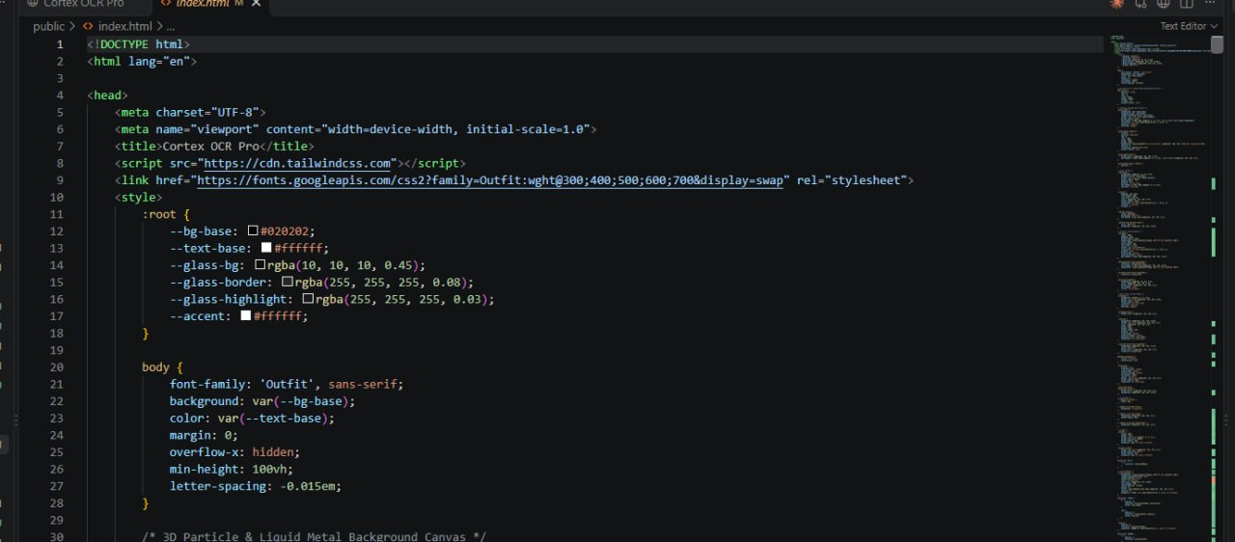

14.2 ocr.py
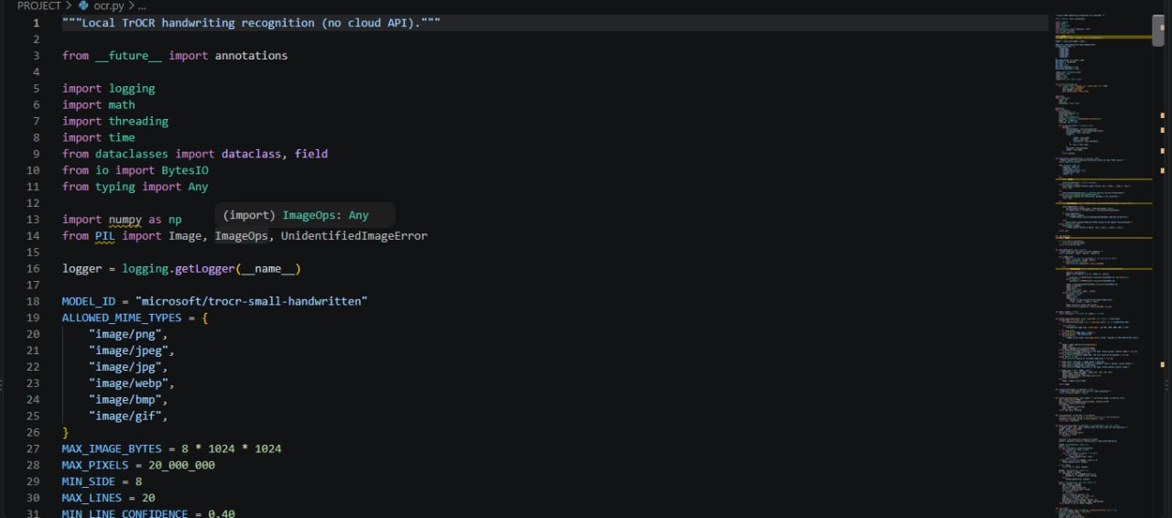

14.3 server.py
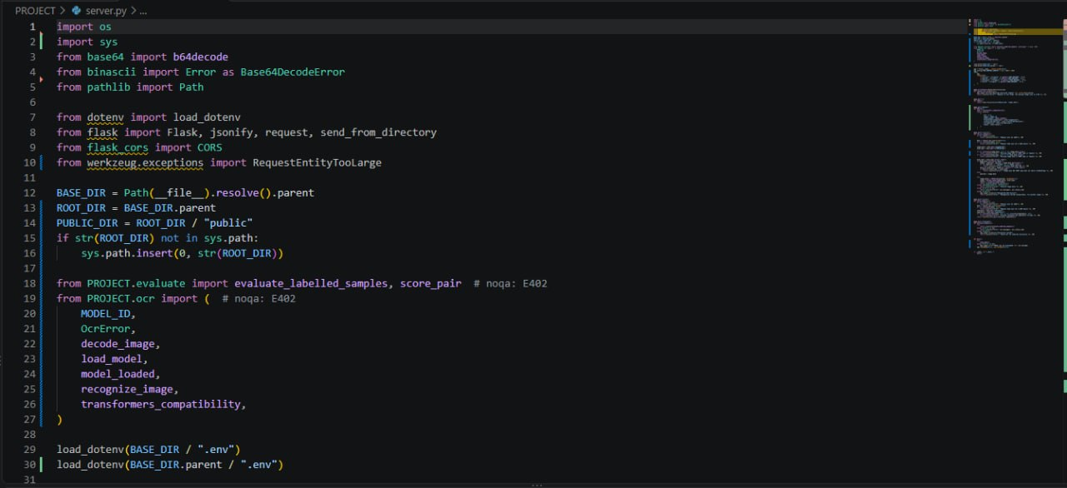

14.4 evaluate.py
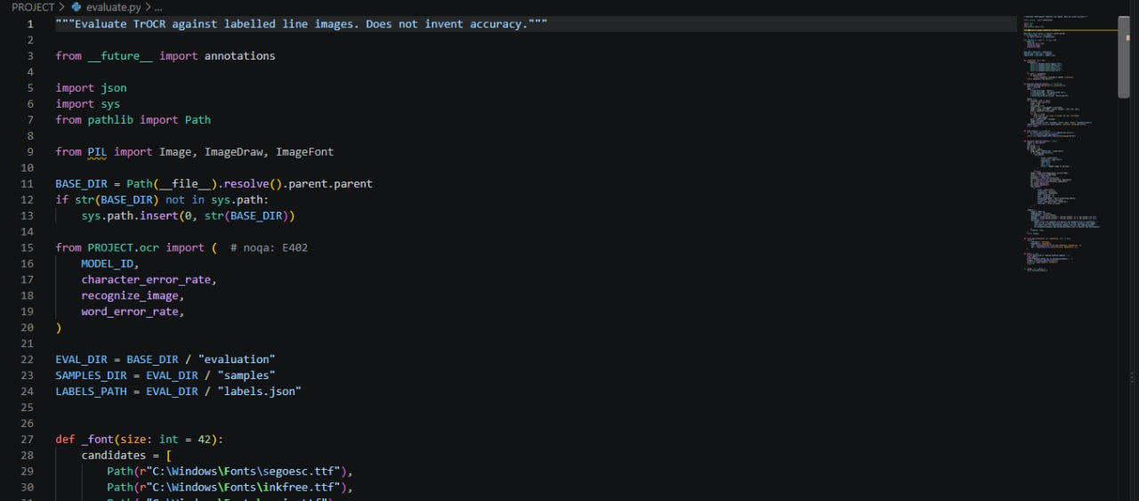
14.5 stream_evaluate.py
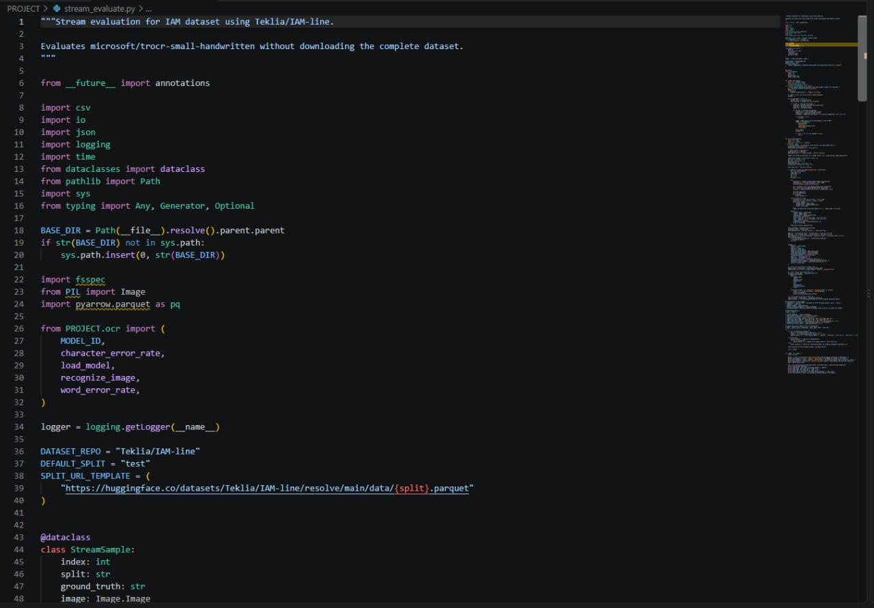

14.6 transformer workflow
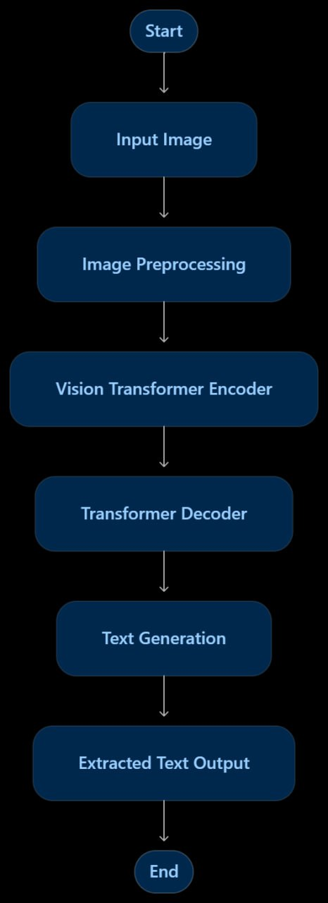

14.7 ML Evaluation Workflow
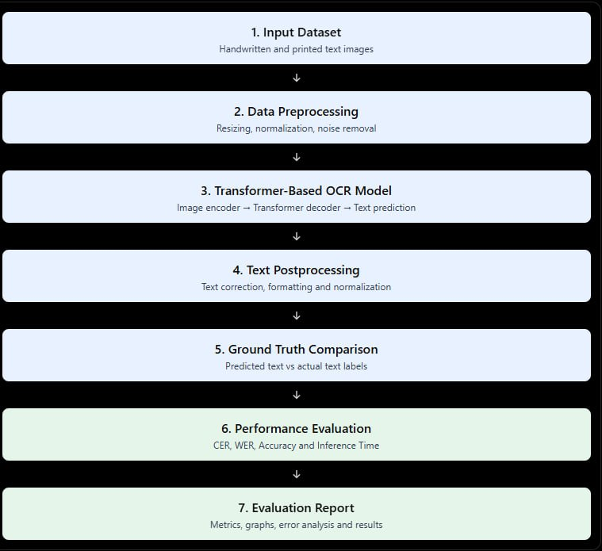

List of Main Features
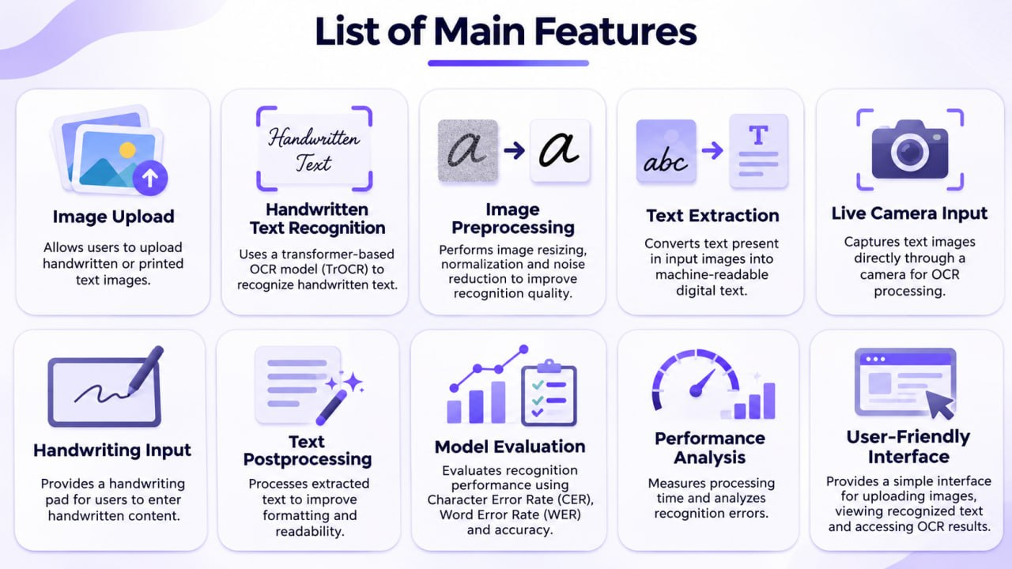

Output

