For the third ARM programming assignment there were new concepts applied. To start off here is the code written in Nano.

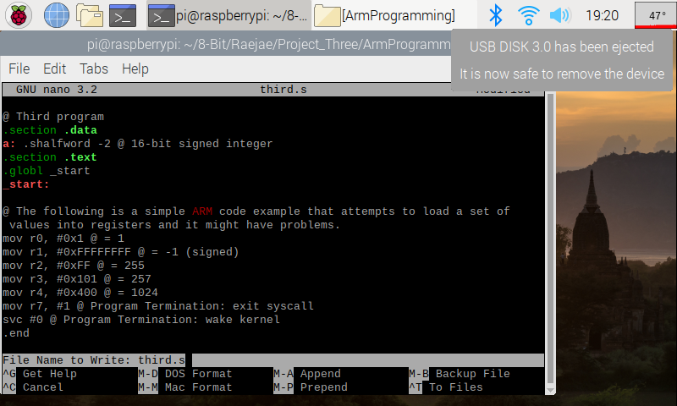

While programming I did come across a bug which was along the lines of Pseudo-op: ‘.shalfword’. This was fixed after swapping to .hword.   
I found out that this is because in ARM we automatically assign types to signed.

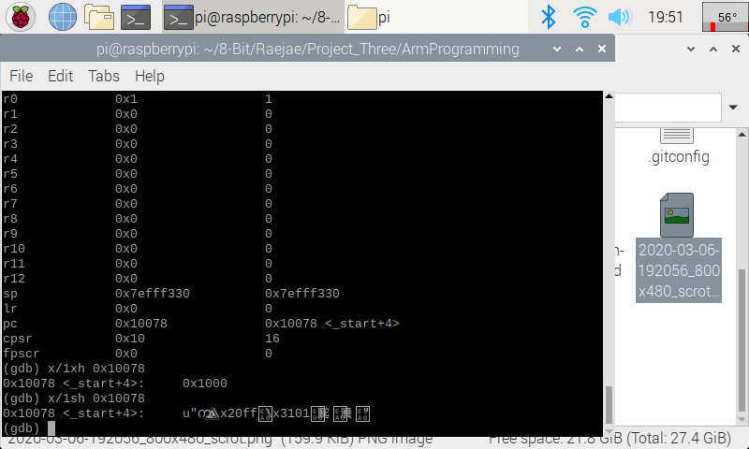

This code was fun to write and explore because you get to see the effect of working with signed numbers. For this one after opening, I used info registers to find the memory address. At B 7 the address is 0x10078. Using “x/1xh 0x10078” returned 0x1000 however on the call of x/1sh we get a new string format which is because of the signed word.

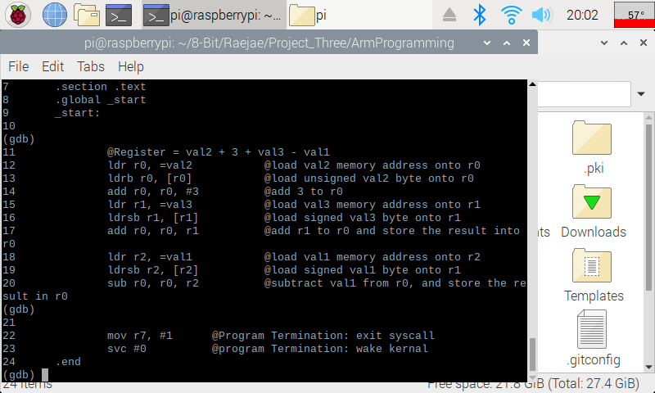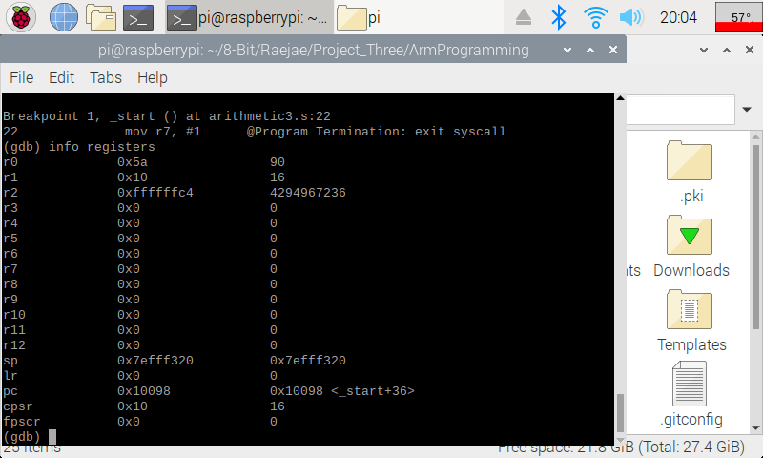

This is the code after running Aritmethic Three and the interesting concept is when we use signed values instead to get our result of 90. If we pay attention we see we get ff5a which gives a weird number; however, taking the complement gives us our true intended value.