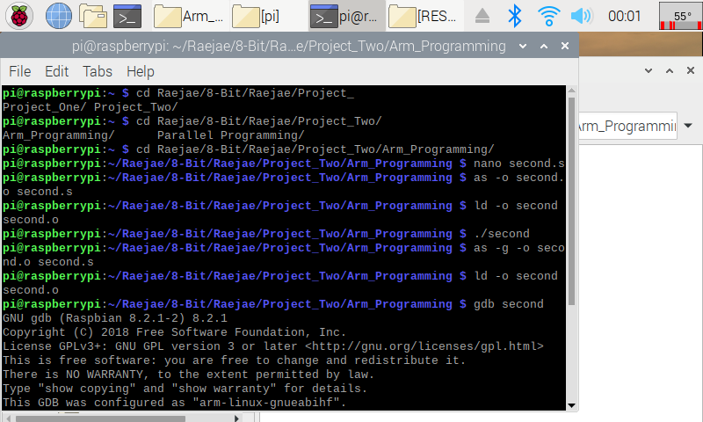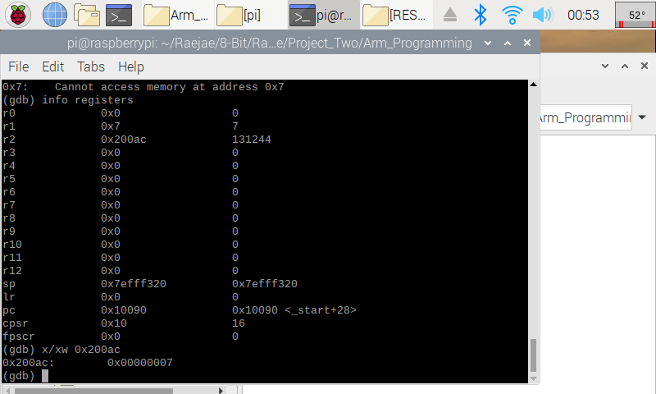

The setup for this code was very similar and its explanation is straightforward as we use register manipulation and addresses to display a word with hexadecimal. We introduced new concepts this time by stepping into breakpoints, and using address searches to locate numbers. In the code after running through the functions we run x/xw to tell our code to locate the hexadecimal in address 0x200ac. The address was found by searching (info registers) and then we confirmed that the value is indeed 7.

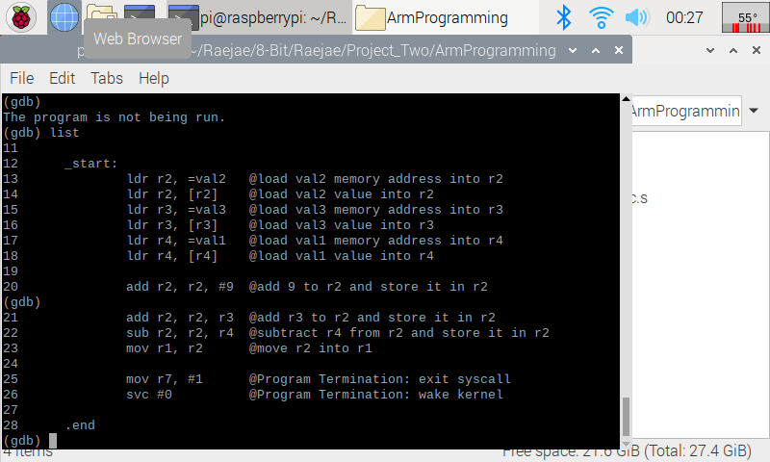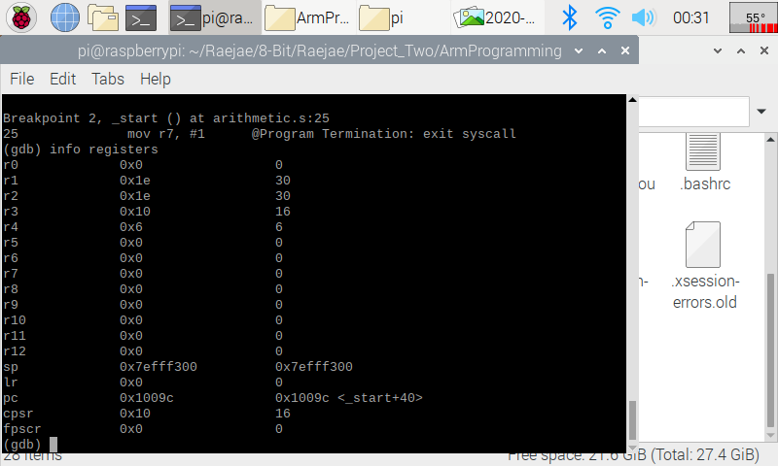

In this code we implemented the same functions, but the interesting concepts is how we loaded the variables into the registers to carry out our operations. By stepping into the final breakpoint we can see the output sets to 30 placing it into the first register after storing in each and placing the operations into registers we finalize our code by setting the result in r1.