# AppTy

1) Create a new Spring Starter(Boot) Project - AppTy

2) Download the src folder and replace it with src folder in workspace directory.

3) The documents structure must look like this

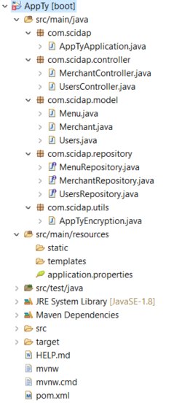

4) Also download the sql file and create databases.

5) Also replace pom.xml contents.

6) Now run AppTyApplication.java class as java application.

7) Below are the service calls:

1) To Create Users:

URL - POST - api/users/create

Body - {"username":"rohit.setty926@gmail.com","password":"password"}

2) To get Users:

URL - GET - api/users/get/{id}

3) To Validate:

URL - POST - api/users/validate

Body - {"username":"rohit.setty926@gmail.com","password":"password"}

4) To create merchants

URL - POST - api/merchants/create

BOdy - {"name":"karachi Bakery","location":"Kothapet","email":"karachibakery@gmail.com","contact_number":"8886728845","address":"hyderabad","menu_id":"12334"}

5) TO get merchants

URL - GET - api/merchants/get/{id}

6) To create menu

URL - POST - api/merchants/{merchant_id}/menu/create

Body - {"category":"Biryani","name":"Chicken Biryani","cost":"200","sellingPrice":"200","cuisineType":"Indian","description":"Chicken Biryani","mealType":"Non-Veg"}

7) To get menu of merchant

URL – GET - http://localhost:8080/api/merchants/{merchant_id}/menu/