Site: <https://jqueryui.com>

Go to download <https://jqueryui.com/download/>

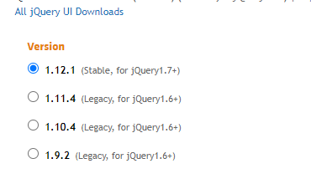

Theme🡪start

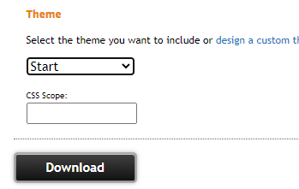

Zip file will be downloaded

Extract place on desktop

Folder name: jquery-ui-1.12.1.custom

Check for files

Css file 🡪jquery-ui.css

Js file 🡪jquery-ui.js

Js file 🡪jquery.js

References order

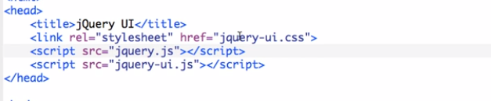

For online sources go to

Google search

<https://developers.google.com/speed/libraries>

go to ui for ui

<link rel="stylesheet" href="https://ajax.googleapis.com/ajax/libs/jqueryui/1.12.1/themes/smoothness/jquery-ui.css">  
<script src="https://ajax.googleapis.com/ajax/libs/jqueryui/1.12.1/jquery-ui.min.js"></script>

go to jquery for jquery

<script src="https://ajax.googleapis.com/ajax/libs/jquery/1.12.4/jquery.min.js"></script>

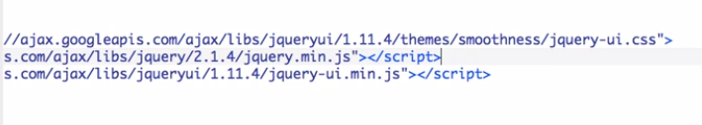

Theme smoothness change to start