Wordcount

Load the file in pig

B = LOAD ‘/home/acadgild/f1. txt’ AS(lines:chararray);

Dump B;

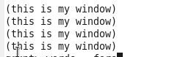

Words = foreach B generate flatten(TOKENIZER(line.’ ‘)) AS word;

Dump Words;

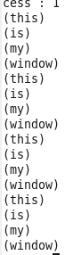

Grp = group Words by word;

Dump grp;

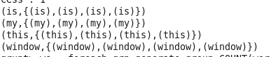

We = foreach grp generate group ,COUNT(Words);

Dump We;

