**Assignment 24.3:**

**Commands:**

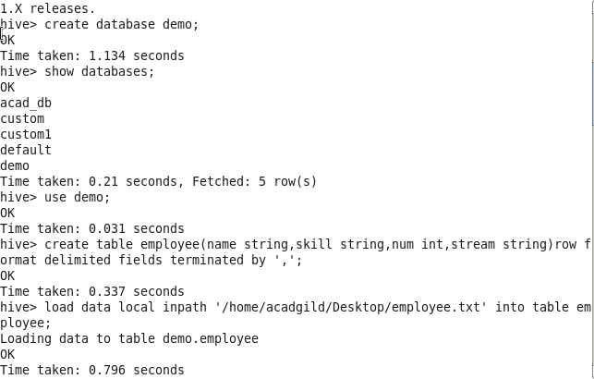

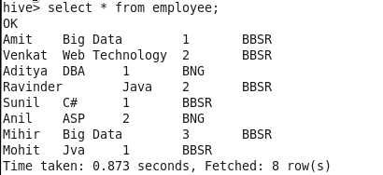

C:\Users\613000\Pictures\hive\24.3cmds3.PNG

**Output:**

