**SET DESCRIPTION**

**Column 1 : PassengerId**

**Column 2 : Survived (survived=0 & died=1)**

**Column 3 : Pclass**

**Column 4 : Name**

**Column 5 : Sex**

**Column 6 : Age**

**Column 7 : SibSp**

**Column 8 : Parch**

**Column 9 : Ticket**

**Column 10 : Fare**

**Column 11 : Cabin**

**Column 12 : Embarked**

**I Create database**

**C:\Users\613000\Pictures\hi\1.PNG**

**II create table**

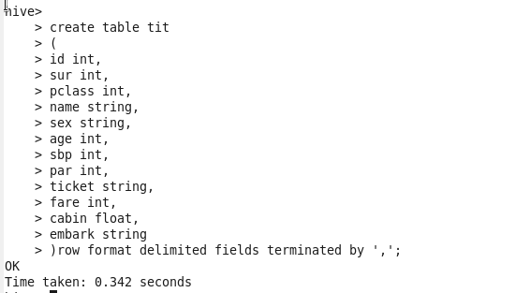

**III LOAD data in table**



**1.Write a hive query find the average age of male and female persons died in the titanic tragedy**

**C:\Users\613000\Pictures\hi\query.PNG**

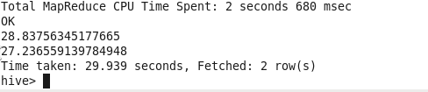

**2.Write a hive query to find the number of people died and survived in each class**

