**Assignment 24.5:**

1. **Create database pokemon;**
2. **Use pokemon;**

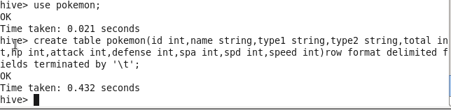

1. **Describe table;**

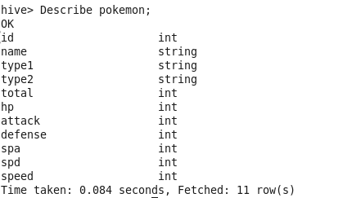

1. **load data**

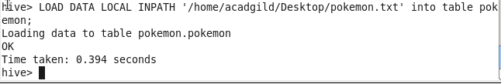

1. **Find out the average HP (Hit points) of all the Pokémons**

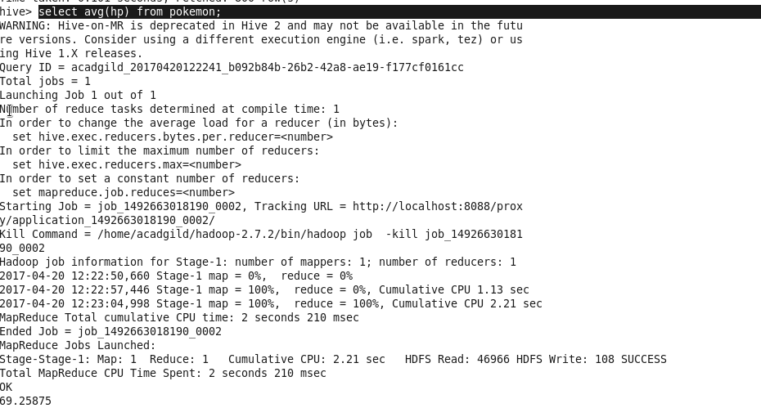

1. **Find out the average Defense of all the pokemon**

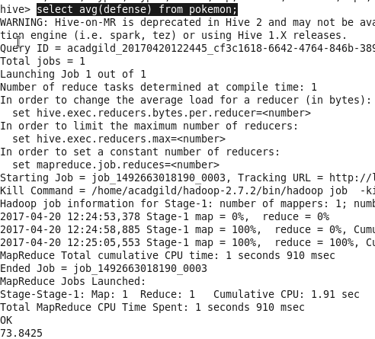

1. **Find out the average Sp.Atk of all the pokemons**

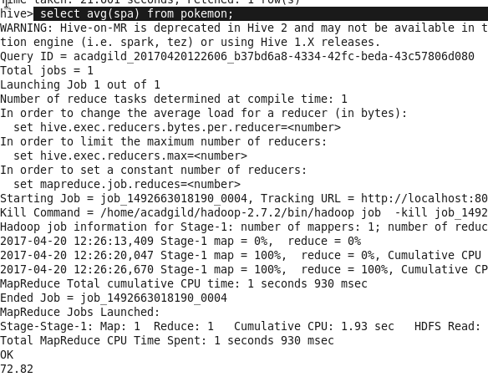

1. **Find out the average sp.Def of all the pokemons**

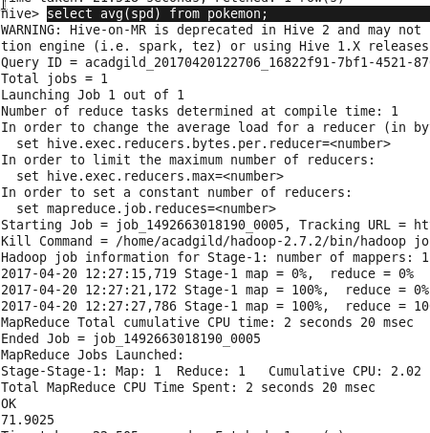

1. **Find out the average Speed of all the pokemons**

