FSDInputStream :

Utility that wraps a FSInputStream in a [DataInputStream](http://docs.oracle.com/javase/7/docs/api/java/io/DataInputStream.html?is-external=true" \o "class or interface in java.io) and buffers input through a [BufferedInputStream](http://docs.oracle.com/javase/7/docs/api/java/io/BufferedInputStream.html?is-external=true" \o "class or interface in java.io).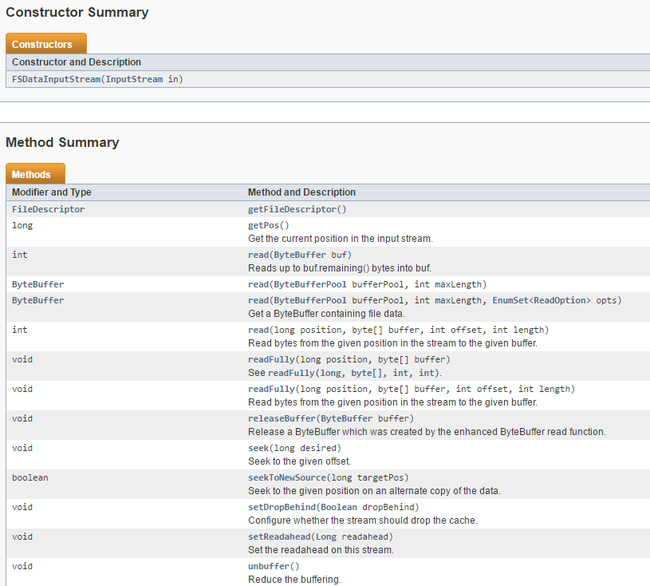

DFSInputStream • Handles communication of the namenode with various datanodes. • Handles integrity of data contained by the blocks. • Manages data read activity in case of datanode failure. • Called internally by FSDataInputStream.

FSDataOutputStream • Provides stream (channel) for writing data.

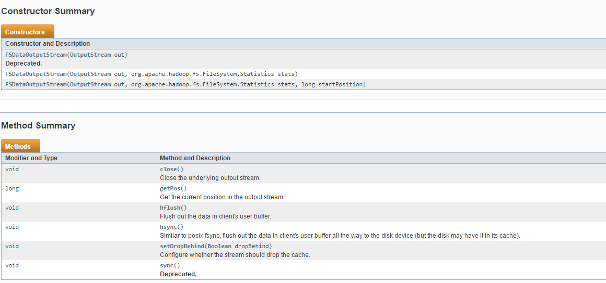

DFSOutputStream • Handles communication of the namenode with various datanodes. • Called internally by FSDataOutputStream.