Emp :

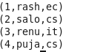

Dep:

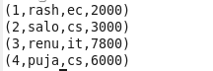

Inner join/Self join:

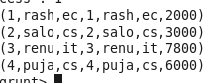

Right join:

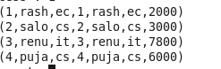

Left join:

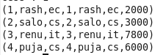

Outer join:

