Project SD701 : movie recommendation

1. Project description

The aim of the project is to provide movie recommandations, using the Movie Lens database. I want to propose alternative metrics and methodologies compared to what was done in TP1. Specifically, I develop two metrics : a similarity index (part 1), and a ratings system (part 2) based on linear regression. The project uses Spark, with extensive use of RDDs for part 1 and dataframes for part 2.

2. A first methodology : a similarity-based recommandation system

By contrast with TP1 where recommandations were based on user similarities, I propose here an alternative index based on movie similarities. Specifically, for any given user, I create a benchmark movie profile from his ratings history. I then calculate a similarity index bewween this benchmark and any other movie in the database. The recommandations obtain as the movies with the highest similarity index.

a) benchmark features

The calculation of the benchmark implies four features :

1/ the average release year of the movies rated by the user. This carries information about both the age of the user, and the period at which was released the kind of movies he likes. The database does not propose the release year as a base variable. It can however be obtained indirectly from the column « title » after some parsing, as each movie title is followed by the release year.

2/ the average of the ratings delivered by the user. This can look questionable as it may mostly reveal how strict the user is in his ratings. I believe however that it does carry useful information about tastes. For instance, a user systematically producing high ratings is likely to be little demanding and watch mostly blockbusters and wide audience movies. By contrast, a user producing a larger number of low ratings may be identified as a risk-seeking user, looking for less mainstream productions, with some disappointment. This assumes that ratings don’t represent only scores, but also contain information about how much mainstream a movie can be.

3/ the average number of ratings on the movies rated by the user. This also reflects how much mainstream or « wide audience » a movie is, and thus contains information about the type of movies appreciated by the user.

4/ the genres of movies rated by the user. This is self-explanatory : if a user tends to watch mostly movies from a few given genres (like action and horror), serving him with the same genre of movies will likely be more succesful than proposing a completely different genre (like romance).

b) calculation of the similarity index

The index is calculated as follows. Denote respectively by , and the average year, rating and number of ratings of movies from the target user. Also, denote by the vector of dimension 18 containing for each of the 18 possible genres the proportion of movies watched by the user corresponding to this genre. For any other movie m in the database, denote respectively by , and the release year, average rating and number of ratings for this movie, and by the 18-entry vector containing binary (0 or 1) values depending on whether the movie matches the corresponding genre of not. Denote by ,,and a set of four weight such that , and by and a set of positive curvature values. Then the index between u and m is given by :

The index comprises four elements. The first one considers the distance between the movie year of release and the benchmark year , normalised to 1 thanks to the arctan function. represents the curvature of the function, and for my purpose anvalue of 0.0005 proved reasonable. The second component considers the distance between the movie and benchmark ratings and . It is also normalised to obtain a maximum value of 1 when the rating for the movie and the benchmark are equal. The third component considers the distance between the number of ratings of the movie and that of the benchmark , again normalised with an arctan device. A curvature factor of proved good enough in this case. The final component is the genre similarity component. It is an average genre value compared to the benchmark. For instance, if movie m has genres action and adventures, and the benchmark has corresponding proportion coefficients of 0.34 and 0.42 for these two genres, then the average 0.38 similarity factor will be returned.

Finally, the set of weights ,,and ponderate how much importance is granted to each component and constrain the index value between 0 and 1. For simplicity, and to consider the impact of all components, I propose . These hyperparameters may however be tuned to apprehend different aspects of the recommandations.

c) Running the recommandation programme

Consider for example user 1 in the database. A sample of movies rated by this user is as follows :
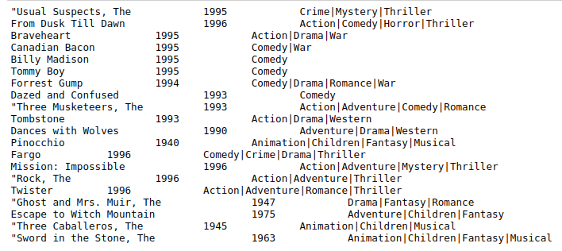
This user favours movies from the 1990’s, and a few older movies from the 1940’s and 1960’s. He has a taste for action, adventure, comedy, and animation movies. If certain movies in this list are very famous blockbusters, others are considerably less known : this user is open-minded and considers movies out of the main stream, with possibly a smaller audience.

Using my similarity-based recommander system, I obtain the following top 20 recommandations :

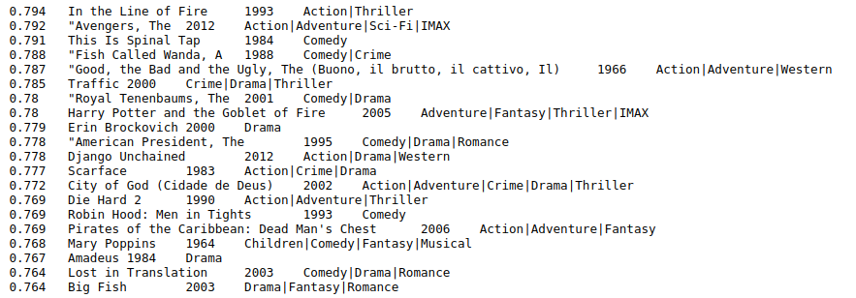
The recommandations follow closely the genres appreciated by the user : action, adventure and comedy. Animation movies seem to be left somewhat apart. The release years of the recommanded movies are also consistent with user 1 preferences : mostly around the 1990’s, with a bit of 1960’s and 1980’s. Here again, a few blockbusters (Avengers, Pirates of the Caribbean) side with other less famous movies. Overall, I would say this recommender system produces adequate recommandations.

3. A second methodology : a linear regression recommender system

The first methodology mostly focused on similarities between movies, and paid limited attention to the rating. As an alternative, I also propose a system based on ratings, building on the user personal preferences.

a) the model

I use a simple linear regression model which produces personalised The methodology goes as follows : each user is assumed to rate movies according to his own tastes or features. Those features are :

- the average rating received for this movie. Logically, the higher the average rating, the more likely is any specific user to like the movie as well. This amounts to explaining a rating with other ratings, and it may sound tautological. However, the average ratings represents only one factor among others, and the weight granted to this factor may vary from one user to another.

- the number of ratings . A user may appreciate movies with many ratings, reflecting a wide audience (blockbuster amateur) or on the contrary prefer movies which attract fewer people (author movie amateur). To remain scalable, this variable is switched to log value.
- the standard deviation of ratings on this movie. This carries information about the kind of movies appreciated : consensual movies with small standard deviation on ratings, or more controversial movies with larger standard deviation.

- the year of release of the movie. This reflects information on the age and tastes of the user, along with the style of the movie. To remain scalable, years are formulated as difference from reference year 2000 (so for instance th value for a 1996 movie is -4) .

- the genres of the movie. The database identifies 18 of them, resulting in 18 dummy variables . Because there is one dummy for each genre, the constant is omitted in the regression.

Denoting bythe rating attributed to movieby user, this produces the following regression :

b) estimation

For a given user, the model is trained on the movies rated by the user, using his personal ratings as . Once the set of coefficients and the series of coefficients are estimated, the model can be applied to all the movies not visioned by the user. Predicted ratings are then obtained, and recommandations can be produced based on the highest values.

c) Running the recommandation programme

As a comparison exercise, it is interesting to consider again user 1. After training the model, one obtains the following set of coefficients :
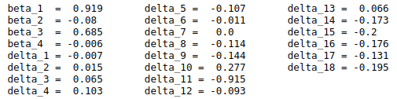

The coefficients are informative on their own. First, shows that user 1 attributes significant weight to other user ratings, but nevertheless reacts less than one to one. Thus, other factors matter for his personal ratings. and show that user 1 likes less movies rated by many people and more movies with high variance on the ratings. This is clearly the sign of a profile oriented towards controversial, or author movies. The slightly negative coefficient finally establishes that user 1 prefers older movies, though this is not very strong. The set of genre coefficients eventually reveals a user appreciating the genres « animation », « children », « film noir » and « mystery » (et ) .

Using the trained model, the top 20 recommandations for user 1 are :

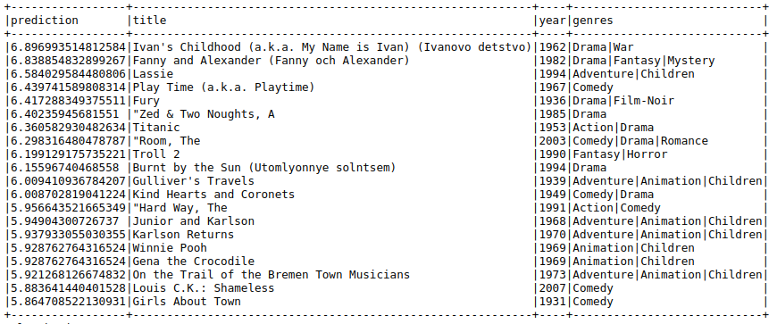

The recommandations are overall consistent with the identified profile of user 1 : movies that are not very recent, many of them entering the categories children or animation. Hardly any « film noir » or « mystery » movies are yet to be found in this top 20, a sign that other factors play a significant role. Also, only a few blockbusters appear on the list, confirming the taste of user 1 for more undergournd movies. In this respect, the propositions are consistent with those produced in part 1 of the exercise, though this second recommendation system seems definitiely more « animation » and « children » oriented for user 1.

4. Overall conclusion

I have proposed two alternative recommender systems for movies based on the movie lens database. The two systems seem consistent in terms of the type of movies they recommend, even though the specific titles proposed are not the same.

I can find both strenghts and weaknesses in these two recommender models. Unlike many other systems, they stick closely to the user profile and don’t seem biased towards succesful commercial blockbusters. In this respect, they support diversity more than competing recommenders. But this may in fact also represent their main weakness. From a commercial point of view, the movies recommended are not necessarily very famous and little likely to generate high volume of sales.

For movie amateurs, these systems are probably adequate, but for professional from the movie industry, they probably offer too limited commercial perspectives.

The sum of the vector entries may exceed 1 given that most movies have several genres listed.

