Insights on inventory Items

# Category wise Products

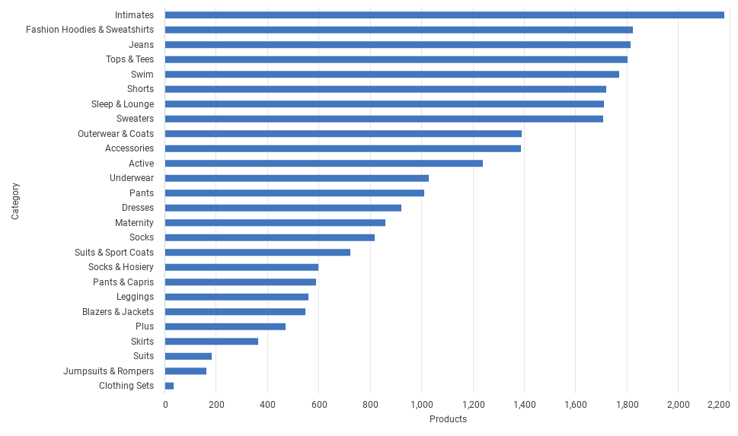

# Inventory Items Created over Time

