Does sunshine make people happy?

F. Rodriguez-Sanchez

Thursday, 17 November 2016

## Introduction

It is well known that individual well-being can be influenced by climatic conditions (**???**, **???**). However (Drew et al., 2013), …

## Methods

We collected data on 99 individuals and fitted a linear model.

## Results

We found that…

|  |  |  |  |  |
| --- | --- | --- | --- | --- |
|  | Estimate | Std. Error | t value | Pr(>|t|) |
| (Intercept) | -0.0704830 | 0.4248716 | -0.1658924 | 0.8685869 |
| sunshine | 0.0100304 | 0.0004218 | 23.7790806 | 0.0000000 |

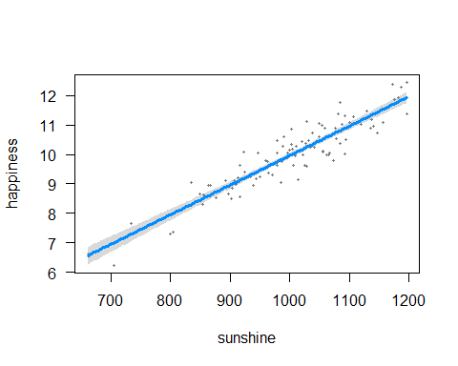

## Discussion

These results confirm that sunshine is good for happiness (slope = 0.0100304).

## Acknowledgements

Y. Xie, J. MacFarlane, Rstudio…

## References

Drew, B.T., Gazis, R., Cabezas, P., Swithers, K.S., Deng, J., Rodriguez, R., Katz, L. a, Crandall, K. a, Hibbett, D.S., Soltis, D.E., 2013. Lost Branches on the Tree of Life. PLoS Biology 11, e1001636. <https://doi.org/10.1371/journal.pbio.1001636>