**LED test:**

Purpose for the test is to test LED. **Expected result**: When button is pressed LED lights up. 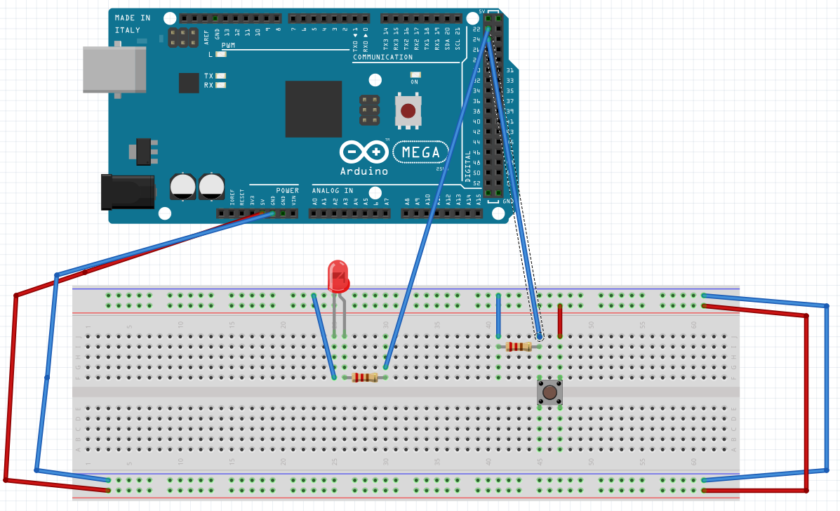

**Code in Arduino.cc:**

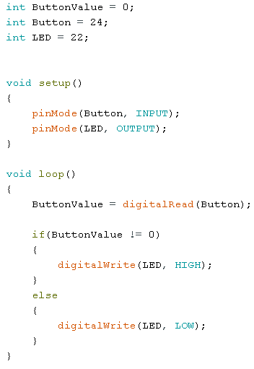

**Result:**

Result as expected. When the button is pressed LED lights up.