**PIR Movement sensor test with LED:**

Purpose for the test is to test PIR Movement sensor with LED**. Expected result**: When there is movement the LED lights up.

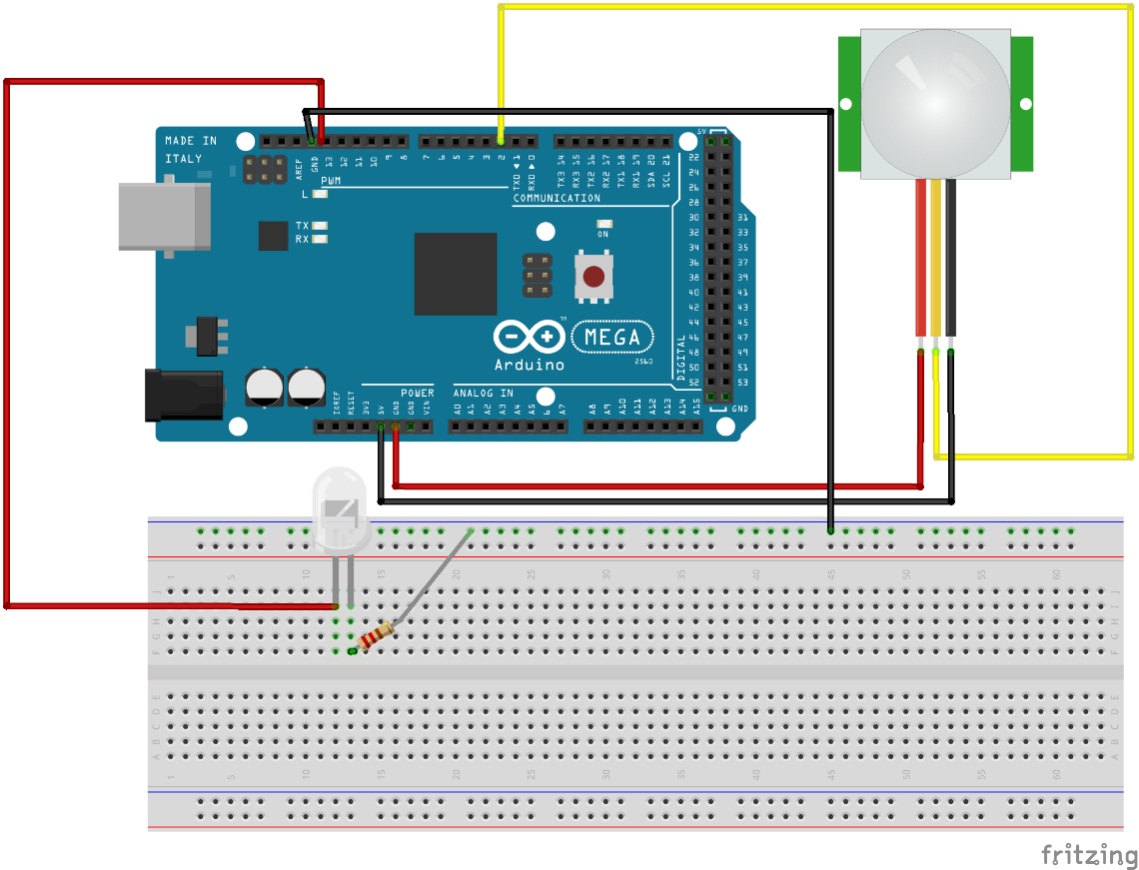

**Code in Arduino.cc:**

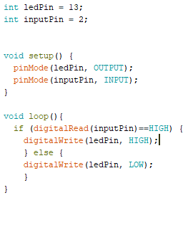

**Result:**

Result as expected. When there is movement LED light up.