**PIR Movement sensor test with LED:**

Purpose for the test is to test PIR Movement sensor with LED**. Expected result**: When there is movement in front of PIR Movement sensor the LED lights up.

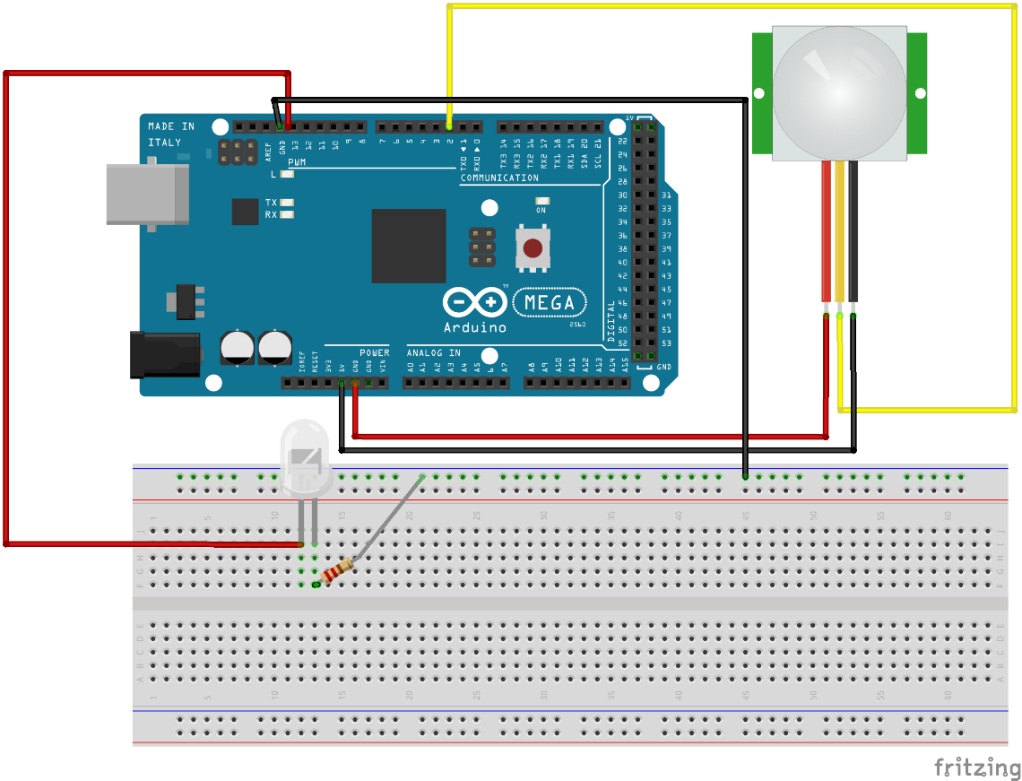

**Code in Arduino.cc:**

**Result:**

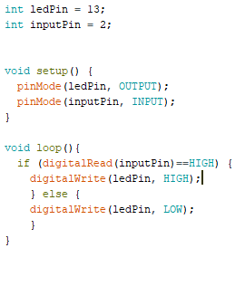

Result as expected. When there is movement LED light up