**DOKUZ EYLUL UNIVERSITY ENGINEERING FACULTY**

**DEPARTMENT OF COMPUTER ENGINEERING**

**METROPOLITAN AREA NETWORK SIMULATION PROJECT**

**by**

**Batuhan Doğan**

**Eren Çağlar Erdoğan**

**Ali Şiyar Arslan**

**12.05.2023**

**İZMİR**

**Table of Content**

**1. Introduction…………………………………………………………………………………….…….……..3-6**

* 1. Project Definition and Problem Formulation………………………..……......3

* 1. The purpose and motivation of the project…………………………………....3
  2. Term Definitions………………………………………………………………...............4-6

1.4. Related Work……………………………………………………………………..............7

1. **Method and Simulation……………………………………………………………………………7-16** 
   1. Simulation and Modeling Concepts………………………………………..…......7
   2. Simulation Environment/Tool………………………………………..………….....8-11
   3. Network Design Requirements……………………………………………….......11-12
   4. Requirement Analysis…………………………………………………………..........12-13
   5. Definitions of the System/Model………………………………………………….13-18
   6. Simulation Elements………………………………………………….…………...........19
2. **Traffic Analysis and Simulation Results…………………………………..……………..….20-56**

1. **Conclusion....................................................................................................... 57**
2. **References...................................................................................................... 58**

**CHAPTER ONE**

**INTRODUCTION**

**1.1. Project Definition and Problem Formulation**

The problem we aim to solve is the design and implementation of a Metropolitan Area Network (MAN) that connects two distinct branches of an office in a city. Each branch consists of three facilities, and the users in these facilities have specific roles and functions. There is no dedicated server for each facility, and all users share the same servers located in a central server room. The goal is to create a network infrastructure that facilitates efficient communication and seamless data transfer between users of both branches. This requires careful consideration of the specific requirements and features of each user group in the different facilities. In essence, the MAN will serve as the backbone that connects the various facilities, users, and shared servers, providing a robust and reliable communication platform for the organization.The network design includes the use of at least two routers for each branch, which are connected over an ISP. We will also consider the connection technologies between the ISP and the branches.

To accomplish this, we used the Cisco Packet Tracer software, which allows us to simulate the network and test its functionality. We used various networking concepts and terminology, such as routers, servers, workstations, wireless users, VoIP, DHCP, and DNS, among others.

**1.2. The Purpose and Motivation of the Project**

The purpose of this project is to design a Metropolitan Area Network (MAN) for a company with two branches in a city, each branch containing three facilities with different network requirements. The main motivation behind this project is to improve communication and collaboration between the company's users in different facilities, as well as to increase the efficiency of their daily tasks. The business goals of the project include providing reliable and secure network connectivity, ensuring high performance with minimum delay, and minimizing the cost of network hardware.

The main benefits of this project include improved communication and collaboration between users, increased efficiency in daily tasks, and reduced cost of hardware by optimizing the network design. However, there are also risks associated with the project, such as potential network failures or security breaches, which need to be carefully considered and addressed in the design phase. Overall, this project aims to improve the company's network infrastructure to meet the evolving needs of its users and enhance their productivity.

The motivation and importance of this project are significant, as a well-designed computer network can greatly benefit an organization in terms of efficient communication, increased productivity, and reduced costs. A properly designed MAN can support a maximum number of network users and traffic load with minimum delay, while also providing adequate hardware support for network expansions. However, achieving this balance between hardware cost and system requirements is crucial, and requires careful planning and design.

This project is important to realize because the design of a well-functioning computer network architecture that can handle a large number of users, traffic loads, and network expansions with minimum delay is crucial for the smooth operation of the company's communication and workflow processes.

**1.3. Term Definitions**

**Node:** A node is a device that is connected to the network and can send, receive or process data. In a MAN network, a node can be a computer, router, switch, or any other network device.

**Packet:** A packet is a unit of data that is transmitted over a network. It consists of a header, which contains control information, and a payload, which contains the actual data being transmitted. In a MAN network, packets are used to transmit data between nodes.

**Channel:** A channel is a communication path between two nodes in a network. In a MAN network, a channel can be a physical cable or wireless connection that connects two nodes.

**Protocol:** A protocol is a set of rules and standards that define how data is transmitted over a network. In a MAN network, different protocols may be used for different types of data transmission, such as TCP/IP for internet traffic and SIP for VoIP traffic.

**System:** A system refers to a collection of hardware, software, and network components that work together to achieve a common goal. In a MAN network, the system may include servers, routers, switches, and other network devices.

**Architecture:** Architecture refers to the overall design and structure of a network. In a MAN network, the network architecture defines how the network is organized, including the number and type of nodes, the routing and switching protocols used, and the physical and logical layout of the network.

**Network :** Network is a group of two or more devices or nodes that can communicate. The devices or nodes in question can be connected by physical or wireless connections. The key is that there are at least two separate components, and they are connected.

**Wireless :** Wireless is a term used to define telecommunication and data transmission without wires. In a broad sense, wireless refers to any telecommunications or data transfer in which electromagnetic waves - rather than some form of wire or cable -carry signals over all or part of the data communication path.This refers to a type of network that broadcasts an access signal to the workstations.This allows for transporting laptops and tablet PCs from room to room while maintaining a network connection continuously.

**Router:** A router is a networking device that routes data packets between computer networks. A router can connect networked computers to the Internet, so multiple users can share a connection. Routers help connect networks within an organization or connect the networks of multiple branch locations. And a router works as a dispatcher. It directs data traffic, choosing the best route for information to travel across the network, so that it's transmitted as efficiently as possible.

**Switch:** Switches facilitate the sharing of resources by connecting together all the devices, including computers, printers, and servers, in a small business network. Thanks to the switch, these connected devices can share information and talk to each other, regardless of where they are in a building or on a campus. Building a small business network is not possible without switches to tie devices together.

**Hypertext Transfer Protocol (HTTP):** The HTTP is the foundation of data communication for the World Wide Web. The hypertext is structured text that uses hyperlinks between nodes containing texts. The HTTP is the application protocol for distributed and collaborative hypermedia information systems. The default port of HTTP is 80 and 443 is the secured port.

**File Transfer Protocol (FTP):** The FTP is the most common protocol used in the file transferring on the Internet and within private networks. The default port of FTP is 20/21.

**Domain Name System (DNS):** Domain name system is used to convert the domain name to IP address. There are root servers, TLDs and authoritative servers in the DNS hierarchy. The default port of DNS is 53.

**SMTP :** Stands for "Simple Mail Transfer Protocol." This is the protocol used for sending e-mail over the Internet. Your email client uses SMTP to send a message to the mail server, and the mail server uses SMTP to relay that message to the correct receiving mail server.

**Workstation :** Workstation, a high-performance computer system that is basically designed for a single user and has advanced graphics capabilities, large storage capacity, and a powerful central processing unit. A workstation is more capable than a personal computer (PC) but is less advanced than a server (which can manage a large network of peripheral PCs or workstations and handle immense data-processing and reporting tasks).

**Server :** A server is a piece of computer hardware or software (computer program) that provides functionality for other programs or devices, called "clients". This architecture is called the client–server model. Servers can provide various functionalities, often called "services", such as sharing data or resources among multiple clients, or performing computation for a client. Typical servers are database servers, file servers, mail servers, print servers, web servers, game servers, and application servers.

**1.4.Related Work**

Yes, there are many other works about network modeling/simulation and network design. These works can be found in academic research papers, industry reports, and online resources. Here are some examples:

"Design and Simulation of a Campus Network Using OPNET" by I. A. M. Abkar and M. A. Abdullahi (2016)

"A Study on the Design and Simulation of the Backbone Network of a Metropolitan Area Network" by C. J. Lim, W. J. Kim, and J. H. Lee (2013)

"Design and Simulation of a Wireless Sensor Network for Industrial Automation" by S. K. S. Kavitha and P. R. Subramanian (2015)

These works cover a wide range of topics related to network modeling and simulation, including LAN, WAN, MAN, wireless networks, industrial automation, and more. They use various simulation tools and techniques, such as OPNET, NS-3, MATLAB, and GNS3. They also provide insights into network design principles, traffic engineering, network performance analysis, and optimization.

**CHAPTER TWO**

**METHOD AND SIMULATION**

**2.1. Simulation and Modelling Concepts**

Discrete-event simulation is a technique used to model and simulate the behavior of systems that are driven by events that occur at specific points in time. In such systems, the state of the system changes only in response to the occurrence of an event. Discrete-event simulation involves modeling the system as a series of events and the actions that occur in response to those events. It is useful in modeling complex systems where the behavior of the system cannot be easily predicted. In this project, the behavior of the network system is modeled using discrete-event simulation, where events such as user requests and network traffic are simulated to evaluate the performance of the network. The modeling of the network system involves defining the components of the system, the events that occur, and the rules that govern the behavior of the system.

Modeling and simulation provide numerous benefits over real implementations in network design. Firstly, simulation allows for testing of different scenarios and configurations without the need for expensive hardware and implementation. This saves time and money in the planning phase. Additionally, modeling and simulation can help identify potential issues and bottlenecks in the network, allowing for optimization and fine-tuning before deployment.

However, there are also some challenges associated with modeling and simulation. Firstly, the accuracy of the simulation depends heavily on the quality of the model and the assumptions made. If the model is not representative of the real-world environment, the results may not accurately reflect what will happen in the actual implementation. Secondly, there may be limitations in the simulation software itself, such as the inability to model certain network behaviors or the lack of support for certain protocols. Finally, simulation may not capture all the nuances and complexities of real-world scenarios, which can lead to unexpected issues during deployment.

This project includes two branches. First, branches were created. Three facilities were established inside the branches. IPs were assigned to each of these facilities. While users were connecting to each other, they were connected to successfully communicate with switches, routers, wireless routers and connecting cables. Devices are connected to switches with copper cable. Router has been used for two different networks which are commonly used same network channel rules/bases. We created our

servers at each facility using the DHCP server and assigned IP addresses to the users. Server farms at the third facility of the first branch office so that users can send/receive mail, browse the web, send/receive files, VoIP Services (sending voice data over an IP between private users/workstations), automatically assigning an IP. created. In the server room, web server, dns server, mail server, ftp server and dhcp server were configured, and the servers were made ready for use and connected to the main switch of the server farm.

**2.2. Simulation Environment**

While designing this model, we use Cisco Packet Tracer as a simulation tool. Cisco Packet Tracer is a network simulation software that is widely used by students, educators, and network professionals to design, configure, and troubleshoot complex network topologies. Here are some of the advantages and disadvantages, as well as the key concepts and approaches associated with Cisco Packet Tracer:

**Advantages:**

**Easy to use:** Cisco Packet Tracer has an intuitive drag-and-drop interface that makes it easy to build and configure network topologies.

**Simulation:** Packet Tracer allows you to simulate network behavior and test different configurations without the need for physical hardware.

**Realistic environment:** It provides a realistic environment for network simulation that includes real Cisco devices and operating systems.

**Educational tool:** Packet Tracer is a powerful educational tool that can help students learn about networking concepts, protocols, and technologies.

**Disadvantages:**

**Limited device support:** Although Packet Tracer includes a wide range of devices, it doesn't support all the devices that are available in the real world.

**Limited functionality:** Some advanced features and functionalities of Cisco devices may not be fully supported in Packet Tracer.

**Limited scalability:** Packet Tracer is not designed for large-scale networks and may not be suitable for designing complex networks.

**Concepts and approaches:**

**Top-down design:** Packet Tracer follows a top-down approach to network design, starting with the network requirements and then building the topology from there.

**Modular design:** Packet Tracer supports modular network design, which involves breaking the network down into smaller, more manageable components.

**Network protocols and technologies:** Packet Tracer includes support for a wide range of network protocols and technologies, including Ethernet, IP, TCP, OSPF, EIGRP, VLANs, and more.

**Troubleshooting:** Packet Tracer can be used to troubleshoot network issues and test different scenarios to identify and resolve problems.

In Cisco Packet Tracer, architecture refers to the overall design of a network, including the components that make up the network and how they are connected. This includes routers, switches, servers, workstations, and other devices, as well as the logical connections between them.

Modeling, on the other hand, refers to the process of creating a virtual representation of a network in Packet Tracer. This involves selecting the appropriate devices and configuring them with the necessary settings and protocols to simulate the behavior of a real network.

There are different modeling concepts and approaches that can be used in Packet Tracer, depending on the specific network being simulated. For example:

**Top-down modeling:** This approach involves starting with the high-level design of a network and then working down to the individual device configurations. This is useful for designing large and complex networks.

**Bottom-up modeling:** This approach involves starting with the individual device configurations and building up to the overall network design. This is useful for simulating smaller networks or individual devices.

**Modular modeling:** This involves breaking the network into smaller, more manageable modules or subsystems, and modeling each module separately before integrating them into the overall network. This can help with organization and troubleshooting.

**Prototype modeling:** This approach involves creating a simplified version of the network to test out a specific configuration or behavior before implementing it in the actual network.

**Some of Cisco Packet Tracer key capabilities include:**

**Network simulation:** Packet Tracer allows users to design, configure, and simulate networks of varying sizes and complexities, including LAN, WAN, and wireless networks.

**Device emulation:** The tool includes a wide range of network devices such as routers, switches, firewalls, and wireless access points that can be configured and simulated to test network functionalities.

**Protocol analysis:** Packet Tracer supports the analysis of network protocols, such as TCP/IP, IPv6, OSPF, and EIGRP.

**Interactive activities:** Packet Tracer offers interactive activities that enable users to learn and experiment with network concepts, including configuring network devices and protocols.

**Collaboration:** Packet Tracer allows users to collaborate on network designs and projects in real-time, promoting teamwork and enhancing learning experiences.

**Some limitations to using Packet Tracer:**

**Limited device support:** Although Packet Tracer includes many types of network devices, it may not include some of the more advanced or specialized devices used in enterprise networks.

**Limited scalability:** Packet Tracer is suitable for small to medium-sized network simulations, but may not be suitable for larger and more complex networks.

**Limited protocol support:** Although Packet Tracer supports many common network protocols, it may not support some of the more specialized or proprietary protocols used in certain networks.

**Limited real-world testing:** Packet Tracer is a simulation tool and may not accurately reflect the behavior of a real-world network environment. Therefore, testing network designs and configurations in a live environment is still important to ensure proper functionality.

**Here are the steps to program or run a simulation in Cisco Packet Tracer:**

**1)** Open Cisco Packet Tracer and create a new blank project.

**2)** Drag and drop network devices from the device list on the left-hand side to the workspace area on the right-hand side to create your network topology.

**3)** Configure the network devices by double-clicking on them and setting their properties, such as IP addresses, subnet masks, default gateways, etc.

**4)** Connect the devices together by clicking on the "Connections" button in the toolbar and then clicking and dragging between the device interfaces.

**5)** Test the network topology by clicking on the "Simulation" button in the toolbar and then clicking the "Play" button to start the simulation. You can then send traffic between devices to verify connectivity.

**6)** Save your project and export it as needed.

**2.3. Network Design Requirements**

**Characteristics of the network:**

Metropolitan Area Network (MAN) consisting of two branches

Multiple facilities in each branch with varying units and requirements

Users with different devices and abilities

Ability to connect to the Internet and perform various tasks such as browsing, email, file transfer, VoIP, and server hosting

**Architecture and structure of the network:**

Two distinct branches connected by routers over an ISP

At least two routers for each branch

Different connection technologies between ISP and branches

Each facility within a branch has its own network with switches and devices

Server farm located in the third facility of each branch

**Configuration and protocols used in the network:**

DHCP protocol used for automatic IP address assignment

VoIP protocol used for voice data transmission

Web, FTP, email, and DNS protocols used for various tasks

Copper cables used to connect devices to switches

Wireless routers used for wireless connections

**Design of the network:**

Iterative process involving topological design, network architectures, and network traffic characterization

Well-designed to support maximum number of network users, traffic load with minimum delay, and adequate hardware support for network expansions

Designer should balance cost of network hardware and system requirements.

**2.4. Requirement Analysis**

**Functional requirements for different applications and services in this project:**

**VoIP:** The network must support VoIP conference events in the second facility of the first branch. This requires adequate bandwidth allocation and Quality of Service (QoS) mechanisms to ensure voice traffic is prioritized over other traffic types.

**Web browsing:** All users in both branches must be able to browse the web using their devices. This requires providing internet connectivity and configuring routers and switches to allow traffic flow.

**Email:** All users in both branches must be able to send and receive emails using their devices. This requires configuring email servers and clients with appropriate settings.

**File transfer:** Users in both branches must be able to transfer files using their devices. This requires configuring appropriate file sharing protocols and access permissions.

**Wireless connectivity:** Users in both branches must be able to connect to the network using wireless connections. This requires deploying wireless access points and configuring them to provide secure and reliable wireless connectivity.

**Server access:** Users in the first branch must be able to access servers in the third facility, including Web servers, FTP servers, DHCP server, mail server, and DNS. This requires configuring appropriate access controls and routing settings.

Overall, the functional requirements of the network should ensure that all users in both branches have access to the resources they need to perform their tasks efficiently and effectively.

**Browse web:** First branch first facility, First branch second facility, Second branch first facility, Second branch second facility, Second branch third facility these allowed

**E-mail:** First branch first facility, Second branch first facility, Second branch third facility these allowed

**Transfer Files:** First branch first facility, Second branch second facility these allowed

**FTP:** First branch second facility this allowed

**VoIP:** First branch second facility this allowed

**Wireless Connection:** Second branch third facility this allowed

**Edit applications:** Second branch second facility this allowed

There are totally 45 workstation (PC) users, 8 wireless users (laptop), 8 smartphone users, 10 tablet users, and 5 mobile devices that are used in this project.

**2.5. Definitions of the System/Model**

The structure of the system is a Metropolitan Area Network (MAN) that consists of two distinct branch offices in a city. Each branch office has three distinct facilities with different units and requirements. The branches are connected by routers over an ISP, and the connection technologies between ISP and branches should be considered.

The network topology used in the project designed to support maximum number of network users, traffic load with minimum delay, and adequate hardware support for network expansions. The network applications and services that will be modeled/deployed are web browsing, email, file transfer, VoIP conference events, and server farms including Web servers, FTP servers, DHCP server, mail server, and domain name server (DNS).

The network configuration should include addressing, routing, and equipment configuration. The data types and sources, as well as the device types such as hosts and managed devices, should also be considered.

**General Design of the System**

**harita, diyagram, çizgi, ekran görüntüsü içeren bir resim

Açıklama otomatik olarak oluşturuldu**

**First Branch First Facility**

**ekran görüntüsü, tasarım içeren bir resim

Açıklama otomatik olarak oluşturuldu**

**metin, çizgi, diyagram içeren bir resim

Açıklama otomatik olarak oluşturuldu**

**First Branch Second Facility**

**metin, diyagram, ekran görüntüsü, çizgi içeren bir resim

Açıklama otomatik olarak oluşturuldu**

**First Branch Third Facility**

**metin, diyagram, çizgi, daire içeren bir resim

Açıklama otomatik olarak oluşturuldu**

**Second Branch First Facility**

**metin, saat içeren bir resim

Açıklama otomatik olarak oluşturuldu**

**harita, metin, diyagram, daire içeren bir resim

Açıklama otomatik olarak oluşturuldu**

**Second Branch Second Facility**

**metin, ekran görüntüsü, daire içeren bir resim

Açıklama otomatik olarak oluşturuldu**

**metin, harita, diyagram, daire içeren bir resim

Açıklama otomatik olarak oluşturuldu**

**Second Branch Third Facility**

**metin, daire, çizgi film, diyagram içeren bir resim

Açıklama otomatik olarak oluşturuldu**

**metin, çizim, diyagram, çizgi içeren bir resim

Açıklama otomatik olarak oluşturuldu**

**2.6. Simulation Elements**

In this project, the devices in the Cisco Packet Tracer simulation tool were used and their numbers are as follows:

Network Devices:

3 Routers

6 Switches

4 Wireless Devices

End Devices:

45 PCs

8 Laptops

10 Servers

5 Mobile devices

10 Tablets

8 Smartphones

Connection Devices: Copper Straight , Serial DTE

**CHAPTER THREE**

**Traffic Analysis and Simulation Results**

1. A wireless user from first facility of second branch wants to read emails and browse Web.

metin, elektronik donanım, ekran görüntüsü, yazı tipi içeren bir resim

Açıklama otomatik olarak oluşturuldu

metin, ekran görüntüsü, yazılım, sayı, numara içeren bir resim

Açıklama otomatik olarak oluşturuldu

metin, ekran görüntüsü, yazılım, sayı, numara içeren bir resim

Açıklama otomatik olarak oluşturuldu

metin, ekran görüntüsü, yazılım, sayı, numara içeren bir resim

Açıklama otomatik olarak oluşturuldu

metin, ekran görüntüsü, yazılım, sayı, numara içeren bir resim

Açıklama otomatik olarak oluşturuldu

ekran görüntüsü, ekran, görüntüleme, metin, yazılım içeren bir resim

Açıklama otomatik olarak oluşturuldu

metin, ekran görüntüsü, ekran, görüntüleme, yazılım içeren bir resim

Açıklama otomatik olarak oluşturuldu

2. A computer engineer from second facility of second branch developed a web application and wants to send his/her code files to FTP server in the third facility of first branch.

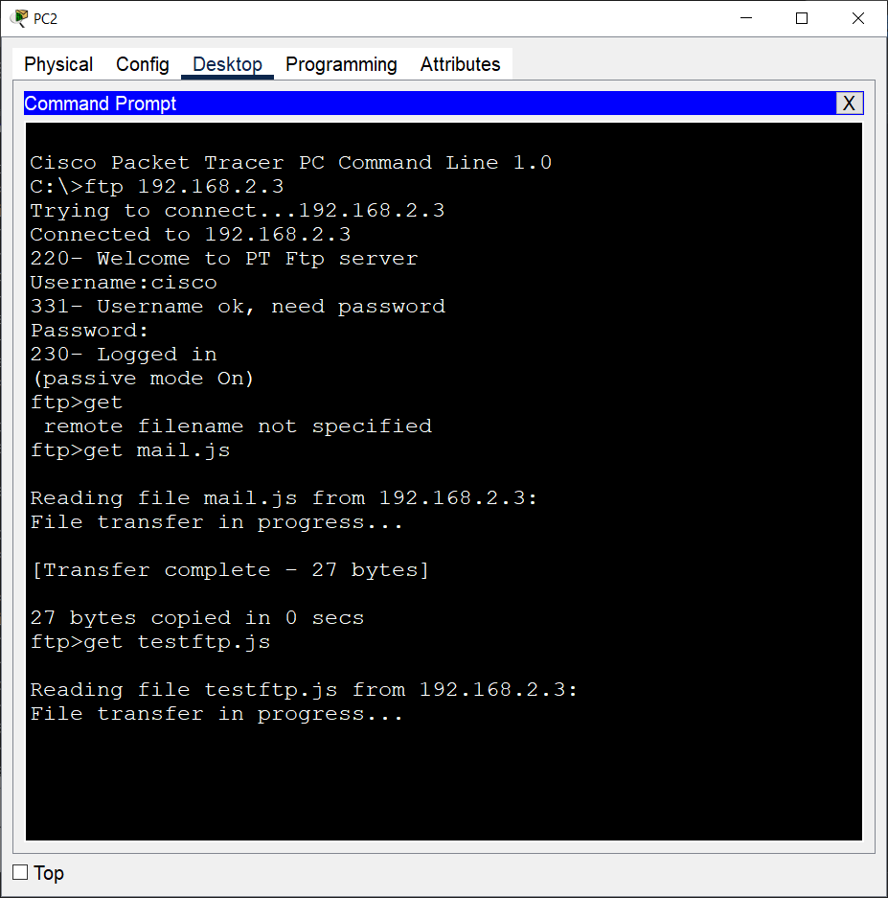

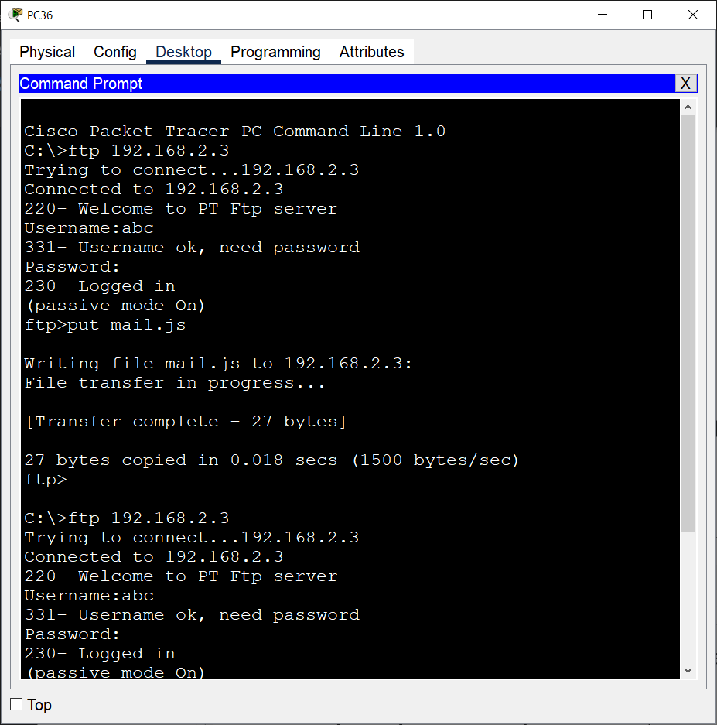

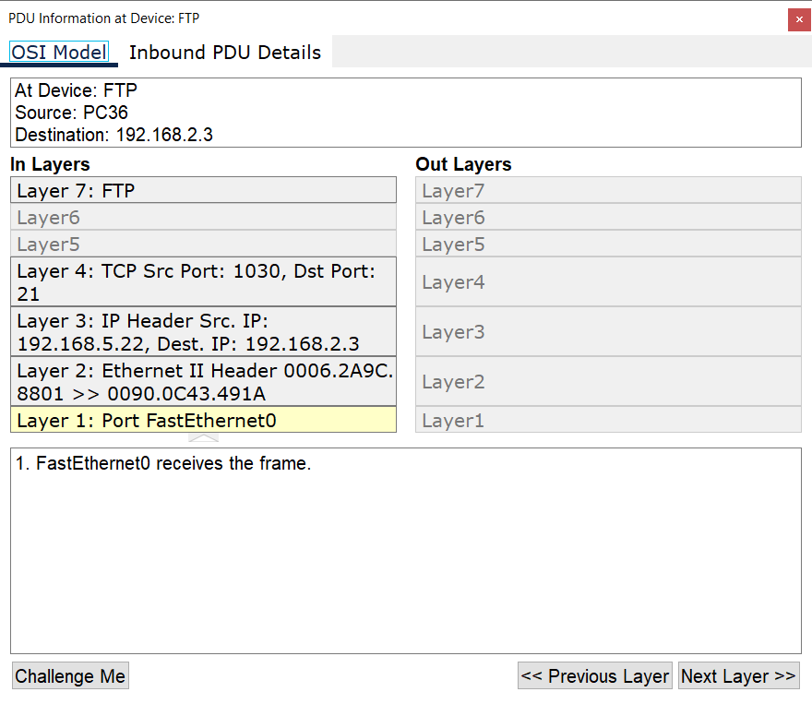metin, ekran görüntüsü, sayı, numara, yazı tipi içeren bir resim

Açıklama otomatik olarak oluşturuldumetin, ekran görüntüsü, ekran, görüntüleme, yazılım içeren bir resim

Açıklama otomatik olarak oluşturuldu

3)Two users from second facility of first branch want to talk via VoIP. metin, elektronik cihaz, elektronik donanım, multimedya içeren bir resim

Açıklama otomatik olarak oluşturuldumetin, elektronik cihaz, elektronik donanım, multimedya içeren bir resim

Açıklama otomatik olarak oluşturuldu

metin, ekran görüntüsü, sayı, numara, yazı tipi içeren bir resim

Açıklama otomatik olarak oluşturuldumetin, ekran görüntüsü, sayı, numara, yazı tipi içeren bir resim

Açıklama otomatik olarak oluşturuldu

metin, ekran görüntüsü, yazılım, ekran, görüntüleme içeren bir resim

Açıklama otomatik olarak oluşturuldu

4. A user in the second facility of first branch wants to send an email message to his friend in the second facility of second branch. Users in the second facility of first branch and second facility of second branch are not authorized to send or receive mail. So the workstation user in the second facility of first branch could not send an email to the workstation user in the second facility of the second branch.

metin, ekran görüntüsü, yazılım, ekran, görüntüleme içeren bir resim

Açıklama otomatik olarak oluşturuldu

metin, ekran görüntüsü, ekran, görüntüleme, yazılım içeren bir resim

Açıklama otomatik olarak oluşturuldu

metin, ekran görüntüsü, sayı, numara, yazı tipi içeren bir resim

Açıklama otomatik olarak oluşturuldumetin, ekran görüntüsü, sayı, numara, yazı tipi içeren bir resim

Açıklama otomatik olarak oluşturuldumetin, ekran görüntüsü, sayı, numara, ekran, görüntüleme içeren bir resim

Açıklama otomatik olarak oluşturuldu

5)A user from first facility of second branch pings Web server of second facility of first branch.

metin, elektronik donanım, ekran görüntüsü, ekran, görüntüleme içeren bir resim

Açıklama otomatik olarak oluşturuldu

metin, elektronik donanım, ekran görüntüsü, bilgisayar içeren bir resim

Açıklama otomatik olarak oluşturuldu

metin, ekran görüntüsü, yazılım, sayı, numara içeren bir resim

Açıklama otomatik olarak oluşturuldu

6) A laptop user from first facility of first branch office wants to send email to her friend in the first facility of second branch office.

metin, elektronik donanım, ekran görüntüsü, ekran, görüntüleme içeren bir resim

Açıklama otomatik olarak oluşturuldu

metin, ekran görüntüsü, makbuz, sayı, numara içeren bir resim

Açıklama otomatik olarak oluşturuldu

metin, ekran görüntüsü, makbuz, sayı, numara içeren bir resim

Açıklama otomatik olarak oluşturuldu

metin, ekran görüntüsü, sayı, numara, yazılım içeren bir resim

Açıklama otomatik olarak oluşturuldu

8) User from the first branch of the first facility call an unidentified number.metin, elektronik cihaz, elektronik donanım, multimedya içeren bir resim

Açıklama otomatik olarak oluşturuldumetin, ekran görüntüsü, ekran, görüntüleme, yazılım içeren bir resim

Açıklama otomatik olarak oluşturuldumetin, ekran görüntüsü, sayı, numara, paralel içeren bir resim

Açıklama otomatik olarak oluşturuldu

metin, ekran görüntüsü, yazılım, sayı, numara içeren bir resim

Açıklama otomatik olarak oluşturuldu

9 . A computer engineer from first facility of first branch developed a web application and wants to send his/her code files to FTP server in the second facility of second branch.

elektronik donanım, metin, ekran görüntüsü, yazılım içeren bir resim

Açıklama otomatik olarak oluşturuldu

metin, ekran görüntüsü, ekran, görüntüleme, yazılım içeren bir resim

Açıklama otomatik olarak oluşturuldumetin, ekran görüntüsü, ekran, görüntüleme, yazılım içeren bir resim

Açıklama otomatik olarak oluşturuldumetin, ekran görüntüsü, sayı, numara, paralel içeren bir resim

Açıklama otomatik olarak oluşturuldumetin, ekran görüntüsü, ekran, görüntüleme, yazılım içeren bir resim

Açıklama otomatik olarak oluşturuldu

**CHAPTER FOUR**

**Conclusion**

In summary, the project requires the design and implementation of a Metropolitan Area Network (MAN) using Cisco Packet Tracer software. The network consists of two distinct branches, each with three facilities that have varying requirements and units. The first branch includes 10 workstation users, wireless and smartphone users, 5 workstation users, and a server farm. The second branch has similar requirements, but with the addition of tablet users and mobile devices.

The network design should consider the connection technologies between the ISP and the branches, and include at least two routers for each branch. The network architecture should support maximum users and traffic load with minimal delay, while considering the balance between the cost of network hardware and the system requirements.

In conclusion, building a MAN for a complex organization with different units and requirements is a challenging task that requires careful planning, design, and implementation. A well-designed network should provide high-speed connectivity and adequate hardware support for network expansion, while balancing the costs of the network hardware and system requirements. The use of tools like Cisco Packet Tracer can help in the effective design and implementation of such networks.

**CHAPTER FIVE**

**References**

M. J. Kowalski, "Introduction to computer networks," *IEEE Communications Magazine, vol. 18, no. 1, pp. 10-18*, Jan. 1980.

T. Chen and Y. Li, "Design and simulation of a computer network using Cisco Packet Tracer," in 2019 *International Conference on Computer, Information and Telecommunication Systems (CITS)*, Jeju Island, South Korea, Jul. 2019, pp. 1-5.

J. J. Johnson, "Cisco Packet Tracer: A powerful simulation tool for teaching and learning computer networks," *in 2016 IEEE Frontiers in Education Conference (FIE),* Erie, PA, USA, Oct. 2016, pp. 1-6.

D. O. Ogunyemi and O. C. Nwokolo, "Exploring the capabilities of Cisco Packet Tracer for teaching computer networks," *in 2015 International Conference on Electrical, Electronics and Computer Engineering (ICEECE)*, Dhaka, Bangladesh, Dec. 2015, pp. 107-112.

R. K. Sahoo and S. S. Mohapatra, "Design and simulation of a computer network using Cisco Packet Tracer," in *2018 International Conference on Advances in Computing, Communications and Informatics (ICACCI),* Bangalore, India, Sep. 2018, pp. 1425-1428.