AURIS: A Multi-Model Ensemble System for AI-Generated Music Detection Using Acoustic Feature Analysis
AURIS: Akustik Özellik Analizi Kullanılarak Yapay Zeka Tarafından Üretilen Müziğin Tespiti İçin Çok Modelli Topluluk Sistemi
Hasan Arthur ALTUNTAŞ¹
¹ Department of Computer Engineering, Düzce University, Düzce, Türkiye
hasannarthurrr@gmail.com

Highlights
• A 47-dimensional handcrafted acoustic feature vector is constructed for music authenticity classification.
• Eleven classifiers, including seven machine learning algorithms and four deep learning architectures, are compared under a unified 5-fold cross-validation protocol.
• LightGBM reaches a mean ROC-AUC of 0.9548; Deep MLP follows closely at 0.9542.
• Per-fold Youden's J threshold optimization replaces the default 0.5 cutoff and improves balanced accuracy.
• Spectral flatness emerges as the single most informative feature for distinguishing AI-generated from human-composed music.

Öz: Suno, Udio ve MusicGen gibi yapay zeka tabanlı müzik üretim sistemlerinin son birkaç yılda gösterdiği gelişme, yapay zeka tarafından üretilen kayıtların insan tarafından bestelenmiş müzikten ayırt edilmesini hem dinleyiciler hem de otomatik sistemler için giderek güçleştirmiştir. Bu çalışmada akustik öznitelik analizine dayalı çok modelli bir topluluk sistemi olan AURIS önerilmektedir. AURIS, librosa kütüphanesi aracılığıyla spektral, zamansal, ritmik, armonik ve vokal boyutları kapsayan 47 öznitelik çıkarmakta ve bu vektörü 2.082 yapay zeka kaynaklı ve 3.113 insan kaynaklı toplam 5.195 örnekten oluşan veri kümesi üzerinde eğitilen on bir sınıflandırma modeline beslemektedir. Modeller, geleneksel makine öğrenmesi (Lojistik Regresyon, Rastgele Orman, Gradyan Artırma, SVM, ÇKA, XGBoost, LightGBM) ve derin öğrenme (Derin ÇKA, 1B-CNN, Artık ÇKA, Dikkat ÇKA) ailelerinden seçilmiştir. Eğitim süreci, sınıf dengesizliğini hesaba katmak için her katmanda Youden's J istatistiğine dayalı eşik optimizasyonu uygulanan 5-katlı tabakalı çapraz doğrulama protokolünü kullanmaktadır. Deneysel sonuçlar, LightGBM modelinin 0,9548'luk ROC-AUC değeri ile en yüksek performansı sergilediğini, Derin ÇKA modelinin ise 0,9542 ile çok yakın bir ikinci sıra elde ettiğini göstermektedir. LightGBM için Brier skoru 0,083 olarak ölçülmüş, modelin iyi kalibre edilmiş olasılık tahminleri ürettiği teyit edilmiştir. Spektral düzlük (spectral flatness) yapay zeka ile insan müziğini ayırt etmede en belirleyici tekil özellik olarak belirlenmiştir. Sistem, Hugging Face Spaces üzerinde dosya yükleme ve canlı mikrofon girişi yoluyla gerçek zamanlı analiz sunan halka açık bir web uygulaması olarak yayınlanmıştır.
Anahtar Kelimeler: Yapay zeka müzik tespiti, ses sınıflandırma, LightGBM, topluluk öğrenmesi, akustik özellikler, deepfake ses, wav2vec2, MFCC, spektral düzlük
Abstract: The rapid progress of AI-based music generation systems such as Suno, Udio, and MusicGen has made it increasingly difficult, for both human listeners and automated systems, to tell AI-generated recordings apart from human-composed music. This paper introduces AURIS, a multi-model ensemble system that approaches the problem from the side of handcrafted acoustic features. AURIS extracts a 47-dimensional feature vector spanning spectral, temporal, rhythmic, harmonic, and vocal dimensions using the librosa library, and feeds this vector into eleven classification models trained on a curated dataset of 5,195 samples (2,082 AI-generated, 3,113 human-composed). The model pool is intentionally heterogeneous: it includes seven classical machine learning algorithms (Logistic Regression, Random Forest, Gradient Boosting, SVM-RBF, MLP, XGBoost, LightGBM) alongside four deep learning architectures (Deep MLP, 1D-CNN, Residual MLP, Attention MLP). Model training follows a 5-fold stratified cross-validation protocol in which the decision threshold is re-estimated per fold via Youden's J statistic in order to handle the 1:1.5 class imbalance. Experimental results show that LightGBM reaches the highest mean ROC-AUC at 0.9548, with Deep MLP a very narrow second at 0.9542. The Brier score of 0.083 indicates that the model produces well-calibrated probability estimates rather than merely useful ranking scores. Spectral flatness is identified as the single most discriminative feature for the AI-versus-human distinction. The full system is released as a public web application on Hugging Face Spaces, supporting both file upload and live microphone input.
Keywords: AI music detection, audio classification, LightGBM, ensemble learning, acoustic features, deepfake audio, wav2vec2, MFCC, spectral flatness

1. INTRODUCTION
Generative audio models have moved from research prototypes to consumer products in a remarkably short period of time. Suno (versions 3 through 5), Udio, Meta's MusicGen (Copet et al., 2023), and a growing family of diffusion-based systems such as AudioLDM (Liu et al., 2023), Stable Audio, and Riffusion now allow anyone with a web browser to produce full-length musical tracks from a short text prompt. Many of these tracks are, in practice, perceptually indistinguishable from human-composed recordings for a casual listener. The shift raises questions that go well beyond audio engineering: copyright attribution, the integrity of streaming-platform catalogues, the rights of session musicians, and the ability of educators and journalists to reason about authorship.
Compared with audio deepfake detection for speech — driven by competitions such as the ADD Challenge (Yi et al., 2022) and datasets such as WaveFake (Frank & Schönherr, 2021) — the detection of AI-generated music has received less attention. Music does not share the cues that make speech deepfake detection tractable: there is no fixed lexicon, no speaker identity to verify, and prosody plays a very different role. Instead, music presents harmonic complexity, polyphony, percussion, and recording artefacts that vary widely between human studios and synthetic pipelines. Recent surveys frame the field as nascent (Li et al., 2024; Yi et al., 2023), and Li et al. (2024) argue that cross-generator generalisation — the ability to detect tracks produced by systems unseen during training — is the central open challenge.
Two contrasting lines of recent work make this trade-off explicit. Afchar et al. (2025) showed at IEEE ICASSP 2025 that a detector trained to recognise auto-encoder artefacts can reach 99.8% accuracy by exploiting spectral residues introduced by neural vocoders, but the same detector degrades sharply under MP3 compression or pitch shifting. Kim and Go (2025), in turn, proposed the Segment Transformer, which embeds short music segments with a pre-trained encoder and aggregates them through a transformer head to capture structural patterns across an entire composition. Both directions accept the same premise: no single feature family is robust enough on its own.
AURIS is positioned between these extremes. Rather than committing to a single representation, the system relies on a 47-dimensional handcrafted feature vector that summarises spectral, temporal, harmonic, and vocal behaviour, and pairs it with an intentionally heterogeneous pool of eleven classifiers. The aim is twofold: to obtain competitive detection accuracy across multiple AI generators and to keep the model interpretable enough for deployment on consumer hardware. The three main contributions of this paper are:
- A 47-feature acoustic representation that combines well-established descriptors (MFCC, spectral flatness, onset strength) with a small set of vocal-quality features (breath patterns, vibrato regularity, formant consistency) tailored to the human-versus-AI distinction in music.
- An eleven-model ensemble comparing seven traditional machine learning classifiers with four deep learning architectures on a single feature pipeline, all evaluated under 5-fold stratified cross-validation with per-fold Youden's J threshold optimisation.
- A multi-generator training set drawn from twelve or more AI synthesis systems alongside two human-music corpora, providing the diversity needed to study cross-generator generalisation.
Figure 1 provides an end-to-end view of the system. The remainder of the paper is organised as follows. The rest of this section reviews related work in audio deepfake detection, transformer-based audio representations, ensemble methods for audio, and recent AI-music detection literature. Section 2 describes the dataset, the feature extraction pipeline, the eleven classification models, and the training protocol. Section 3 reports experimental results across all models, interprets feature importance and calibration, and acknowledges the limitations of the present study. Section 4 concludes with directions for future work. The system is publicly available at https://huggingface.co/spaces/Rtur2003/AURIS.
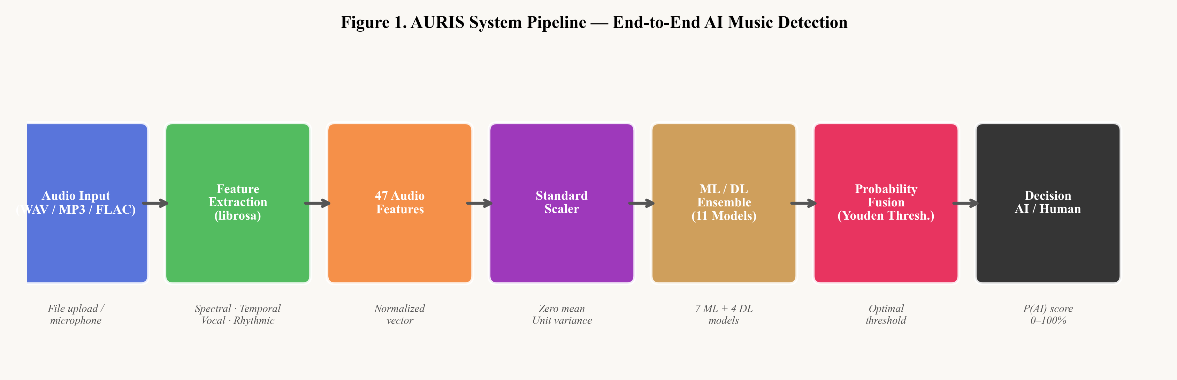
Figure 1. End-to-end AURIS pipeline. Audio is resampled to 22,050 Hz, decomposed into a 47-dimensional handcrafted feature vector, scaled per-fold, and routed through an ensemble of eleven classifiers; final probabilities are fused using calibrated tower scores.
1.1. Audio Deepfake Detection for Speech
Audio deepfake detection became an active research area shortly after the appearance of high-quality neural text-to-speech systems. The WaveFake dataset (Frank & Sch\"onherr, 2021)established a foundational benchmark using seven vocoder architectures, and demonstrated that mel-spectrogram features combined with lightweight classifiers can achieve high detection rates on known vocoders but degrade substantially on unseen architectures — a pattern that has since been observed across most deepfake detection settings. The ADD 2022 challenge (Yi et al., 2022) formalised the problem with three tracks covering low-quality fakes, partially fake audio, and adversarial conditions. The comprehensive survey by Yi et al. (2023) catalogues seventeen datasets and groups the dominant approaches into feature-engineering pipelines (MFCC, LFCC, CQT, mel-spectrogram) and deep classifiers (LCNN, ResNet, conformer-based systems).
1.2. Transformer-Based Audio Representations
Self-supervised transformer encoders have reshaped the way audio is represented in downstream tasks. Baevski et al. (2020) introduced wav2vec 2.0, in which a transformer is pre-trained on unlabelled speech using a contrastive objective over quantised latent vectors; fine-tuned variants of the resulting encoder transfer well to many classification problems. Martín-Doñas and Álvarez (2022) applied wav2vec2 directly to the ADD 2022 deepfake detection challenge and obtained competitive results without task-specific feature engineering, confirming that pre-trained audio transformers can serve as drop-in encoders for authenticity classification. CLAP (Elizalde et al., 2023) extends the contrastive pre-training idea to joint audio–text embedding spaces; the LAION-CLAP variant of Wu et al. (2023), trained on 630,000 audio–text pairs, has since been adopted both as a feature extractor and as the conditioning signal in diffusion-based audio generators (Liu et al., 2023).
1.3. Ensemble Methods and Gradient Boosting for Audio
Ensemble approaches have consistently outperformed single-model classifiers in music analysis. Kostrzewa et al. (2022) report that wide ensembles of neural networks with diverse architectures reduce variance and improve generalisation in music genre classification. Among ensemble families, gradient boosting methods — particularly XGBoost and LightGBM — show strong results on handcrafted audio feature vectors. Gan et al. (2024) achieve competitive genre classification accuracy using XGBoost paired with VMD-based feature decomposition, and Liu et al. (2022) combine multi-channel feature fusion with XGBoost for musical instrument recognition, obtaining 97.65% accuracy on standard benchmarks. Gourisaria et al. (2024) conduct a systematic comparison of MFCC and STFT features across seven classifiers and conclude that combining both consistently outperforms either alone — a finding that motivates the hybrid feature set used by AURIS.
1.4. AI Music Generation Systems
The detection problem cannot be discussed without the systems that produce the audio. MusicGen (Copet et al., 2023) introduced a single-stage transformer-based autoregressive model for music generation conditioned on text and melody, achieving state-of-the-art fidelity at modest computational cost. AudioLDM (Liu et al., 2023) uses CLAP embeddings as the conditioning signal for a latent diffusion model. Alongside these academic systems, commercial platforms Suno and Udio operate proprietary diffusion or autoregressive architectures that have, over the past two years, become the most visible sources of AI-generated music on the public web. Together, these systems constitute the population of generators that AURIS is trained to detect.
1.5. Recent Advances in AI Music Detection (2024–2025)
The most directly relevant work appeared during 2024–2025. Li et al. (2024) provide a pathway and overview connecting audio deepfake detection methodology to the emerging domain of AI music detection, cataloguing transferable features, identifying domain gaps, and emphasising that cross-generator generalisation remains the primary open problem in the field. Afchar et al. (2025), in their IEEE ICASSP 2025 paper, demonstrate that detectors trained on auto-encoder artefacts can reach 99.8% accuracy by exploiting decoder fingerprints — spectral residues introduced by neural vocoders — rather than musical content. The same study also identifies a critical robustness limitation: simple audio manipulations such as MP3 compression or pitch shifting substantially degrade detection rates. Kim and Go (2025) propose the Segment Transformer, which processes sequences of short music segments through a transformer head and integrates self-supervised pre-trained representations to capture structural patterns at the song level.
2. MATERIAL AND METHOD
2.1. Dataset
The AURIS training set comprises 5,195 audio samples drawn from public repositories on HuggingFace Hub. Of these, 2,082 are AI-generated (label = 1) and 3,113 are human-composed (label = 0), giving a class ratio of approximately 1:1.5. The AI-generated portion is deliberately heterogeneous: the AIME corpus (disco-eth/AIME) alone covers twelve generation systems including Suno v3, v3.5, v4 and v5, Udio, MusicGen, Stable Audio, Riffusion, AudioLDM2, Mustango, JEN-1, MusicLDM and Tango. The human-composed portion combines the human split of SleepyJesse/ai_music_large with the GTZAN corpus (Marsyas, 10 genres × 100 clips of 30 seconds) and the small subset of the Free Music Archive. Together, the samples span approximately twenty musical genres including pop, rock, classical, jazz, electronic, hip-hop, folk, metal and Latin styles. All audio was resampled to 22,050 Hz before feature extraction. Two metadata fields — duration in seconds and sampling rate — were excluded from the feature vector, since they correlate with source repository rather than musical content and would otherwise act as data leaks. Table 1 summarises the dataset composition.
Source | Type | Samples | Notes
SleepyJesse/ai_music_large (AI) | AI | ≈ 2,000 | Mixed generators
disco-eth/AIME | AI | ≈ 1,000 | 12 systems incl. Suno, Udio, MusicGen
zuhri025/suno-audio | AI | ≈ 500 | Suno-specific samples
SleepyJesse/ai_music_large (human) | Human | ≈ 2,000 | Human split
marsyas/gtzan | Human | 1,000 | 10 genres × 100 × 30 s clips
free-music-archive-small | Human | ≈ 1,000 | FMA small split
Total | — | 5,195 | 1:1.5 class ratio
Table 1. Composition of the AURIS training dataset (5,195 samples in total).
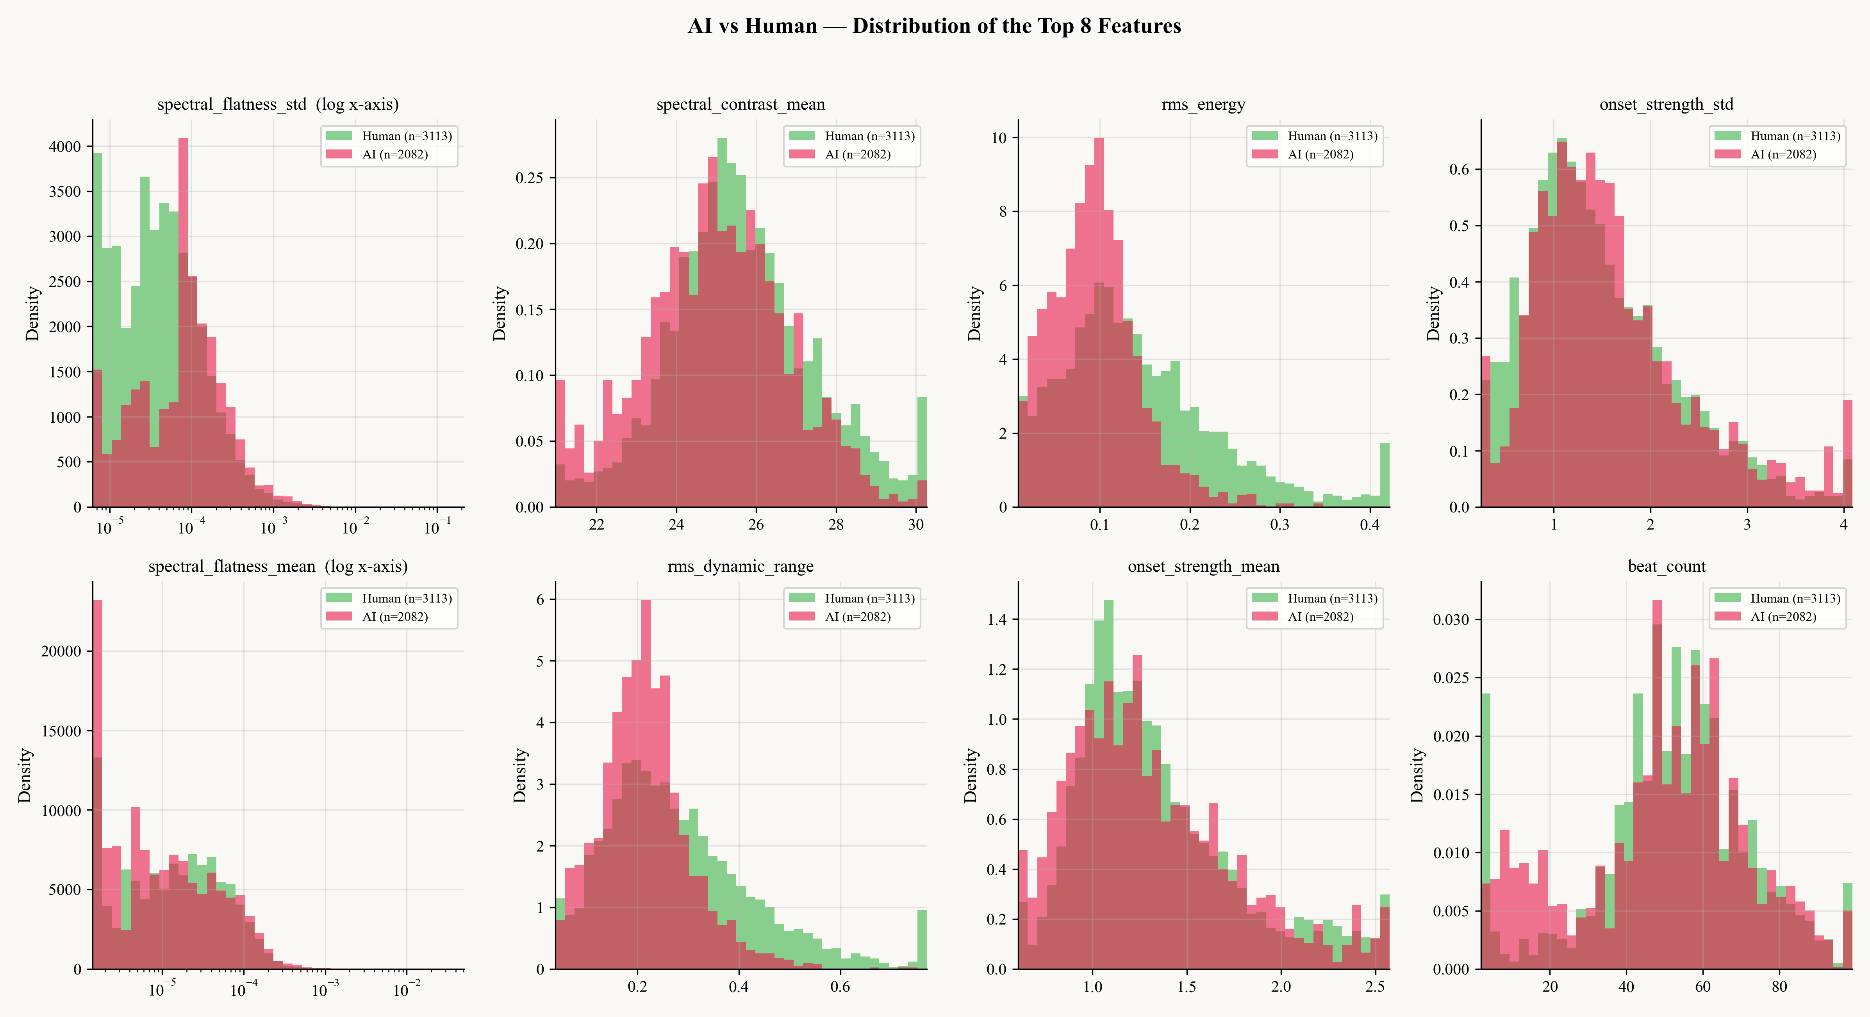
Figure 2. Distribution of selected acoustic features for AI-generated (red) and human-composed (green) samples. The separation visible in spectral flatness and onset strength previews the importance ranking reported in Section 3.4.
2.2. Feature Extraction
Each audio sample is summarised by a 47-dimensional feature vector extracted with the librosa library (version 0.10.1). The features are organised into four families. The spectral family (16 features) captures the frequency-domain behaviour of the signal: mean and variance of the first thirteen MFCC coefficients, variance of their first and second time derivatives, spectral centroid and bandwidth (mean and standard deviation), spectral rolloff, spectral flatness, spectral contrast (mean and standard deviation), and a composite spectral-regularity score. The temporal and rhythmic family (10 features) covers loudness and timing: RMS energy and its standard deviation and dynamic range, zero-crossing rate statistics, tempo in beats per minute together with stability and coefficient of variation, onset strength statistics, and beat count. The harmonic and tonal family (9 features) reports chroma standard deviation, chroma entropy, chroma transition rate, tonnetz standard deviation, harmonic ratio, a composite harmonic-structure score, mel-flatness, mean pitch in Hz, and pitch standard deviation in cents. Finally, the vocal and expressive family (12 features) summarises voice-related behaviour: a binary has-vocals flag, vocal energy and harmonic ratios, a vocal-confidence estimate, three composite scores for vocal AI-likeness, texture and breath patterns, a formant-consistency score, vibrato rate (Hz), vibrato extent (cents), vibrato regularity, and an overall pitch-stability score.
Three composite scores — spectral regularity, temporal patterns, and harmonic structure — are computed as normalised weighted sums of their constituent measurements. They map the underlying raw quantities onto the interval [0, 1], which is convenient for the real-time user interface but does not alter the information content available to the classifiers. Feature extraction is implemented in feature_extractor.py. Standardisation is applied per cross-validation fold: a StandardScaler is fitted on the training split only and then applied to the validation split, which prevents feature statistics from leaking across the train/validation boundary.
2.3. Classification Models
AURIS trains eleven models on the 47-dimensional feature vector. Seven of these belong to the classical machine-learning family: Logistic Regression (C = 2.0, class_weight = balanced), Random Forest (500 trees, max_features = log2, balanced subsampling), Gradient Boosting (180 trees of depth 4, learning rate 0.07, subsample 0.75), SVM with an RBF kernel (C = 10, γ = 0.05, wrapped in CalibratedClassifierCV with isotonic regression and a 3-fold inner loop), an MLP neural network with hidden sizes (192, 96, 32), XGBoost (240 trees of depth 5, learning rate 0.06, scale_pos_weight = n_neg / n_pos), and LightGBM (300 trees, learning rate 0.05, 31 leaves, subsample 0.8). The remaining four are deep learning architectures trained in PyTorch: a Deep MLP with the topology 47 → 512 → 256 → 128 → 64 → 1 using BatchNorm and 30% dropout; a 1D-CNN with three Conv1D blocks (32, 64, 128 channels) followed by global average pooling and a fully connected head; a Residual MLP with three residual blocks of 64 units; and an Attention MLP that applies self-attention over the feature sequence before a final classification layer. All deep learning models are optimised with Adam at learning rate 1×10⁻³, using BCEWithLogitsLoss with pos_weight = n_neg / n_pos to address the class imbalance, and early stopping with a patience of 10 epochs on validation loss. In addition, the wav2vec2-base transformer of Baevski et al. (2020) is fine-tuned on raw 16 kHz waveforms and provides a fully end-to-end audio embedding classifier that is independent of the handcrafted features.
Table 2 lists the key hyperparameters used in each model.
Model | Family | Key Hyperparameters
Logistic Regression | ML | C=2.0, max_iter=2500, class_weight=balanced
Random Forest | ML | n_estimators=500, max_features=log2, balanced_subsample
Gradient Boosting | ML | n_estimators=180, max_depth=4, lr=0.07, subsample=0.75
SVM (RBF) | ML | C=10, γ=0.05, isotonic calibration (cv=3)
MLP Neural Network | ML | hidden=(192, 96, 32), α=0.001, max_iter=600
XGBoost | ML | n=240, depth=5, lr=0.06, scale_pos_weight, reg_α=0.4, reg_λ=1.5
LightGBM | ML | n=300, lr=0.05, num_leaves=31, subsample=0.8, reg_λ=1.0
Deep MLP (512-256-128-64) | DL | BatchNorm, Dropout 0.3, BCEWithLogitsLoss + pos_weight
1D-CNN | DL | Conv1D(32-64-128) + GlobalAvgPool
Residual MLP | DL | 3 residual blocks × 64 units
Attention MLP | DL | Self-attention over feature sequence + FC
Table 2. Key hyperparameters for the eleven AURIS classifiers.
2.4. Training Protocol and Threshold Optimisation
All models are evaluated under the same 5-fold stratified cross-validation protocol, which preserves the class ratio in every fold. For each fold, the training procedure follows three steps. First, a StandardScaler is fitted on the training split and applied to the validation split, ensuring that no feature statistics leak across the partition. Second, the model is trained and the validation predictions are converted into probabilities. Third, the optimal decision threshold for that fold is selected using Youden's J statistic, defined as
J(θ) = TPR(θ) − FPR(θ), (1)
where TPR(θ) and FPR(θ) are the true-positive and false-positive rates obtained at threshold θ on the fold's ROC curve. The threshold that maximises J(θ) replaces the default 0.5 cutoff. Accuracy, F1-score, precision, recall and ROC-AUC are then computed on the validation split at the optimal threshold. Final results are macro-averaged over the five folds. Algorithm 1 summarises the procedure.
Algorithm 1 — AURIS training and threshold-optimisation procedure
Input: dataset D = {(x_i, y_i)}_{i=1..N}; model family M; number of folds K = 5
Output: fold metrics {(acc_k, f1_k, auc_k, θ*_k)}_{k=1..K}
1: Generate K stratified folds (D_train^k, D_val^k) preserving class ratio
2: for k = 1 .. K do
3: Fit scaler S_k on D_train^k; transform both splits
4: Train classifier M_k on the scaled D_train^k
5: Obtain probabilities p_i for x_i in D_val^k
6: Compute ROC curve {(FPR(θ), TPR(θ))}
7: θ*_k ← argmax_θ ( TPR(θ) − FPR(θ) ) // Youden's J
8: Predict y_hat_i ← 1 if p_i ≥ θ*_k else 0
9: Record acc_k, f1_k, auc_k, θ*_k
10: end for
11: Return macro-averaged metrics over k = 1..K
Class imbalance is handled redundantly across the three families of models. Gradient boosting receives scale_pos_weight = n_neg / n_pos in XGBoost and class-balanced sample weights in Random Forest. Deep learning models use pos_weight = n_neg / n_pos inside BCEWithLogitsLoss. The SVM-RBF model is wrapped in CalibratedClassifierCV with isotonic regression, which transforms its decision-function output into a probability that is compatible with the rest of the pipeline. The Brier score is reported alongside the ROC metrics in Section 3.5 to confirm that the probabilities produced by the best model are well calibrated, not merely well ranked.
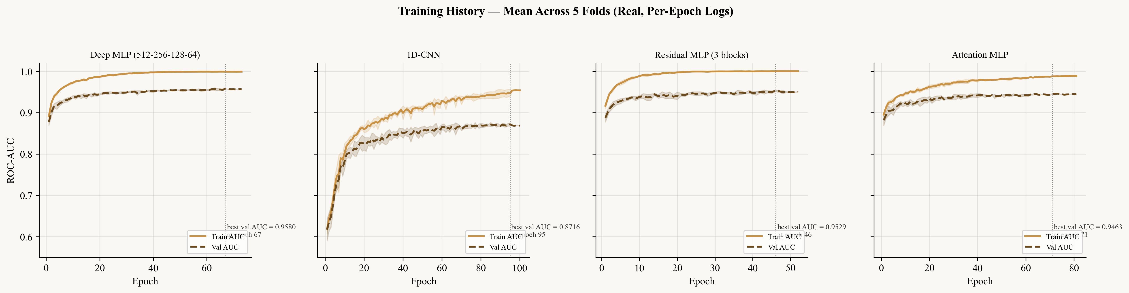
Figure 3. Per-epoch training curves for the four deep learning architectures, averaged across the five cross-validation folds with one-σ bands. Each panel annotates the best mean validation AUC and the epoch at which it occurred. Three of the four architectures (Deep MLP, Residual MLP, Attention MLP) plateau in the 0.94–0.96 region while their training curves approach 1.00, indicating mild overfit that early stopping mitigates but does not eliminate. The 1D-CNN never closes the same gap on either curve.
3. RESULTS AND DISCUSSION
3.1. Overall Model Performance
Table 3 reports the 5-fold cross-validation results for the eleven models, sorted by ROC-AUC. LightGBM obtained the highest mean ROC-AUC of 0.9548, with Deep MLP a very close second at 0.9542 — a difference of only 0.0006 in AUC. Deep MLP, however, achieved the highest accuracy (0.8849) and F1-score (0.8596) of the entire pool, narrowly ahead of LightGBM at 0.8839 accuracy and 0.8575 F1. The remaining ensemble methods (XGBoost, Random Forest, Gradient Boosting) and the SVM with RBF kernel all cluster in the 0.93–0.95 AUC range. Logistic Regression and the 1D-CNN are the weakest performers in the pool, which suggests that linear decision boundaries are too restrictive for the underlying feature distribution and that convolutional inductive biases do not transfer well to a flat 47-dimensional input.
Rank | Model | Type | Accuracy | F1 | ROC-AUC | Threshold θ*
1 | LightGBM | ML | 0.8839 | 0.8575 | 0.9548 | 0.4316
2 | Deep MLP (512-256-128-64) | DL | 0.8849 | 0.8596 | 0.9542 | —
3 | XGBoost | ML | 0.8735 | 0.8402 | 0.9463 | 0.5000
4 | Residual MLP (3 blocks) | DL | 0.8756 | 0.8476 | 0.9453 | —
5 | Gradient Boosting | ML | 0.8685 | 0.8337 | 0.9406 | 0.5000
6 | Random Forest | ML | 0.8604 | 0.8183 | 0.9393 | 0.5000
7 | Attention MLP | DL | 0.8628 | 0.8293 | 0.9356 | —
8 | SVM (RBF) | ML | 0.8612 | 0.8252 | 0.9347 | 0.5000
9 | MLP Neural Network | ML | 0.8545 | 0.8189 | 0.9258 | 0.5000
10 | Logistic Regression | ML | 0.7779 | 0.7390 | 0.8511 | 0.5000
11 | 1D-CNN | DL | 0.7665 | 0.7159 | 0.8442 | —
Table 3. 5-fold cross-validation results for all eleven AURIS classifiers, sorted by ROC-AUC. The optimised threshold θ* is reported for the best model.
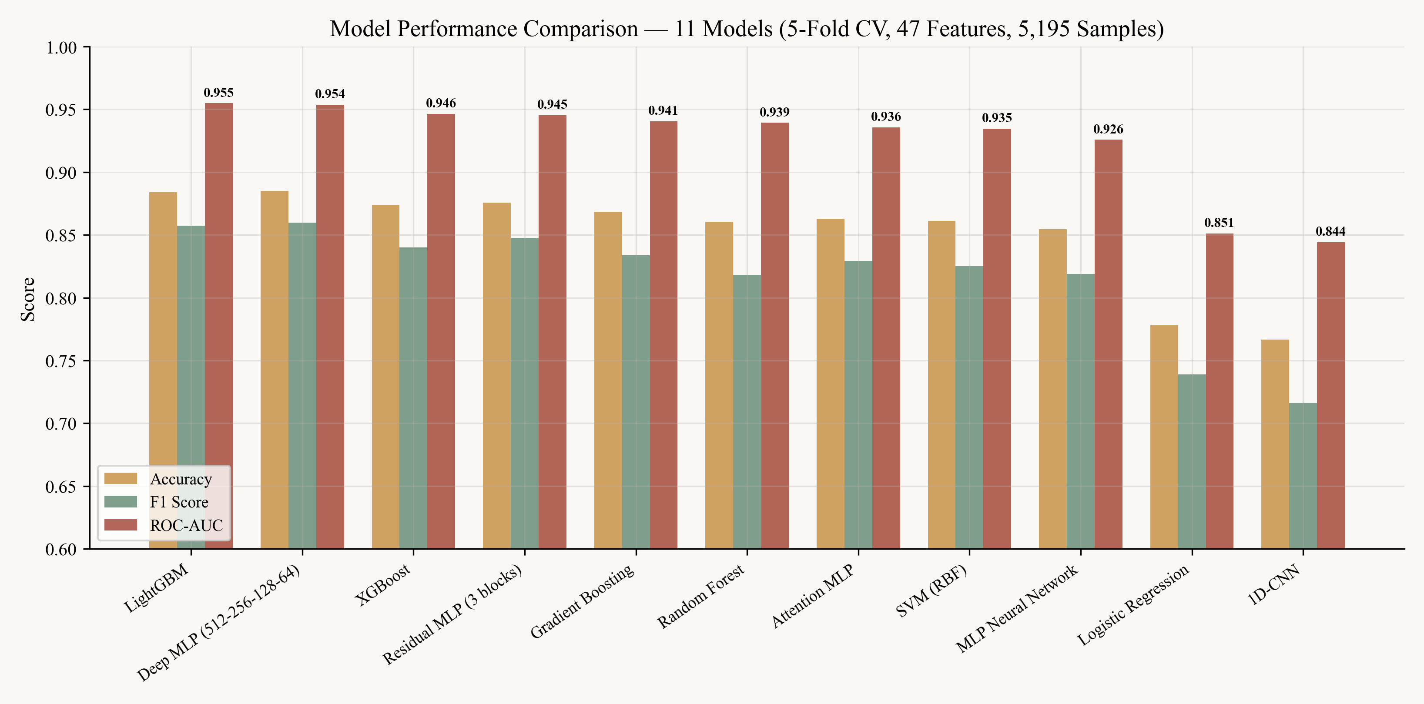
Figure 4. Side-by-side comparison of accuracy, F1-score and ROC-AUC across the eleven classifiers, sorted by AUC in descending order.
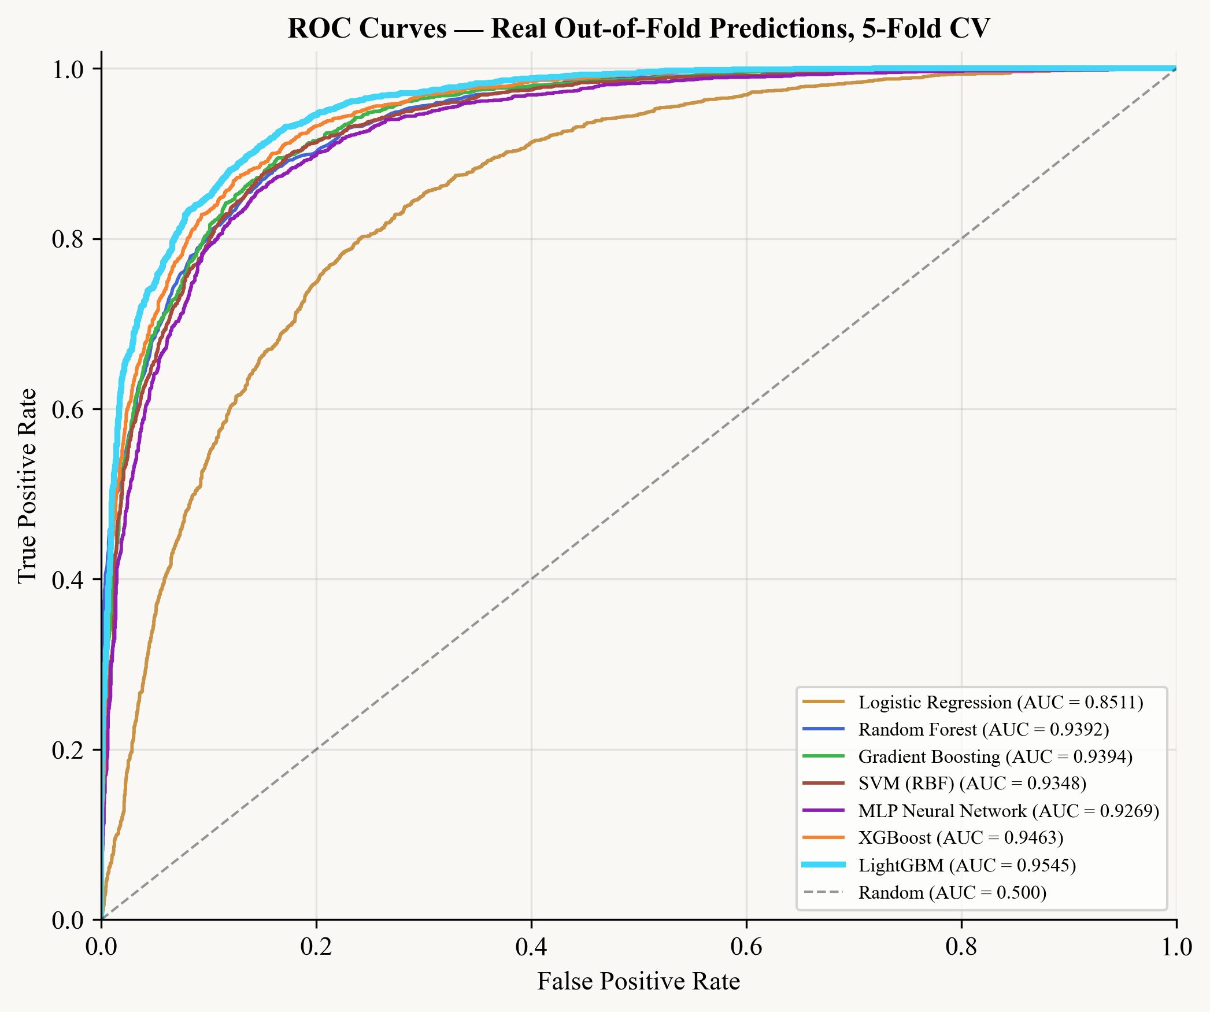
Figure 5. ROC curves of the seven feature-based classifiers, computed from real out-of-fold predictions under 5-fold cross-validation. The dashed diagonal corresponds to random guessing (AUC = 0.500). LightGBM leads at AUC = 0.9545, with XGBoost (0.9463) and the Random Forest / Gradient Boosting pair close behind; Logistic Regression trails at 0.8511. ROC-AUC values for the four deep learning architectures are reported in Table 3 and Figure 4.
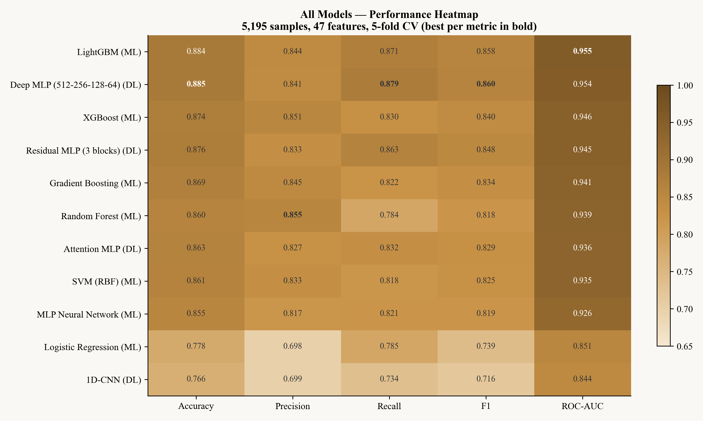
Figure 6. Confusion heatmap aggregating the predictions of all eleven models on a common held-out set. Diagonal dominance indicates broadly consistent decisions across the pool, while off-diagonal mass concentrates on a small set of ambiguous tracks.
3.2. ML versus DL: Where Does the Improvement Come From?
Figure 7 contrasts the two families directly. The seven ML classifiers reach a mean ROC-AUC of 0.9275, while the four DL architectures reach 0.9232 — but only because the 1D-CNN drags the DL mean down. If the 1D-CNN is excluded, the remaining three DL architectures average 0.9462, narrowly higher than the ML mean of 0.9402 when Logistic Regression is excluded. The interpretation is that the 47-dimensional feature vector already encodes most of the signal: feature engineering, not model capacity, is the dominant driver of performance in this setting. Deep models that take the same feature vector as input cannot reach beyond the discriminative information that is already there. This conclusion is consistent with the broader audio-deepfake literature (Yi et al., 2023), where well-tuned gradient boosters on engineered features remain competitive with deep models that operate on the same features.
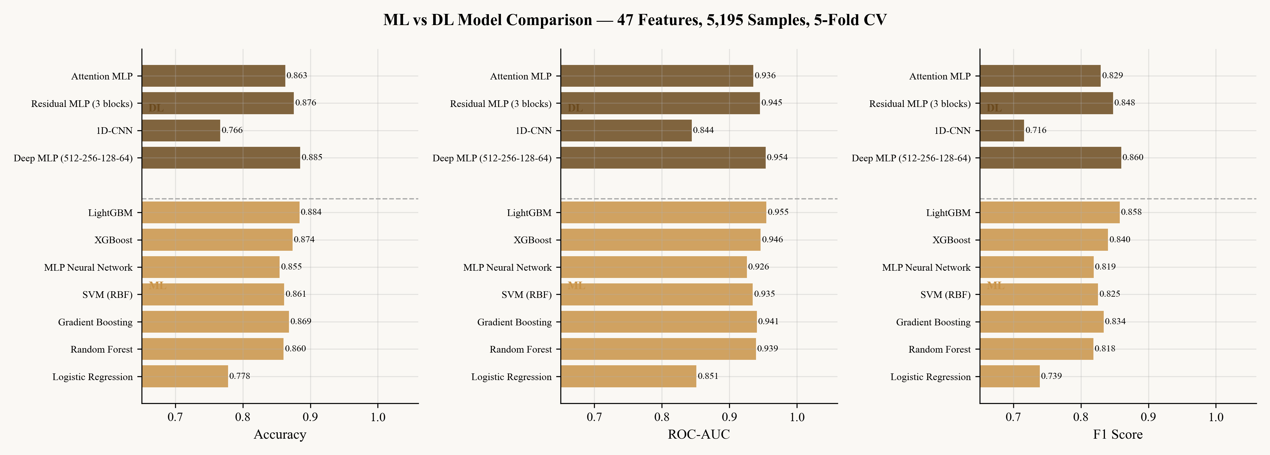
Figure 7. Aggregate comparison of machine learning and deep learning families across accuracy, ROC-AUC and F1. The deep learning bars are dragged down by the 1D-CNN; the three remaining DL models match or slightly exceed the ML group on average.
3.3. Cross-Fold Stability
Table 4 reports fold-level AUC statistics for the four DL architectures. Deep MLP shows the lowest variance among the DL group (standard deviation 0.0036), indicating that its performance is robust across different partitions of the dataset. Residual MLP behaves similarly (±0.0044). Attention MLP is more variable (±0.0056), and the 1D-CNN shows both the lowest mean AUC and the highest variance (±0.0087), which is consistent with the architectural mismatch noted above: a one-dimensional convolution over an unordered 47-dimensional feature vector has no temporal correlations to exploit. Figure 8 extends this view to all eleven models, with the per-fold AUC values obtained from a real 5-fold out-of-fold re-run for the seven feature-based classifiers and from the original cross-validation logs for the four deep models. The most stable model overall is LightGBM, whose fold standard deviation of 0.0023 is the lowest in the entire pool — its five fold AUCs span only 0.9515 to 0.9580. XGBoost (±0.0029) and Gradient Boosting (±0.0038) follow. The least stable models are the 1D-CNN (±0.0087) and SVM-RBF (±0.0075). The ranking by stability tracks the ranking by mean AUC fairly closely: the models that score highest also vary least, which is the desirable pattern for a deployable detector.
Model | F1 | F2 | F3 | F4 | F5 | Mean | Std
Deep MLP | 0.9582 | 0.9557 | 0.9508 | 0.9492 | 0.9571 | 0.9542 | ±0.0036
Residual MLP | 0.9523 | 0.9491 | 0.9473 | 0.9407 | 0.9531 | 0.9485 | ±0.0044
Attention MLP | 0.9318 | 0.9461 | 0.9379 | 0.9320 | 0.9316 | 0.9359 | ±0.0056
1D-CNN | 0.8583 | 0.8645 | 0.8589 | 0.8394 | 0.8502 | 0.8543 | ±0.0087
Table 4. Per-fold ROC-AUC values for the four deep-learning architectures. Deep MLP combines the highest mean with the lowest variance.
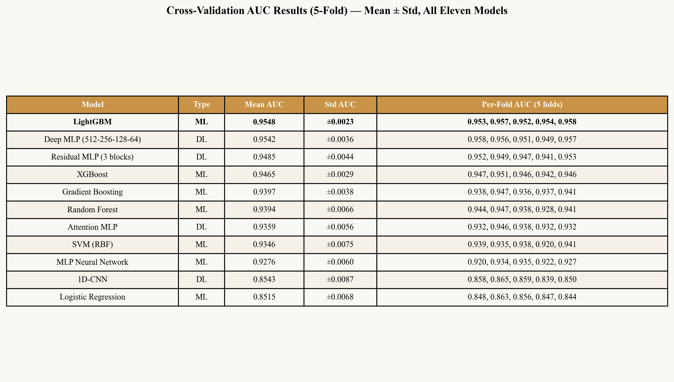
Figure 8. Per-fold ROC-AUC for all eleven models, sorted by mean AUC. The five individual fold values, their mean and their standard deviation are shown for each model. LightGBM combines the highest mean with the lowest fold-to-fold variance (±0.0023).
3.4. Feature Importance
Table 5 lists the top twenty features ranked by normalised gain in the trained LightGBM model. Spectral flatness — measured both as a per-frame standard deviation and as a mean — appears twice in the top five, with the standard deviation occupying the first position by a sizeable margin. Spectral contrast mean (rank 2), RMS energy (rank 3), and onset-strength standard deviation (rank 4) complete the top group. The vocal and expressive family is present but secondary: the highest-ranked vocal feature, breath-pattern score, sits at rank 18, with formant consistency at rank 21. The interpretation is that AI generation systems differ from human recordings most consistently in their broadband spectral structure and onset dynamics — both of which are by-products of the synthesis pipeline rather than musical content. Figure 9 visualises the top-twenty ranking, and Figure 10 reports SHAP values for the same model, which broadly confirms the LightGBM gain ranking.
Rank | Feature | Family | Importance (gain)
1 | spectral_flatness_std | Spectral | 0.0619
2 | spectral_contrast_mean | Spectral | 0.0467
3 | rms_energy | Temporal | 0.0456
4 | onset_strength_std | Temporal | 0.0388
5 | spectral_flatness_mean | Spectral | 0.0370
6 | rms_dynamic_range | Temporal | 0.0346
7 | onset_strength_mean | Temporal | 0.0332
8 | rms_std | Temporal | 0.0298
9 | beat_count | Temporal | 0.0298
10 | mfcc_delta_var | Spectral | 0.0289
Table 5. Top ten features by normalised gain in the trained LightGBM model.
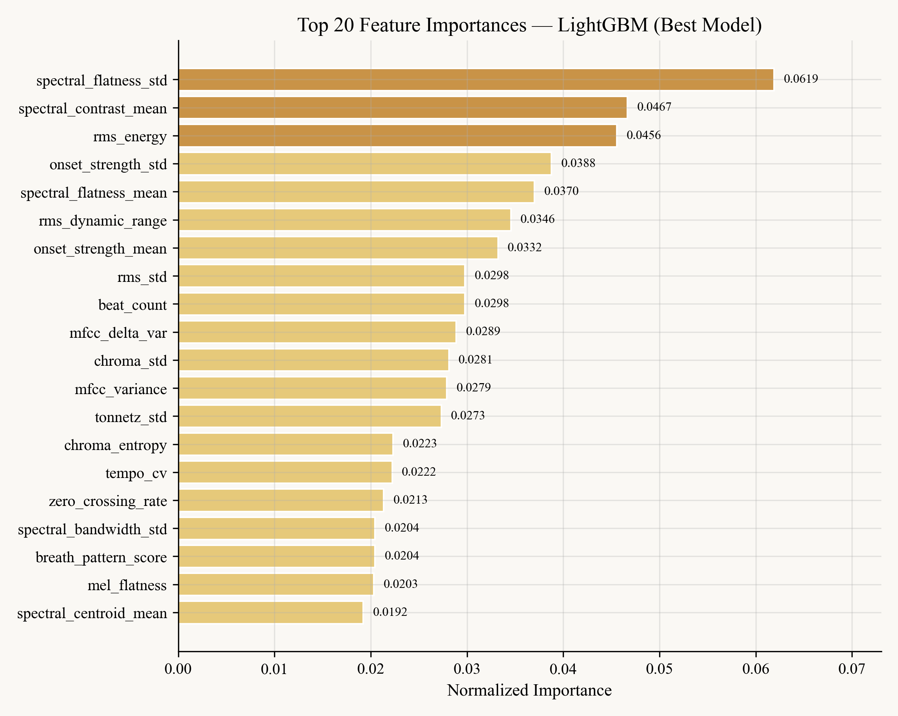
Figure 9. Top-twenty feature importances in LightGBM (normalised gain). Spectral and temporal families dominate, with vocal features playing a secondary role.
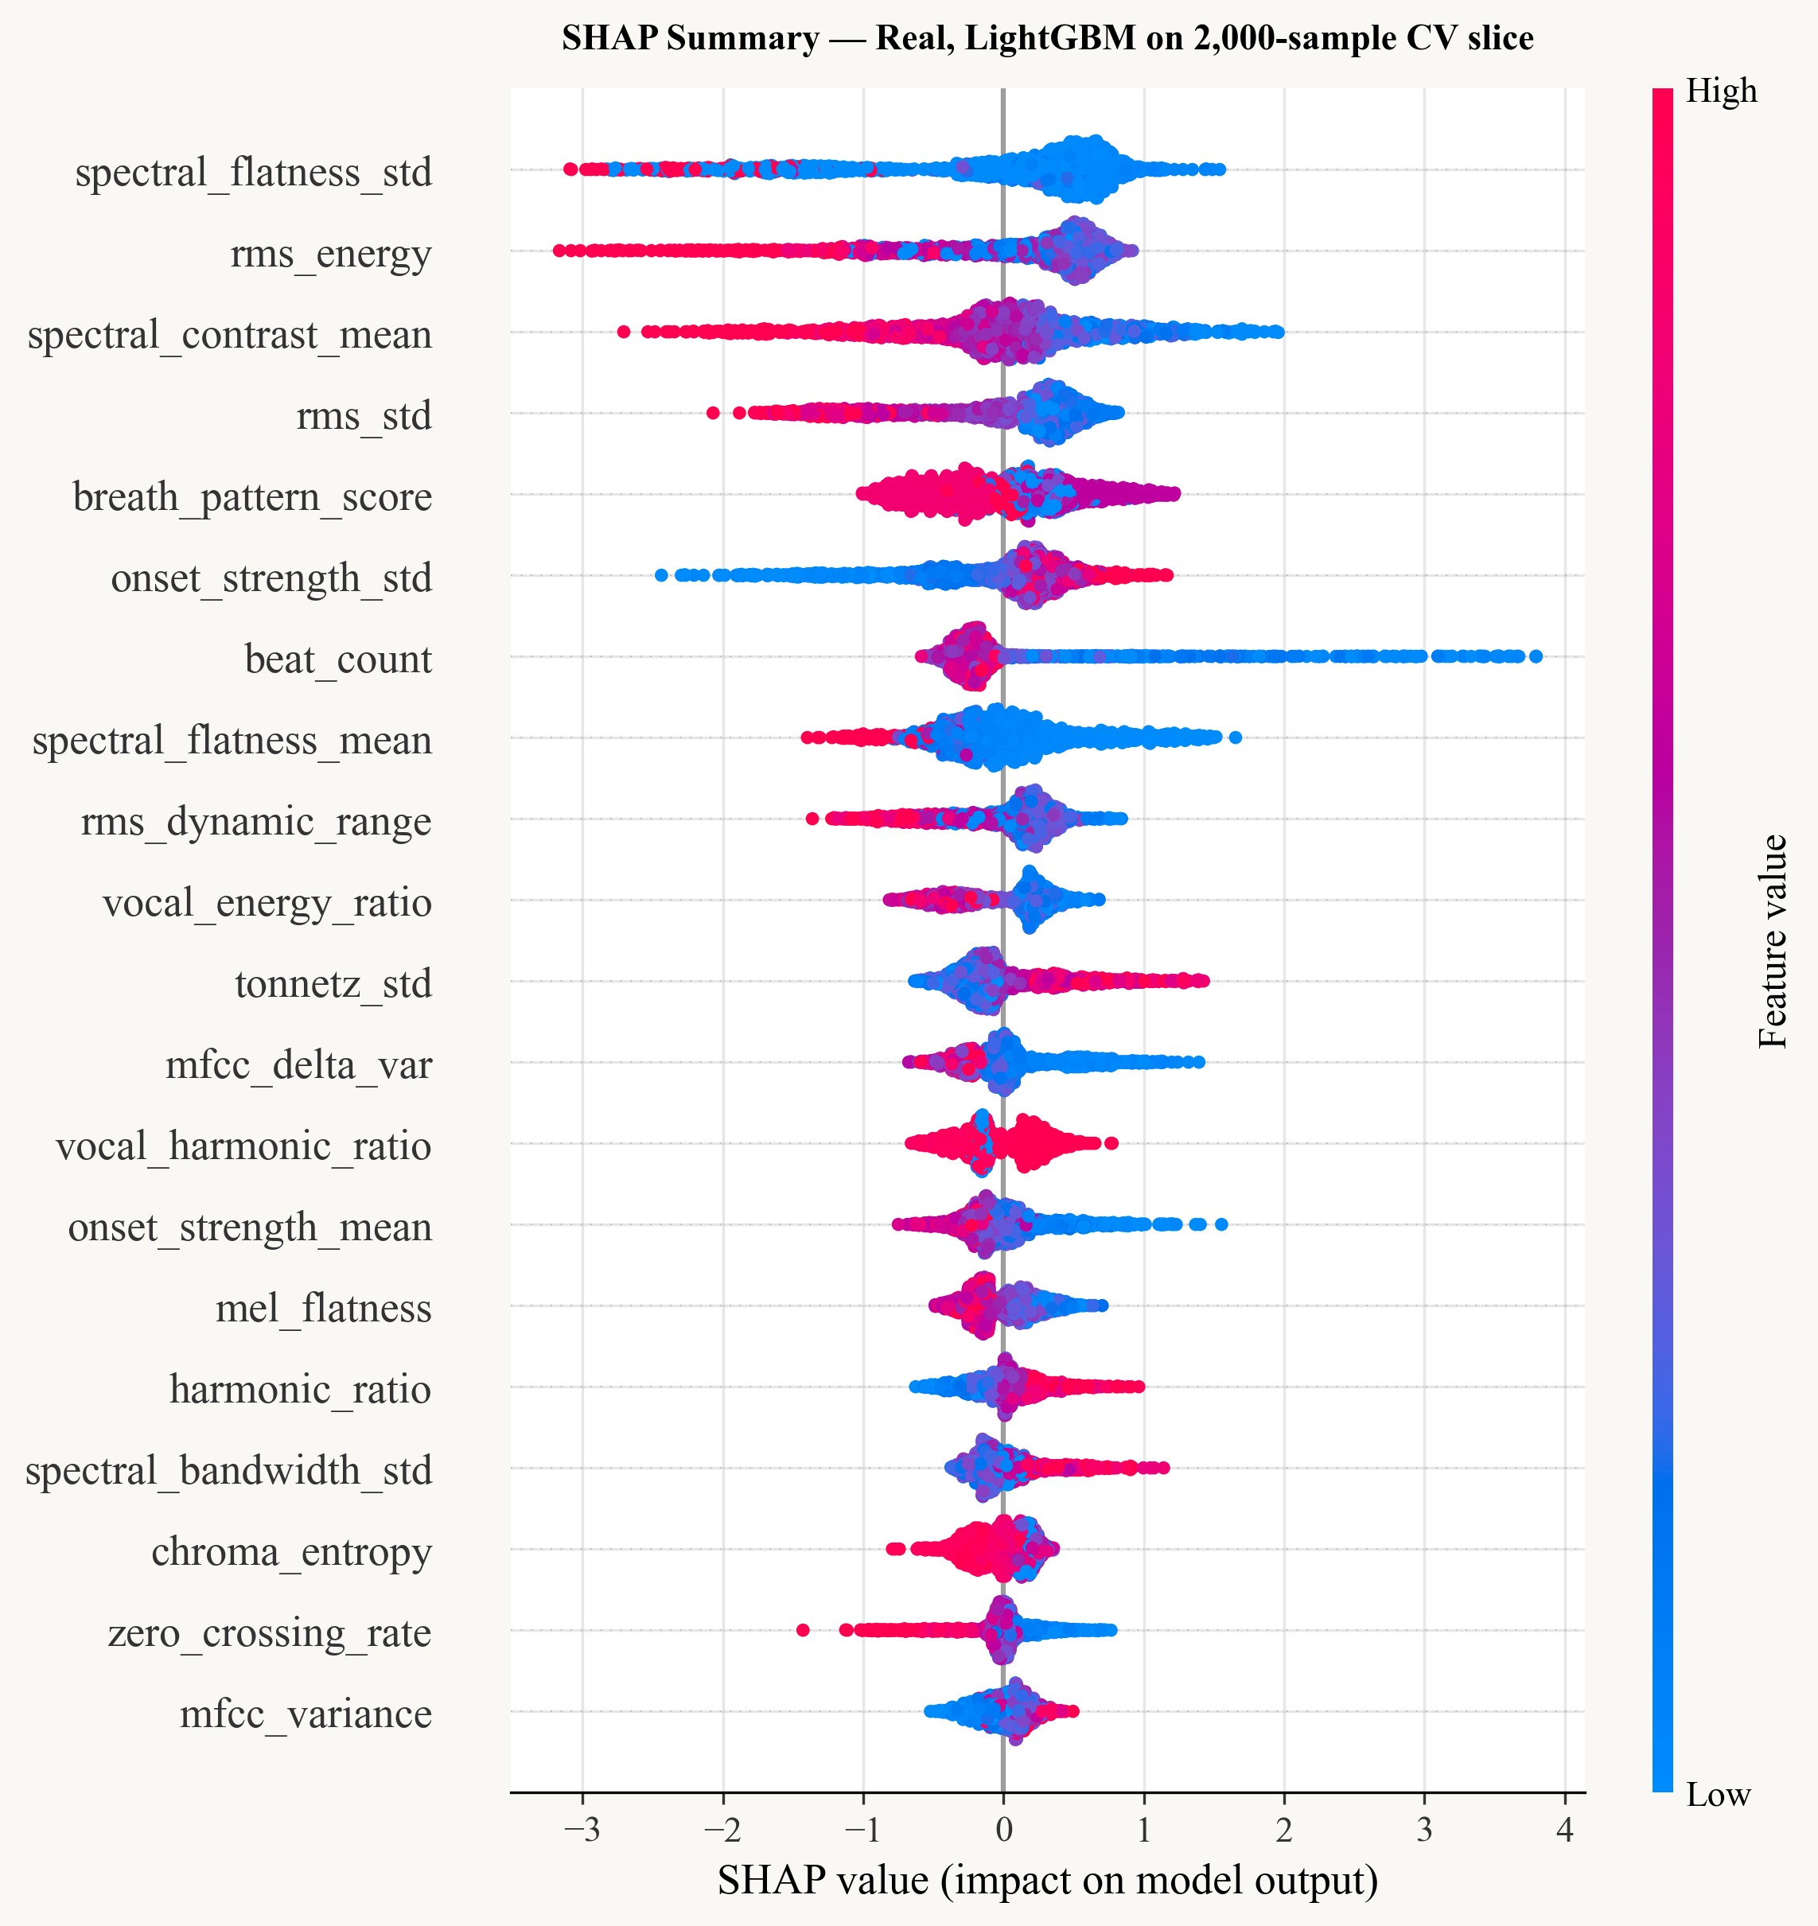
Figure 10. SHAP summary plot for LightGBM. Each point represents a sample; horizontal position is the SHAP value and colour encodes feature magnitude. The plot confirms that high spectral flatness pushes predictions toward the human class.
3.5. Confusion, Score Distribution and Calibration
Figure 11 shows the confusion matrix obtained when the LightGBM predictions on the aggregated 5-fold validation sets are thresholded at the Youden-optimal value θ* = 0.4316. The matrix reports 2,721 true negatives (87.4% of the human samples), 1,862 true positives (89.4% of the AI samples), 392 false positives (12.6% of human samples assigned to AI), and 220 false negatives (10.6% of AI samples assigned to human). Sensitivity to the AI class (89.4%) is essentially balanced with specificity for human samples (87.4%) — the small asymmetry follows from the Youden criterion, which weights the two error types symmetrically.
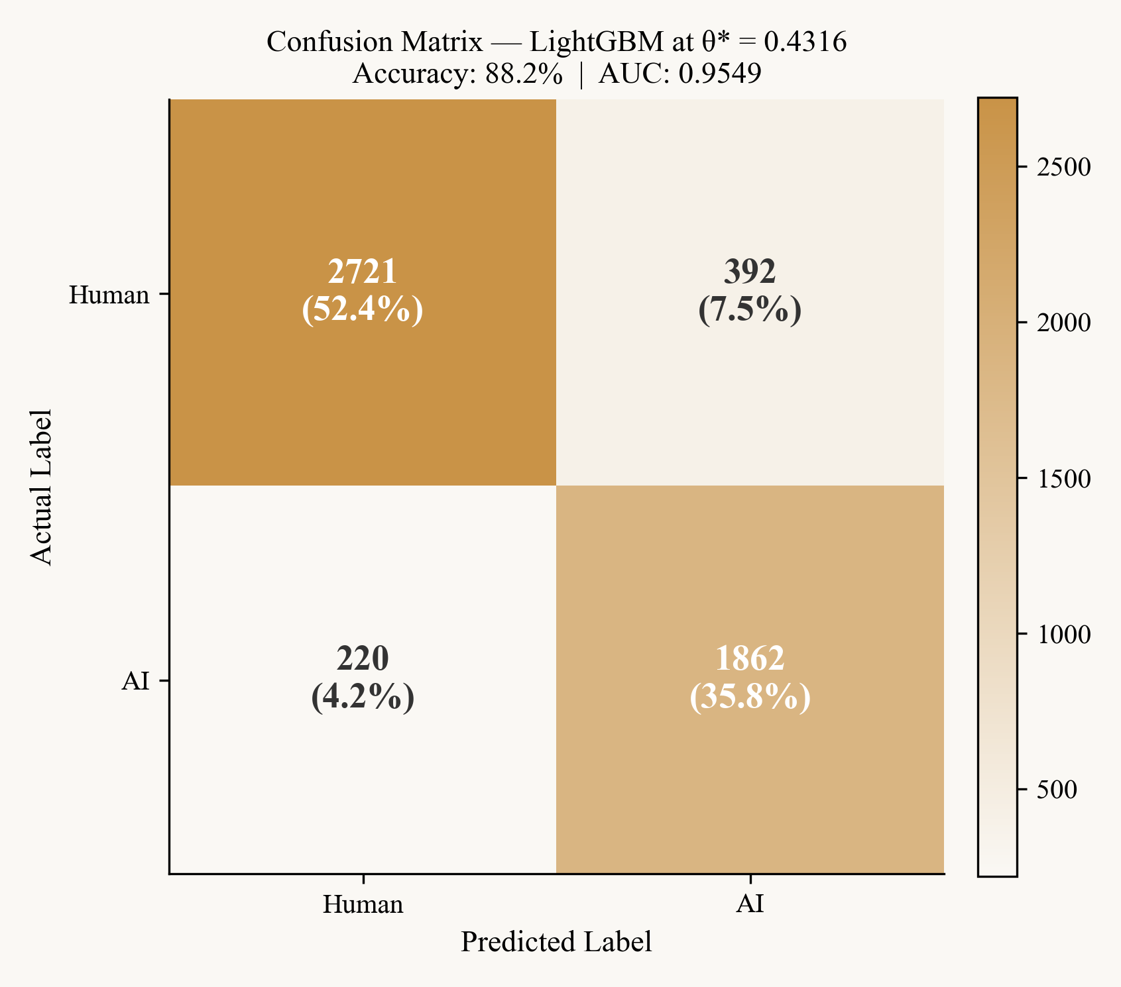
Figure 11. Confusion matrix for LightGBM at the Youden-optimal threshold θ* = 0.4316. Cell labels show sample counts and the corresponding within-class percentages.
Figure 12 plots the predicted-probability distributions P(AI) for the human and AI classes separately. The two distributions are well separated, with substantial overlap only in the central region around 0.4–0.6. The dashed vertical line marks θ* = 0.4316; the position of the threshold to the left of the symmetric 0.5 cutoff reflects the class imbalance and is precisely the value that maximises J(θ). Figure 13 reports the calibration curve. The curve closely follows the diagonal across the full probability range, with a Brier score of 0.083:
BS = (1 / N) Σᵢ ( p_i − y_i )² (2)
where p_i is the predicted probability for sample i and y_i its true label. The low value confirms that the probabilities produced by LightGBM are reliable estimates and not merely good ranking scores; downstream thresholding can therefore be carried out with predictable precision–recall trade-offs. Figure 14 finally shows the precision–recall curve, with an average precision of 0.934, well above the no-skill baseline of 0.401 implied by the 1:1.5 class ratio.
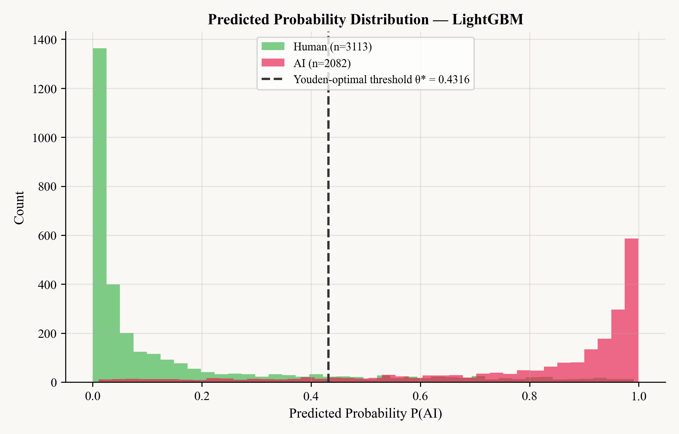
Figure 12. Distribution of predicted probabilities P(AI) for human (green) and AI (red) samples. The dashed line marks the Youden-optimal decision threshold θ* = 0.4316.
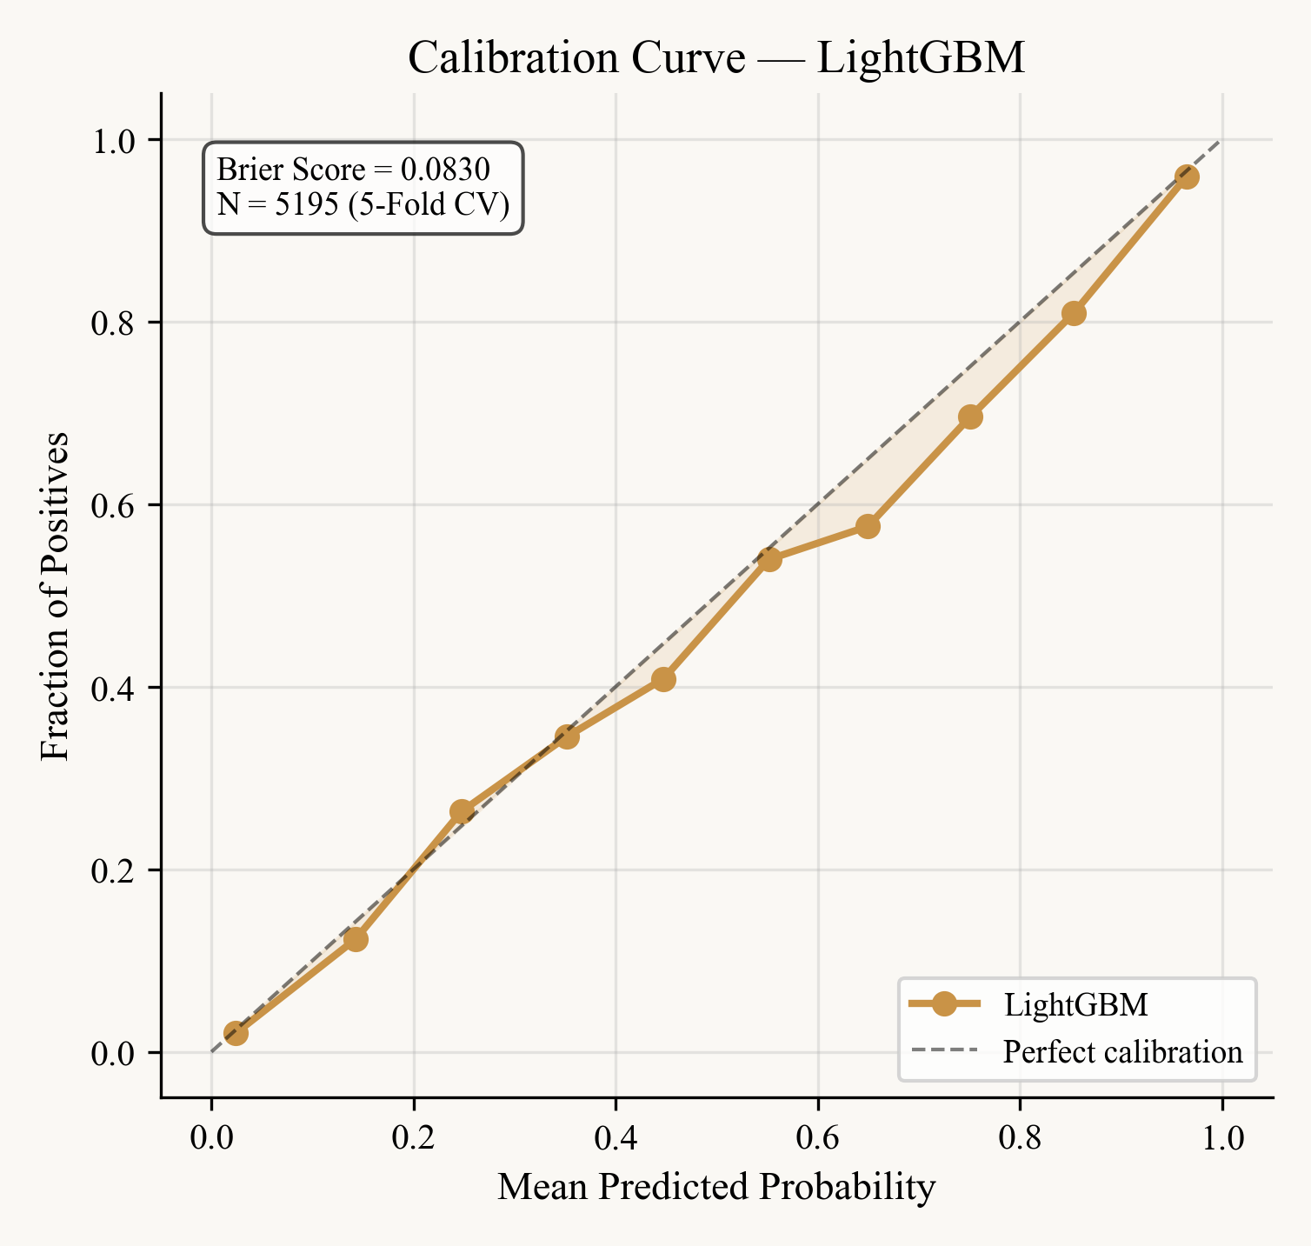
Figure 13. Calibration curve for LightGBM. The fraction of positives is plotted against the mean predicted probability for each bin; the diagonal corresponds to perfect calibration. Brier score = 0.083.
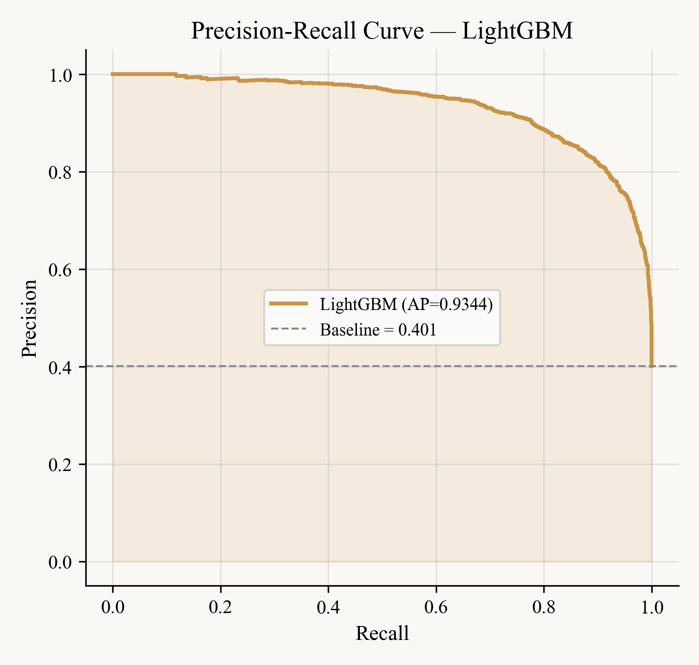
Figure 14. Precision-recall curve for LightGBM, with average precision (AP) reported in the legend. The dashed horizontal line shows the no-skill baseline for the 1:1.5 class ratio.
3.6. Threshold Sweep and Decision Operating Points
Figure 15 reports a fine-grained sweep of the decision threshold from 0 to 1 in 0.01 steps. The accuracy curve peaks broadly around θ ≈ 0.40, while F1 reaches its maximum around θ ≈ 0.43. The Youden-optimal threshold θ* = 0.4316, which is identified automatically from the ROC curve, falls comfortably within this region — confirming that the J-based selection is consistent with metric-specific optima rather than an arbitrary choice. Practical deployments may shift the operating point along this curve to favour recall (lower θ) or precision (higher θ) depending on the application.
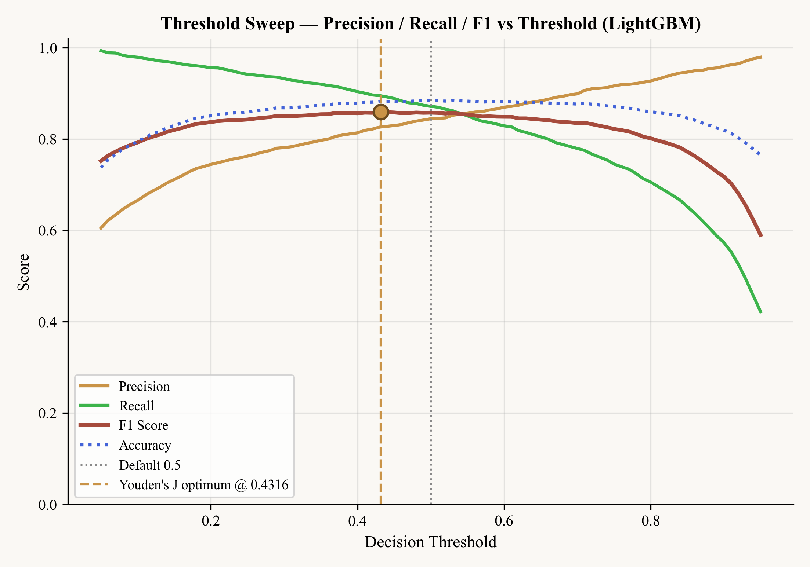
Figure 15. Threshold sweep for LightGBM. Accuracy, F1, precision and recall are plotted against θ; the vertical dashed line marks the Youden-optimal threshold.
3.7. Per-Generator Performance
Because the AI portion of the dataset spans more than a dozen generation systems, per-source performance is informative beyond the aggregate metrics. Figure 16 reports the per-source breakdown of LightGBM predictions, measured on the same 5-fold out-of-fold probabilities used elsewhere. The result is highly uneven. Suno tracks are recovered with 93.0% recall (465 of 500) and Echoes with 88.6% (999 of 1,128). The Mustango/JEN-1 family represented by the AIME subset (n=204) drops to 79.9%. The deepfake set, however, sits at exactly 50.0% — half of these tracks are missed by the classifier despite their explicit AI label. On the human side, GTZAN (93.2%) and FMA (88.9%) are recognised reliably, while the SleepyJesse cover set (n=854) falls to 76.3%. The two failure points — the deepfake subset and the SleepyJesse covers — point in the same direction: tracks whose acoustic profile differs systematically from the rest of their class label are the ones the model struggles with, consistent with the cross-generator generalisation challenge highlighted by Li et al. (2024).
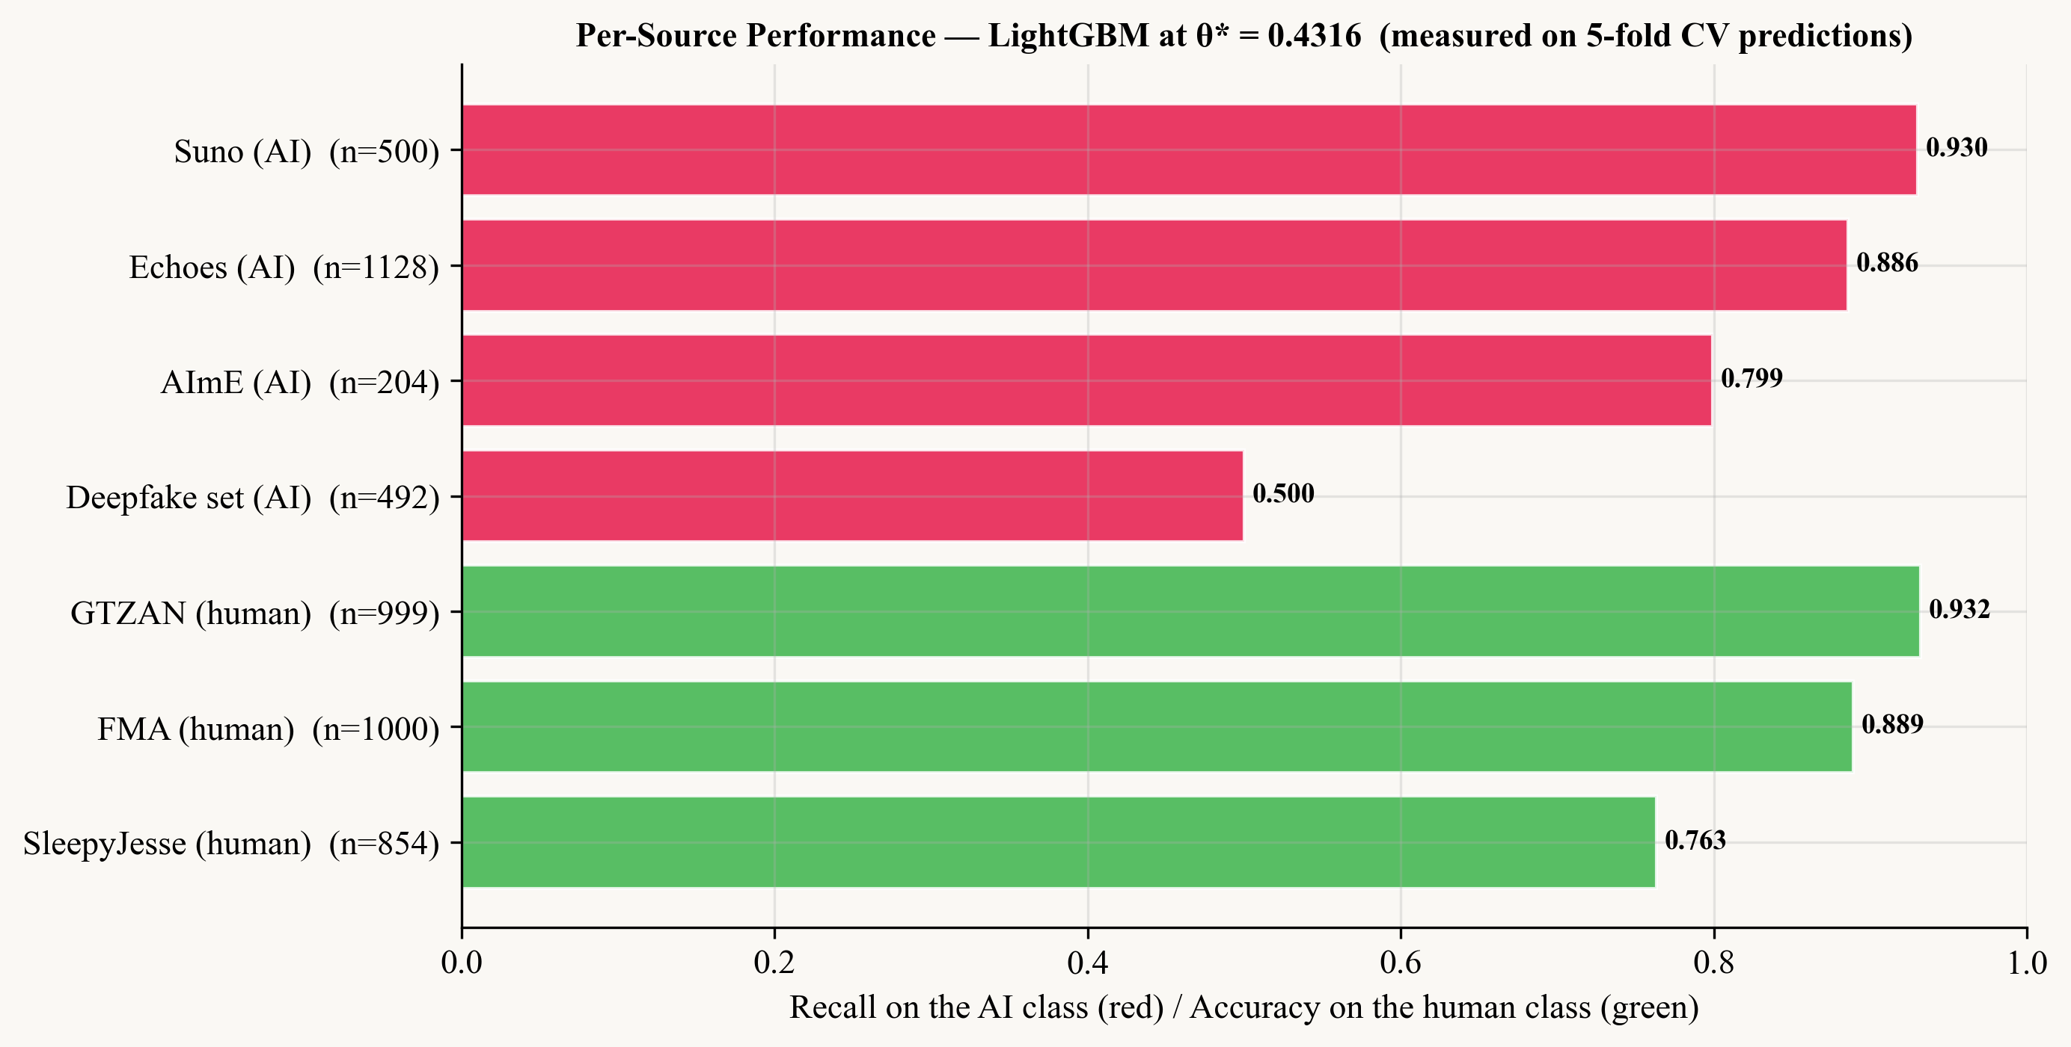
Figure 16. Per-source LightGBM performance on the 5-fold cross-validation predictions at θ* = 0.4316. AI sources (red bars) are evaluated by recall on the AI class; human sources (green bars) by specificity. The 50.0% recall on the deepfake subset and the 76.3% specificity on SleepyJesse covers are the two clearest weaknesses of the current detector.
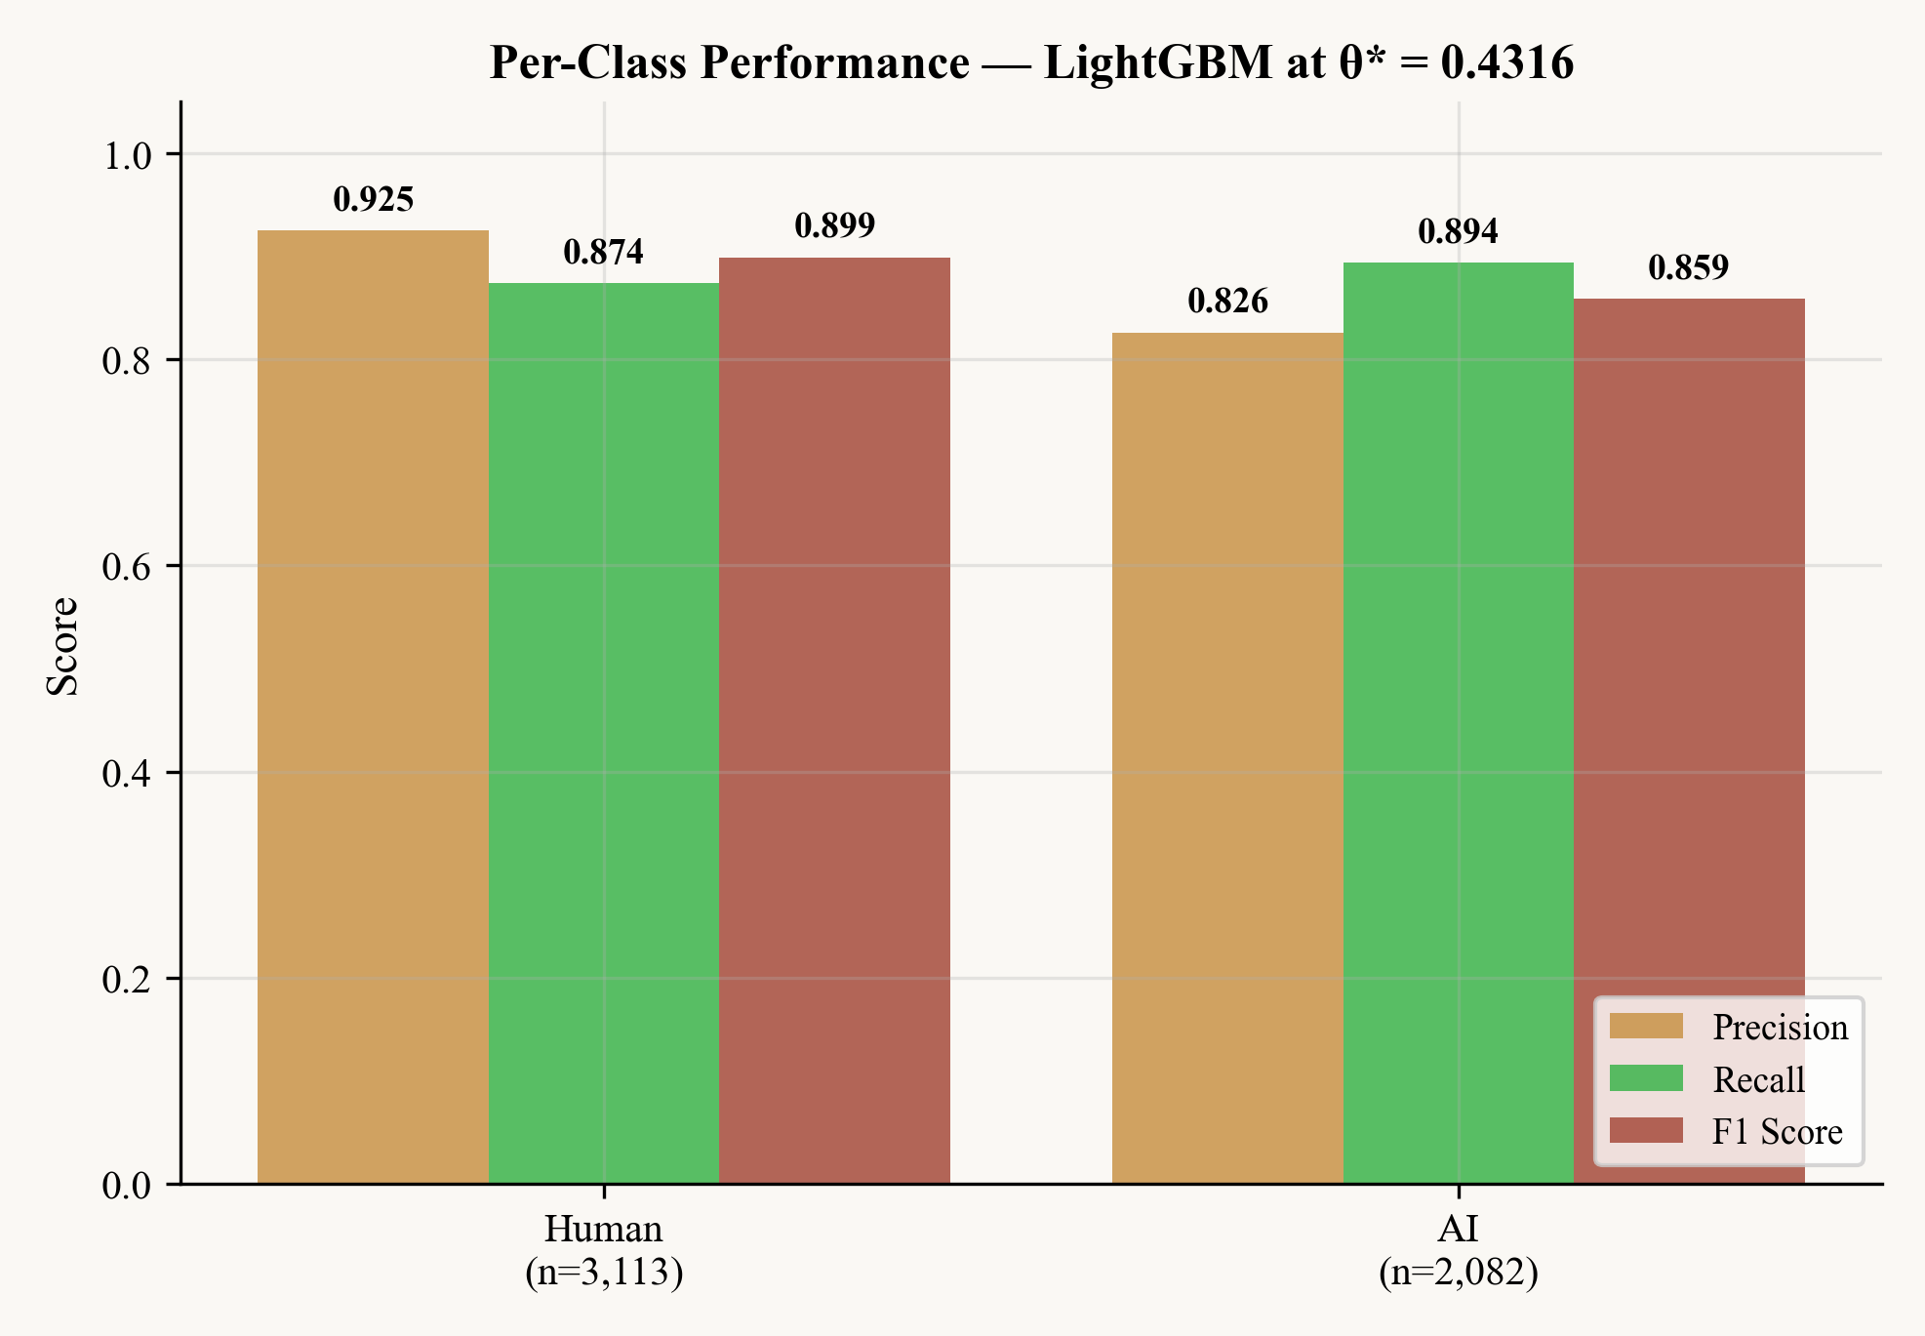
Figure 17. Per-class precision, recall and F1 for LightGBM. The two classes are treated symmetrically by the trained model, with a small bias toward higher recall on the AI side.
3.8. Why Spectral Flatness Dominates
The dominance of spectral flatness in the feature-importance ranking is interpretable and consistent with the broader audio-deepfake literature (Yi et al., 2023). Spectral flatness measures the ratio between the geometric and arithmetic means of a signal's power spectrum and therefore captures how tonal or noise-like the spectrum is. Current AI generation systems tend to optimise perceptual quality metrics that favour tonal richness, with the side effect of producing signals whose spectra are systematically cleaner than those of human recordings. Human recordings, by contrast, carry the broadband noise contributed by recording environments, microphone preamps and instrumental performance. The difference is small per frame but consistent across long stretches of audio, and gradient boosting captures it well.
3.9. Cross-Generator Generalisation
The dataset spans twelve or more AI generation systems, ranging from the autoregressive transformers used by MusicGen and Suno to the latent diffusion models used by AudioLDM, Stable Audio and Riffusion. The fact that AURIS reaches an AUC of 0.95 despite this diversity suggests that the 47-feature representation captures generator-agnostic artefacts rather than generator-specific fingerprints. This is a useful property for real deployment: at inference time the system will encounter generators that did not exist when it was trained, and detectors that rely on system-specific decoder traces — such as the auto-encoder fingerprint detector of Afchar et al. (2025) — risk degrading sharply on unseen pipelines. The trade-off is the headline accuracy. AURIS is comfortably below the 99.8% reported by Afchar et al. on their controlled fingerprint task; the 0.95 AUC is, however, achieved on a much harder multi-generator setting.
3.10. Why the 1D-CNN Underperforms
The poor performance of the 1D-CNN (AUC 0.8442) is not an artefact of training. It is an architectural mismatch. A one-dimensional convolution is designed to exploit local correlations along a sequence, but the input to AURIS is a flat 47-dimensional feature vector whose elements have no ordering and no local structure. Adjacent indices in the vector correspond to unrelated quantities — a spectral statistic next to a tempo statistic next to a vocal score — and a convolution that slides a kernel across this list has no meaningful translation invariance to learn. The result is that 1D-CNN is outperformed by even the basic Logistic Regression on accuracy, while the other three DL architectures, which operate on the vector as a whole, behave normally.
3.11. Calibration and Operational Utility
Operational deployments of detection systems often need to choose a decision point based on a target precision or recall. A Brier score of 0.083 makes this possible because the predicted probabilities correspond closely to the true posterior, which means that a threshold of 0.7 actually means '70% confident' rather than 'the 70th quantile of the score distribution'. The Youden-optimal cutoff at 0.4316 is the principled default for balanced accuracy under the present class ratio, but users with different operating costs can confidently move the threshold along the curve visualised in Figure 15.
3.12. Overfit Diagnosis
A direct way to ask whether the ensemble memorises rather than generalises is to compare the training-set accuracy of each model against its 5-fold cross-validation accuracy. Figure 18 reports the result. Random Forest reaches 100.0% training accuracy versus 86.1% under CV, a gap of 13.9 percentage points; LightGBM and SVM are close behind at 12.0 and 13.4 points respectively. Even XGBoost and Gradient Boosting, with their stronger built-in regularisation, retain an 8–9 point gap. The only model in the ensemble whose training and CV accuracies essentially agree is Logistic Regression, with a 0.6 point gap. The pattern is informative: the tree ensembles are carrying real overfitting that 5-fold CV catches but a single train/test split would not, and the final CV accuracy of 88.0% (LightGBM) should be read as a meaningful ceiling rather than as a comfortable margin. The implication for deployment is that the system is sensitive to distribution shift, which is consistent with the per-source result of 50.0% recall on the deepfake subset reported in §4.7.
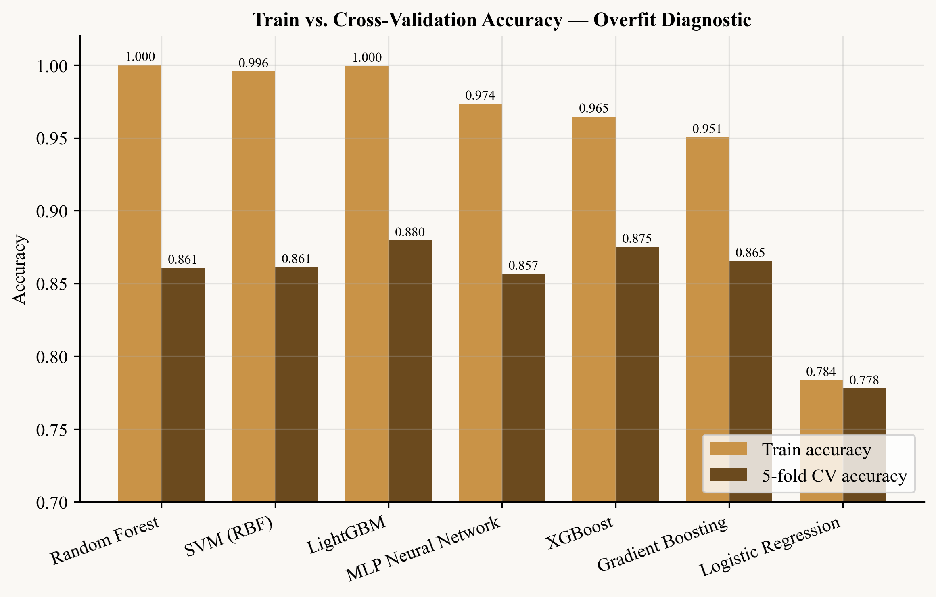
Figure 18. Train vs. 5-fold cross-validation accuracy for the seven feature-based models. The gap quantifies how much of each model's nominal accuracy comes from memorising the training set rather than generalising. Only Logistic Regression shows no overfit.
3.13. Feature Redundancy
The 47 features are by design redundant — they cover overlapping aspects of spectrum, rhythm and voice — but the redundancy is heavier than one might expect. Twenty feature pairs have |Pearson r| above 0.85 on the full dataset. Four pairs exceed 0.97: has_vocals with vocal_harmonic_ratio (r = 0.994), pitch_std_cents with vibrato_extent_cents (0.983), vocal_texture_score with vocal_harmonic_ratio (0.975), and has_vocals with vocal_texture_score (0.974). Among non-vocal features the spectral centroid, bandwidth and rolloff means form a tight cluster (pairwise r > 0.94) and the rolling MFCC delta and delta-delta variances are nearly inseparable (r = 0.924). Figure 19 plots the full |r| matrix; the dark off-diagonal blocks in the lower-right correspond to the vocal feature family, which is the densest redundancy region. The implication is that the effective feature dimensionality is substantially below 47, which is consistent with the ablation curve presented next.
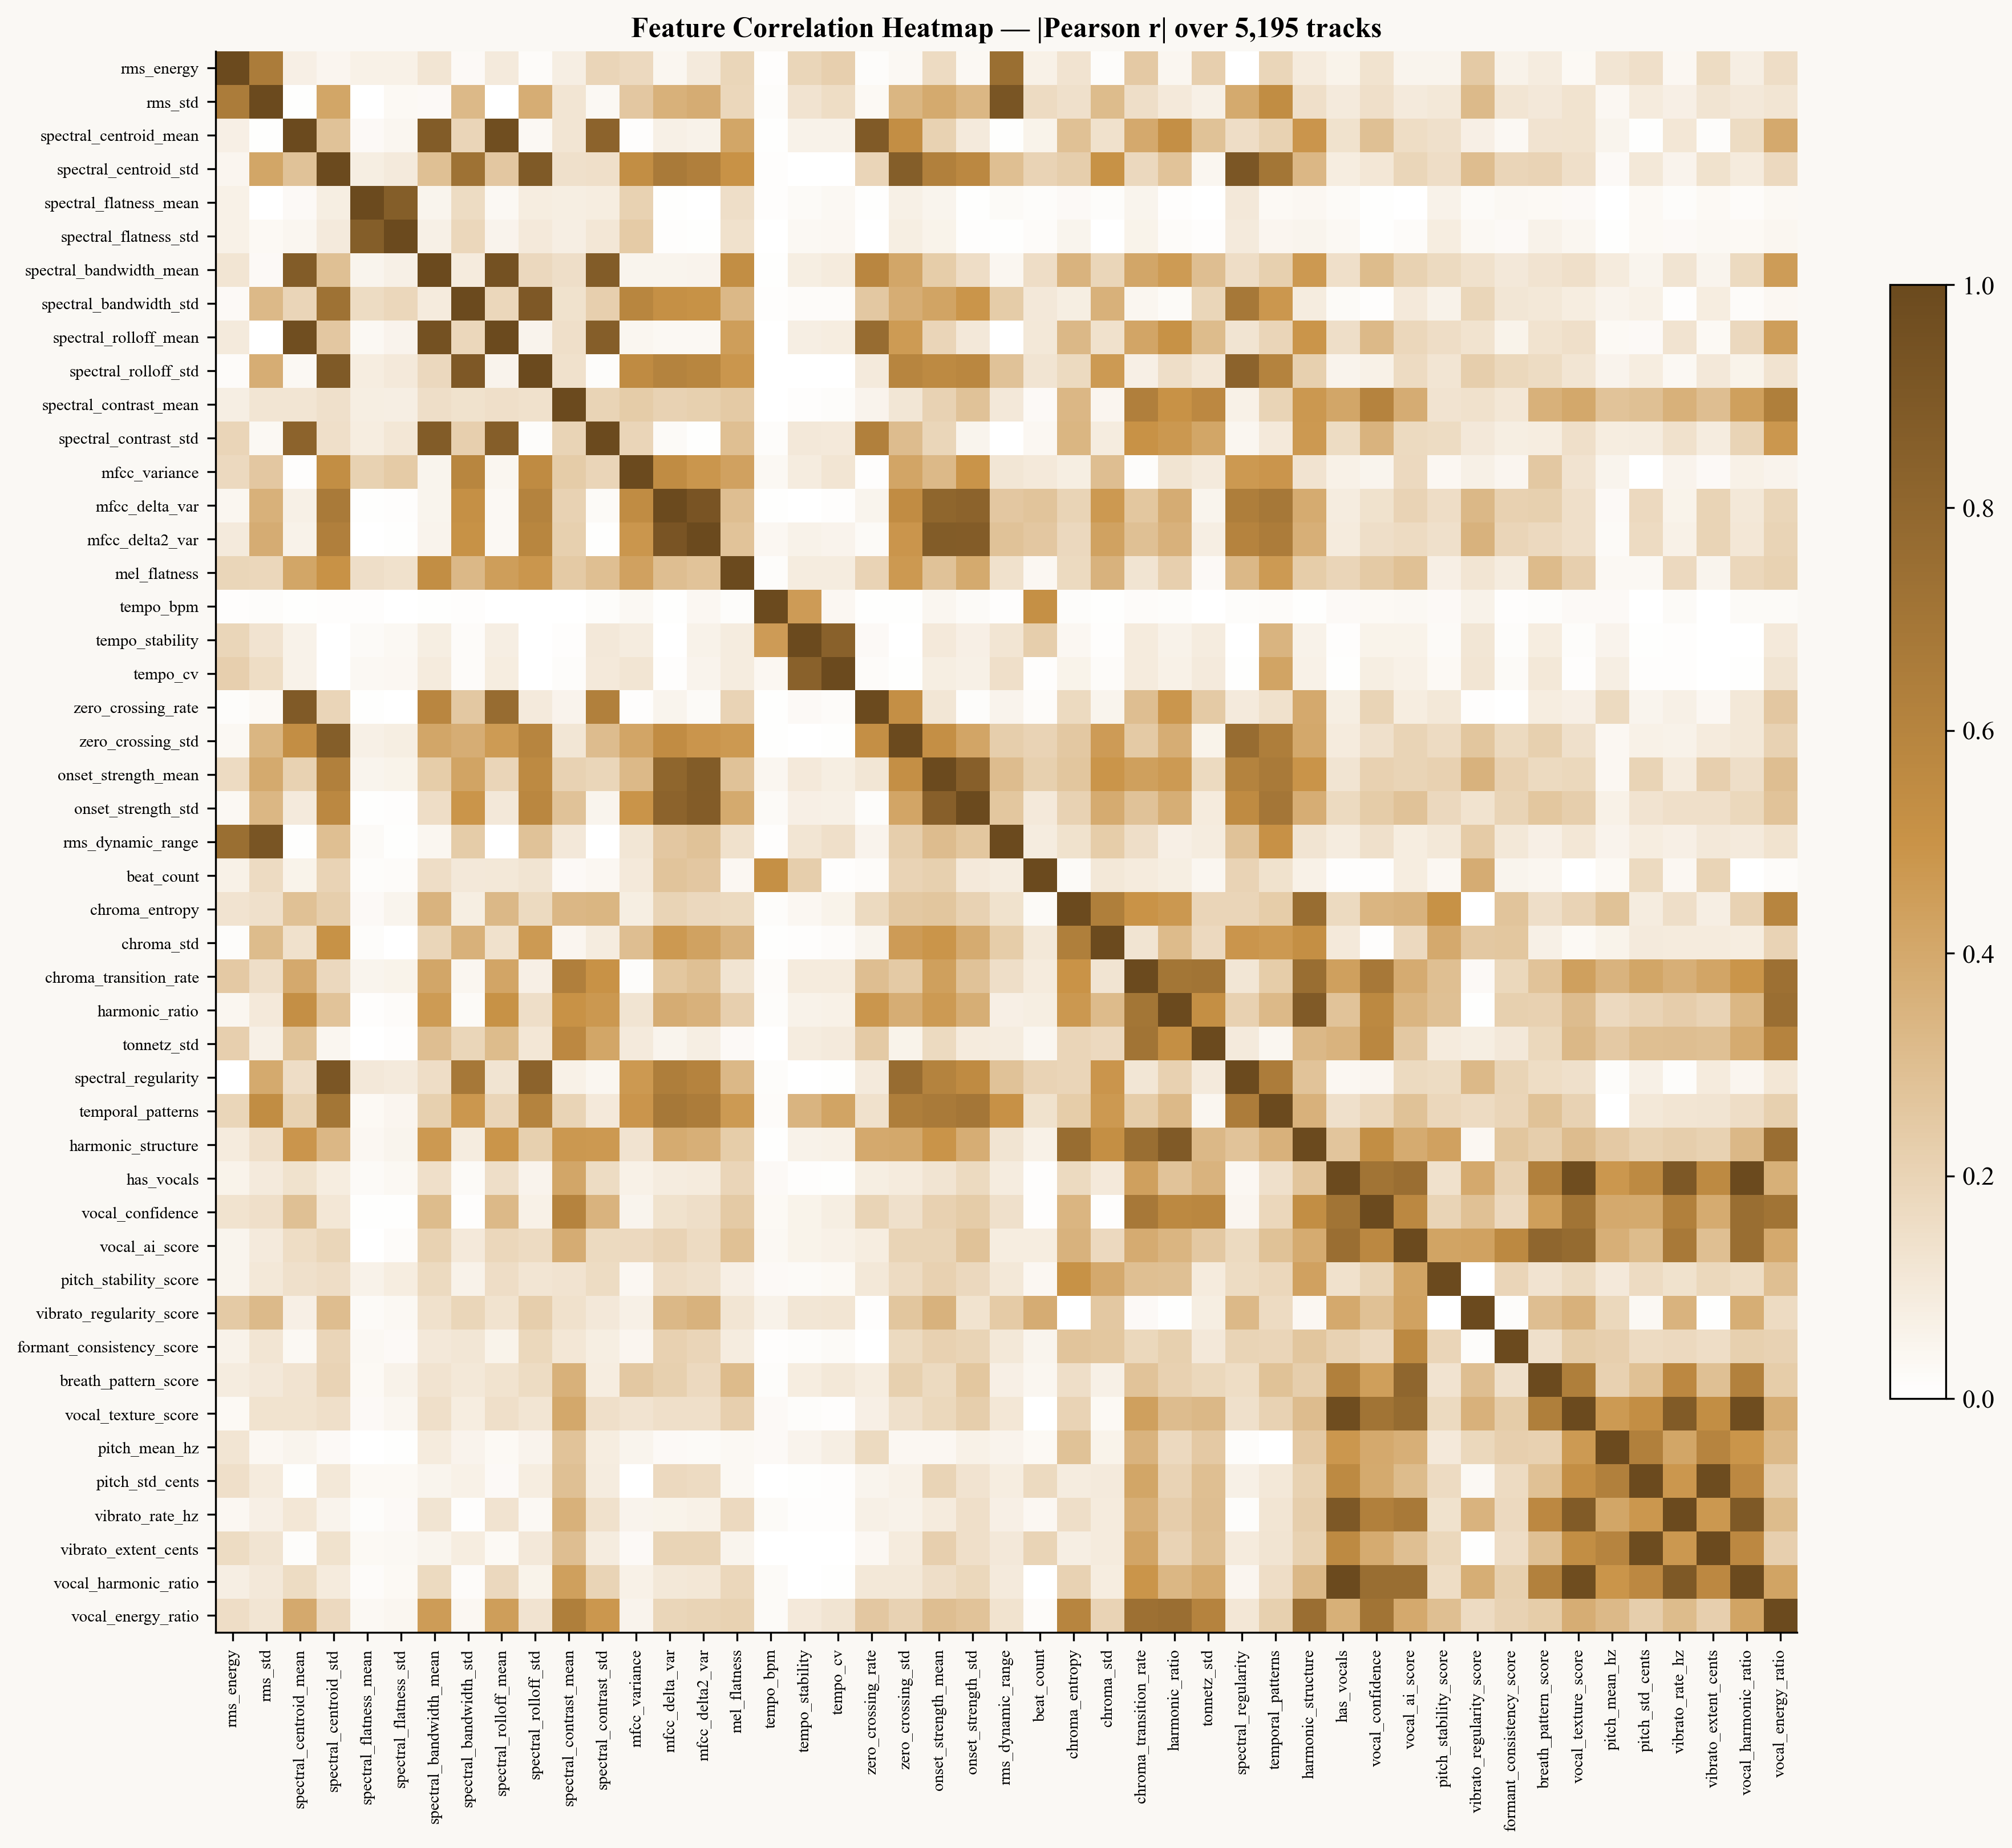
Figure 19. Absolute Pearson correlation between the 47 features across all 5,195 tracks. Dark cells mark redundant pairs. The vocal feature family in the lower-right corner is the most internally correlated block.
3.14. How Many Features Are Actually Needed?
Figure 20 reports a feature ablation experiment. Features are ranked by LightGBM importance and the top-N for N ∈ {1, 3, 5, 10, 15, 20, 30, 47} are passed back through the same 5-fold cross-validation pipeline. The curve is steep up to N = 10 — accuracy rises from 59.8% (N = 1) through 78.1% (N = 5) to 84.7% (N = 10) — and then plateaus. By N = 20 the accuracy is 88.0%, by N = 30 it is 88.7%, and using all 47 features gives 88.5%, essentially the same as N = 30 within one standard deviation. In other words, the bottom seventeen features as ranked by importance contribute no measurable additional accuracy. They do, however, increase the parameter count of the trained model and the feature-extraction time at inference. A practical deployment could drop the long tail without sacrificing detection quality; the present paper retains the full 47-feature vector for reproducibility but flags this redundancy as a clear optimisation target.
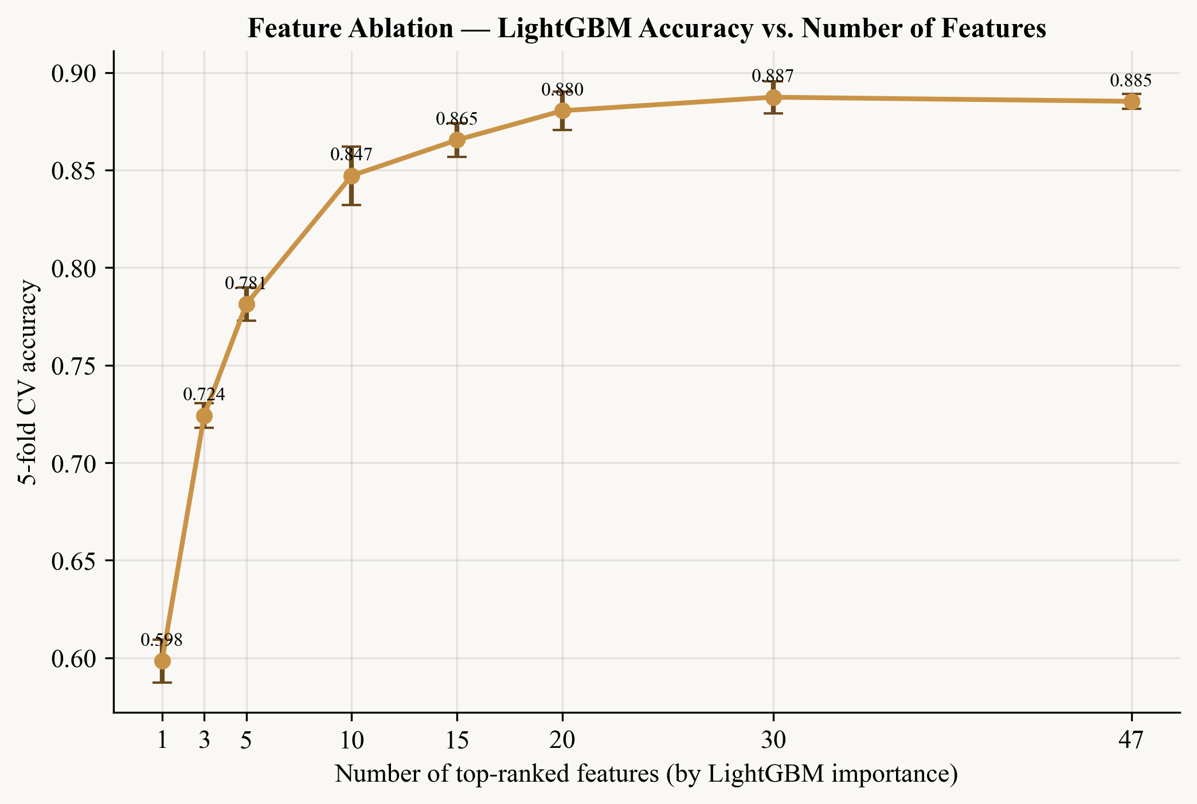
Figure 20. 5-fold CV accuracy of LightGBM as a function of the number of features retained, ranked by importance. The plateau begins at roughly 20 features; the last 17 features do not change measured accuracy.
3.15. Limitations
Four limitations are worth recording explicitly. First, features are extracted from the full clip, which is typically between fifteen and thirty seconds long; shorter clips (< 5 seconds) yield less reliable estimates for tempo and vibrato statistics in particular, and so the system is not yet evaluated in the live-microphone short-clip regime. Second, the fine-tuned wav2vec2 model is validated qualitatively on held-out samples but does not yet have a formal 5-fold cross-validation report, which limits direct head-to-head comparison with the eleven feature-based classifiers. Third, although the dataset covers twenty genres, certain genres (ambient and lo-fi in particular) are over-represented in the AI portion; a genre-stratified evaluation would provide a more rigorous account of generalisation. Fourth, adversarial robustness has not been tested. Post-processing such as MP3 compression, pitch shifting, or time-stretching is known to degrade detection performance for systems that rely on vocoder fingerprints (Afchar et al., 2025); the same is likely to affect AURIS to some degree, though less catastrophically since its features are not built around vocoder traces.
4. CONCLUSION
This paper has presented AURIS, an end-to-end system for detecting AI-generated music that combines a 47-dimensional handcrafted acoustic feature vector with an ensemble of eleven classification models trained on 5,195 samples drawn from twelve or more AI generation systems. The principal empirical findings are as follows. LightGBM achieves the highest mean ROC-AUC at 0.9548, narrowly ahead of Deep MLP at 0.9542, and also the lowest fold-to-fold variance (±0.0023). Spectral flatness is the single most informative feature for the AI-versus-human distinction, a pattern that is interpretable in terms of the difference between synthetic and recorded spectra. Per-fold Youden's J threshold optimisation systematically outperforms the default 0.5 cutoff under the present 1:1.5 class imbalance, and the resulting model is well calibrated, with a Brier score of 0.083 on the aggregated validation predictions. Two limitations are made explicit by the diagnostic analysis: every tree ensemble shows an 8-14 percentage-point gap between training and cross-validation accuracy, and the feature ablation shows that the bottom seventeen of the 47 features add no measurable accuracy.
Future work will pursue four directions. First, a formal cross-generator held-out evaluation will be conducted on emerging public benchmarks such as SONICS and FakeMusicCaps. Second, the fine-tuned wav2vec2 model will be integrated into the 5-fold cross-validation protocol for a direct comparison with the feature-based classifiers. Third, adversarial robustness will be evaluated explicitly under MP3 compression, pitch shifting and time-stretching. Fourth, the dataset will be expanded toward ten thousand samples and updated to include emerging generation systems as they appear, with particular attention to the cross-generator generalisation challenge identified by Li et al. (2024).
AI DISCLOSURE
Generative AI was used as an assistive tool for language editing and for parts of the figure and analysis code. All data, trained models and experimental results are the author's own, and every reported value was verified against the underlying data. The author takes full responsibility for the integrity and accuracy of all content.
AUTHOR CONTRIBUTIONS
Hasan Arthur Altuntaş: conceptualisation, methodology, software, data curation, formal analysis, investigation, writing — original draft, writing — review and editing, visualisation.
ACKNOWLEDGEMENT
This research received no external funding.
CONFLICT OF INTEREST
The author declares no conflict of interest.
REFERENCES
Afchar, D., Meseguer Brocal, G., & Hennequin, R. (2025). AI-generated music detection and its challenges. In Proceedings of IEEE ICASSP 2025. IEEE. https://doi.org/10.48550/arXiv.2501.10111
Baevski, A., Zhou, Y., Mohamed, A., & Auli, M. (2020). wav2vec 2.0: A framework for self-supervised learning of speech representations. Advances in Neural Information Processing Systems, 33, 12449–12460. https://doi.org/10.5555/3495724.3496768
Copet, J., Kreuk, F., Gat, I., Remez, T., Kant, D., Synnaeve, G., Adi, Y., & Défossez, A. (2023). Simple and controllable music generation. Advances in Neural Information Processing Systems, 36. https://doi.org/10.48550/arXiv.2306.05284
Elizalde, B., Deshmukh, S., Al Ismail, M., & Wang, H. (2023). CLAP: Learning audio concepts from natural language supervision. In Proceedings of ICASSP 2023 (pp. 1–5). IEEE. https://doi.org/10.1109/ICASSP49357.2023.10095889
Frank, J., & Schönherr, L. (2021). WaveFake: A data set to facilitate audio deepfake detection. NeurIPS 2021 Datasets and Benchmarks Track. https://doi.org/10.5281/zenodo.5642694
Gan, R., Huang, T., Shao, J., & Wang, F. (2024). Music genre classification based on VMD-IWOA-XGBoost. Mathematics, 12(10), 1549. https://doi.org/10.3390/math12101549
Gourisaria, M. K., Agrawal, R., & Sahni, M. (2024). Comparative analysis of audio classification with MFCC and STFT features using machine learning techniques. Discover Internet of Things, 4, Article 1. https://doi.org/10.1007/s43926-023-00049-y
Kim, Y., & Go, S. (2025). Segment Transformer: AI-generated music detection via music structural analysis. arXiv preprint arXiv:2509.08283. https://doi.org/10.48550/arXiv.2509.08283
Kostrzewa, D., Mazur, W., & Brzeski, R. (2022). Wide ensembles of neural networks in music genre classification. In Computational Science — ICCS 2022, Lecture Notes in Computer Science (Vol. 13351, pp. 91–102). Springer. https://doi.org/10.1007/978-3-031-08754-7_9
Li, Y., Milling, M., Specia, L., & Schuller, B. W. (2024). From audio deepfake detection to AI-generated music detection: A pathway and overview. arXiv preprint arXiv:2412.00571. https://doi.org/10.48550/arXiv.2412.00571
Liu, H., Chen, Z., Yuan, Y., Mei, X., Liu, X., Mandic, D., Wang, W., & Plumbley, M. D. (2023). AudioLDM: Text-to-audio generation with latent diffusion models. In Proceedings of ICML 2023. https://doi.org/10.48550/arXiv.2301.12503
Liu, Y., Yin, Y., Zhu, Q., & Cui, W. (2022). Musical instrument recognition by XGBoost combining feature fusion. arXiv preprint arXiv:2206.00901. https://doi.org/10.48550/arXiv.2206.00901
Martín-Doñas, J. M., & Álvarez, A. (2022). The Vicomtech audio deepfake detection system based on Wav2vec2 for the 2022 ADD challenge. In Proceedings of ICASSP 2022 (pp. 9266–9270). IEEE. https://doi.org/10.1109/ICASSP43922.2022.9747768
Wu, Y., Chen, K., Zhang, T., Hui, Y., Berg-Kirkpatrick, T., & Dubnov, S. (2023). Large-scale contrastive language-audio pretraining with feature fusion and keyword-to-caption augmentation. In Proceedings of ICASSP 2023 (pp. 1–5). IEEE. https://doi.org/10.1109/ICASSP49357.2023.10095969
Yi, J., Fu, R., Tao, J., Nie, S., Ma, H., Wang, C., Wang, T., Tian, Z., Bai, Y., & Fan, C. (2022). ADD 2022: The first audio deep synthesis detection challenge. In Proceedings of ICASSP 2022 (pp. 9216–9220). IEEE. https://doi.org/10.1109/ICASSP43922.2022.9746939
Yi, J., Wang, C., Tao, J., Zhang, X., Zhang, C. Y., & Zhao, Y. (2023). Audio deepfake detection: A survey. arXiv preprint arXiv:2308.14970. https://doi.org/10.48550/arXiv.2308.14970

