LAB 4: VLAN CONFIGURATION

-----------------------

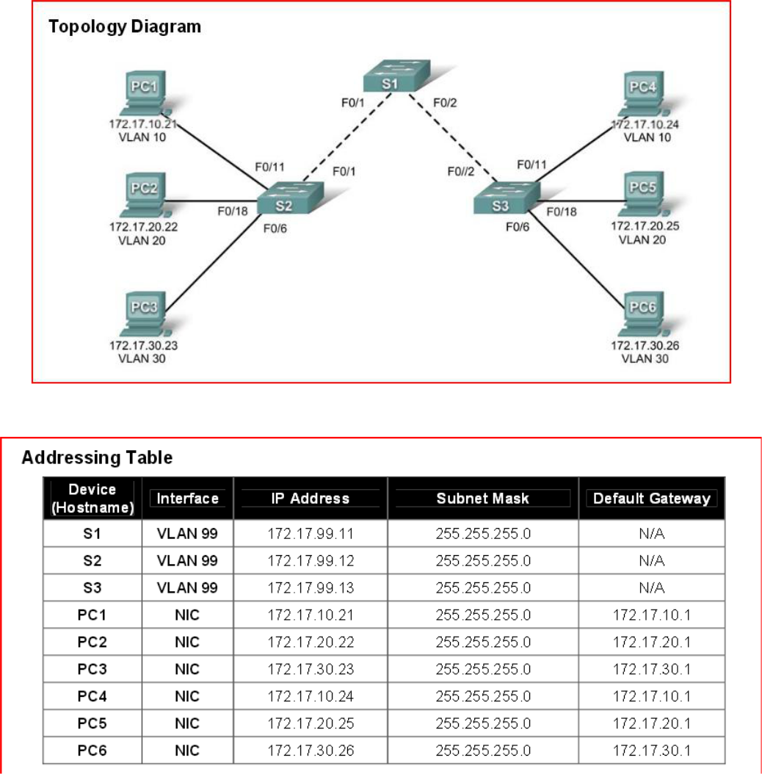

Task 1: Prepare the Network

Create a network same as the one in the topology diagram above in Cisco Packet Tracer. You can use any switch if it has the required interfaces shown in the topology.

For each switch set the hostname in config tab and then use the following commands. For example, for S1:

int vlan 99
ip address 172.17.99. 11 255.255.255.0

Task 2:

Step 1: Disable unused ports on the switches

It is a good practice to disable any unused ports on the switches by putting them in shutdown.
Disable all ports on the switches:

First enable the switch by using command enable.

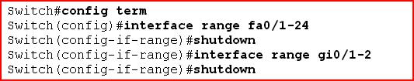

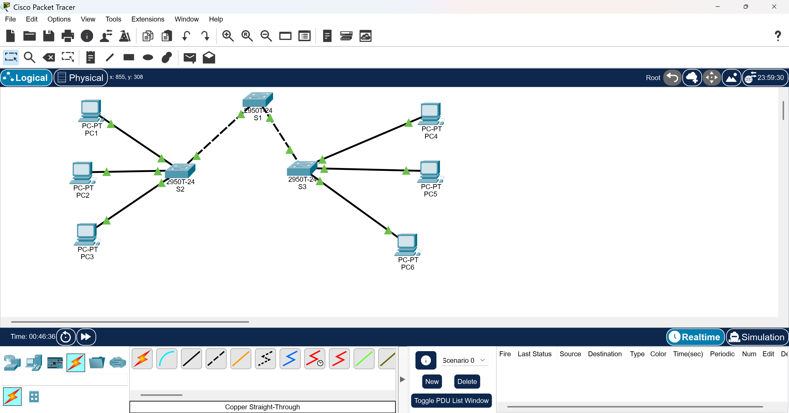
Take a screenshot of you commands and put it in the word document.
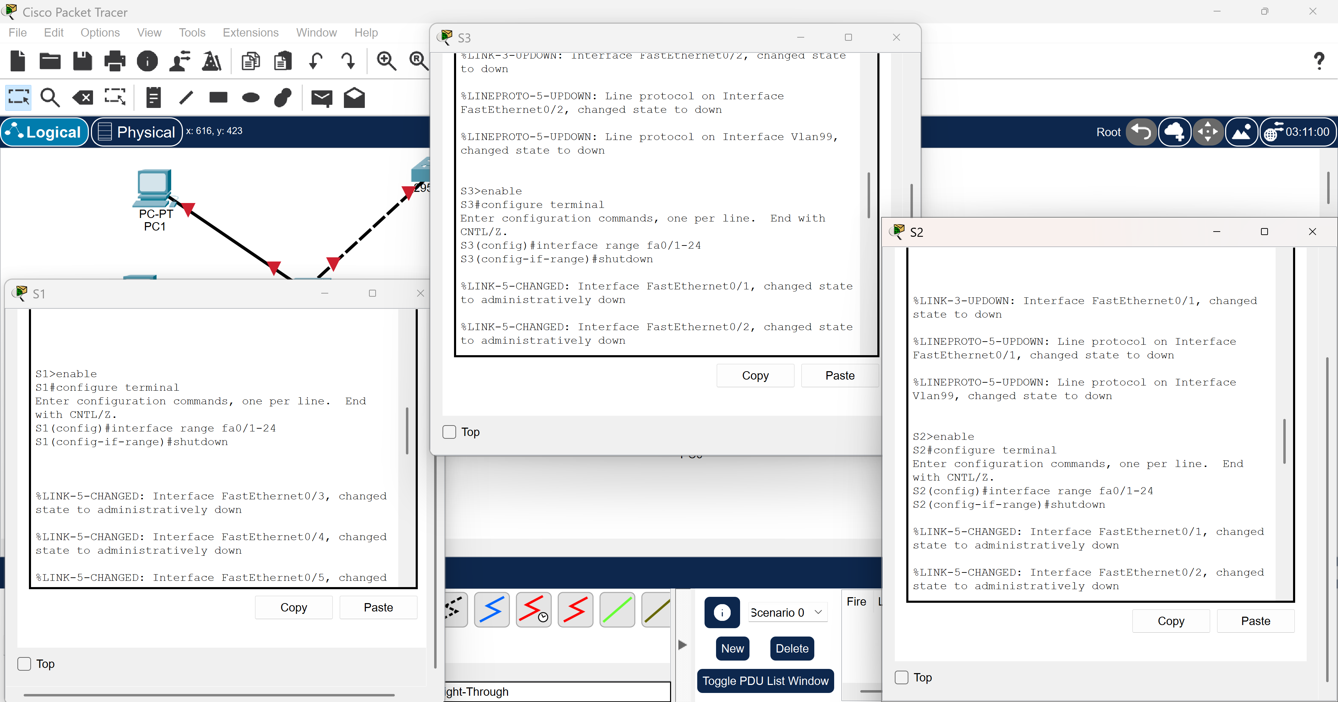

Step 2: Re-enable the user ports on switch:

S(config)# interface range fa0/1, fa0/2, fa0/3,fa0/4
S(config-if-range)# switchport mode access
S(config-if-range)# no shutdown

Take a screenshot of you commands and put it in the word document.

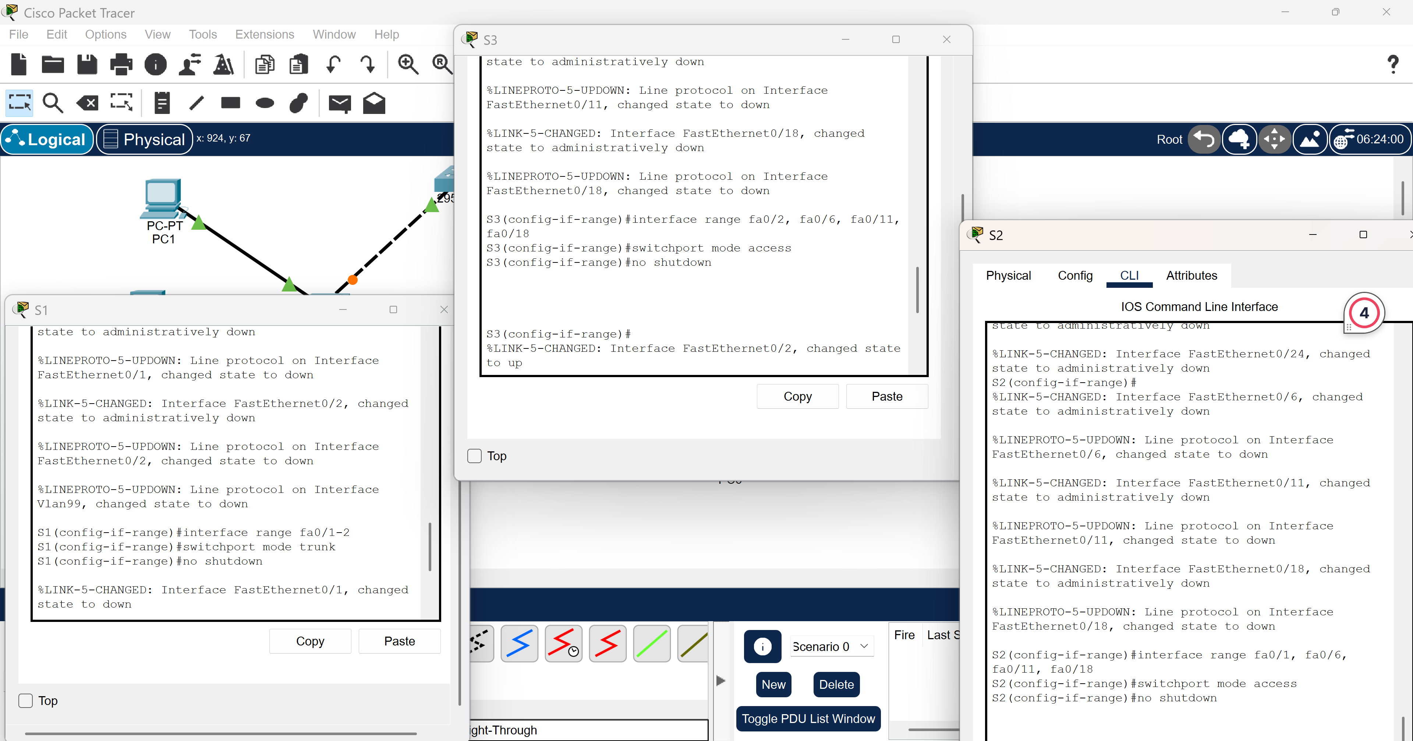
Task 3: Configure VLANs on the Switch

Step 1: Create VLANs on switch S1

There are four VLANS configured for this lab: VLAN 10 (faculty/staff); VLAN 20 (students); VLAN 30 (guest); and VLAN 99 (management). After you create the VLAN, you will be in vlan configuration mode, where you can assign a name to the VLAN with the name vlan name command.
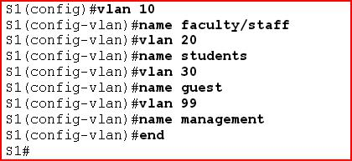

Step 2: Verify that the VLANs have been created on S1
Use the show vlan command. Take a screenshot and put it in your word document.

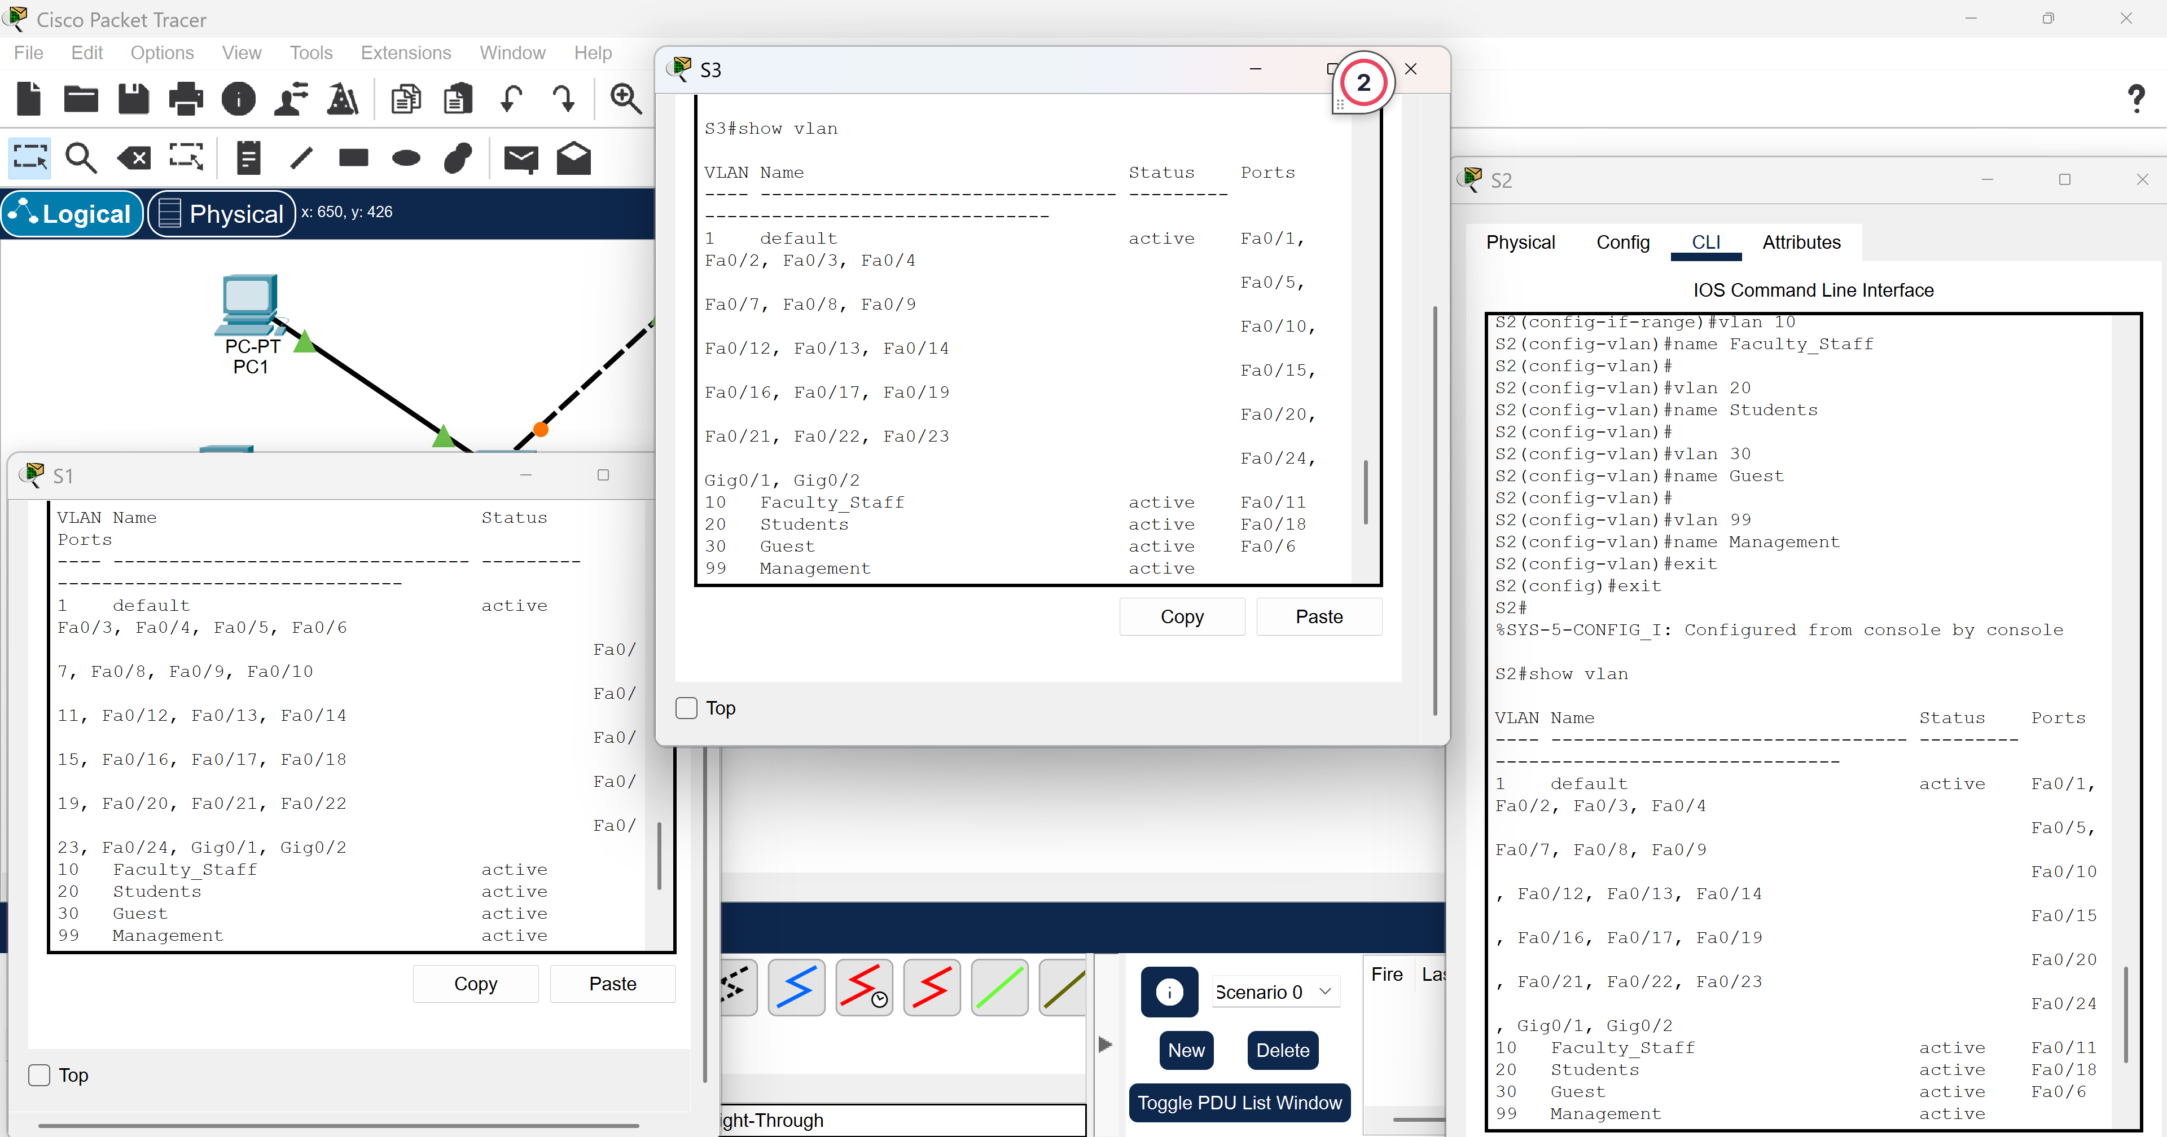

show vlan [VLAN Name]
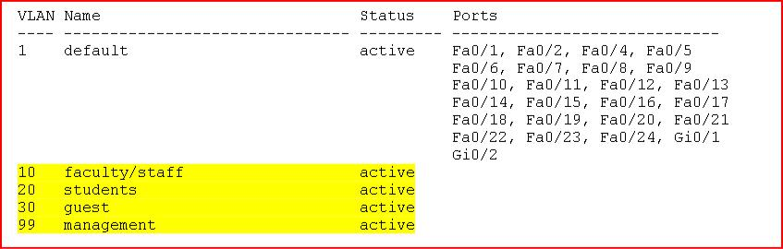

Step 3: Configure and name VLANs on switches S2 and S3.

Create and name VLANs 10, 20, 30, and 99 on S2 and S3 using the commands from Step 1.

Step 4: Assign switch ports to VLANs on S3.

You can assign each port individually or you can use the interface range command to simplify this task, as shown here. First use the command config term. Then type the commands below: 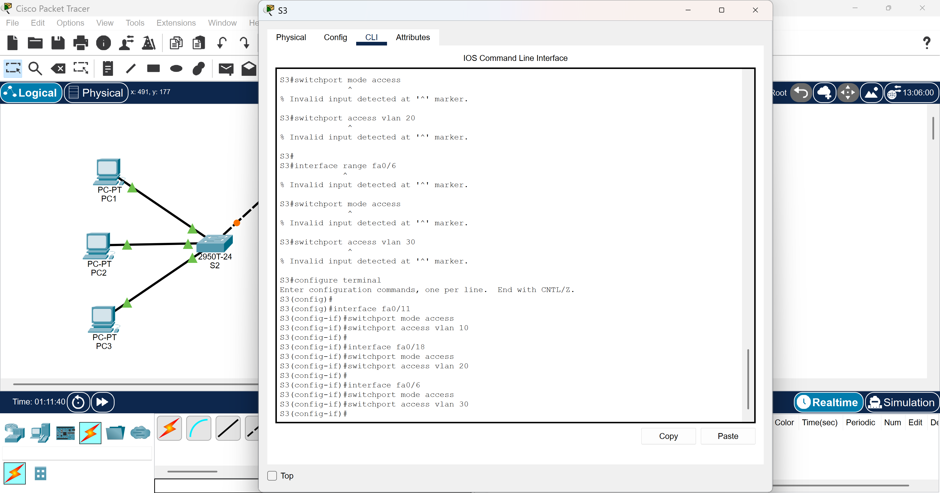
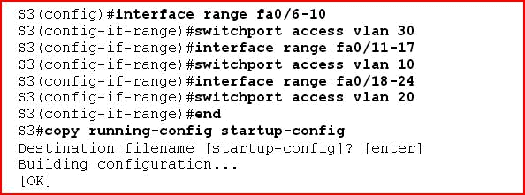

Take a screenshot and put it in your word document.

