User Account Management Lab
Lab 2 – Deliverable
Student: Rtvgb | Date: February 2026

Lab Overview
This lab covers user account management across three operating systems: Windows 11 Client, Ubuntu Client, and Windows Server 2022. Screenshots below serve as evidence of completed tasks for each platform.

Section 1: Windows 11 Client

Task Evidence – User Account Management
The following screenshots demonstrate completion of the Windows 11 user account management tasks including creating local users, assigning group memberships, and configuring password policies via Local Security Policy.

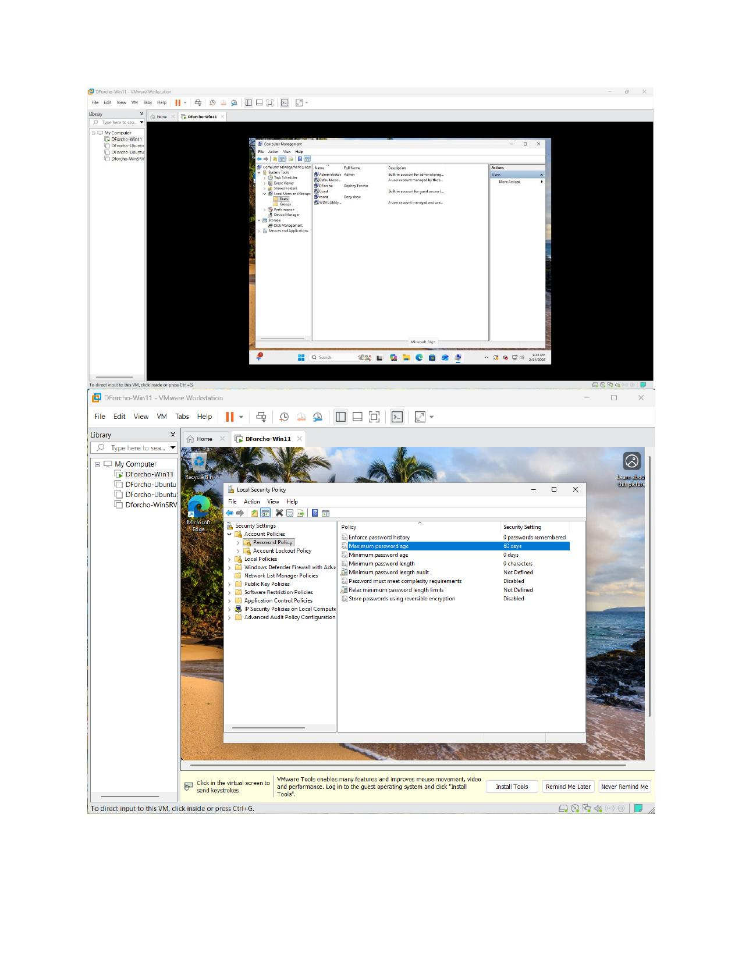

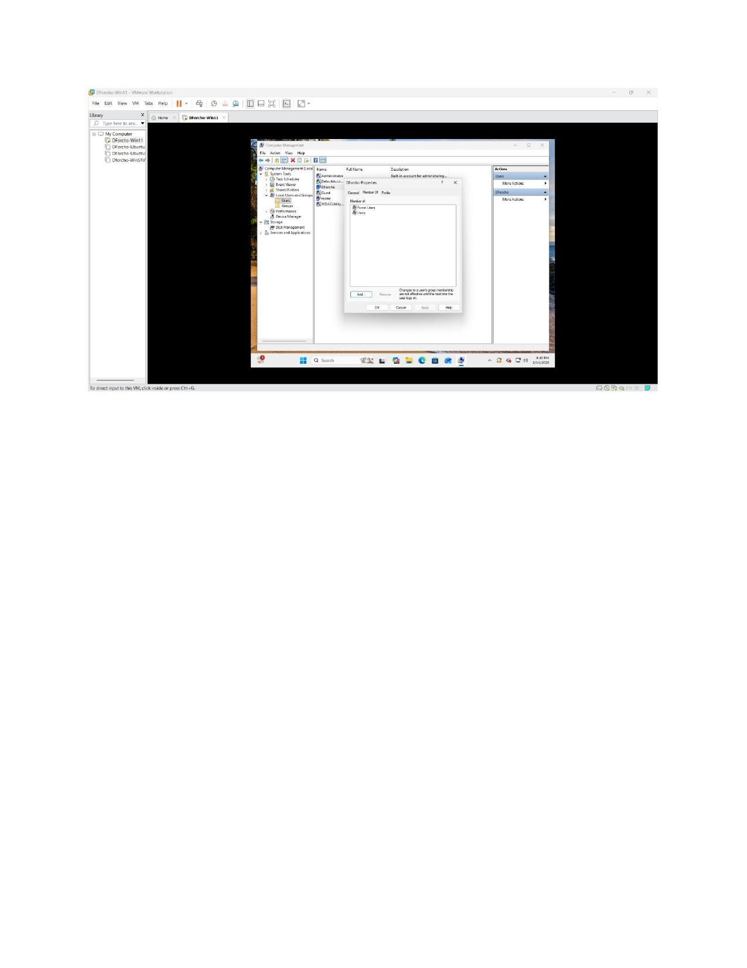

Section 2: Ubuntu Client

Task Evidence – User & Group Management
The following screenshots demonstrate completion of the Ubuntu Client user account management tasks including creating users, assigning group membership using the GNOME Users & Groups GUI, and installing gnome-system-tools.

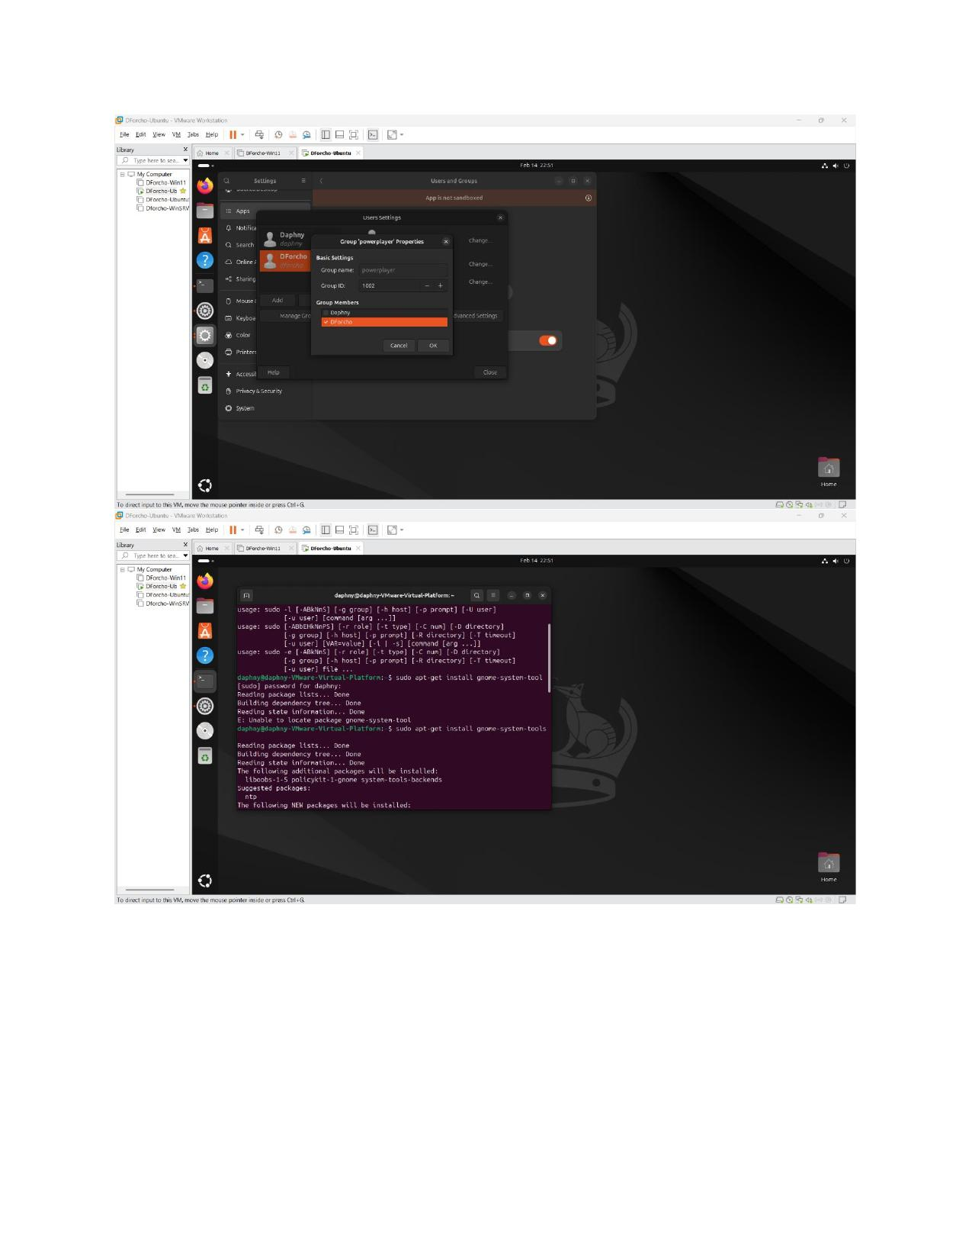

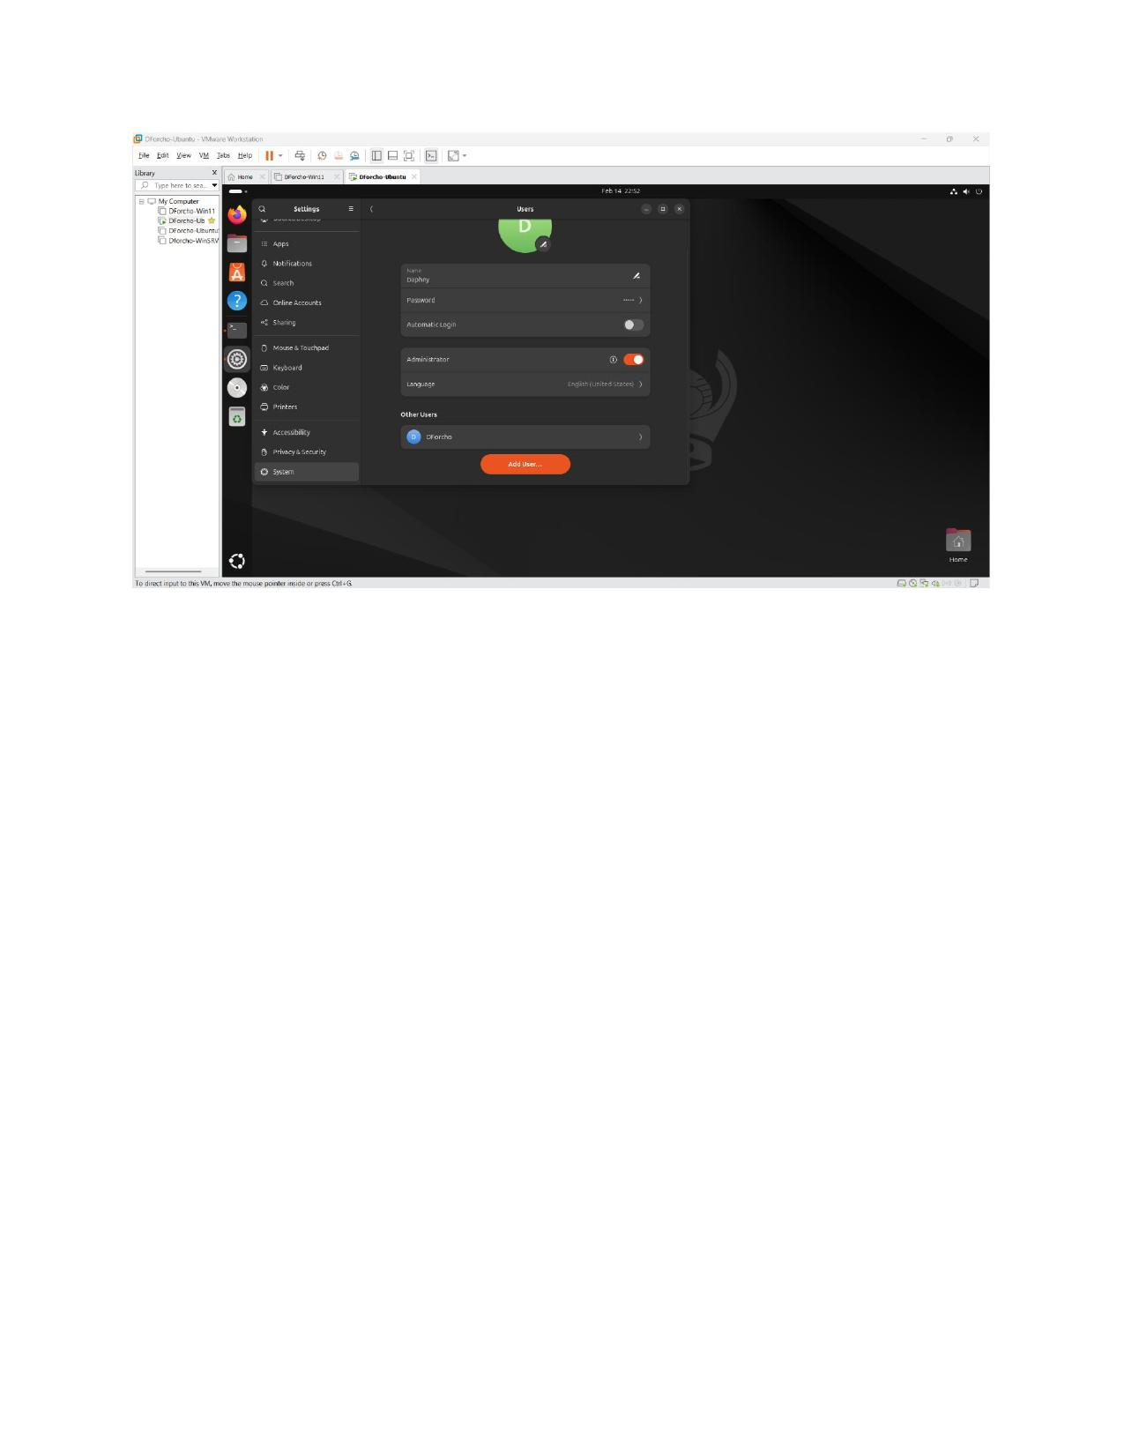

Section 3: Windows Server 2022

Task Evidence – Active Directory User & Group Management
The following screenshots demonstrate completion of the Windows Server 2022 tasks including navigating Active Directory Users and Computers, creating domain users, creating security groups, and assigning users to groups.

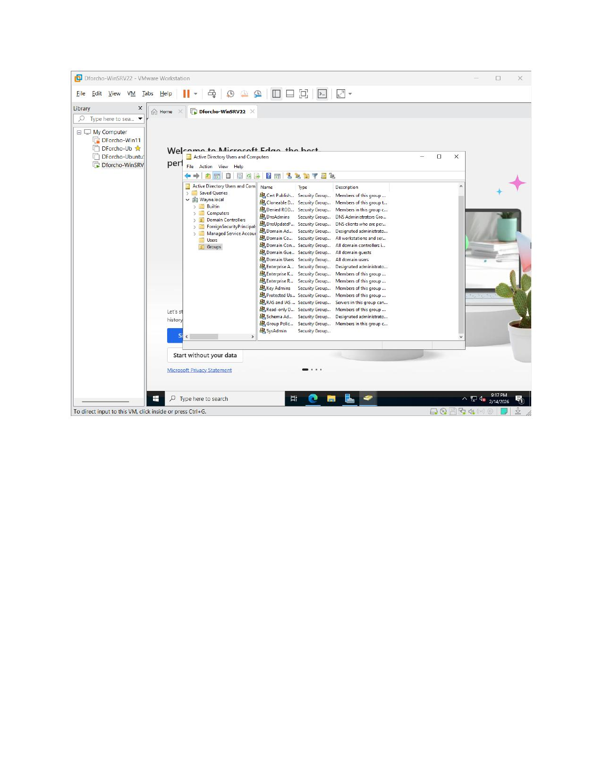

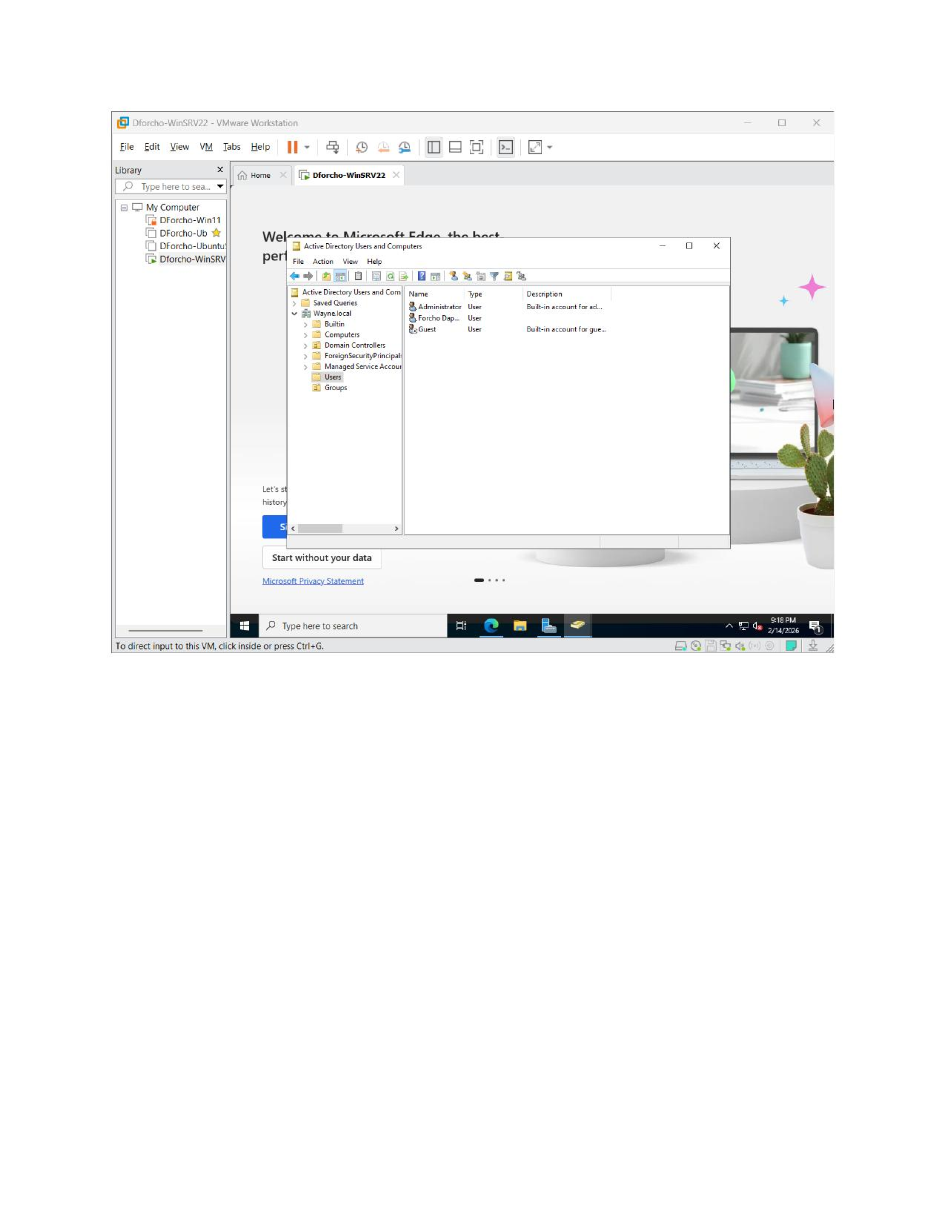

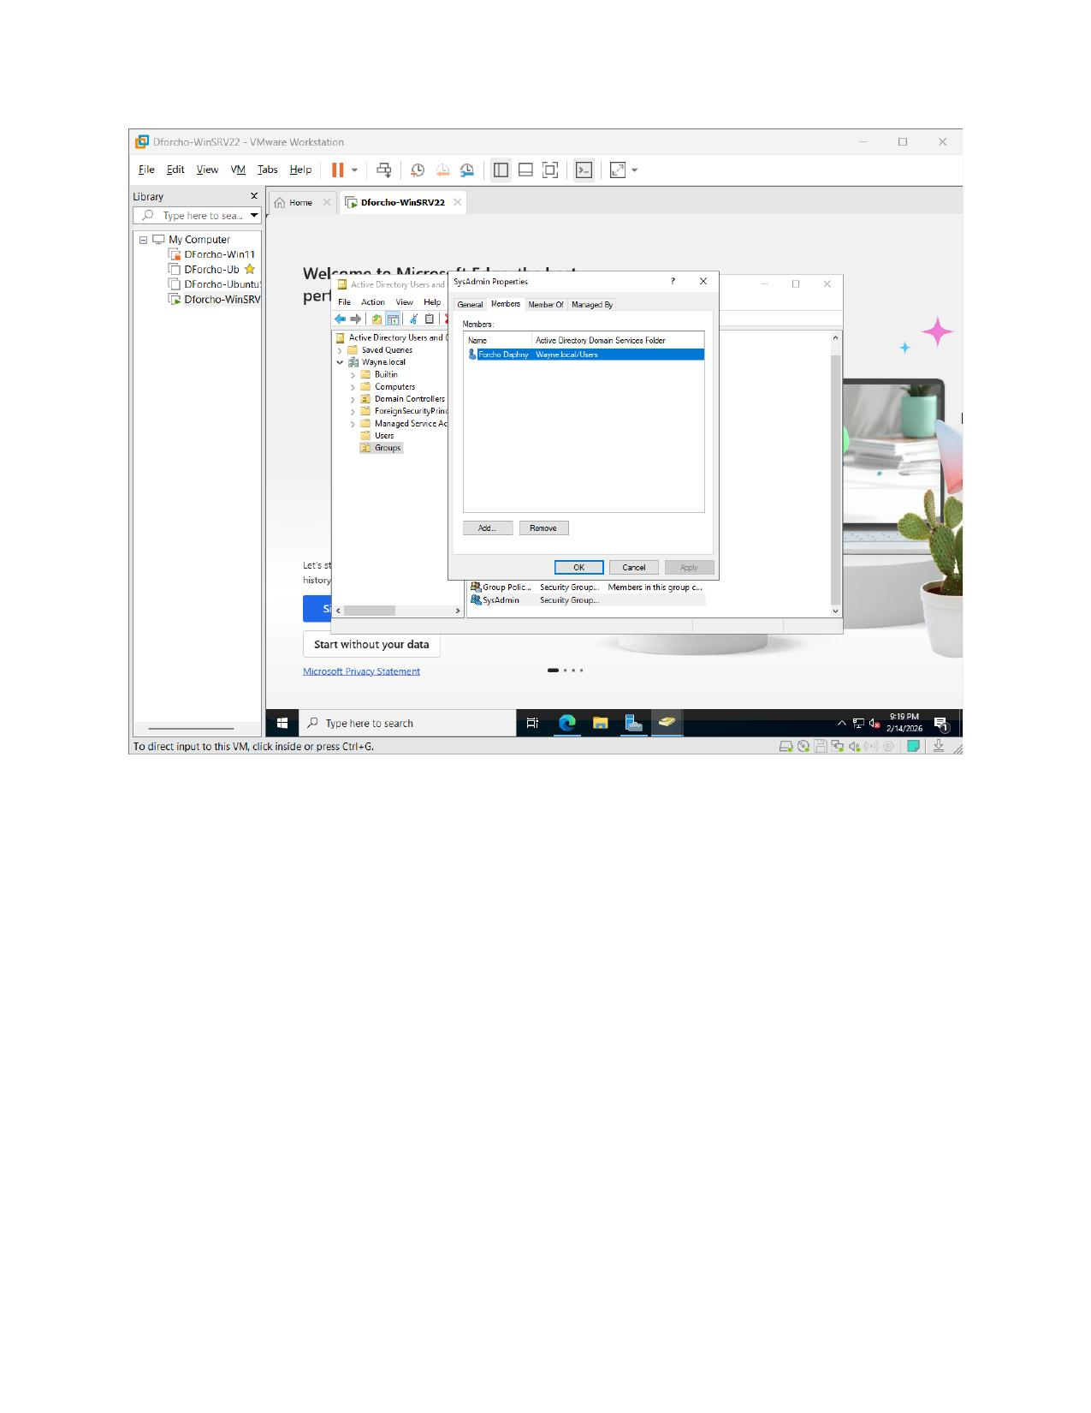

Extra Credit: Ubuntu Server CLI User Creation

Task – Create Users via Command Line
The following screenshot demonstrates completion of the extra credit task: creating three user accounts on the Ubuntu Server using CLI commands (useradd / chpasswd). The /etc/passwd file output confirms all three accounts were successfully created:
- SysAdmin (UID 1002)
- NormalGuy (UID 1001)
- FinanceMgr (UID 1003)

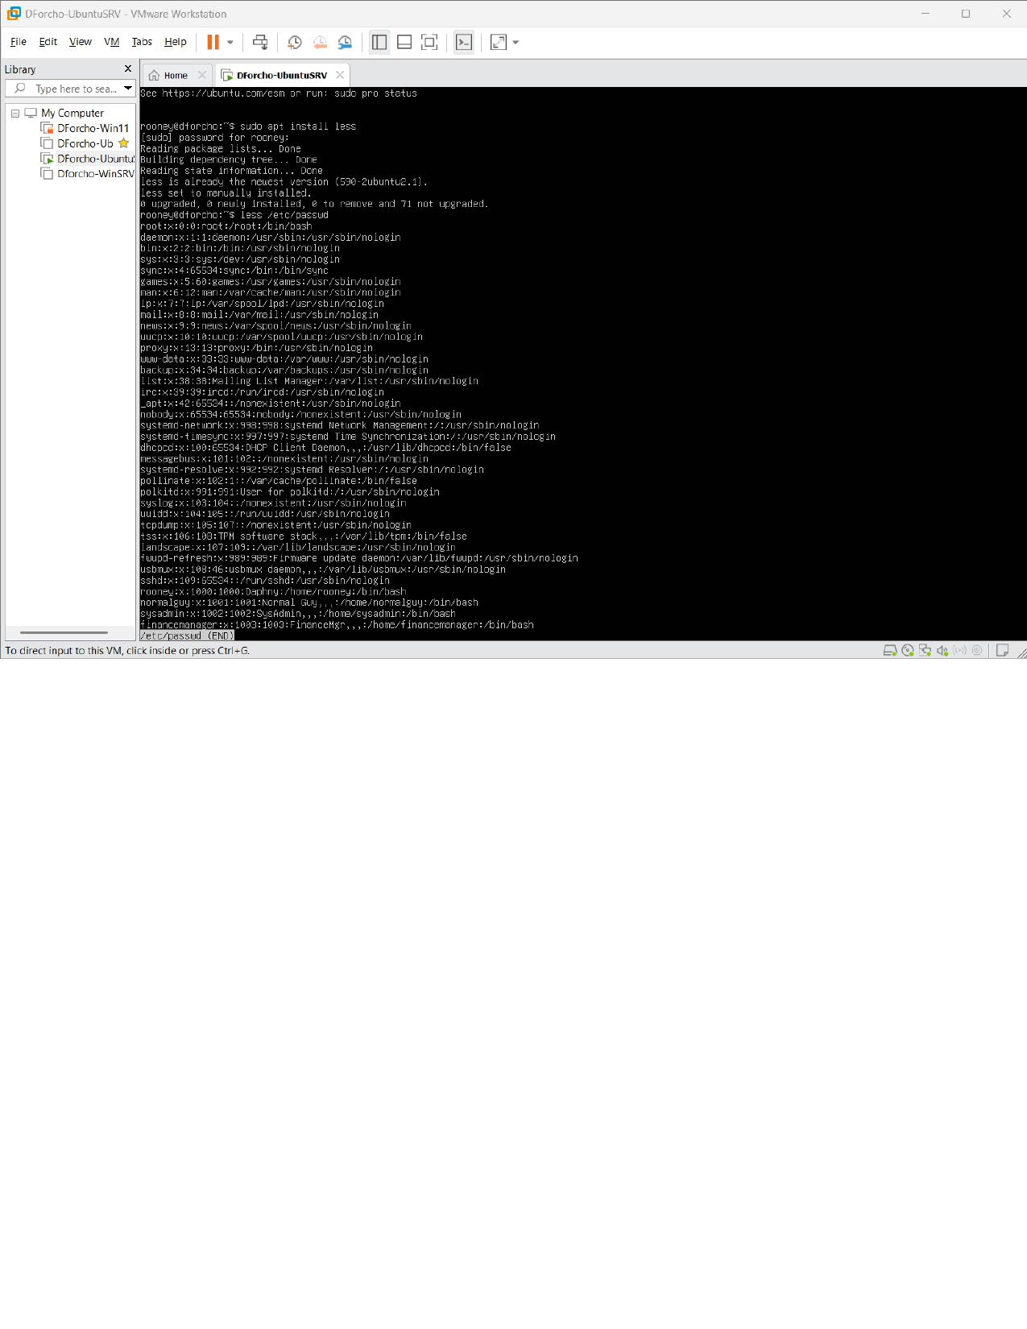

User Account Management Lab – Rtvgb – 2026

