1. In the below elements which of them are values or an expression? eg:- values can be integer or string and expressions will be mathematical operators.

* ---------------------Expression

'hello'-----------------Value

-87.8------------------Value

- -------------expression

/ ------------------expression

* ---------------expression

6 ---------------value

2. What is the difference between string and variable?

**Ans:**

|  |  |
| --- | --- |
| String | Variable |
| Strings are data | Variable is a kind of identifier use to store data |
| It can be written as “abc” or ’abc’ or “123” | Variable cannot start with numbers or any other special symbol except underscore. |

3. Describe three different data types.

**Ans:**

List: the list is used for storing multiple data items in a single variable.

Integer: integer can store only numerical values.

Float: float can store real numbers such as 233.33, 22.2, etc.

4. What is an expression made up of? What do all expressions do?

**Ans**

Expression is made up of values, containers, and mathematical operators (operands) e.g

     a = 2 + 3     and expressions are used to evaluate the values or represent the result on the screen.

5. This assignment statements, like spam = 10. What is the difference between an expression and a statement?

**Ans**: Expression is made up of values, containers, and mathematical operators (operands) and the statement is just like a command that a python interpreter executes like print.

6. After running the following code, what does the variable bacon contain?

bacon = 22

bacon + 1

**Sol:** It gives 23 on code execution

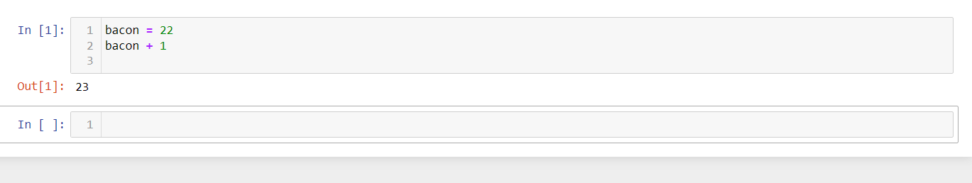

7. What should the values of the following two terms be?

'spam' + 'spamspam'

**Sol:** ‘spamspamspam’

'spam' * 3

**Sol:** ‘spamspamspam’

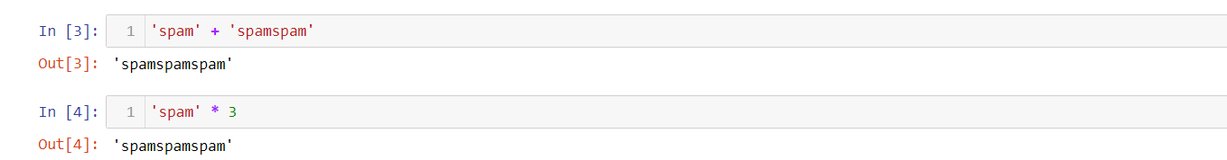

8. Why is eggs a valid variable name while 100 is invalid?

**Ans**: because we can't start giving variable an integer name. if we, we should begin with, a string-like alphabet name then integer. e100 or eggs100 is valid

9. What three functions can be used to get the integer, floating-point number, or string version of a value?

**Ans:** int(), float(),str()

10. Why does this expression cause an error? How can you fix it?

'I have eaten ' + 99 + ' burritos.'

**Ans:**  because 99 is an integer, so it cannot be concatenated with strings, if we have to concatenate it we need to do typecasting.