1.What are the two values of the Boolean data type? How do you write them?

**Ans:-** True and False

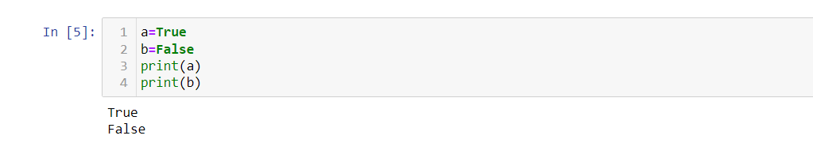

2. What are the three different types of Boolean operators?

**Ans:-** and, or, not

3. Make a list of each Boolean operator's truth tables (i.e. every possible combination of Boolean values for the operator and what it evaluate ).

**Ans:**

Truth Table for AND  
A B output  
0 0 0  
0 1 0  
1 0 0  
1 1 1

Truth Table for OR  
A B output  
0 0 0  
0 1 1  
1 0 1  
1 1 1

Truth Table for NOT  
A output  
0 1  
1 0

4. What are the values of the following expressions?

(5 > 4) and (3 == 5)

**Sol:** False

not (5 > 4)

**sol:** False

(5 > 4) or (3 == 5)

**Sol:** True

not ((5 > 4) or (3 == 5))

**sol:** False

(True and True) and (True == False)

**Sol:** False

(not False) or (not True)

**Sol:** True

5. What are the six comparison operators?

**Ans**  ==, !=, <, >, <=, and >=

6. How do you tell the difference between the equal to and assignment operators?Describe a condition and when you would use one.

**Ans**: == is the equal to operator that compares two values and evaluates to a Boolean, while = is the assignment operator that stores a value in a variable.

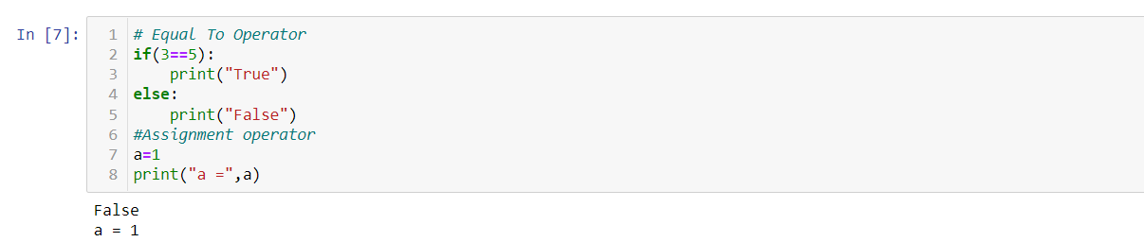

7. Identify the three blocks in this code:

spam = 0

if spam == 10:

print('eggs') **Block 1**

if spam > 5:

print('bacon') **Block 2**

else:

print('ham') **Block 3**

print('spam')

print('spam')

8. Write code that prints Hello if 1 is stored in spam, prints Howdy if 2 is stored in spam, and prints Greetings! if anything else is stored in spam.

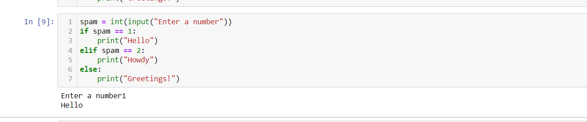

9.If your programme is stuck in an endless loop, what keys you’ll press?

**Ans**  **ctrl+c**.

10. How can you tell the difference between break and continue?

**Ans:** The break statement is used to jump out of a loop whereas continue statement is used to skip an iteration from a loop

11. In a for loop, what is the difference between range(10), range(0, 10), and range(0, 10, 1)?

**Ans:** They all do the same thing. The range(10) call ranges from 0 up to (but not including) 10, range(0, 10) tells the loop to start at 0, and range(0, 10, 1) tells the loop to increase the variable by 1 on each iteration.

12. Write a short program that prints the numbers 1 to 10 using a for loop. Then write an equivalent program that prints the numbers 1 to 10 using a while loop.

**Sol:**

**Using for loop**

**for** i **in** range(1,11):

print(i)

**Use of While Loop**

a **=**1

**while** a **<=** 10:

print(a)

a**+=**1

13. If you had a function named bacon() inside a module named spam, how would you call it after importing spam?

**Ans:** This function can be called with spam.bacon().