PRACTICAL

Aim : Write Lex Specification to recognize and count number of identifiers in a given input file

Code:
%{
#include <stdio.h>
int count = 0;
int yywrap() {
return 1; // Indicate that there are no more files to process
}
%}

op [+-*/]
letter [a-zA-Z]
digitt [0-9]
id {letter}*|({letter}{digitt})+
notid {digitt}{letter}+

%%
[\t\n]+

("int")|("float")|("char")|("case")|("default")|("if")|("for")|("printf")|("scanf") {printf("%s is a keyword\n", yytext);}

{id} {printf("%s is an identifier\n", yytext); count++;}

{notid} {printf("%s is not an identifier\n", yytext);}

%%

int main()
{
FILE *fp;
char file[100];
printf("\nEnter the filename: ");
scanf("%s", file);
fp = fopen(file, "r");
if (fp == NULL) {
perror("Error opening file");
return 1;
}
yyin = fp;
yylex();
printf("Total identifiers are: %d\n", count);
fclose(fp);
return 0;
}

Input File :
#file name tokens.txt
int
float
78f
90gh
a
d
are case
default
printf
scanf

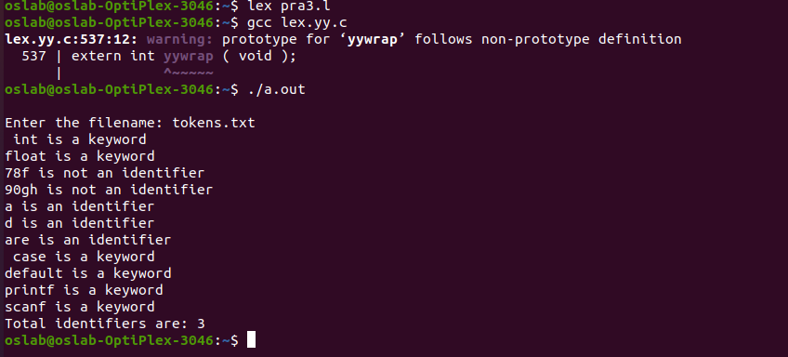
Output:

