Practical 2

Aim : Write a Lex Specification for each of the following
1. counting number of vowels and consonant in given string.

Code:
%{
#undef yywrap
int yywrap(void);
int vowel_count = 0;
int consonant_count = 0;
%}

%%
[aeiouAEIOU] { vowel_count++; }
[bcdfghjklmnpqrstvwxyzBCDFGHJKLMNPQRSTVWXYZ] { consonant_count++; }
scanf { printf("readf"); }
printf { printf("writef"); }

%%

int main(){
yylex();
printf("Vowels: %d\nConsonants: %d\n", vowel_count, consonant_count);
return 0;

}
int yywrap(void){
return 1;

}
Output :
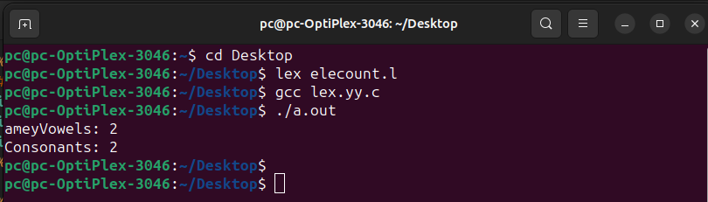

2. For counting number of comments in given c program
Code :

%{
#undef yywrap
int yywrap(void);
int comment_lines = 0;
%}

%%

"/*"(.|\n)*?"*/" { comment_lines++; }
"//"(.*) { comment_lines++; }
. ;

%%

int main() {
yylex();
printf("Comment Lines: %d\n", comment_lines);
return 0;
}

int yywrap(void){
return 1;

}

Output:
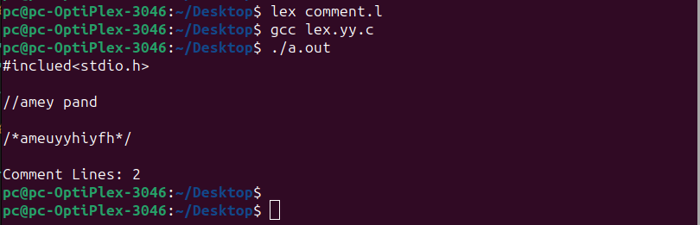

3. For counting number of
i. Positive and negative integers.
ii. Positive and negative fractions.
Code :
%{
#undef yywrap
int yywrap(void);
int positive_integers = 0;
int negative_integers = 0;
int positive_fractions = 0;
int negative_fractions = 0;
%}
%%
[+-]?[0-9]+ {
int num = atoi(yytext);
if (num > 0) {
positive_integers++;
} else if (num < 0) {
negative_integers++;
}
}
[+-]?[0-9]+[.][0-9]+ {
double num = atof(yytext);
if (num > 0) {
positive_fractions++;
} else if (num < 0) {
negative_fractions++;
}
}
. ;

%%
int main() {
yylex();
printf("Positive Integers: %d\nNegative Integers: %d\n", positive_integers, negative_integers);
printf("Positive Fractions: %d\nNegative Fractions: %d\n", positive_fractions, negative_fractions);
return 0;
}

int yywrap(void){
return 1;

}

Output :
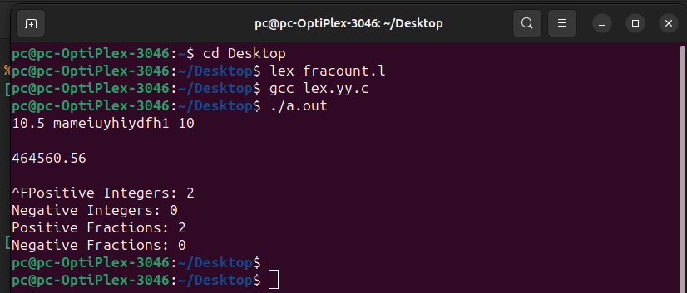
4. for counting Number of characters, words, spaces and line in a given input file
Code :
%{
#undef yywrap
int yywrap(void);
int char_count = 0;
int word_count = 0;
int space_count = 0;
int line_count = 0;
%}

%%
\n { line_count++; }
[ \t] { space_count++; }
[a-zA-Z] { char_count++; }
[a-zA-Z]+ { word_count++; }

%%

int main() {
yylex();
printf("Characters: %d\nWords: %d\nSpaces: %d\nLines: %d\n", char_count, word_count, space_count, line_count);
return 0;
}

int yywrap(void){
return 1;

}
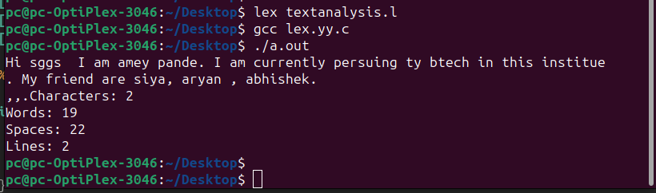
Output :

5. Number of ‘scanf’ and ‘printf’ statements in a C program. Replace them with ‘readf’ and ‘writef’ statements respectively.
Code :
%{
#include <stdio.h>
%}

%%
scanf[^;]*; { printf("readf"); }
printf[^;]*; { printf("writef"); }
. { printf("%s", yytext); }
%%

int main() {
yylex();
return 0;
}
/**************************************************************************/
%{
#undef yywrap
int yywrap(void);
%}

%%
scanf { printf("readf"); }
printf { printf("writef"); }
. ;

%%

int main() {
yylex();
return 0;
}
int yywrap(void){
return 1;

}
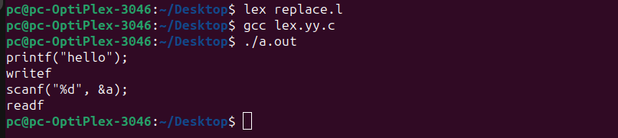
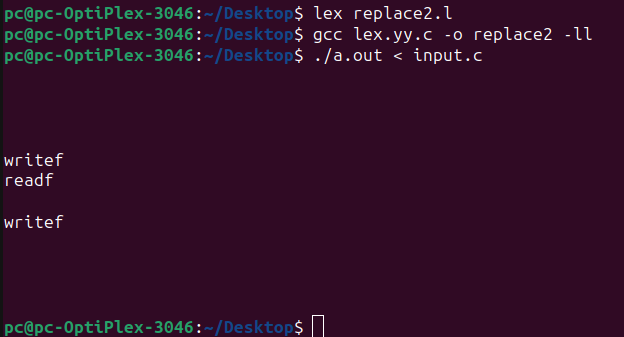
Output :

