PRACTICAL 3

Aim:
- 1.Write Lex Specification to recognize whether given string is simple or compound.
- 2.Write Lex Specification to recognize and count number of identifiers in a given input file

Code:
/*Program to recognize whether a given sentence is simple or compound.*/
%{
#include<stdio.h>
int flag=0;
%}

%%
and |
or |
but |
because |
if |
then |
nevertheless { flag=1; }
. ;
\n { return 0; }
%%

int main()
{
printf("Enter the sentence:\n");
yylex();
if(flag==0)
printf("Simple sentence\n");
else
printf("compound sentence\n");
}

int yywrap( )
{
return 1;
}

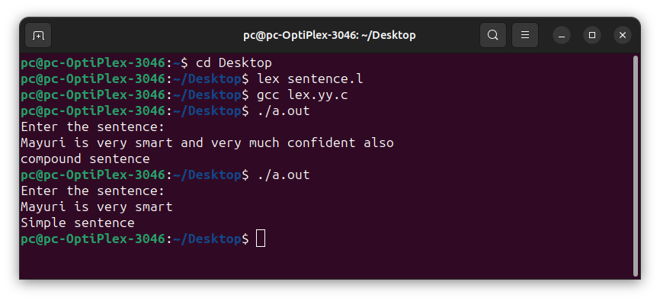
Output:

