CO2104 - CW2

By: Dante Baptiste

Student Number: 209017890

# Introduction

The purpose of this document is to provide a detailed report on the system prototype I have designed for a “Task Manager System”. Everyone has goals, events, achievements or Tasks they need to complete every day but somehow, they but fail to complete these goals because they either get distracted, are forgetful or suffer from poor planning. The purpose of the system is to help its users’ complete these goals effectively by having a virtual assistant to help users organize their everyday activities; including: work, school, events, deadlines and free time. The system achieves theses by utilizing a hierarchy to organize tasks the users will want to complete and present them in a meaningful and memorable manner for them to plan out their day and achieve these goals. The system will also make use of reminders and notifications to remind users of approaching deadlines. This system can be used by anyone with basic computer knowledge but will be most beneficial to Students and working individuals.

This documentation will also include information about the system, heuristic usability methods and will then lead to a summary of the system’s most prevalent issues from the heuristic evaluation.

User requirements:

1. Users can register their account
2. Users can login to their account
3. Users can access profile information
4. Users can see daily tasks
5. Users can manage daily tasks
6. Users can see past and future tasks on calendar
7. Users can see important events/schedules

# Prototype Functionality

testing of the key requirements, accessibility, usability, and to carry out a feasibility studies for the final development

The list of features the prototype will have will be directly connected to user requirements mentioned in the introduction.

## Settings and Profile

The system will make an effort to focus on the “task management” features but will also have some versatility to give users customization options and accessibility to the systems settings to change its presentation and design enough to improve user performance or likeability of the system. The systems setting page will have options to change the systems font-size, text-color, background-color or overall color theme of the system within the appearance tab. The profile tab will show basic information about the user such as: email, username and password; the tab will also offer a change to the user’s profile picture and password. This is a static feature in the system that supports the testing of the accessibility and usability functions. It is a key requirement which users will use to make customization changes to the system.

## Login and Registration

A simi-functioning login and registration page for the user to access their customized tasks, event manager and personalized settings. This function is not fully complete as it does not check the user credentials and will only check if the username and password fields are filled in before allowing them access. This will provide and visual example of how the login and registration pages will look and respond once fully functional but does not check for specific users. Once this feature is fully implemented after the landing(index.html) page a login page with the option of to create an account is presented. Once the correct login information is entered the user will be taken to their personalized task manager. This is a horizontal approach to presenting this feature in the prototype to help developers and stakeholders, end-users and clients test how easily it is for the users to gain access to the system and create accounts. This is very important because users leave a site within the first 15 second upon entering it. Having this feature shown statically will allow developer to receive feedback from end-users on it visual design and how convenient it is for new users.

## Task Manager

The task manager will be fully developed to give a full grasp of it capabilities to the user as that specific webpage is being accessed. This will have multiple smaller features implemented to make up the bigger feature of managing tasks for its users. One of these tasks are adding a task name, starting time, optional ending time and date. These tasks will then be shown to the user in the task window in the home tab; this will be presented clearly and be easy to understand in the order they were added to the list. Within this task window the user is given the option of editing the information of this tasks name, starting time, ending time and date . Finally, the user can then complete the task by marking it off/deleting it once it has been completed a task should be presented to the user as completed with a strike through and dimed text color. This is one of the most important features in the system and needed to be completed to present the end-users a good grasp of many features necessary to create a fully working task manager. Knowing this this feature is still faced with many bugs and issues that can be noticed once tested to its extreme such as overloading the number of tasks to the list and switching between webpages.

## Scheduled/Important tasks

Important tasks will be placed above all tasks on the main page because these will be the first thing the user should see. They will be easy to reach small windows with a customized picture and once the user selects one of these windowed tasks they will be taken to a expanded customized webpage that has thee extended information about that Scheduled important task. The feature is important to allow the user to enter in important information for tasks that will last much longer that one day. It gives user versatility and customization with starting a bigger project or scheduling something they do frequently in their task manger which is something most if not all users will make use off. These extended windows will be static and only hold information prepopulated by the developer however it will be presented in its finished for to allow clients and end-users to test and review their possible functionality in the system. This is important because the required features needed a hierarchy system to the tasks being managed in the system even if not fully implemented.

## Navigation

Navigation within the system will be presented on every and all web-pages of the system. Starting from the landing(index.html) page we enter the site with the “Begin Planning” button which takes us to the login page with its “Login” button and then the home page with its navigation bar and the top right of the page. The home page has a navigation bar with the option to travel to multiple web-pages, these pages are: home, calendar, settings and logout. The calendar.html and settings.html pages will also have the same navigation bar layout at the top right corner of the screen. Users need a clear and easy way to navigate through the application as requested in the user requirements. I believe this navigation bar allows this and will be available for full use by end-users.

## Calendar

The calendar page will be fully static and have no functioning part except for the navigation bar. The window will have a virtual calendar of a one month showing all the task names on their respective dates. In the windows of the days the tasks will either be written normally to show that they are incomplete and have a strike through if the task was completed. This will give the user a view on all the tasks that month they have yet to do and all show them all their completed tasks. This will help full fill the calendar requirement in the user requirements to give user a virtual calendar by which they can prepare their schedules better for in the future. Their will be no dynamic interactions on this page but gives clients and end-users a visual representation of what a functional calendar would look like in the middle of a the user’s monthly scheduling.

**Background technologies –** Briefly explain any external CSS frameworks or JS libraries used in the development of this project

# Background Technologies

For developing this website application, I used Visual Studio Code to assist with writing all the HTML, CSS and JS. While using VS Code I made use of some external sources to help with my development.

## Calendar

The calendar CSS was collected from the website [colorlib.com](https://colorlib.com/wp/template/calendar-20/) demonstrating how a static calendar can be implemented into a webpage. The CSS code makes use of multiple divs and lists to present all of the days within the month to the user. Each day will have space to place all the tasks that the user is going to complete in the future or past tasks for that month. This CSS just offers a clear presentation of task names and when they occur to the user.

## Navigation bar / Landing Page

For the navigation bar and landing page, I made use of some CSS from a simple [Easy Tutorials](https://youtu.be/PgAZ8KzfhO8) YouTube video explaining the use of animations for buttons and the navigation bar. The video gives a minimalistic design to the navigation bar and a simple animation transition whenever the user’s mouse cursor hovers over the navigation buttons or any navigation text. It also gives the CSS for the application’s background image.

## Saving local data YouTube

This YouTube video [[max programming](https://youtu.be/U693xrQKFy4)] explains the saving of local data on the website. These JS codes helped me manage my task manager information allowing me to save the Name, times, and dates.

* **Annotated screenshots** - A series of annotated screenshots (one page of your site per A4 page) that highlights:
  + A short page description (the function of the page)
  + Functions/features of all elements found within each page
  + Where functionality has been simplified for the prototype but could be expanded in the final product (i.e. additional database interactivity)
  + Elements that meet the requirements of the client/end-user
  + Where accessibility has been considered in your implementation (functionality, features and design choices)

# Annotated screenshots

## Index

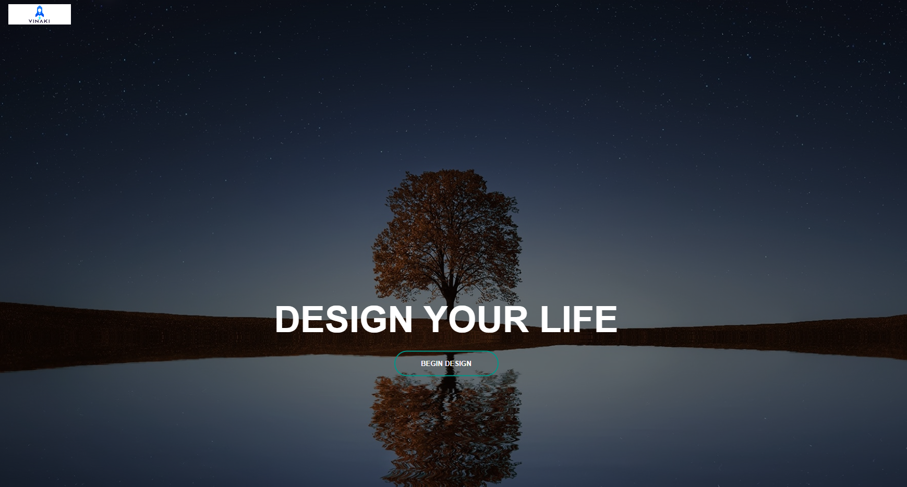

* **Heuristic evaluation and Usability testing results**- A section within your portfolio where you present the results of your Heuristic evaluation, and Usability testing - You should be looking to have had at least FIVE individuals test your product. These can be class peers, but you are encouraged to test with other individuals who could benefit from your product. * (Please refer to the appendix for more information)

# Heuristic Evaluation

The information provided for this heuristic evaluation is going to making use of the following 10 Nielsen’s Usability Heuristics listed below.

### Heuristic Table

1. Visibility of system status
2. The match between the system and the real world
3. User control and freedom
4. Consistency and standards
5. Error prevention
6. Recognition vs recall
7. Flexibility and efficiency of use
8. Aesthetic and minimalist design
9. Ability to identify and recover from errors
10. Help and documentation

### Severity Ranking table

1. I do not agree that this a usability problem at all.
2. Cosmetic problem only. Need not be fixed unless extra time is available on the project
3. Minor usability problem. Fixing this should be given low priority
4. Major usability problem. Important to fix so should be given high priority
5. Usability catastrophes. Imperative to fix this before the product can be released.

## Visibility of system status

The severity ranking of this heuristic is 0. The system’s status is made clear throughout the entire system at all times. Each webpage has a simple title describing the contents of the current webpage. It is positioned at the top of the page allowing users to easily see where they are. When on the login and register pages the layout is changed because the navigation bar is not shown but the title will still at the top of the page.

When the user is creating a new task on the home page and have yet to fill in all of the necessary fields; when they press the “add new button” the user will be notified of which fields are still needed to be filled in with an error message.

## Match between system and the real world

The severity ranking for this heuristic is 2. The task manager is meant to mimic the actions of an everyday helper; who is meant to give you reminders of when tasks need to be completed and assist you in managing your time effectively to complete those tasks. I believe the system can mimic this behavior to an extent however I think to fully achieve this desired effect some features need to be improved upon. When tasks are completed and marked as finished, allowing them to be marked off with strikethrough text would allow users to visually identify them as completed easier. Having some kind of notification or popup appear when your task is about to begin will allow users to interact with the application more frequently as they are being assisted for every task they think they will need help managing or remembering during their busy days. Another feature to help the task manager be more realistic is allowing the editing of tasks. Users right now to change a task will have to delete the previous one and create a new one with the changes they would like. Most of these change are small but allowing for more visual and accessible features would make the task manager more realistic as if having a real assistant by your side.

## Consistency and standards

The severity ranking for this heuristic is --. The website as a whole tries to keep a consistent design as the background is the same on almost all the webpages while you are logged into the website with dimed background wallpaper and if not for the login and register pages it has a green and white background. These can be off-putting but help users easily recognize the state of the website at that moment. The text and buttons all have a very similar minimalistic design with white text, a transparent background, and no borders. This is also seen inside the tasks on the home page. The calendars task shown are a mixture

# Usability Testing Results

* **Feedback and Discussion -** A discussion section on your evaluation findings where you provide a clear review of the feedback. This review should then document the influence of change on your design or justify why your design will not change even when feedback identifies potential issues with end-users.

# Feedback and Discussion

* **Conclusion**- A conclusion (1-2 paragraphs) where you summarise what you produced, the success of implementing your original idea, and what would be required to progress this into becoming the starting point for the final development (if it was to be made).

# Conclusion