According to TIOBE Programming Community index for May 2013 (<http://www.tiobe.com/index.php/content/paperinfo/tpci/index.html>) the list below captures the index of top 20 programming languages:

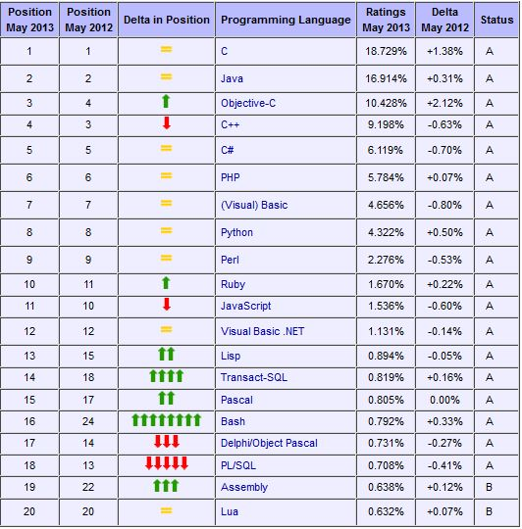

The index itself is an indicator of popularity and is updated on a monthly basis. The ratings are calculated by counting hits of the most popular search engines. The search query that is used is: +"<language> programming". Below is a basic overview on some of those languages:

**C#: General-purpose programming language developed by Microsoft evolved from C and C++ as a part of the software company’s .NET initiative.**

**Java**: An object-oriented programming language developed in the late 1990s by James Gosling and colleagues at Sun Microsystems. Aimed at developers who prefer to stay away from .NET.

**C++**: General purpose multi-paradigm spanning compiled language that has both high-level and low-level languages’ features. It was started as an enhancement to the C programming language, Bjarne Stroustrup in 1979. Used for developing systems software, application software, server and client applications, and entertainment software such as video games.

**Objective-C:** This object-oriented programming language created first by Brad Cox and Tom Love at their company Stepstone in the early 1980s, adds Smalltalk-like messaging to the C programming language. Used for developing Mac OS X and Apple iOS apps.

**PHP:** Open-source, server-side, cross-platform, interpretive HTML scripting language. Especially suited for Web development because of it easy embedding into HTML pages.

**Perl:** High-level programming language, with emphasis on code readability and clear syntax. Combines Object-oriented and functional programming styles, and is often used as a scripting language. Perl is an open-source language used widely to process text through CGI programs.

**C:** General purpose programming language built by Dennis Ritchie when he was a part of Bell Telephone labs, and the base of C++ and other programming languages. It was built to work with the Unix operating system.