**数据库第四次作业**

2019年4月8日

1. **实验环境：**

|  |  |
| --- | --- |
| 数据库DBMS | MySQL 5.6 |
| 操作平台 | Navicat for MySQL |
| 操作系统 | Windows 10 家庭版 |

1. **实验准备操作**
2. **创建一个名为sjkxtgl的数据库，并转至该目录下**

**create database** sjkxtgl;

**use database** sjkxtgl;

1. **关于S表的操作**

创建S表

**create table create table** s(sno **char**(2),sname **char**(3),status **int**,city **char**(4));

向S中插入数据

**insert into** S(SNO,SNAME,STATUS,CITY) **values**('S1','精益','20','天津');

**insert into** S() **values**('S2','盛锡','10','北京');

**insert into** S() **values**('S3','东方红','30','北京');

**insert into** S() **values**('S4','丰盛泰','20','天津');

**insert into** S() **values**('S5','为民','30','上海');

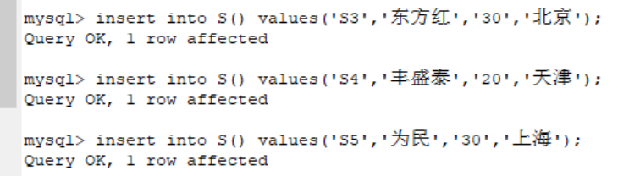

查看S表

**select** * **from** S;

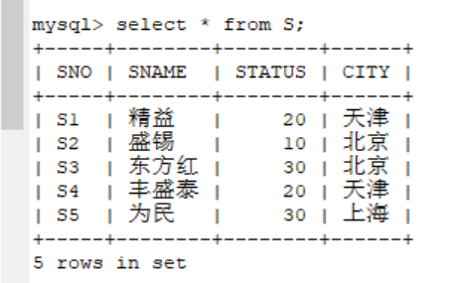

1. **关于P表的操作**

创建P表

**create table** P(PNO **char**(2),PNAME **char**(3),COLOR **char**(1),WEIGHT **int**);

向P表中插入数据

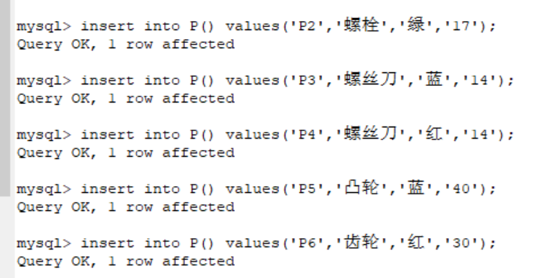**insert into** P() **values**('P1','螺母','红','12');

**insert into** P() **values**('P2','螺栓','绿','17');

**insert into** P() **values**('P3','螺丝刀','蓝','14');

**insert into** P() **values**('P4','螺丝刀','红','14');

**insert into** P() **values**('P5','凸轮','蓝','40');

**insert into** P() **values**('P6','齿轮','红','30');

查看P表

**select** * **from** P;

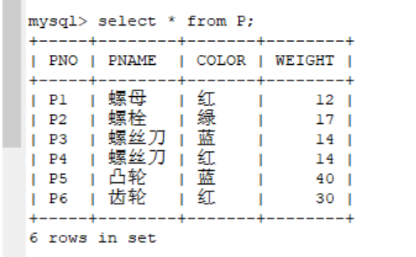

1. **关于J表的操作**

创建J表

**create table** J(JNO **char**(2),JNAME **char**(4),CITY **char**(2));

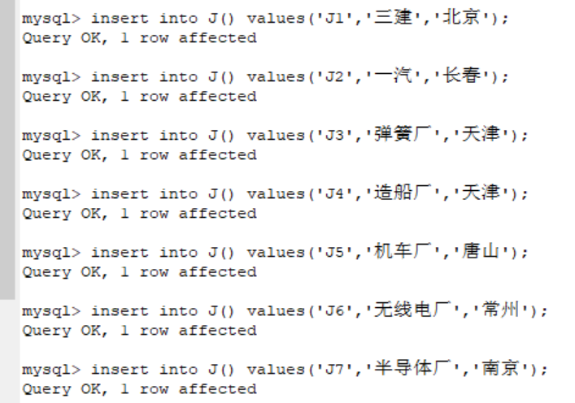向J表中插入数据

**insert into** J() **values**('J1','三建','北京');

**insert into** J() **values**('J2','一汽','长春');

**insert into** J() **values**('J3','弹簧厂','天津');

**insert into** J() **values**('J4','造船厂','天津');

**insert into** J() **values**('J5','机车厂','唐山');

**insert into** J() **values**('J6','无线电厂','常州');

**insert into** J() **values**('J7','半导体厂','南京');

查看J表中的数据

**select** * **from** J;

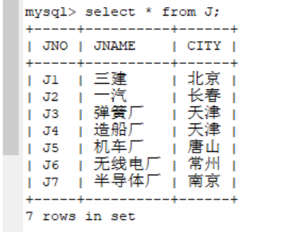

1. **关于SPJ表的操作**

创建SPJ表

**create table** SPJ(SNO **char**(2),PNO **char**(2),JNO **char**(2),QTY **int**);

向SPJ表中插入数据

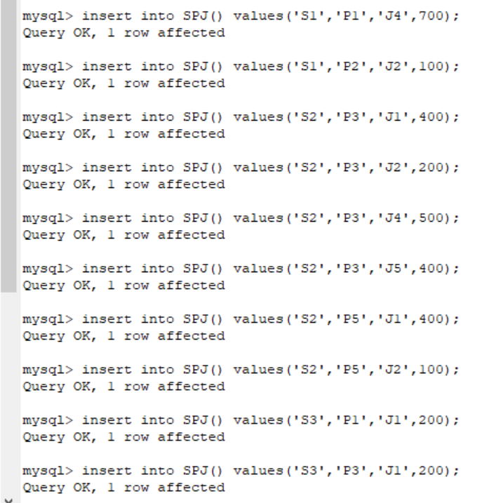**insert into** SPJ() **values**('S1','P1','J3',100);

**insert into** SPJ() **values**('S1','P1','J4',700);

**insert into** SPJ() **values**('S1','P2','J2',100);

**insert into** SPJ() **values**('S2','P3','J1',400);

**insert into** SPJ() **values**('S2','P3','J2',200);

**insert into** SPJ() **values**('S2','P3','J4',500);

**insert into** SPJ() **values**('S2','P3','J5',400);

**insert into** SPJ() **values**('S2','P5','J1',400);

**insert into** SPJ() **values**('S2','P5','J2',100);

**insert into** SPJ() **values**('S3','P1','J1',200);

**insert into** SPJ() **values**('S3','P3','J1',200);

**insert into** SPJ() **values**('S4','P5','J1',100);

**insert into** SPJ() **values**('S4','P6','J3',300);

**insert into** SPJ() **values**('S4','P6','J4',200);

**insert into** SPJ() **values**('S5','P2','J4',100);

**insert into** SPJ() **values**('S5','P3','J1',200);

**insert into** SPJ() **values**('S5','P6','J2',200);

**insert into** SPJ() **values**('S5','P6','J4',500);

查看SPJ表中的数据

**select** * **from** SPJ;

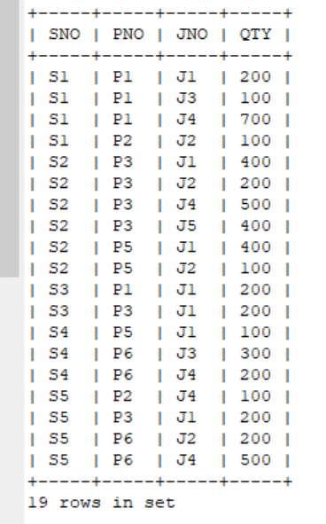

1. **查看当前数据库中的表**

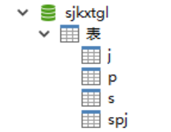show tables;

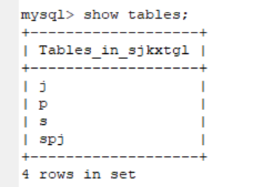

1. **具体实验操作**
2. **找出所有供应商的姓名和所在城市**

**select** SNAME,CITY **from** S;

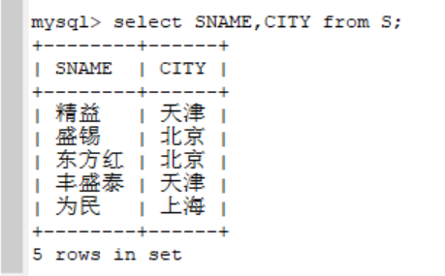

1. **找出所有零件的名称、颜色、重量**

**select** PNAME,COLOR,WEIGHT **from** P;

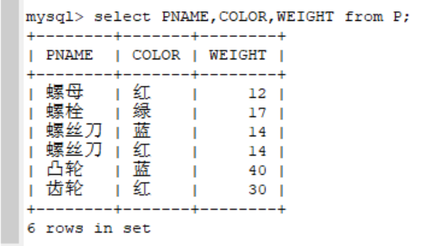

1. **找出使用供应商S1所供应零件的工程号码**

**select** JNO **from** SPJ **where** SNO='S1';

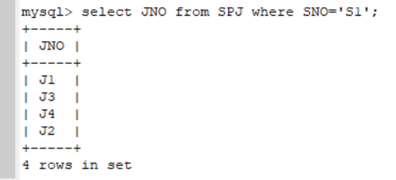

1. **找出工程项目J2使用的各种零件的名称及其数量**

**select** PNAME,QTY **from** P natural **join** SPJ **where** JNO='J2';

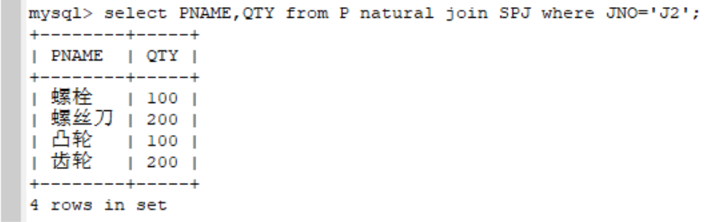

1. **找出上海厂商供应的所有零件号码**

**select distinct** PNO **from** S natural **join** SPJ **where** CITY='上海';

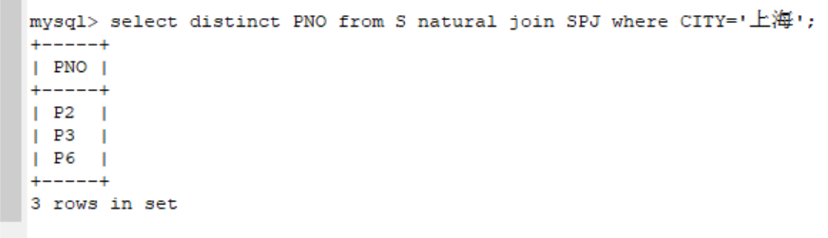

1. **找出使用上海产的零件的工程号码**

**select distinct** JNO **from** S natural **join** SPJ **where** CITY='上海';

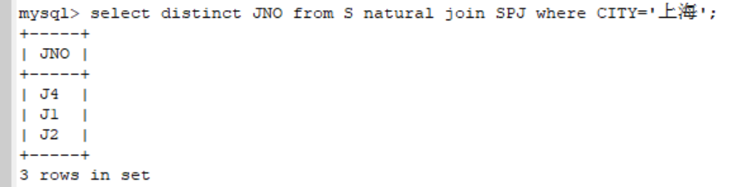

1. **找出没有使用天津产的零件的工程号码**

**select distinct** JNO **from** S natural **join** SPJ **where** CITY<>'天津';

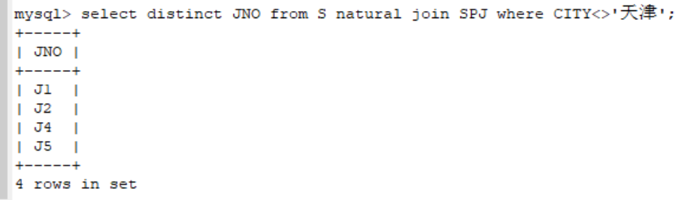

1. **把全部红色零件的颜色改成蓝色**

**update** P **set** color='蓝' **where** color='红';

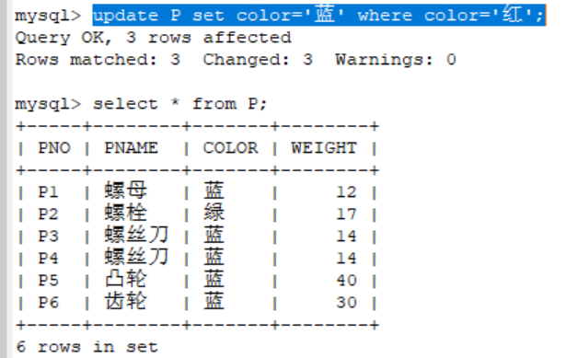

1. **由S5供给J4的零件P6改为由S3供应，请作必要修改**

**update** SPJ **set** SNO='S3' **where** SNO='S5' **and** JNO='J4' **and** PNO='P6';

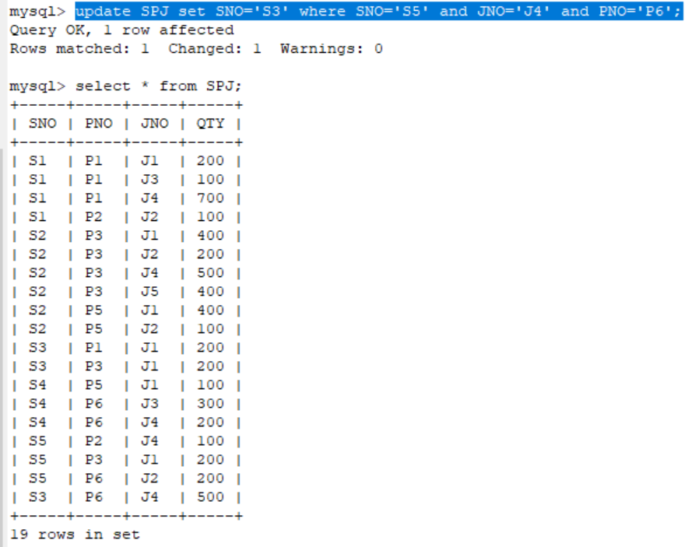

1. **从供应商关系中删除S2的记录，并从供应情况关系中删除相应的记录**

**delete from** S **where** SNO='S2';

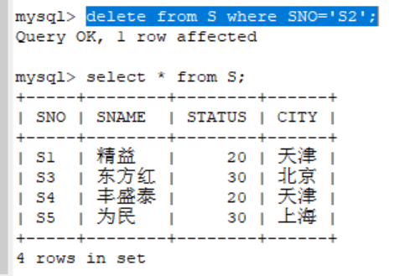

**delete from** SPJ **where** SNO='S2';

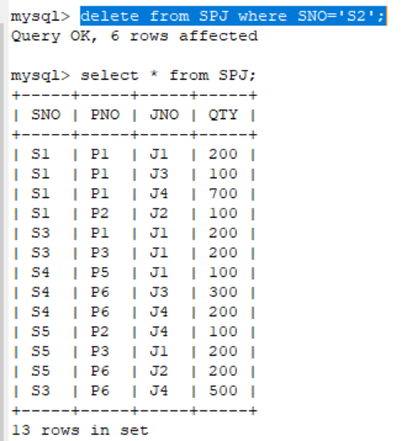

1. **请将（S2,J6,P4,200）插入供应情况关系**

**insert into** SPJ **values**('S2','J6','P4',200);

