CIS 311: Neural Networks

Multilayer Perceptrons

1. The Multilayer Perceptron

The multilayer perceptron (MLP) is a hierarchical structure of
several perceptrons, and overcomes the shortcomings of these
single-layer networks.

The multilayer perceptron is an artificial neural network that learns
nonlinear function mappings. The multilayer perceptron is capable
of learning a rich variety of nonlinear decision surfaces.

Nonlinear functions can be represented by multilayer perceptrons with
units that use nonlinear activation functions. Multiple layers of cascaded
linear units still produce only linear mappings.

1.1 Differentiable Activation Functions

The training algorithm for multilayer networks requires differentiable,
continuous nonlinear activation functions. Such a function is the sigmoid,
or logistic function:

o = σ( s ) = 1 / ( 1 + e^{-s} ),

where s is the sum: s=Σ_{i=0}^{d} w_{i} x_{i}.
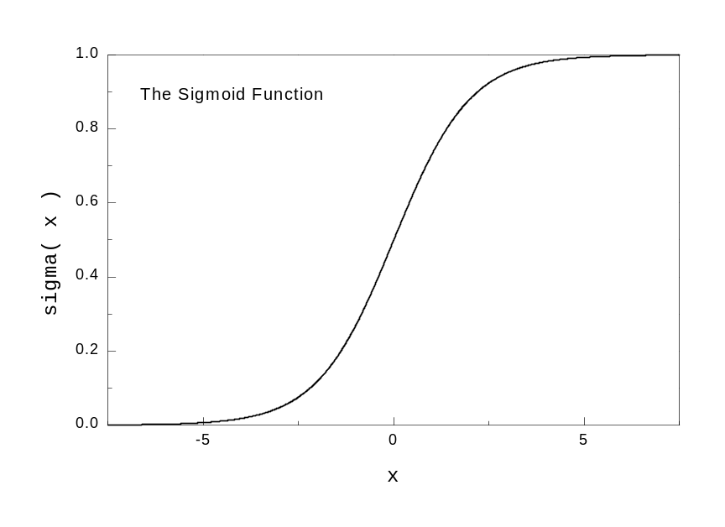
Sometimes σ is called alternatively squashing function as it maps a very
large input domain to a small range of outputs.

Another nonlinear function often used in practice is the hyperbolic tangent:

o = tanh( s ) = ( e^{s} - e^{-s} ) / ( e^{s} + e^{-s} )

Sometimes the hyperbolic tangent is preferred as it makes the training
a little easier.
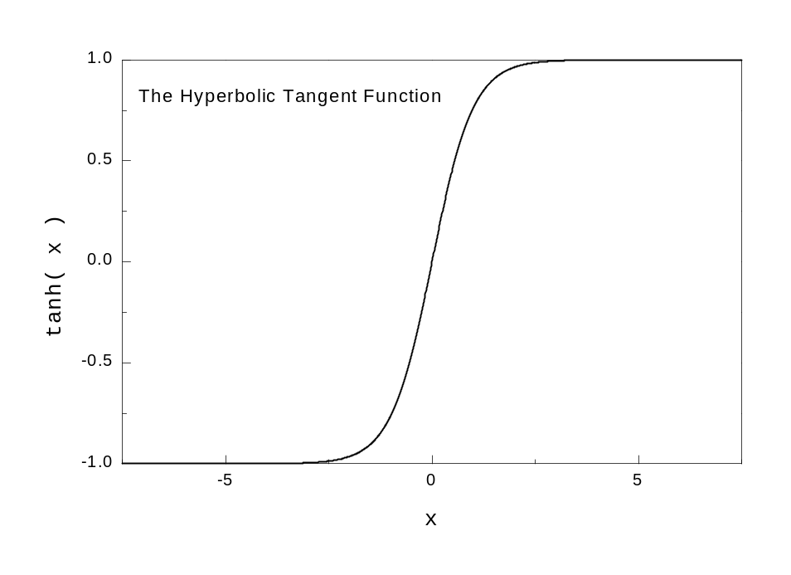

1.2 Multilayer Network Structure

A neural network with one or more layers of nodes between the input
and the output nodes is called multilayer network.

The multilayer network structure, or architecture, or topology, consists of
an input layer, two or more hidden layers, and one output layer. The input
nodes pass values to the first hidden layer, its nodes to the second and so on till producing outputs.

A network with a layer of input units, a layer of hidden units and a layer of
output units is a two-layer network.

A network with two layers of hidden units is a three-layer network, and so
on. A justification for this is that the layer of input units is used only as an
input channel and can therefore be discounted.
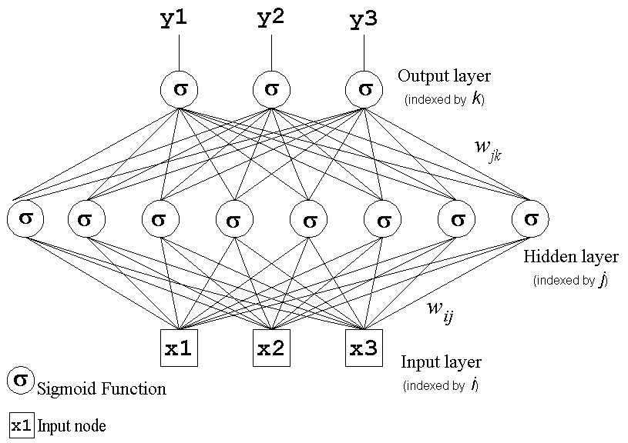

The above two-layer neural network implements the function:

f( x )= σ( w_{jk} σ( Σ_{i} w_{ij} x_{i} + w_{0j} ) + w_{0k} )

where: x is the input vector,
w_{0j} and w_{0k} are the thresholds,
w_{ij} are the weights connecting the input with the hidden nodes
w_{jk} are the weights connecting the hidden with the output nodes
σ is the sigmoid activation function.
These are the hidden units that enable the multilayer network to
learn complex tasks by extracting progressively more meaningful
information from the input examples.

The multilayer network MLP has a highly connected topology since
every input is connected to all nodes in the first hidden layer, every
unit in the hidden layers is connected to all nodes in the next layer,
and so on.

The input signals, initially these are the input examples, propagate
through the neural network in a forward direction on a layer-by-layer
basis, that is why they are often called feedforward multilayer networks.

Two kinds of signals pass through these networks:

- function signals: the input examples propagated through the hidden units
and processed by their activation functions emerge as outputs;

- error signals: the errors at the otuput nodes are propagated backward
layer-by-layer through the network so that each node returns
its error back to the nodes in the previous hidden layer.
1.3 Representation Power of MLP

Several properties concerning the representational power of the
feedforward MLP have been proven:

- learning arbitrary functions: any function can be learned with an
arbitrary accuracy by a three-layer network;

- learning continuous functions: every bounded continuous function
can be learned with a small error by a two-layer network (the number
of hidden units depends on the function to be approximated);

- learning boolean functions: every boolean function can be learned
exactly by a two-layer network although the number of hidden units
grows exponentially with the input dimension.

2. Backpropagation Learning Algorithm

MLP are successfully applied on practical tasks after the discovery
of a supervised training algorithm for learning their weights, this is
the backpropagation learning algorithm.

The backpropagation algorithm for training multilayer neural networks
is a generalization of the LMS training procedure for nonlinear logistic
outputs. As with the LMS procedure, training is iterative with the
weights adjusted after the presentation of each case.

The error backpropagation algorithm includes two passes
through the network:
- forward pass and
- backward pass.

During the backward pass the weights are adjusted in accordance
with the error correction rule.

It suggests that the actual network output is subtracted from the given
output in the example.

The weights are adjusted so as to make the network output more
closer to the desired one.

The backpropagation algorithm does gradient descent as it moves in direction opposite to the gradient of the error, that is in direction of the steepest decrease of the error. This is the direction of most rapid error decrease by varying all the weights simultaneously in proportion of how much good is done by the individual changes:

∇ E( w ) = [ ∂E/∂ w₀, ∂E/∂ w₁, …, ∂E/∂ w_{d} ]

The gradient descent learning strategy requires a continuous
activation function.

The network is trained initially selecting small random weights and
then presenting all training data incrementally. Weights are adjusted
after every trial using side information specifying the correct class until weights converge and the cost function is reduced to an acceptable value.

The overall idea of backpropagation relies on examining the
interdependencies that influence the computation of the gradient
in the weight space:

• effect on a particular weight change from the output of the neuron ;
• effect on a particular weight change from all neurons in the next layer
• effect on a particular weight change from the output nodes .
Backpropagation Training Algorithm

Initialization: Examples {( x_{e}, y_{e} )}_{e=1}^{N}, initial weights w_{i} set to small random values, learning rate η = 0.1

Repeat
for each training example ( x, y )

- calculate the outputs using the sigmoid function:
oj = σ( sj ) = 1 / ( 1 + e^{-sj} ), sj = Σ_{i=0}^{d} wij oi where oi = xi // at the hidden units j
ok = σ( sk ) = 1 / ( 1 + e^{-sk} ), sk = Σ_{i=0}^{d} wjk oj // at the output units k

compute the benefit βk at the nodes k in the output layer:
βk = ok ( 1 - ok ) [ yk - ok ] // effects from the output nodes

compute the changes for weights j→k on connections to nodes in the output layer:
Δ wjk = η βk oj // effects from the output of the neuron
Δ w0k = η βk
compute the benefit βj for the hidden nodes j with the formula:
βj = oj ( 1 - oj ) [ ∑k βk wjk ] // effects from multiple nodes in the next layer

compute the changes for the weights i→j on connections to nodes in the hidden layer:
Δ wij = η βj oi // effects from the output of the neuron
Δ w0j = η βj

- update the weights by the computed changes:
w = w + Δ w

until termination condition is satisfied.
Derivation of the Backpropagation Algorithm

The backpropagation algorithm for training the multilayer perceptron implements a generalized delta rule according to which with each training example every weight is updated as follows:

w = w + Δ w
where: Δ w = - η ∂Ee/∂w
Ee = ( 1/2 ) Σk ( yk - ok )²

The implementation of the generalized delta rule requires to derive an expression for the computation of the derivatives ∂Ee/∂w:

∂Ee/∂w = ∂Ee/∂s ∂s/∂w

The first part ∂Ee/∂s reflects the change of the error as a function of the change in the network
weighted input to the unit. The second part ∂s/∂w reflects the change of the error as a function
of the change of particular weight w to that node. Since:

∂s/∂w = ∂(Σl wl ol )/∂w = o // from the case wl = w

the expression is reduced as follows:
∂Ee/∂w = ( ∂Ee/∂s ) o
Delta Rule for weights j→k on connections to nodes in the output layer

∂Ee/∂ wjk = ( ∂Ee/∂sk ) oj
∂Ee/∂sk = ∂Ee/∂ok ∂ok/∂sk

∂Ee/∂ok = ( ∂(( 1/2 ) Σl ( yl - ol )²)) /∂ok
= ( ∂(( 1/2 ) ( yk - ok )²)) /∂ok // from the case l = k
= ( 1/2 ) 2 ( yk - ok ) [ ∂( yk - ok ) /∂ok ]
= - ( yk - ok )

∂ok/∂sk = ∂ σ(sk) / ∂sk
= ok ( 1 - ok ) // from: σ(sk) = 1 / ( 1 + e^{-sk} )

Therefore:

∂Ee/∂sk = - ( yk - ok ) ok ( 1 - ok )

and when we substitute: βk = ok ( 1 - ok ) [ yk - ok ]

the Delta rule for the output units becomes:

Δ wjk = -∂Ee/∂wjk = η βk oj
Delta Rule for weights i→j on connections to nodes in the hidden layer

In this case the error depends on the errors committed by all output units:

∂Ee/∂ wij = ( ∂Ee/∂sj ) oi

∂Ee/∂sj = ∑k ∂Ee/∂sk ∂sk/∂sj
= ∑k (-βk) ∂sk/∂sj // from ∂Ee/∂sk = -βk
= ∑k (-βk) ( ∂sk/∂oj )( ∂oj/∂sj )
= ∑k (-βk) wjk ( ∂oj/∂sj )
= ∑k (-βk) wjk oj ( 1 - oj )

Therefore, when we substitute:
βj = - ∂Ee/∂sj = oj ( 1 - oj ) ∑k (-βk) wjk

the Delta rule for the hidden units becomes:

Δ wij = -∂Ee/∂wij = η βj oi

Note: This analysis was made for a single training pattern, but it can be generalized so that:

∂Etotal/∂wij = ∑e ∂Ee/∂wij

Thus, we just need to sum out weight changes over the examples.

Example: Learning from the XOR examples with a one-hidden-layer network with two hidden
and one output unit (assuming a threshold activation function)

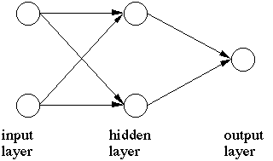

This multilayer network correctly classifies the XOR examples with the following weights:

w10 = - 3 / 2 w20 = - 1 / 2 w30 = - 1 / 2
w11 = 1 w21 = 1 w31 = -2
w21 = 1 w22 = 1 w32 = 1

(x1,x2) | Y
---------
(0,0) | 0 The output unit 3 is off because the input units 1 and 2 are off

(0,1) | 1 The output unit 3 is on due to the positive excitation from unit 2

(1,0) | 1 The output unit 3 is on due to the positive excitation from unit 2

(1,1) | 0 The output unit 3 is off because of the inhibitory effect from unit 1

Suggested Readings:

Bishop,C. (1995) "Neural Networks for Pattern Recognition",
Oxford University Press, Oxford, UK, pp.116-149 (Chapter 4).

Haykin, Simon. (1999). Neural Networks. A Comprehensive Foundation.,
Second Edition, Prentice-Hall, Inc., New Jersey, 1999.

