|  |
| --- |
|  |

Ministry of Health

Up-Skilling Project



Supervised by:

Dr. Jalal Kiswani

Dr.William Smairat

Ms. Jacquelyn Brown

Ms. Hana Al-Rasheed

# Acknowledgements

After thanking God for everything, I would like to thank Hussein Technical University for giving me this great opportunity to develop my knowledge of programming, soft skills and English language that I never had. I would like to thank Dr. Jalal Kiswani, Dr.William Smairat, Ms. Jacquelyn Brown, and Ms. Hana Al-Rasheed for supporting and helping me all this time.

# Abstract

I wanted my website to be simple, and uncomplicated with colors that are suitable and comfortable.

This website is programmed in PHP Work as backend programmer and the frontend is designed with HTML5, CSS3, JavaScript and Bootstrap framework.



# Table of content

1. **Acknowledgements----------------------------------------------------------------------------------------------1**
2. **Abstract-------------------------------------------------------------------------------------------------------------2**
3. **Intruduction ------------------------------------------------------------------------------------------------------3**
4. **Technology --------------------------------------------------------------------------------------------------------3**
   * 1. **Front-End ------------------------------------------------------------------------------- 3**
     2. **Back-End -------------------------------------------------------------------------------- 4**
5. **Requirments -------------------------------------------------------------------------------------------------------5**
6. **Prototype -----------------------------------------------------------------------------------------------------------6**
7. **Conclusion ---------------------------------------------------------------------------------------------------------7**
8. **References----------------------------------------------------------------------------------------------------------7**

# List of figures

Figure 1 Technology 4

Figure 2 Prototype . 6

# Introduction

The foundation of success in life is good health: that is the substratum fortune; it is also the basis of happiness. A person cannot accumulate a fortune very well when he is sick.

I chose the Ministry of Health because it is considered the most important ministry at the present time due to the corona pandemic. We all have to care about our health and read everything about it (articles, advice...) because the human is our most precious possession.

My website contains many tips, information about many diseases, news, announcements, and many electronic services that citizens need: Ideal Weight, Suggestions or Complaints and Vaccinations for Babies.

I created my website to be easy to use, simple, able to open from any device (mobile/laptop), responsive, can be translated into different multiple languages, and the colors are suitable and comfortable.

# Technology

### 1. Front End

Front-end developers work on what the user can see. Which are:

* HTML: Hypertext Markup Language (HTML) is the standard [markup language](https://en.wikipedia.org/wiki/Markup_language) for documents designed to be displayed in a [web browser](https://en.wikipedia.org/wiki/Web_browser).
* CSS:Cascading Style Sheets (CSS) is a [style of sheet language](https://en.wikipedia.org/wiki/Style_sheet_language) used for describing the [presentation](https://en.wikipedia.org/wiki/Presentation_semantics) of a document written in a [markup language](https://en.wikipedia.org/wiki/Markup_language) such as [HTML](https://en.wikipedia.org/wiki/HTML).

* JavaScript: is a programming language commonly used in web development. It was originally developed by Netscape as a means to add dynamic and interactive elements to websites.
* Bootstrap framework: is a [free and open-source](https://en.wikipedia.org/wiki/Free_and_open-source) [CSS framework](https://en.wikipedia.org/wiki/CSS_framework) directed at responsive, [mobile-first](https://en.wikipedia.org/wiki/Responsive_web_design#Mobile_first,_unobtrusive_JavaScript,_and_progressive_enhancement) [front-end web development](https://en.wikipedia.org/wiki/Front-end_web_development). It contains [CSS](https://en.wikipedia.org/wiki/CSS)- and (optionally) [JavaScript](https://en.wikipedia.org/wiki/JavaScript)-based design templates for [typography](https://en.wikipedia.org/wiki/Web_design#Typography), [forms](https://en.wikipedia.org/wiki/Form_(HTML)), [buttons](https://en.wikipedia.org/wiki/Button_(computing)#HTML), [navigation](https://en.wikipedia.org/wiki/Web_navigation#Local_website_navigation), and other interface components.

### 2. Back End

Back-end developers build the infrastructure that supports it.

* PHP: is a [general-purpose](https://en.wikipedia.org/wiki/General-purpose_programming_language) [scripting language](https://en.wikipedia.org/wiki/Scripting_language) especially suited to [web development](https://en.wikipedia.org/wiki/Web_development). It was originally created by Danish [programmer](https://en.wikipedia.org/wiki/Programmer) [Rasmus Lerdorf](https://en.wikipedia.org/wiki/Rasmus_Lerdorf" \o "Rasmus Lerdorf) in 1994; the PHP [reference implementation](https://en.wikipedia.org/wiki/Reference_implementation) is now produced by The PHP Group.
* MySQL: is an [open-source](https://en.wikipedia.org/wiki/Open-source_software) [relational database management system](https://en.wikipedia.org/wiki/Relational_database_management_system) Its name is a combination of "My", the name of co-founder [Michael Widenius](https://en.wikipedia.org/wiki/Michael_Widenius)'s daughter, and "[SQL](https://en.wikipedia.org/wiki/SQL)", the abbreviation for [Structured Query Language](https://en.wikipedia.org/wiki/Structured_Query_Language).

### Figure 1 Technology

# Requirements

## The User Requirements Specification describes the business needs for what users require from the system. The user requirements used in this website:

## The user should be able to use the Website easily.

## The user should be able to navigate through the pages.

## The user should be able to open the website from a mobile (responsive).

## The user should be able to download AMAN application easily provided in the Website header.

## The user should be able to send suggestions and complaint.

## The user should be able to know when their baby should receive vaccines.

## The user should be able to know their ideal weight.

## The user should be able to translate it into different multiple languages.

# Prototype

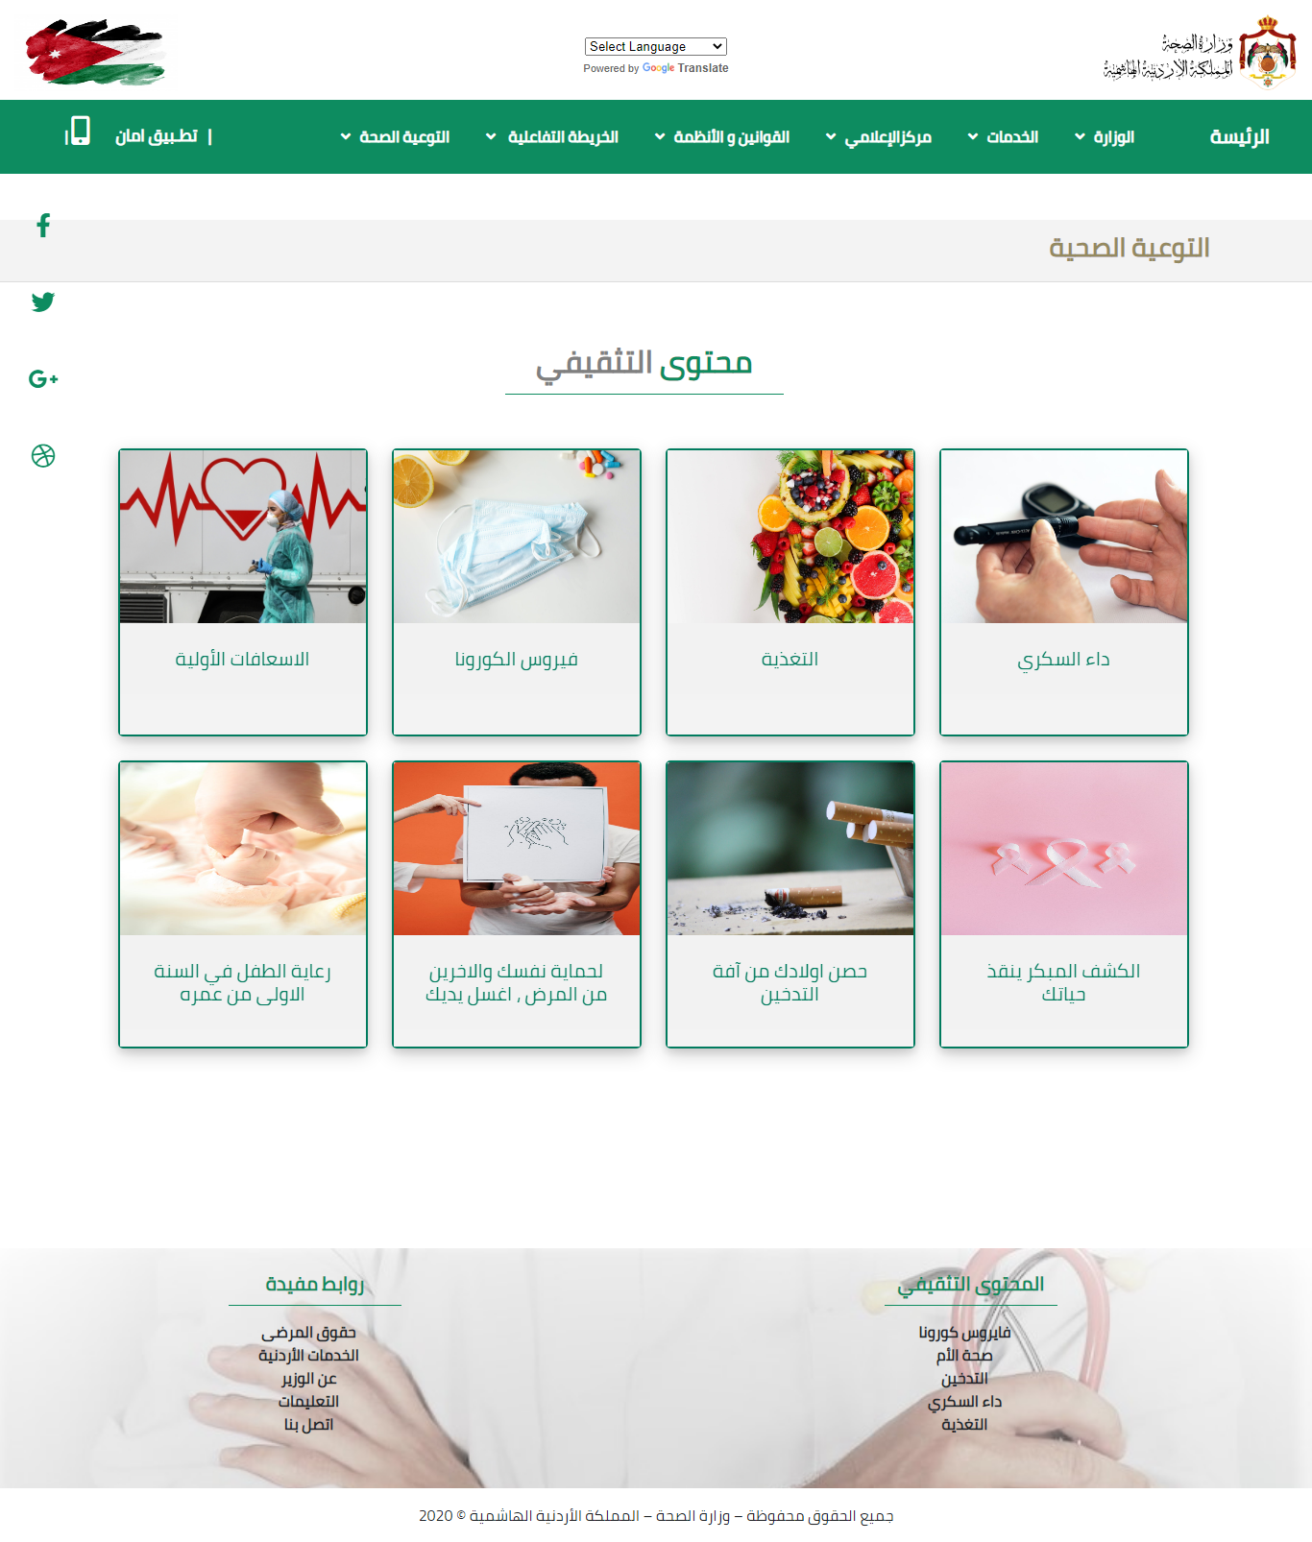

### Figure 2 Prototype.

# Conclusion

The human is our most precious possession. In the beginning, I chose the Ministry of Health, then created a Sitemap and wrote content for each page, and after that I made a wireframe, then a mockup.  
I started coding to create pages using (HTML5, CSS3, JavaScript and bootstrap framework) for front end and (PHP) for back end.

 I have programmed three electronic services for the Ministry of Health; also it contains information about the ministry, news, health awareness and regulations.

The goals of this web application are to improve my technical skills and apply what I have learned in this training. I hope my web application exceeds your expectations. In the future, I will develop my web application to make it better.

# References

[1] <https://en.wikipedia.org/wiki/HTML>

[2] <https://en.wikipedia.org/wiki/CSS>

[3] https://techterms.com/definition/javascript

[4] https://en.wikipedia.org/wiki/Bootstrap_(front-end_framework)

****[5] https://en.wikipedia.org/wiki/PHP

[6] https://en.wikipedia.org/wiki/MySQL

[7] https://www.pexels.com/