Attended droidcon Amman 18th – 20th, Jan 2024. And participate with

The hackathon as mobile application development with a full written code for tourism application.

Bachelor's Degree in Computer Science with strong academic achievement and volunteering experience and have project in different concepts in my GitHub account. Possess Strong leadership and communication skills with fluency English.

github.com/RuaaWalweel

Github::

Java

•

IGCSE and A-Level, Cambridge School

Al-Zaytoonah University of Jordan: 2021-2025



RUAA RAED

WALWEEL

Computer Science|Front-end Developer

|

**Objective**

Dedicated and innovative Computer Science professional with a strong foundation in algorithms, data structures, and software development. Seeking to leverage expertise in programming, web development to solve complex problems and contribute to user-focused solutions.

**CONTACT**

PHONE:

00962780624547

LinkedIn

:

Linkedin.com/Ruaa Walweel

EMAIL:

ruaaraed2002@gmail.com

**EDUCATION**

•

•

.

**WORKSHOP**

**CERTIFICATION**

•

Full-stack web development

•

Microsoft Excel advanced

**SKILLS**

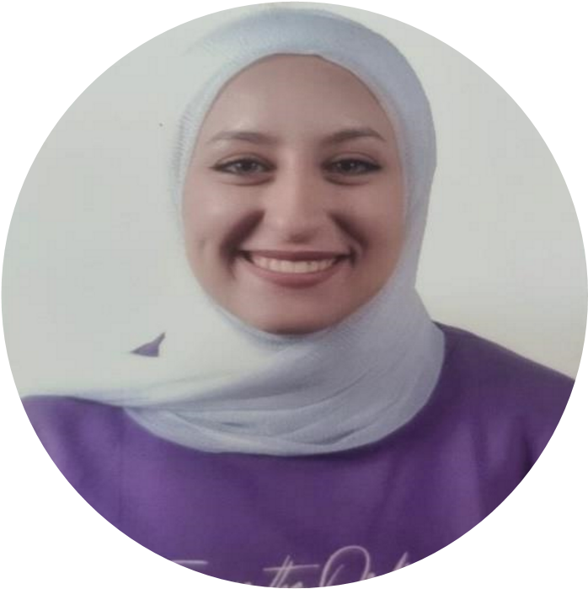

Programming Languages:

•

Python

Web Development:

•

HTML

•

CSS

•

JavaScript

•

React js

Mobile Programming:

•

JQuery

Database

Management

:

•

SQL

•

Oracle database