**Correlation coefficients:**

Correlation coefficient:

Calculate the NxN matrix of pairwise Pearson’s correlation coefficients between all combinations of N binned spike trains.

For each pair of spike trains (i,j), the correlation coefficient C[i,j]is obtained by binning iand jat the desired bin size. Let b_iand b_jdenote the binary vectors and m_iand m_jtheir respective averages. Then

C[i,j] = <b_i-m_i, b_j-m_j> /
             \sqrt{<b_i-m_i, b_i-m_i>*<b_j-m_j,b_j-m_j>}

where <..,.> is the scalar product of two vectors.

For an input of n spike trains, a n x n matrix is returned. Each entry in the matrix is a real number ranging between -1 (perfectly anti-correlated spike trains) and +1 (perfectly correlated spike trains).

If binary is True, the binned spike trains are clipped to 0 or 1 before computing the correlation coefficients, so that the binned vectors b_iand b_jare binary.

Dataset 0:

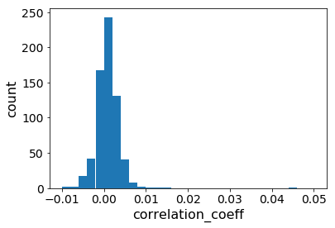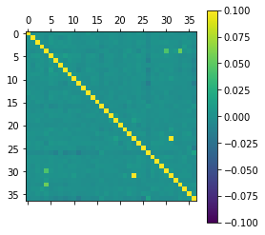

Dataset1:

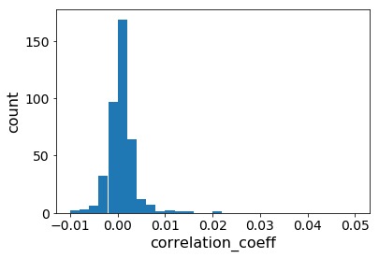



Dataset 2:

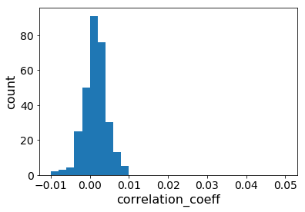

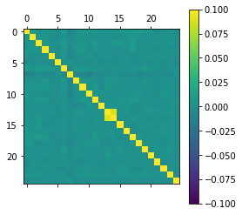

Dataset 3:

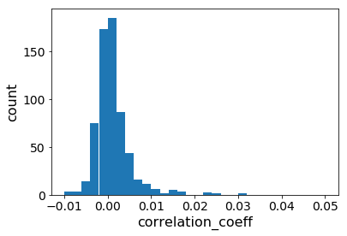

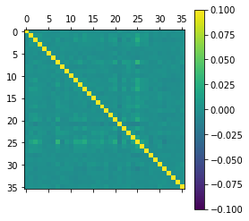

**Spike trains**

Spike trains for 5secs as shown below.

Dataset0:

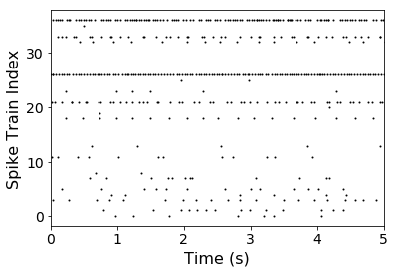

Dataset1:

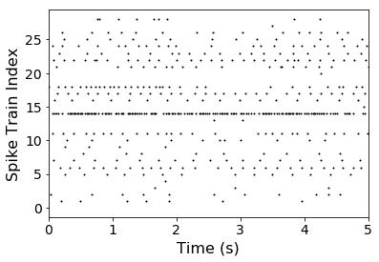

Dataset2:

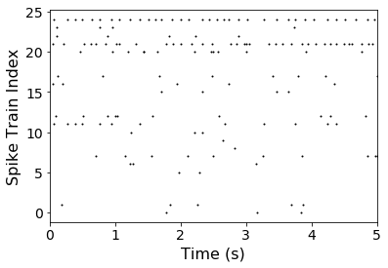

Dataset3:

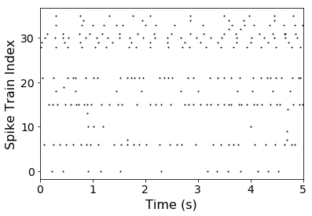

**Coefficient of variance**

**Dataset0:**

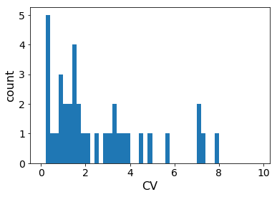

Dataset1:

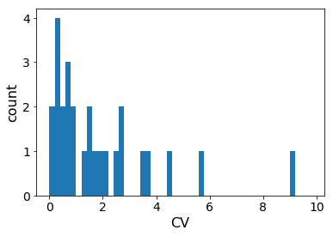

Dataset2:

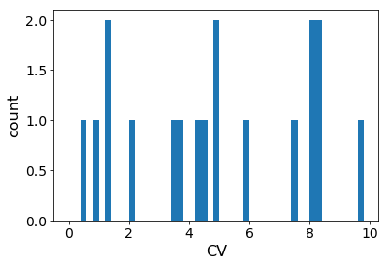

Dataset3:

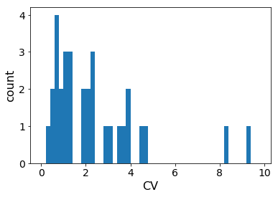

ISI of 1st spike train

Dataset0:

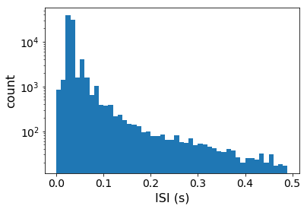

Dataset1:

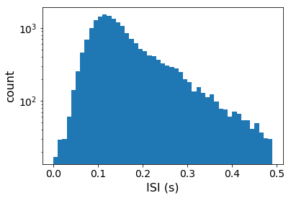

Dataset2:

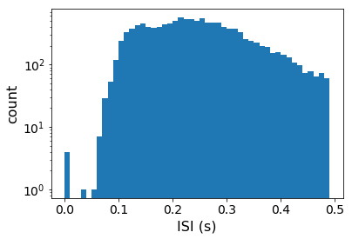

Dataset3:

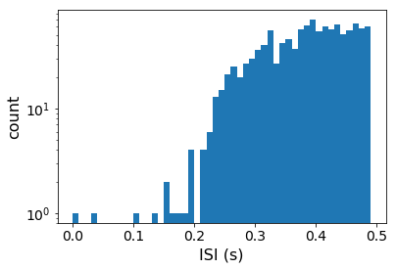

ISI of entire recording

Dataset 3:

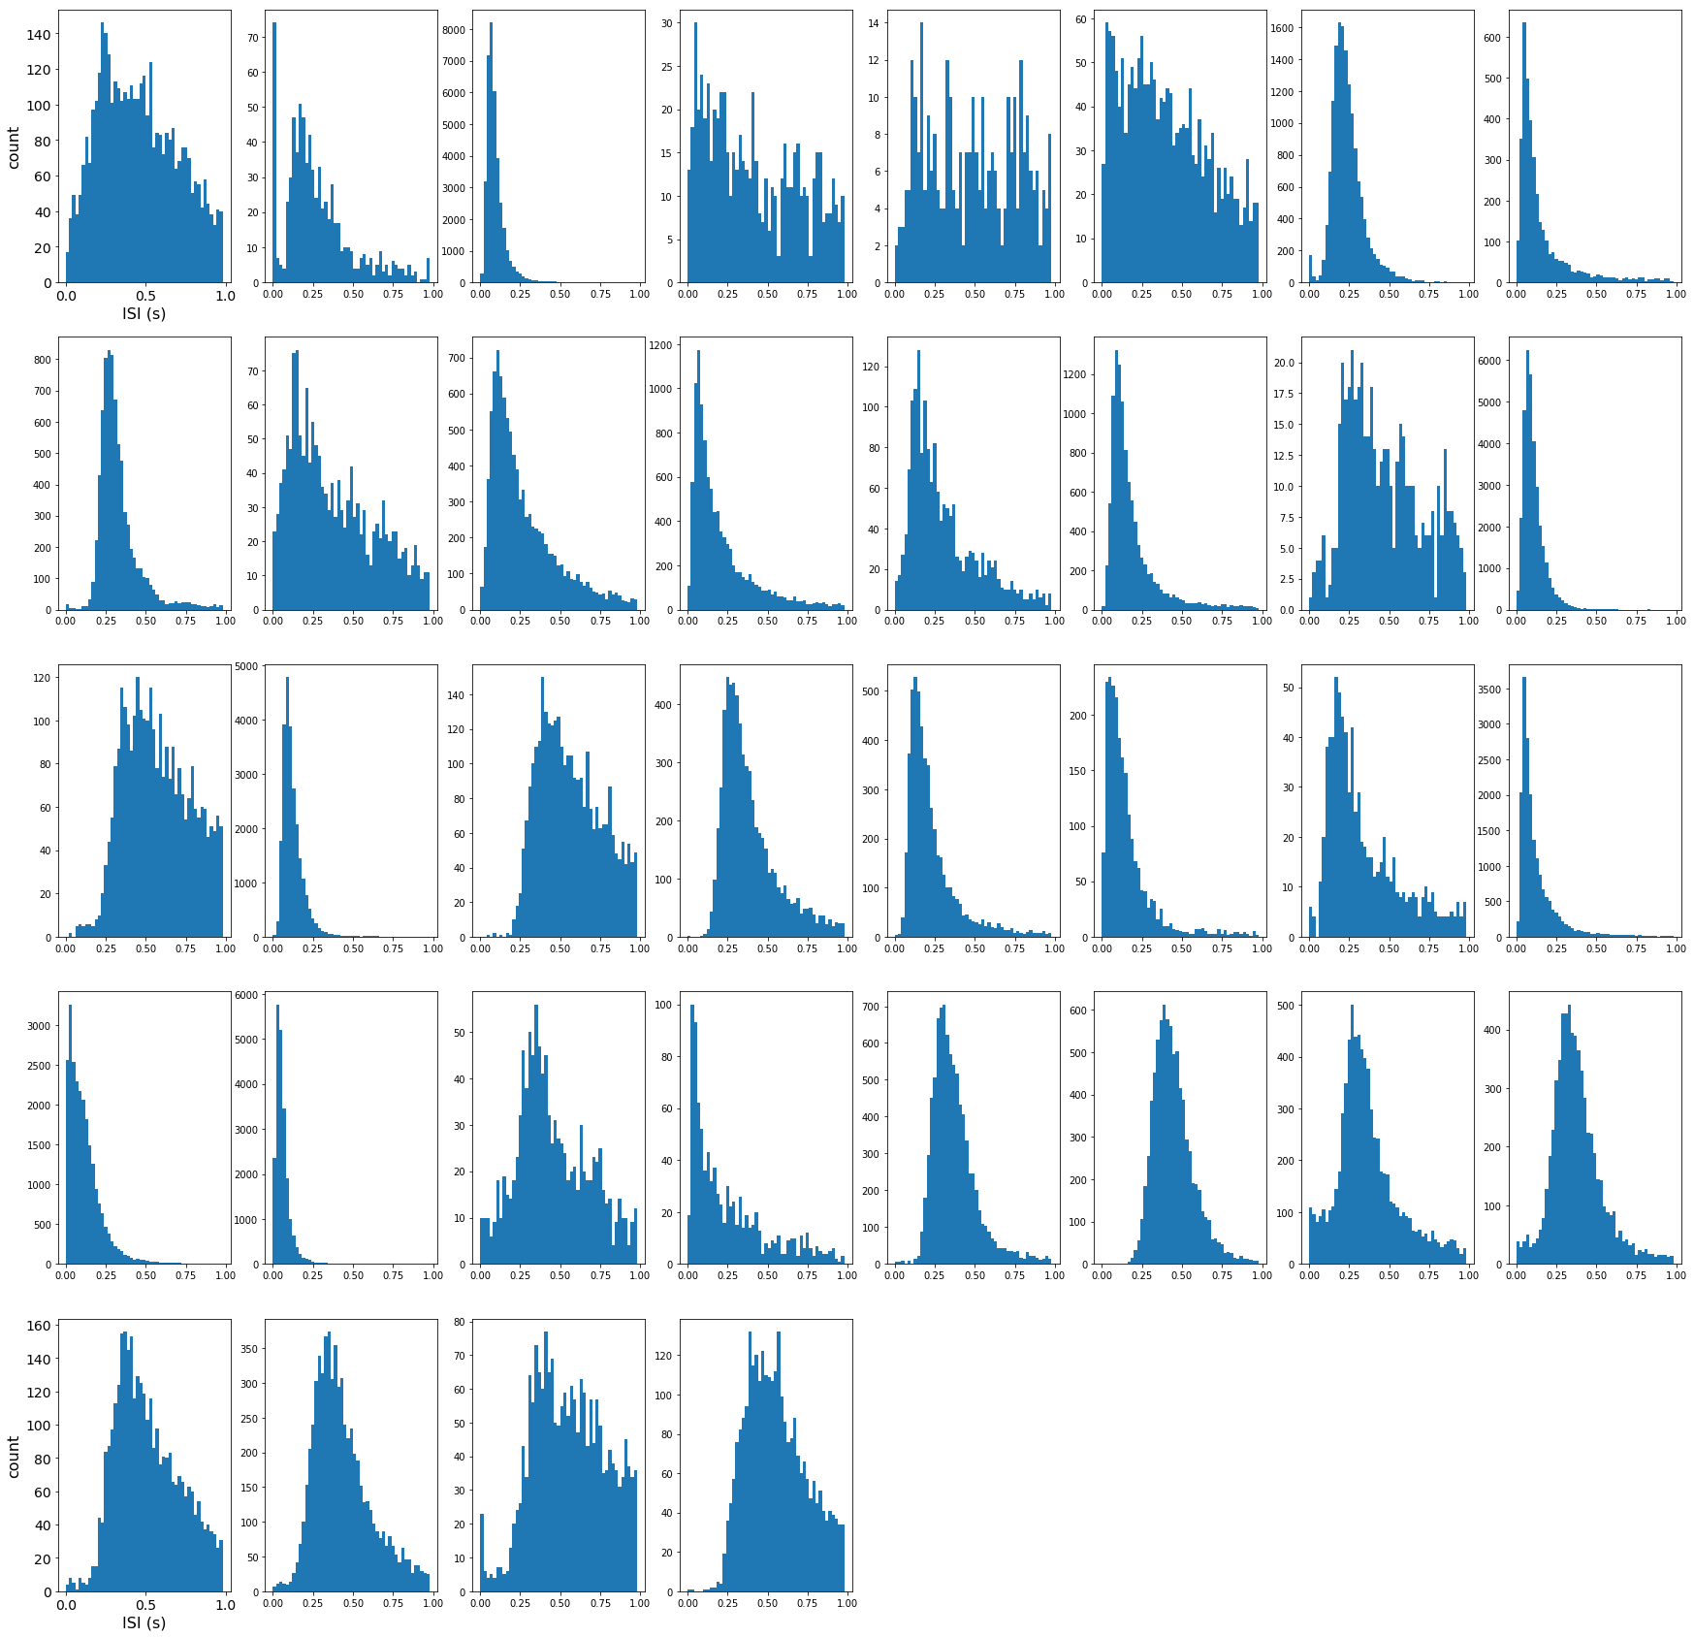

Dataset 2:

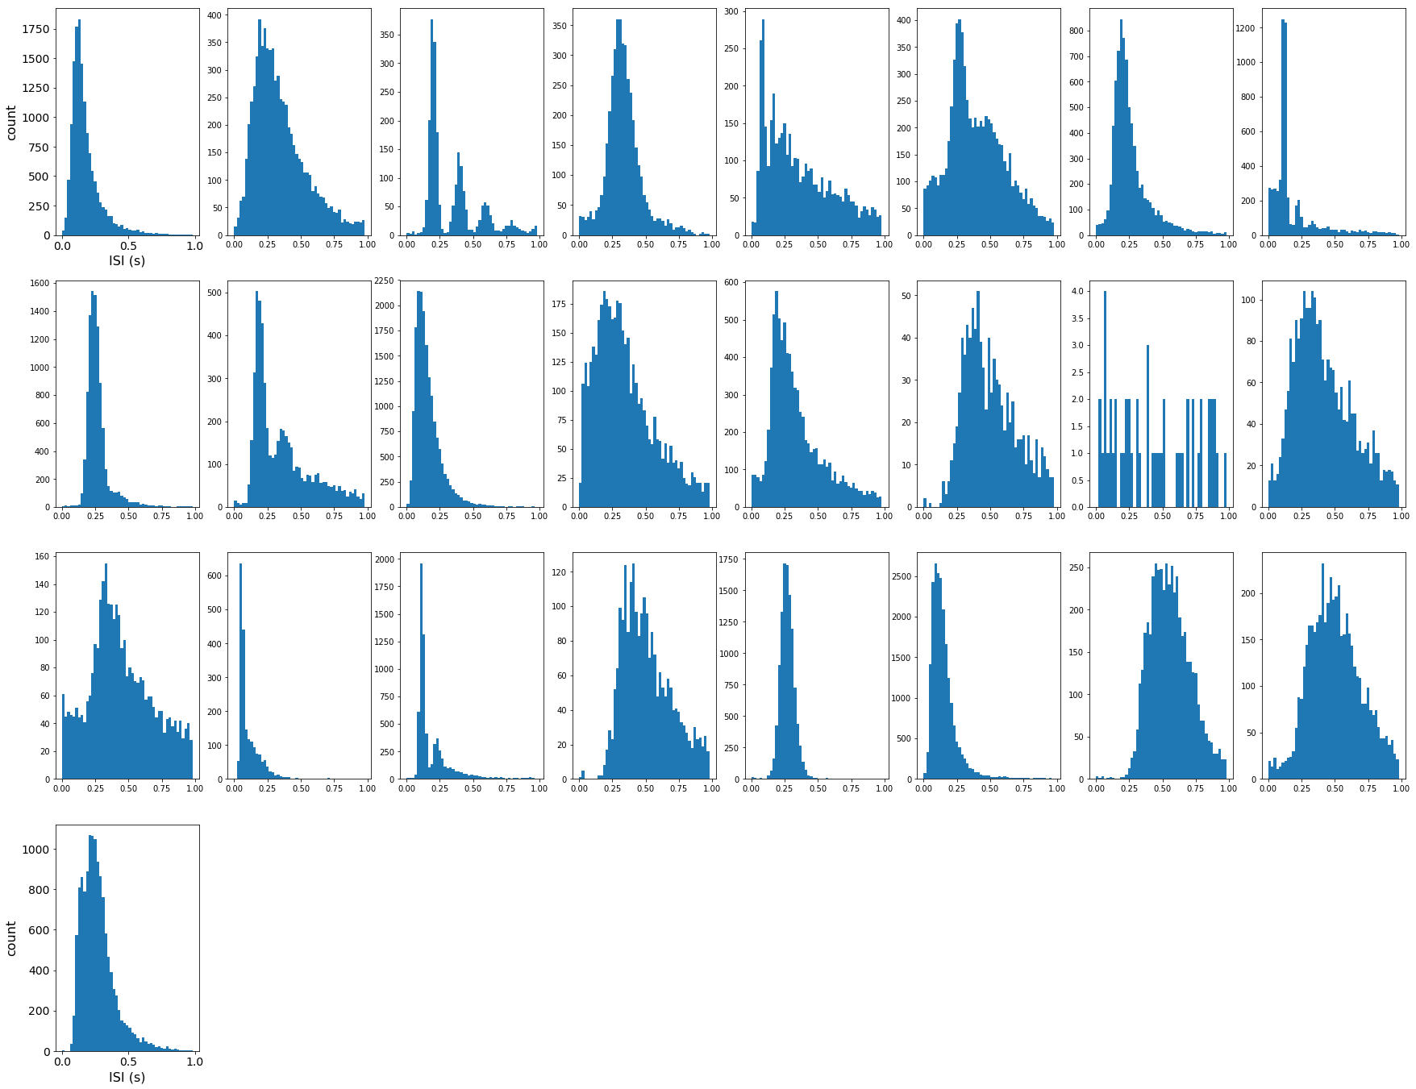

Dataset1:

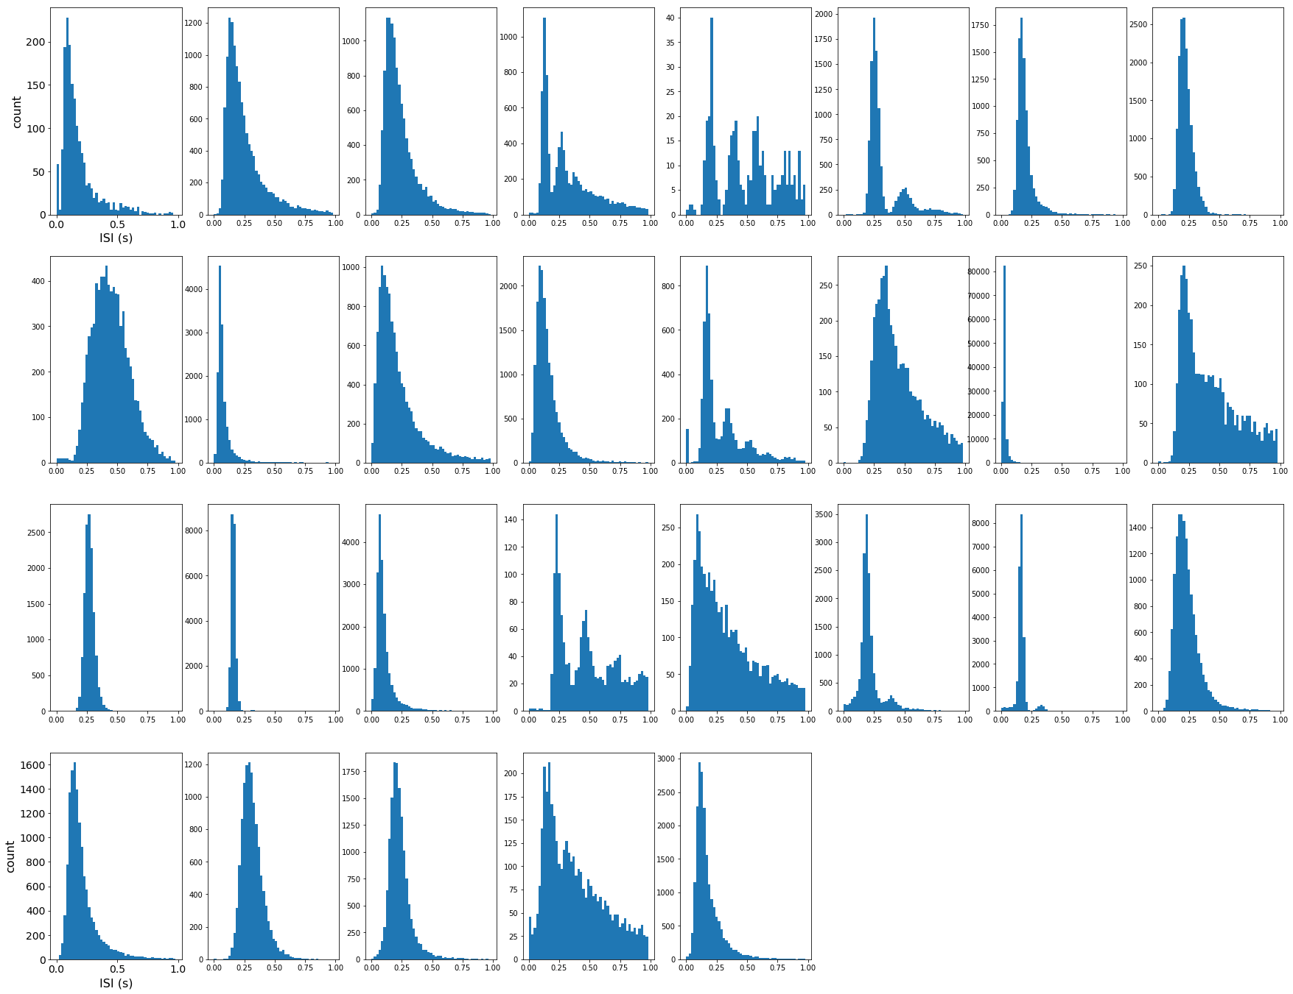

Dataset0:

