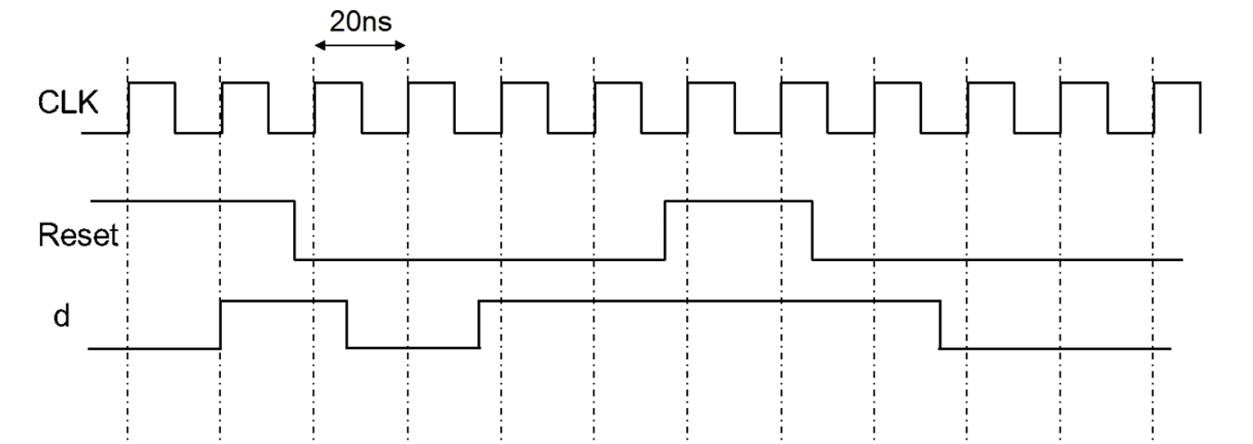

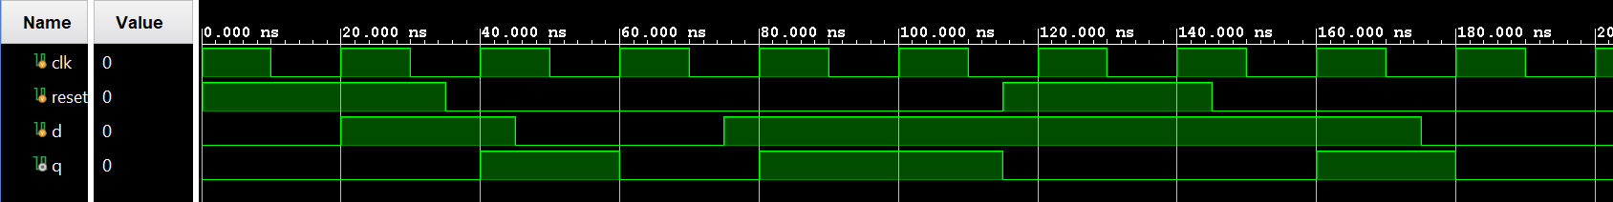

Posedge d-flip-flop test

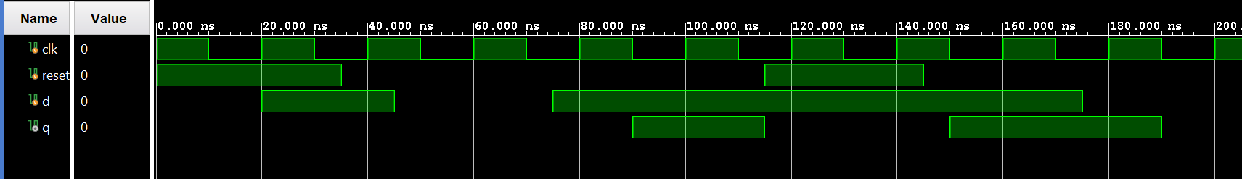

Negedge

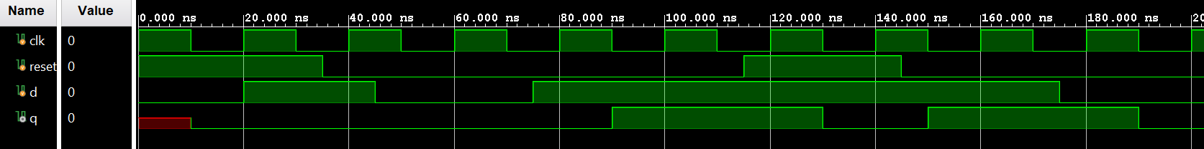

Synchronous reset, negedge

Temperature counter worked as expected.

Buttons have to be held longer than expected, probably due to polling speed.

For LFSR:

Linear feedback shift register can produce:

* Pseudo-random sequence
* Make test patters for testing



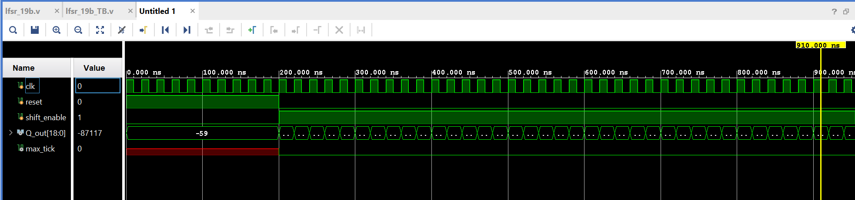

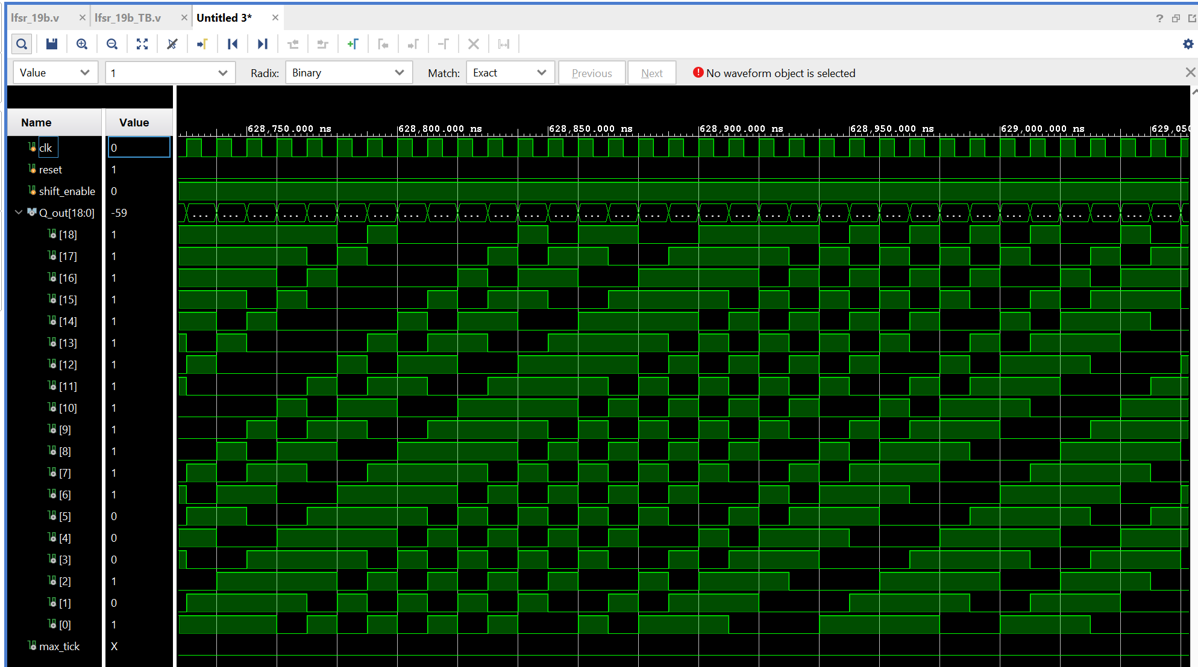

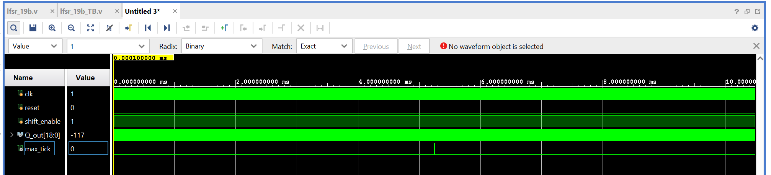

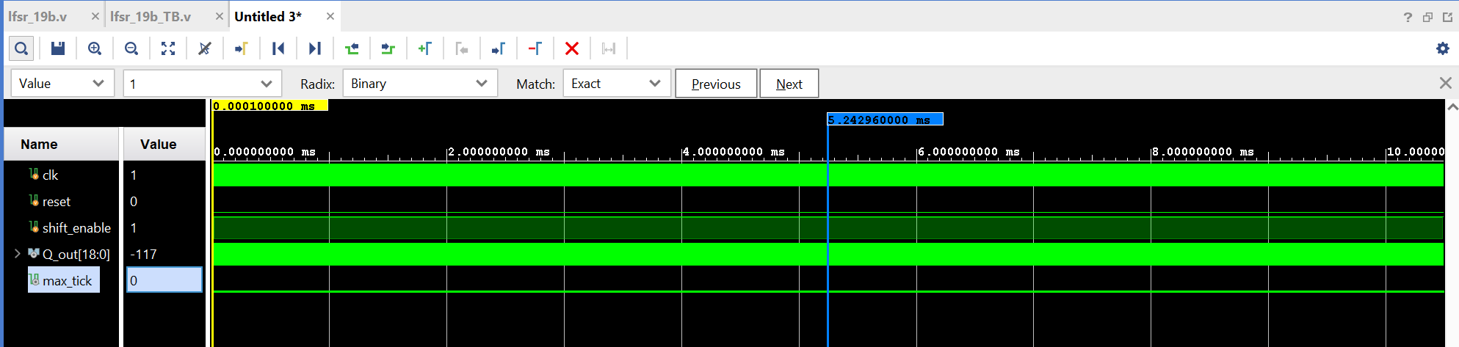

Forbidden value would be all 0s.