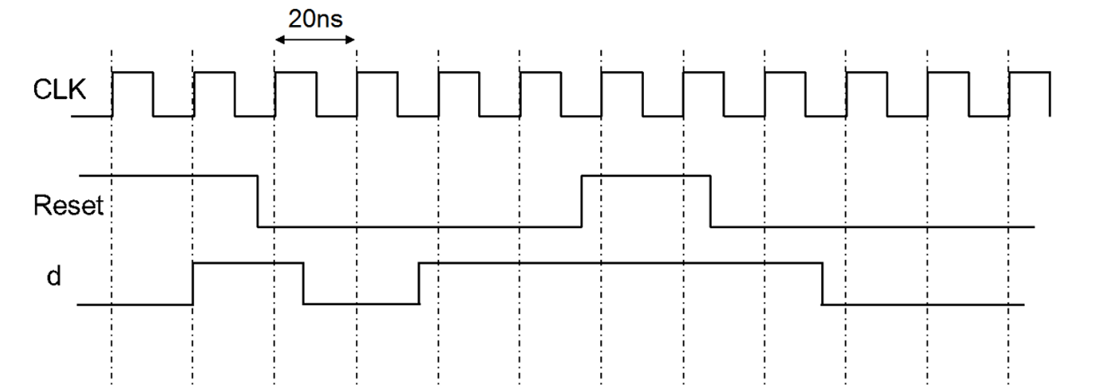
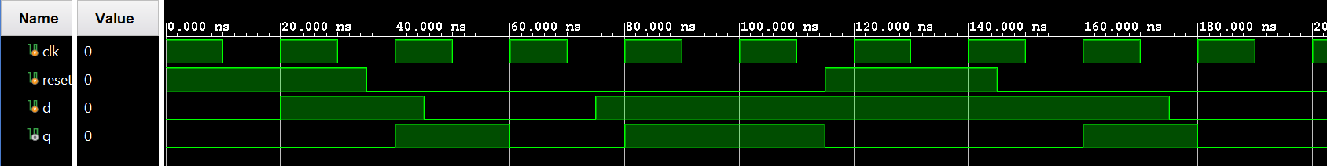
Posedge d-flip-flop test

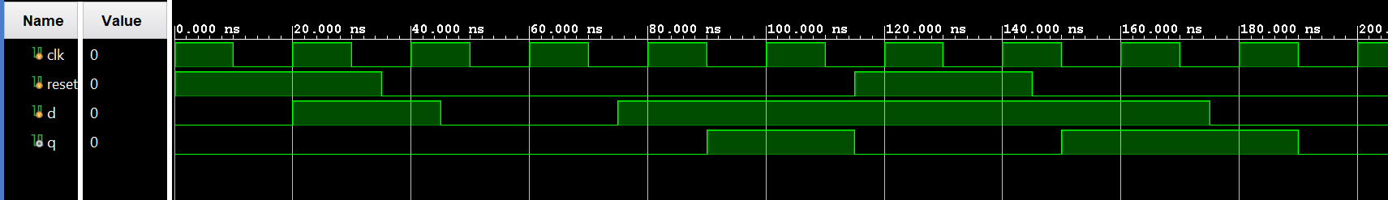
Negedge

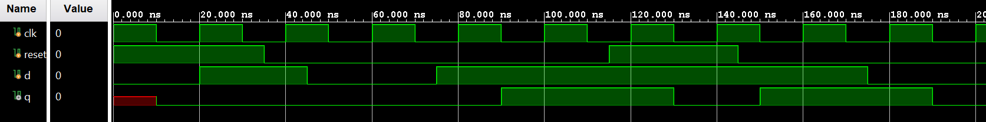
Synchronous reset, negedge

Temperature counter worked as expected.
Buttons have to be held longer than expected, probably due to polling speed.

For LFSR:
Linear feedback shift register can produce:
- Pseudo-random sequence
- Make test patters for testing

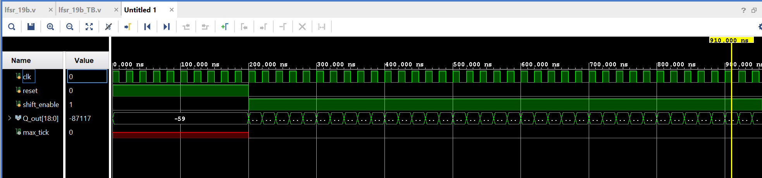
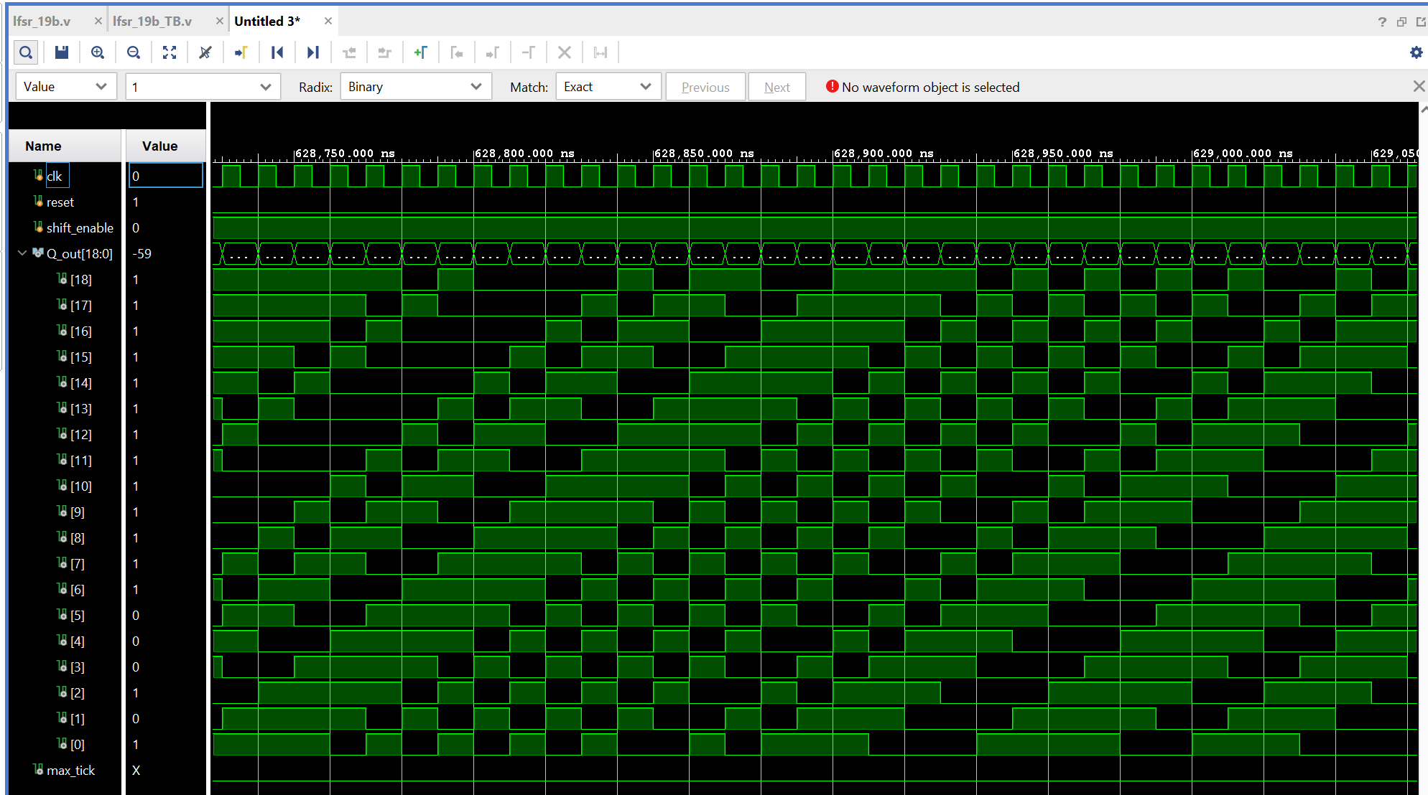
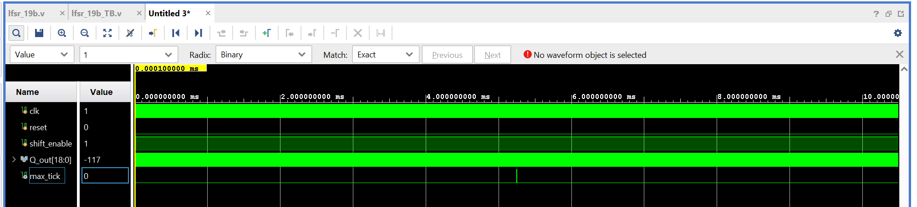
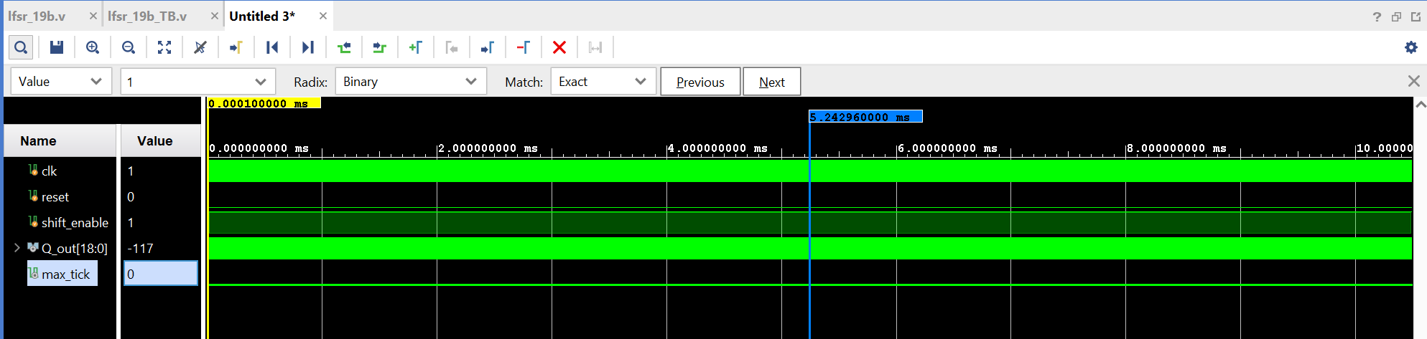
Forbidden value would be all 0s.

